APPENDIX:
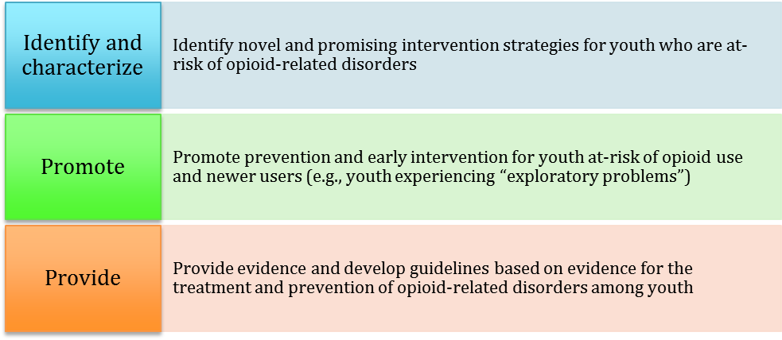
FIGURE 1: EHT At-risk/Newer Users Project Objectives
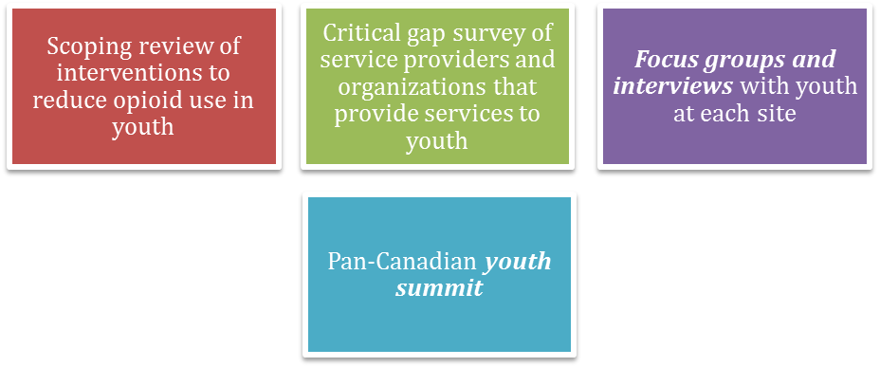
FIGURE 2: Four-pronged Methodological Protocol

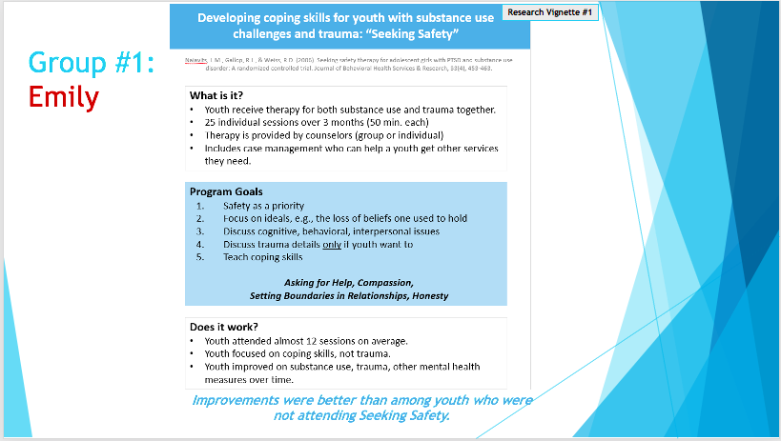

FIGURE 3: Example of youth-friendly vignette slide

GRAPHIC DESIGNS:
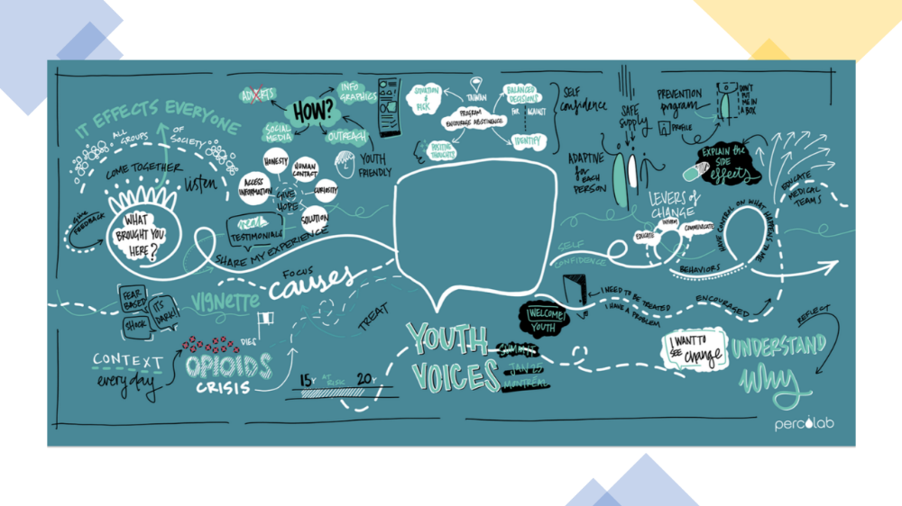FIGURE 4: Montreal Graphic Design
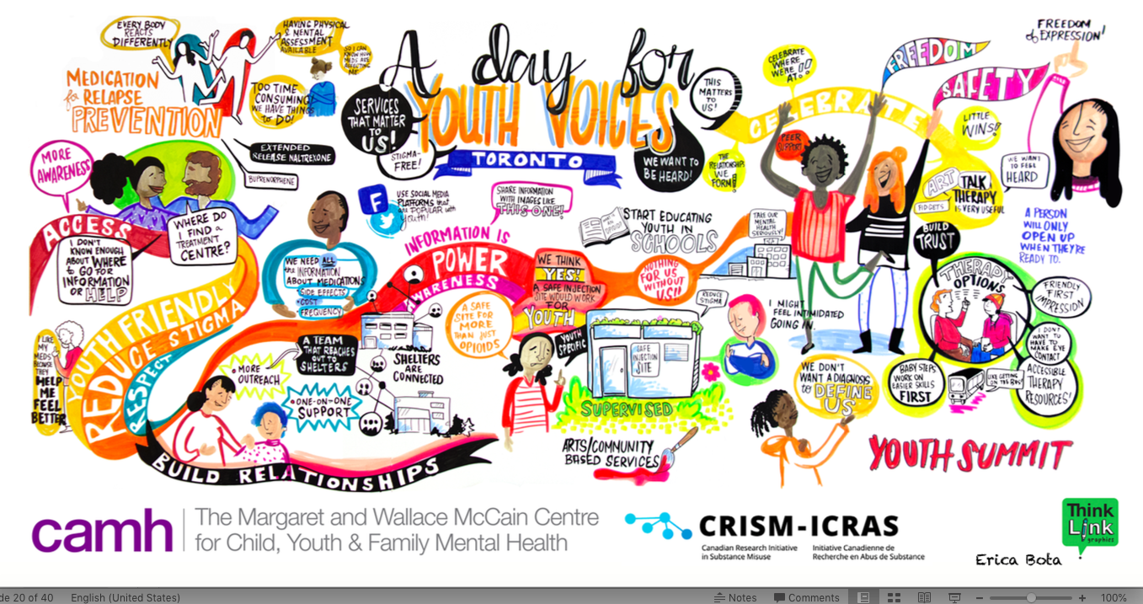FIGURE 5: Toronto Graphic Design

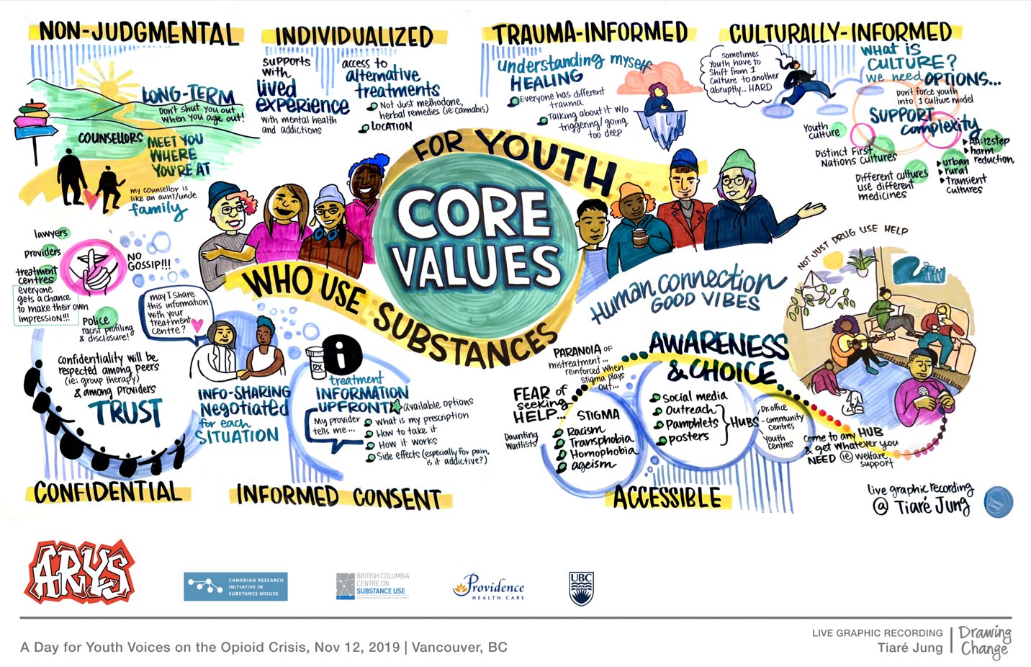

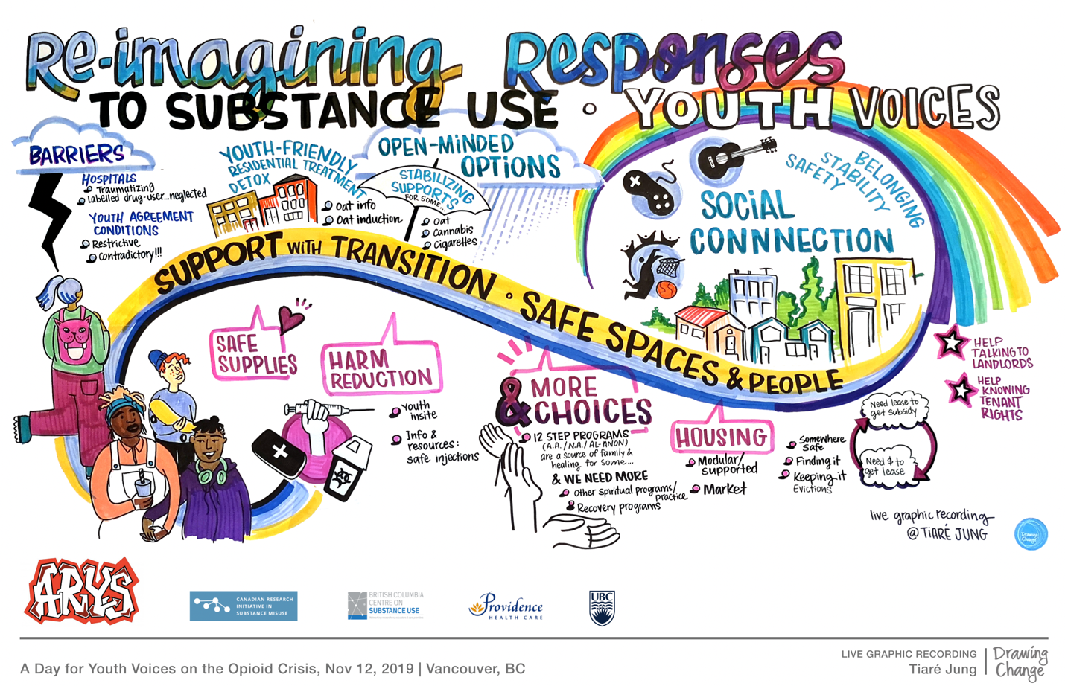
FIGURE 6: Vancouver Graphic Designs
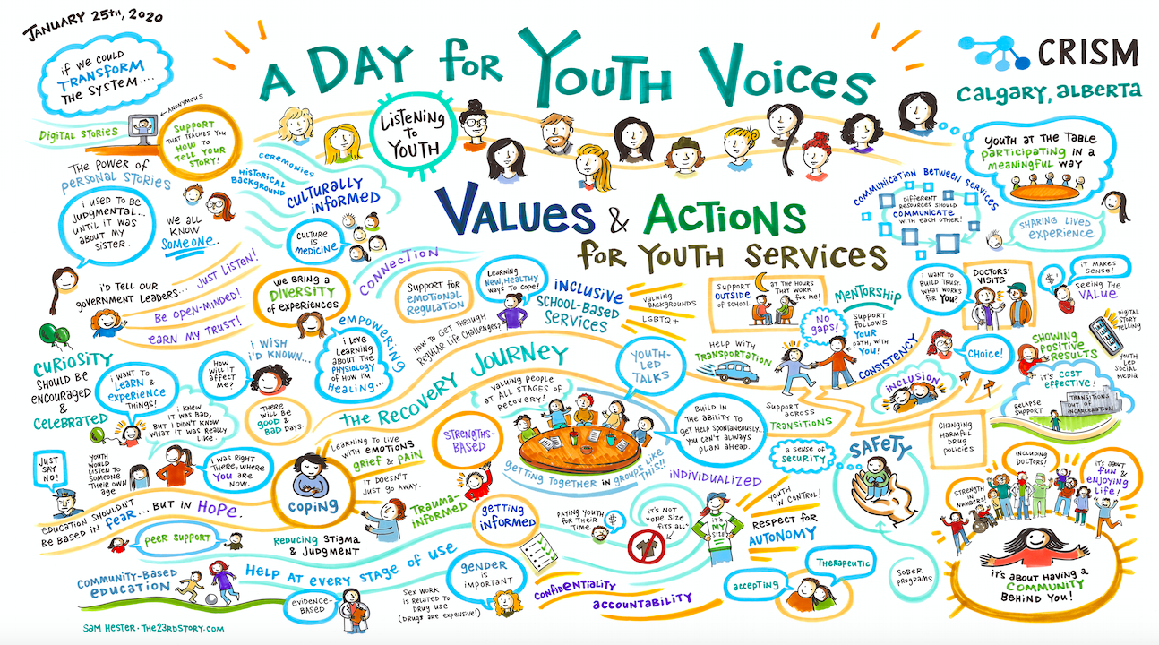
FIGURE 7: Calgary Graphic Design
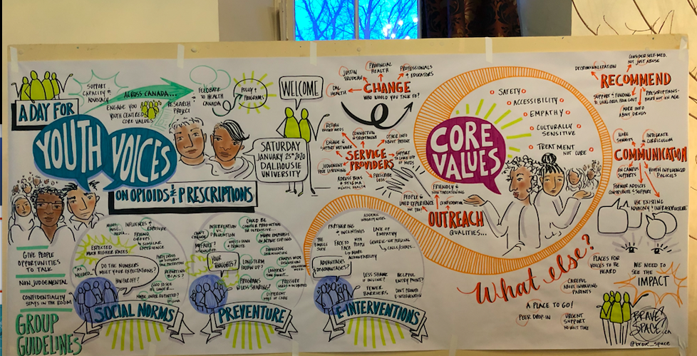
FIGURE 8: Halifax Graphic Design

