Supplemental Material Table of Contents

- Supplemental Table 1: Patient, donor, and transplant characteristics of study population by race/ethnicity separated by activation era

- Supplemental Table 2: Differences in recipient, donor, and transplant characteristics for cohort with missing data versus cohort with full data

- Supplemental Figure 1: Hazard vs Cox-Snell residuals testing fit for log-logistic AFT models

Supplemental Table 1: Patient, donor, and transplant characteristics of study population by race/ethnicity separated by activation era
 |  |  | Pre-KAS (n=4,463) |  |  |  |  | Post-KAS (n=3,033)
Variable |  |  | White (n=1,664) | Black (n=1,095) | Hispanic (n=1,417) | Other (n=287) | Total (n=4,463) | White (n=1,184) | Black (n=643) | Hispanic (n=930) | Other (n=276) | Total (n=3,033)
Transplants |  |  | 1,453 (87) | 958 (87) | 1,238 (87) | 255 (89) | 3,904 (87) | 697 (59) | 416 (51) | 589 (63) | 148 (54) | 1,850 (61)
Age at listing
 | Age 0-4 |  | 358 (21) | 169 (15) | 226 (16) | 75 (26) | 828 (19) | 217 (18) | 103 (16) | 162 (17) | 60 (22) | 542 (18)
 | Age 5-9 |  | 294 (18) | 159 (15) | 196 (14) | 41 (14) | 690 (15) | 180 (15) | 87 (13) | 139 (15) | 35 (13) | 441 (15)
 | Age 10-14 |  | 427 (26) | 287 (26) | 406 (29) | 74 (26) | 1,194 (27) | 323 (28) | 191 (30) | 271 (29) | 71 (26) | 856 (28)
 | Age >=15 |  | 585 (35) | 480 (44) | 589 (41) | 97 (34) | 1,751 (39) | 464 (39) | 262 (41) | 358 (39) | 110 (39) | 1,194 (39)
Male |  |  | 981 (59) | 683 (62) | 769 (54) | 137 (48) | 2,570 (58) | 721 (61) | 407 (63) | 500 (54) | 158 (57) | 1,786 (59)
Payer
 |  | Private | 765 (46) | 285 (26) | 301 (21) | 110 (38) | 1,461 (33) | 543 (46) | 157 (25) | 153 (16) | 121 (44) | 974 (32)
 |  | Medicaid/CHIP | 469 (28) | 459 (42) | 741 (53) | 111 (39) | 1,780 (40) | 438 (37) | 337 (52) | 576 (62) | 109 (39) | 1,460 (48)
 |  | Medicare | 330 (20) | 326 (30) | 286 (20) | 60 (21) | 1,002 (22) | 136 (11) | 125 (19) | 119 (13) | 27 (10) | 407 (14)
 |  | Other | 100 (6) | 25 (2) | 89 (6) | 6 (2) | 220 (5) | 67 (6) | 24 (4) | 82 (9) | 19 (7) | 192 (6)
Blood type
 |  | A | 611 (37) | 282 (26) | 382 (27) | 79 (28) | 1,354 (31) | 436 (37) | 174 (27) | 231 (25) | 76 (28) | 917 (30)
 |  | AB | 72 (4) | 41 (4) | 29 (2) | 10 (3) | 152 (3) | 54 (4) | 25 (4) | 20 (2) | 14 (5) | 113 (4)
 |  | B | 191 (11) | 220 (20) | 123 (9) | 55 (19) | 589 (13) | 131 (11) | 121 (19) | 80 (9) | 63 (22) | 395 (13)
 |  | O | 790 (48) | 552 (50) | 883 (62) | 143 (50) | 2,368 (53) | 563 (48) | 323 (50) | 599 (64) | 123 (45) | 1,608 (53)
Days on dialysis^{B} |  |  | 593  (304-1,095) | 725  (392-1,298) | 720  (405-1,303) | 689  (387-1,104) | 670  (364-1,197) | 469  (258-753) | 555  (302-872) | 544  (331-865) | 499  (298-807) | 514  (296-835)
Primary diagnosis
 |  | CAKUT | 736 (44) | 410 (38) | 513 (36) | 113 (39) | 1,772 (40) | 575 (49) | 255 (40) | 380 (41) | 116 (42) | 1,326 (44)
 |  | GN | 150 (9) | 90 (8) | 135 (9) | 25 (9) | 400 (9) | 98 (8) | 44 (7) | 77 (8) | 36 (13) | 255 (8)
 |  | Secondary GN | 155 (10) | 156 (14) | 173 (12) | 38 (13) | 522 (12) | 85 (7) | 76 (12) | 120 (13) | 24 (9) | 305 (10)
 |  | FSGS | 138 (8) | 222 (20) | 192 (14) | 31 (11) | 583 (13) | 89 87) | 138 (21) | 102 (11) | 35 (13) | 364 (12)
 |  | Other | 438 (29) | 217 (20) | 404 (29) | 80 (28) | 1,186 (26) | 337 (28) | 130 (20) | 251 (27) | 65 (23) | 783 (26)
cPRA
 |  | 0-39% | 1,540 (92) | 992 (90) | 1,317 (93) | 242 (84) | 4,091 (92) | 1,101 (93) | 584 (91) | 856 (92) | 247 (90) | 2,788 (92)
 |  | 40-79% | 95 (6) | 73 (7) | 77 (5) | 28 (10) | 273 (6) | 69 (6) | 41 (6) | 57 (6) | 20 (7) | 187 (6)
 |  | 80+ | 29 (2) | 30 (3) | 23 (2) | 17 (6) | 99 (2) | 14 (1) | 18 (3) | 17 (2) | 9 (3) | 58 (2)
KDPI^{A}*
 |  | 0-20 | 583 (40) | 356 (37) | 504 (41) | 100 (39) | 1,394 (40) | 275 (40) | 138 (34) | 223 (38) | 55 (39) | 691 (38)
 |  | 20-34 | 492 (34) | 359 (38) | 491 (40) | 105 (41) | 1,299 (37) | 277 (40) | 179 (44) | 238 (41) | 61 (42) | 755 (41)
 |  | 35+ | 372 (26) | 241 (25) | 240 (19) | 50 (20) | 835 (23) | 137 (20) | 90 (22) | 120 (21) | 27 (19) | 374 (21)
Cold ischemic time (hours)^{A}^ |  |  | 12 (8-16) | 12 (9-17) | 12 (8-15) | 11 (7-15) | 12 (8-16) | 11 (7-16) | 12 (8-17) | 12 (9-17) | 11 (7-16) | 12 (8-16)
Delayed graft function^{A}** |  |  | 96 (7) | 93 (10) | 86 (7) | 17 (7) | 1292 (8) | 40 (6) | 25 (6) | 30 (5) | 8 (6) | 103 (6)
Pre-KAS: Activation date from January 1st, 2008 to December 13th, 2014. Post-KAS: Activation date from December 14th, 2014 to June 2nd, 2020.
All values represent n (%) or median (IQR) unless otherwise indicated.
^{A}Restricted to patients who were on dialysis (Pre-KAS: n=3,229; Post-KAS: n=1,688). ^{B}Restricted to patients who were transplanted (Pre-KAS: n=3,904; Post-KAS: n=1,850);
*1% missing; **4% missing, ^7% missing.
KAS, Kidney Allocation System; CHIP, children’s health insurance program; cakut, congenital anomalies of the kidney and urinary tract; GN, glomerulonephritis; FSGS, focal segmental glomerulosclerosis; HLA, human leukocyte antigen; cPRA, calculated panel reactive antibodies; KDPI, kidney donor profile index.

Supplemental Table 2: Differences in recipient, donor, and transplant characteristics for cohort with missing data versus cohort with full data
 |  | Missing data cohort (n=109) | Full data cohort (n=7,387)
Race
 | White | 23 (21) | 2,825 (38)
 | Black | 28 (26) | 1,710 (23)
 | Hispanic | 48 (44) | 2,299 (31)
 | Other | 10 (9) | 553 (7)
Age at listing
 | Age 0-4 | 12 (11) | 1,358 (18)
 | Age 5-9 | 21 (19) | 1,110 (15)
 | Age 10-14 | 33 (30) | 2,017 (27)
 | Age >=15 | 43 (39) | 2,902 (39)
Male |  | 59 (54) | 4,297 (58)
Payer
 | Private | 28 (26) | 2,407 (33)
 | Medicaid/CHIP | 45 (41) | 3,195 (43)
 | Medicare | 35 (32) | 1,374 (19)
 | Other | 1 (1) | 411 (6)
Blood type
 | A | 20 (18) | 2,251 (30)
 | AB | 8 (7) | 257 (3)
 | B | 16 (15) | 968 (13)
 | O | 65 (60) | 3,911 (53)
Days on dialysis |  | 700 (502-971) | 599 (335-1,050)
Primary diagnosis
 | CAKUT | 44 (40) | 3,054 (41)
 | GN | 11 (10) | 644 (9)
 | Secondary GN | 14 (13) | 813 (11)
 | FSGS | 22 (20) | 925 (13)
 | Other | 18 (17) | 1,951 (26)
cPRA
 | 0-39% | 90 (83) | 6,789 (92)
 | 40-79% | 15 (14) | 445 (6)
 | 80+ | 4 (4) | 153 (2)
KDPI^{A}*
 | 0-20 | 33 (36) | 2,201 (39)
 | 20-34 | 41 (45) | 2,161 (38)
 | 35+ | 18 (20) | 1,289 (22)
Cold ischemic time (hours)^{A}^ |  | 10 (6-14) | 12 (8-16)
Delayed graft function |  | 7 (8) | 388 (7)
All values represent n (%) or median (IQR)
^{A}Restricted to patients who were on dialysis (n=4,917). ^{B}Restricted to patients who were transplanted (n=5,754);
CHIP, children’s health insurance program; CAKUT, congenital anomalies of the kidney and urinary tract;
GN, glomerulonephritis; FSGS, focal segmental glomerulosclerosis; cPRA, calculated panel reactive antibodies; KDPI, kidney donor profile index

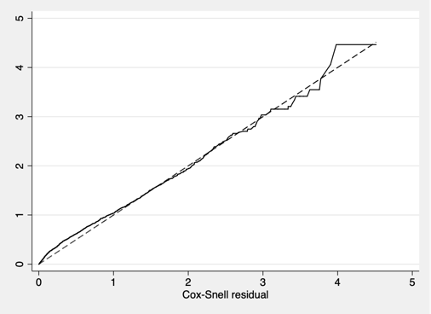
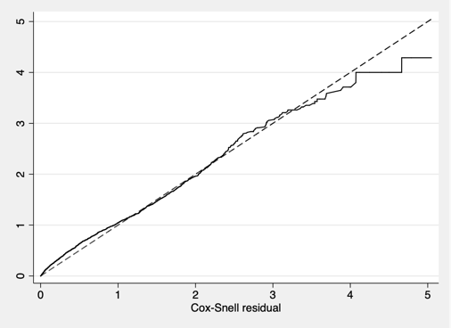
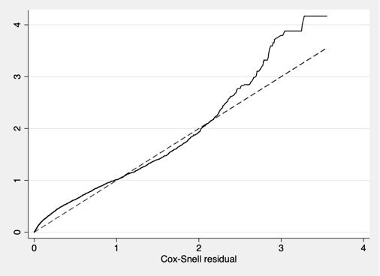
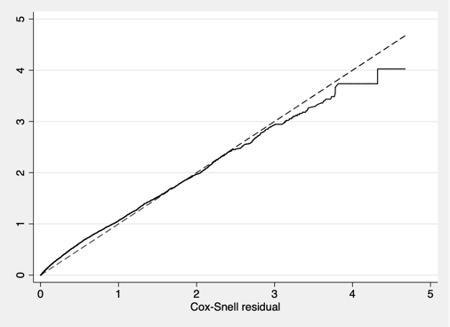
Supplemental Figure 1: Hazard vs Cox-Snell residuals testing fit for log-logistic AFT models
A B C D

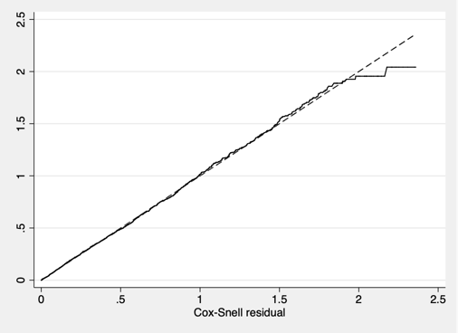
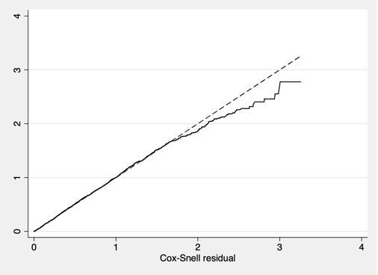
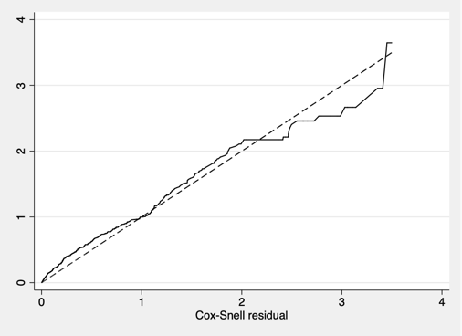
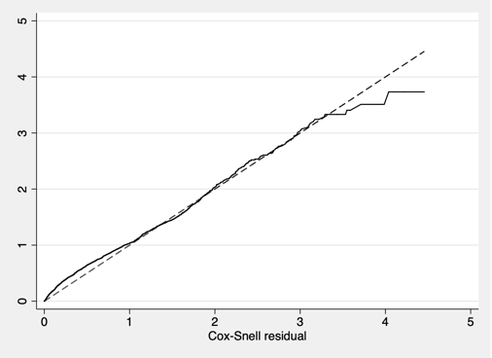
E F G H

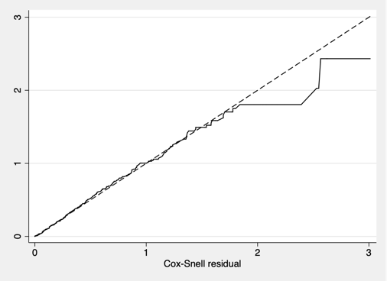
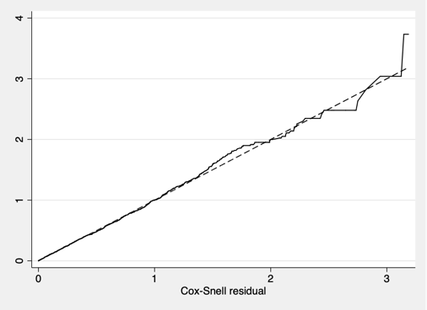
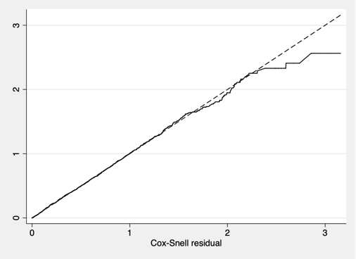
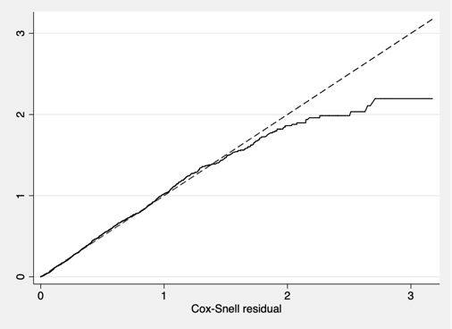
I J K L

A – Pre-KAS: Activation Time; B – Post-KAS: Activation Time; C – White: Activation Time; D – Black: Activation Time; E – Hispanic: Activation Time; F – Other: Activation Time; G – Pre-KAS: Dialysis Time; H – Post-KAS: Dialysis Time; I – White: Dialysis Time; J – Black: Dialysis Time; K – Hispanic: Dialysis Time; L – Other: Dialysis Time

