Supplemental Material

Assessment of Proximal Tubular Function by Tubular Maximum Phosphate Reabsorption Capacity in Heart Failure

Johanna E. Emmens, MD, PhD, Martin H. de Borst MD, PhD, Eva M. Boorsma, MD, Kevin Damman, MD, PhD, Gerjan Navis, MD, PhD, Dirk J. van Veldhuisen, MD, PhD, Kenneth Dickstein, MD, PhD, Stefan D. Anker, MD, PhD, Chim C. Lang, MD, PhD, Gerasimos Filippatos, MD, PhD, Marco Metra, MD, PhD, Nilesh J. Samani, MD, FRCP, Piotr Ponikowski, MD, PhD, Leong L. Ng, MD, FRCP, Adriaan A. Voors, MD, PhD, Jozine M. ter Maaten, MD, PhD

Table of Contents
Supplemental Method
Supplemental Table 1. Baseline characteristics of study subset and patients without TmP/GFR measurements in BIOSTAT-CHF
Supplemental Table 2. Baseline characteristics according to low/high TmP/GFR and presence of CKD
Supplemental Table 3. Baseline characteristics according to low, normal, and high TmP/GFR
Supplemental Table 4. Multivariable regression analysis for log TmP/GFR with phosphate included
Supplemental Table 5. Cox regression analysis of serum phosphate
Supplemental Table 6. Cox proportional hazards analysis according to low/high TmP/GFR and presence of CKD predicting all-cause mortality
Supplemental Table 7. Cox proportional hazards analysis according to low/high TmP/GFR and presence of CKD predicting the combined end point
Supplemental Table 8. Baseline characteristics of the EMPA-RESPONSE-AHF cohort stratified by above or below median TmP/GFR
Supplemental Figure 1. Kaplan-Meier curve for the combined end point for quartiles of TmP/GFR
Supplemental Figure 2. Kaplan-Meier curves according to low/high TmP/GFR and presence of CKD predicting the combined end point
Supplemental Figure 3. Correlation plot of TmP/GFR with fractional excretion of lithium
Supplementary Method 1. Measurement of lithium by inductively coupled plasma-mass spectrometer

Principle of measurement
After dilution the sample is sprayed in an argon torch of at least 6000°C. This destructs the matrix and leads the to be measured elements to the mass spectrometer for measurement. A calibration curve is used to determine quantities of the measured elements.

Serum/EDTA plasma

Necessary reagents and other materials
- Water = ultra pure
- Triton X-100, Sigma-Aldrich Pcode 101371896
- Titriplex III, Merck art.: 1.08418.1000
- Nitric acid 65 % p.a. Merck art. 456
- Lithium standard 1000 mg/L Merck art. nr.: 70223
- Yttrium standard 1000 mg/L Merck art. nr.: 18909

- Nitric acid 1%: dilute 100 ml nitric acid 65% with water to 10 liters
- Washing agent: dilute 50 μl concentrate solution for heavy metals to 100 ml with water.
- Concentrate solution for heavy metals: weigh 10 grams Triton X-10 and dissolve under slight heating in water, and let it cool off. Add 10 grams Titriplex III and add water until 100ml.

Calibrator stock solution:
The Lithium standard contains 1000 mg/L lithium.

Internal standard solution:
Dilute 0,1 ml Yttrium with nitric acid 1% to 1,0 liter.

Preparation of calibrators:
- Pipet 100 μL Lithium standard and add until 100,0 mL with nitric acid 1% (V1= 1000 μg/L).
- Dilute 250 μL solution V1 with nitric acid 1% to 50 mL (V2= 5 μg/L).
- Prepare the calibrators according to the scheme below.

Calibrator | 0 | 1 | 2 | 3 | 4 | 5 | 6 | 7
mL V2 | 0 | 0.05 | 0.10 | 0.20 | 0.40 | 0.60 | 0.80 | 1.00
mL nitric acid 1% | 1.00 | 0.95 | 0.90 | 0.80 | 00.60 | 0.40 | 0.20 | 0.00
Concentration µg/L | 0.00 | 0.25 | 0.50 | 1.00 | 2.00 | 3.00 | 4.00 | 5.00

Preparation of control samples:
- Pipet 100 μL Lithium standard and add until 100 mL with nitric acid 1% (V1= 1000 μg/L).
- Dilute 250 μL solution V1 with nitric acid 1% tot 50 mL (V2= 5 μg/L).
- Prepare the controls according to the scheme below.

Control | Low | Med | High
mL V2 | 0.15 | 0.50 | 0.90
mL nitric acid 1% | 0.85 | 0.50 | 0.10
Concentration µg/L | 0.75 | 2.50 | 4.50

Machine
iCAP TQ SOP 50240 ICP mass spectrometer ( iCAP TQ Thermo Scientific)

Volume
At least 2 ml blood or 1 ml serum or plasma.

Treatment of sample at laboratory
Centrifuge
Centrifuge the sample at ± 2000 rcf. at room temperature. Transport the serum into a clean, labelled tube.

Execution
- Mix the sample.
- Centrifuge 5 min. at ± 2000 rcf.
- Pipet from all calibrators, controls and patients 200 μL in a polypropylene tube of 10 mL and add 2.0 ml internal standard solution.
- Mix and measure.
- Measure each time after ± 20 samples a blank and control or end the measurement series with a blank or control.

Results
Calculation
The software of ICP-MS calculates from the calibration data the quantities by using linear regression.
Values smaller than 0.5 µg/L are being subtracted with the value of the blank.

Control and registration
If the measured values are approved, the results are exported in an Excel format.

Limit of Quantitation
0.25 μg/L

Measurement is applicable to ranges of:
0.25 - 5.0 μg/L

Urine

Necessary reagents and other materials
- Water = ultra pure
- Nitric acid 65 % p.a. Merck art. 456
- Lithium standard 1000 mg/L Merck art. nr.: 70223
- Yttrium standard 1000 mg/L Merck art. nr.: 18909

- Washing agent (nitric acid 1%): dilute 100 ml nitric acid 65% with water to 10 liter
- Diluting agent: dilute 0,1 ml Yttrium with washing agent to 1 liter

Calibrator stock solution
The Lithium standard contains 1000 mg/L lithium

Internal standard solution
The internal standard Yttrium is dissolved in the diluting agent.

Preparation of calibrators
- Pipet 100 μL Lithium standard and add with nitric acid 1% to 100,0 ml (V1= 1000 μg/L)
- Dilute 2.5 mL solution V1 with nitric acid 1% to 50 mL (V2= 50 μg/L)
- Prepare the calibrators according to the scheme below.

Calibrator | 0 | 1 | 2 | 3 | 4 | 5 | 6
mL V2 | 0 | 0.10 | 0.20 | 0.40 | 0.60 | 0.80 | 1.00
mL nitric acid | 1.00 | 0.90 | 0.80 | 0.60 | 0.40 | 0.20 | 0.00
Concentration µg/L | 0.00 | 5.00 | 10.0 | 20.0 | 30.0 | 40.0 | 50.0

Preparation of control samples
- Pipet 100 μL Lithium standard and add with nitric acid 1% to 100 mL (V1= 1000 μg/L)
- Dilute 2.5 mL solution V1 with nitric acid 1% to 50 mL (V2= 50 μg/L)
- Prepare the controls according to the scheme below.

Control | Low | Med | High
mL V2 | 0.15 | 0.50 | 0.90
mL nitric acid 1% | 0.85 | 0.50 | 0.10
Concentration µg/L | 7.50 | 25.0 | 45.0

Machine
iCAP TQ SOP 50240 ICP massa spectrometer ( iCAP TQ Thermo Scientific)

Volume
At least 1 mL urine.

Centrifuge
Centrifuge the sample at ± 2000 rcf. at room temperature. Optional to transfer Breng de urine eventueel over in een schone gelabelde buis.

Execution
- Mix the sample.
- Centrifuge 5 minutes at ± 2000 rcf.
- Pipet of all calibrators, controls, and patients samples of 50 μL in a polypropylene tube of 10 mL and add 2 mL of diluting agent.
- Mix and measure the solutions.
- Measure each time after ± 20 samples a blank and control or end the measurement series with a blank or control.

Results
Calculation
The software of ICP-MS calculates from the calibration data the quantities by using linear regression.
Values smaller than 0.5 µg/L are being subtracted with the value of the blank.

Control and registration
If the measured values are approved, the results are exported in an Excel format.

Limit of Quantitation
5 μg/L

Measurement is applicable to ranges of:
5-50 μg/L

Regarding the analysis
The regression coefficients of the calibration line in water and urine are identical and independent from creatinine.
The method is linear until 50 μg/L.

Supplemental Table 1. Baseline characteristics of study subset and patients without TmP/GFR measurements in BIOSTAT-CHF

Variable | Study subset  N = 2,085 | Patients without TmP/GFR measurements  N = 431 | P-value
Clinical characteristics
Age (years) | 69 ± 12 | 69 ± 12 | 0.453
Sex (male), n (%) | 1526 (73) | 319 (74) | 0.715
BMI (kg/m²) | 27 (24 – 31) | 27 (24 – 31) | 0.318
NYHA classification (III/IV), n (%) | 1250 (60) | 272 (63) | 0.405
Systolic blood pressure (mmHg) | 125 ± 21 | 125 ± 22 | 0.988
Diastolic blood pressure (mmHg) | 75 ± 13 | 75 ± 13 | 0.582
Heart rate (bpm) | 76 (67 – 90) | 76 (66 – 90) | 0.574
Presence of atrial fibrillation/flutter, n (%) | 693 (33) | 127 (29) | 0.160
LVEF (%) | 30 (25 – 37) | 30 (25 – 35) | 0.305
Diabetes mellitus, n (%) | 675 (32) | 144 (33) | 0.695
Smoking (past or current), n (%) | 1311 (63) | 262 (61) | 0.501
Primary heart failure etiology, n (%)
Ischemic heart disease | 928 (45) | 197 (46) | 0.633
Hypertension | 225 (11) | 31 (7) | 0.032
Cardiomyopathy | 519 (25) | 112 (26) | 0.643
Medication, n (%)
ACE inhibitor/angiotensin receptor blocker | 1498 (72) | 322 (75) | 0.221
Beta-blocker | 1724 (83) | 368 (85) | 0.164
Loop diuretics | 2075 (99) | 428 (99) | 1
Loop diuretic dose (mg furosemide equivalent) | 40 (40 – 100) | 40 (40 – 120) | 0.326
Aldosterone antagonist | 1096 (53) | 242 (56) | 0.176
Laboratory values
Hemoglobin (g/dL) | 13.3 (11.9 – 14.5) | 13.4 (11.9 – 14.5) | 0.916
Sodium (mEq/L) | 140 (137 – 142) | 139 (137 – 141) | 0.002
Potassium (mEq/L) | 4.2 (3.9 – 4.6) | 4.2 (3.9 – 4.5) | 0.381
Phosphate (mg/dL) | 2.6 (2.1 – 3.2) | 2.9 (2.4 – 3.4) | <0.001
NT-proBNP (ng/L) | 2728 (1214 – 5932) | 2544 (917 – 4704) | 0.003
ASAT (U/L) | 25 (19 – 35) | 26 (20 – 36) | 0.466
ALAT (U/L) | 25 (17 – 37) | 26 (17 – 41) | 0.251
Kidney function
Creatinine (mg/dL) | 1.16 (0.95 – 1.47) | 1.16 (0.95 – 1.49) | 0.962
eGFR (mL/min/1.73m²) | 60 ± 23 | 60 ± 23 | 0.948
Plasma NGAL (ng/mL) | 60 (38 – 97) | 62 (38 – 99) | 0.479
Urea (mg/dL) | 68 (46 – 109) | 71 (48 – 112) | 0.337
Urinary creatinine (mg/dL) | 59 (31 – 107) | 57 (29 – 115) | 0.856
Urinary KIM-1(ng/gCr) | 1899 (918 – 3613) | 1625 (751 – 3175) | 0.014
Urinary NGAL (μg/gCr) | 32 (16 – 80) | 28 (14 – 61) | 0.114
UACR (mg/gCr) | 24 (7 – 103) | 18 (6 – 81) | 0.097
FE_{Na} (%) | 0.99 (0.44 – 2.22) | 1.41 (0.49 – 3.48) | 0.083
FE_{Urea} (%) | 29 (19 – 41) | 36 (20 – 46) | 0.078
FE_{Phosphate} (%) | 21 (13 – 35) | NA | NA
Neurohormonal activation
Aldosterone (pg/mL) | 94 (44 – 195) | 95 (44 – 204) | 0.619
Renin (µUI/mL) | 89 (29 – 253) | 90 (30 – 305) | 0.736
Aldosterone-renin ratio (ng/dL/ng/mL) | 181 (50 – 515) | 133 (33 – 408) | 0.213
Biomarkers
FGF23 (RU/mL) | 221 (118 – 591) | 200 (113 – 474) | 0.211
Bio-ADM (pg/mL) | 33 (22 – 54) | 36 (25 – 53) | 0.135
PENK (pmol/L) | 86 (64 – 120) | 87 (60 – 127) | 0.847
Pro-ADM (ng/mL) | 0.50 (0.32 – 0.82) | 0.51 (0.31 – 0.75) | 0.473
Galectin-3 (ng/mL) | 21 (15 – 30) | 22 (16 – 32) | 0.223
GDF-15 (ng/L) | 2734 (1730 – 5613) | 2540 (1581 – 4060) | 0.054
IL-6 (pg/mL) | 5.2 (2.8 – 10.4) | 5.1 (2.9 – 8.7) | 0.305
Event rates, n (%)
Mortality | 559 (27) | 109 (25) | 0.555
HF hospitalization | 535 (26) | 87 (20) | 0.019
Combined end point | 878 (42) | 155 (36) | 0.021

*Only 275 measurements available

Normally distributed continuous variables are presented as mean ± standard deviation and non-normally distributed continuous variables as median (interquartile range). Abbreviations: ACE, angiotensin-converting enzyme; ALAT, alanine transaminase; ASAT, aspartate aminotransferase; Bio-ADM, bioactive adrenomedullin; BMI, body mass index; eGFR, estimated glomerular filtration rate; FE, fractional excretion; FGF23, fibroblast growth factor 23; gCR, gram of urinary creatinine; GDF‐15, growth differentiation factor 15; IL-6, interleukin 6; KIM-1, kidney injury molecule-1; LVEF, left ventricular ejection fraction; NGAL, Neutrophil Gelatinase-Associated Lipocalin; NT-proBNP, N terminal pro brain natriuretic peptide; NYHA, New York Heart Association; pro-ADM, proadrenomedullin; TmP/GFR, tubular maximum phosphate reabsorption capacity; UACR, urine albumin-to-creatinine ratio
Supplemental Table 2. Baseline characteristics according to low/high TmP/GFR and presence of CKD*

Variable | CKD + Low TmP/GFR, n = 635 | CKD + High TmP/GFR, n = 443 | P-value | No CKD + Low TmP/GFR, n = 408 | No CKD + High TmP/GFR, n = 599 | P-value
Clinical characteristics
Age (years) | 74 ± 9 | 73 ± 10 | 0.007 | 65 ± 11 | 63 ± 12 | <0.001
Sex (male), n (%) | 458 (72) | 292 (66) | 0.035 | 316 (77) | 460 (82) | 0.868
BMI (kg/m²) | 27 (24 – 30) | 27 (24 – 30) | 0.646 | 28 (24 – 32) | 27 (24 – 31) | 0.116
NYHA classification (III/IV), n (%) | 415 (65) | 292 (66) | 0.562 | 228 (56) | 315 (53) | 0.068
Systolic blood pressure (mmHg) | 124 ± 22 | 124 ± 22 | 0.933 | 128 ± 21 | 124 ± 23 | 0.005
Diastolic blood pressure (mmHg) | 72 ± 13 | 74 ± 14 | 0.058 | 77 ± 12 | 76 ± 14 | 0.250
Heart rate (bpm) | 75 (65 – 85) | 76 (67 – 90) | 0.010 | 77 (68 – 90) | 79 (70 – 91) | 0.389
Presence of atrial fibrillation/flutter, n (%) | 229 (36) | 165 (37) | 0.722 | 131 (32) | 168 (28) | 0.178
LVEF (%) | 30 (25 – 38) | 30 (25 – 38) | 0.640 | 30 (25 – 35) | 30 (25 – 35) | 0.566
Diabetes mellitus, n (%) | 236 (37) | 162 (37) | 0.892 | 118 (29) | 159 (27) | 0.449
Smoking (past or current), n (%) | 397 (63) | 251 (57) | 0.053 | 263 (64) | 400 (67) | 0.004
Primary heart failure etiology, n (%)
Ischemic heart disease | 345 (54) | 200 (45) | 0.019 | 166 (41) | 217 (36) | 0.602
Hypertension | 57 (9) | 62 (14) | 0.074 | 54 (13) | 52 (7) | 0.012
Cardiomyopathy | 107 (17) | 95 (21) | 0.315 | 116 (28) | 201 (34) | 0.099
Medication, n (%)
ACE inhibitor/angiotensin receptor blocker | 420 (66) | 302 (68) | 0.528 | 308 (75) | 468 (78) | 0.367
Beta-blocker | 521 (82) | 357 (81) | 0.598 | 339 (83) | 507 (85) | 0.567
Loop diuretics | 633 (99) | 441 (99) | 1 | 407 (99) | 594 (99) | 0.437
Loop diuretic dose (furosemide equivalent) | 80 (40 – 125) | 40 (40 – 120) | <0.001 | 40 (40 – 80) | 40 (40 – 80) | 0.328
Aldosterone antagonist | 288 (45) | 219 (49) | 0.208 | 241 (59) | 348 (58) | 0.809
Laboratory values
Hemoglobin (g/dL) | 12.5 (11.1 – 13.7) | 13.1 (11.7 – 14.4) | <0.001 | 13.5 (12.1 – 14.5) | 14.4 (12.8 – 15.1) | <0.001
Sodium (mEq/L) | 140 (137 – 142) | 139 (136 – 142) | 0.376 | 140 (138 – 142) | 140 (137 – 141) | 0.049
Potassium (mEq/L) | 4.2 (3.9 – 4.7) | 4.3 (3.9 – 4.7) | 0.248 | 4.2 (3.9 – 4.5) | 4.2 (3.9 – 4.6) | 0.108
Phosphate (mg/dL) | 6.8 (5.6 – 8.0) | 10.2 (9.0 – 11.6) | <0.001 | 6.4 (5.3 – 7.3) | 9.6 (8.3 – 11.1) | <0.001
NT-proBNP (ng/L) | 3992 (1877 – 8728) | 3617 (1702 – 7305) | 0.060 | 1982 (882 – 3999) | 1928 (901 – 4436) | 0.626
ASAT (U/L) | 25 (18 – 35) | 25 (19 – 36) | 0.346 | 25 (20 – 34) | 26 (20 – 36) | 0.284
ALAT (U/L) | 21 (15 – 32) | 23 (16 – 34) | 0.022 | 26 (18 – 38) | 29 (20 – 44) | 0.006
Kidney function
Creatinine (mg/dL) | 1.54 (1.30 – 1.91) | 1.38 (1.21 – 1.63) | <0.001 | 0.96 (0.83 – 1.10) | 0.94 (0.80 – 1.07) | 0.069
eGFR (mL/min/1.73m²) | 40 ± 12 | 46 ± 11 | <0.001 | 78 ± 13 | 81 ± 14 | <0.001
Plasma NGAL (ng/mL) | 83 (53 – 125) | 74 (46 – 118) | 0.027 | 44 (27 – 67) | 47 (32 – 70) | 0.119
Urea (mg/dL) | 89 (61 – 142) | 81 (55 – 133) | 0.027 | 49 (37 – 76) | 52 (36 – 85) | 0.680
Urinary creatinine (mg/dL) | 48 (28 – 79) | 53 (29 – 104) | 0.005 | 72 (37 – 118) | 71 (33 – 123) | 0.892
Urinary KIM-1(ng/gCr) | 2239 (1136 – 4068) | 2099 (1109 – 4260) | 0.891 | 1729 (751 – 3198) | 1621 (738 – 2921) | 0.397
Urinary NGAL (μg/gCr) | 44 (19 – 115) | 34 (16 – 81) | 0.007 | 28 (12 – 57) | 28 (14 – 56) | 0.922
UACR (mg/gCr) | 44 (10 – 167) | 28 (9 – 112) | 0.015 | 17 (6 – 83) | 16 (6 – 53) | 0.355
FE_{Na} (%) | 1.55 (0.71 – 3.39) | 1.21 (0.49 – 2.50) | <0.001 | 0.65 (0.34 – 1.31) | 0.66 (0.31 – 1.43) | 0.908
FE_{Urea} (%) | 34 (23 – 45) | 26 (17 – 38) | <0.001 | 29 (20 – 41) | 27 (17 – 39) | 0.027
FE_{Phosphate} (%) | 41 (29 – 56) | 18 (12 – 25) | <0.001 | 25 (17 – 33) | 11 (7 – 17) | <0.001
Neurohormonal activation
Aldosterone (pg/mL) | 96 (42 – 209) | 103 (49 – 227) | 0.183 | 79 (36 – 161) | 94 (47 – 196) | 0.008
Renin (µUI/mL) | 106 (36 – 299) | 106 (31 – 287) | 0.475 | 67 (21 – 194) | 79 (27 – 238) | 0.061
Aldosterone-renin ratio (ng/dL/ng/mL) | 145 (39 – 443) | 179 (50 – 539) | 0.054 | 218 (53 – 559) | 195 (67 – 548) | 0.805
Biomarkers
FGF23 (RU/mL) | 387 (175 – 1002) | 296 (148 – 702) | 0.005 | 154 (95 – 359) | 154 (97 – 306) | 0.966
Bio-ADM (pg/mL) | 42 (28 – 68) | 36 (24 – 57) | <0.001 | 28 (20 – 45) | 27 (19 – 42) | 0.565
PENK (pmol/L) | 118 (89 – 163) | 107 (82 – 140) | 0.001 | 68 (55 – 87) | 68 (53 – 84) | 0.560
Pro-ADM (ng/mL) | 0.73 (0.46 – 1.14) | 0.62 (0.40 – 0.93) | <0.001 | 0.38 (0.24 – 0.59) | 0.38 (0.25 – 0.59) | 0.985
Galectin-3 (ng/mL) | 26 (19 – 36) | 24 (18 – 33) | 0.030 | 17 (13 – 23) | 18 (13 – 24) | 0.466
GDF-15 (ng/L) | 3706 (2266 – 6276) | 3626 (2241 – 6024) | 0.574 | 2072 (1396 – 3218) | 2057 (1320 – 3395) | 0.861
IL-6 (pg/mL) | 6.2 (3.4 – 12.3) | 5.4 (3.2 – 11.3) | 0.861 | 4.5 (2.4 – 9.7) | 4.5 (2.5 – 8.4) | 0.588
*Defined as eGFR < 60 mL/min/1.73m²

Normally distributed continuous variables are presented as mean ± standard deviation and non-normally distributed continuous variables as median (interquartile range). Abbreviations: ACE, angiotensin-converting enzyme; ALAT, alanine transaminase; ASAT, aspartate aminotransferase; Bio-ADM, bioactive adrenomedullin; BMI, body mass index; CKD, chronic kidney disease; eGFR, estimated glomerular filtration rate; FE, fractional excretion; FGF23, fibroblast growth factor 23; gCR, gram of urinary creatinine; GDF‐15, growth differentiation factor 15; IL-6, interleukin 6; KIM-1, kidney injury molecule-1; LVEF, left ventricular ejection fraction; NGAL, Neutrophil Gelatinase-Associated Lipocalin; NT-proBNP, N terminal pro brain natriuretic peptide; NYHA, New York Heart Association; pro-ADM, proadrenomedullin; TmP/GFR, tubular maximum phosphate reabsorption capacity; UACR, urine albumin-to-creatinine ratio
Supplemental Table 3. Baseline characteristics according to low*, normal, and high TmP/GFR

TmP/GFR (mmol/L)
Variable | Low, n = 1392  0.53 (0.38 – 0.67)  [min: -0.38, max: 0.80] | Normal, n = 600  0.95 (0.87 – 1.08)  [min: 0.80, max: 1.35] | High, n = 93  1.57 (1.46 – 1.76)  [min: 1.36, max: 6.81] | P for trend
Clinical characteristics
Age (years) | 70.3 ± 11.4 | 66.8 ± 12.6 | 62.9 ± 12.4 | <0.001
Sex (male), n (%) | 1041 (75) | 419 (69) | 66 (71) | 0.035
BMI (kg/m²) | 27 (24 – 30) | 27 (24 – 31) | 26 (24 – 30) | 0.258
NYHA classification (III/IV), n (%) | 875 (63) | 327 (55) | 48 (52) | <0.001
Systolic blood pressure (mmHg) | 125 ± 21 | 124 ± 24 | 122 ± 21 | 0.424
Diastolic blood pressure (mmHg) | 75 ± 13 | 75 ± 15 | 75 ± 13 | 0.352
Heart rate (bpm) | 75 (66 – 88) | 79 (70 – 92) | 78 (68 – 90) | <0.001
Presence of atrial fibrillation/flutter, n (%) | 480 (34) | 189 (32) | 24 (26) | 0.047
LVEF (%) | 30 (25 – 37) | 30 (25 – 35) | 30 (25 – 38) | 0.346
Diabetes mellitus, n (%) | 461 (36) | 185 (31) | 29 (31) | 0.346
Smoking (past or current), n (%) | 867 (67) | 387 (65) | 57 (61) | 0.581
Primary HF etiology, n (%)
Ischemic heart disease | 655 (47) | 240 (40) | 33 (35) | <0.001
Hypertension | 151 (11) | 70 (12) | 4 (4) | 0.396
Cardiomyopathy | 329 (24) | 155 (26) | 35 (38) | 0.009
Medication, n (%)
ACE inhibitor/angiotensin receptor blocker | 983 (71) | 453 (76) | 62 (67) | 0.293
Beta-blocker | 1153 (89) | 497 (83) | 74 (80) | 0.618
Loop diuretics | 1387 (99) | 596 (99) | 92 (99) | 0.214
Loop diuretic dose (furosemide equivalent) | 40 (40 – 120) | 40 (40 – 80) | 40 (40 – 80) | <0.001
Aldosterone antagonist | 717 (55) | 323 (54) | 56 (60) | 0.093
Laboratory values
Hemoglobin (g/dL) | 13.0 ± 1.9 | 13.6 ± 1.8 | 13.7 ± 1.9 | <0.001
Sodium (mEq/L) | 140 (137 – 142) | 140 (137 – 141) | 139 (136 – 141) | 0.045
Potassium (mEq/L) | 4.2 (3.9 – 4.6) | 4.2 (3.9 – 4.6) | 4.3 (4.1 – 4.7) | 0.024
Phosphate (mg/dL) | 2.3 (1.9 – 2.7) | 3.3 (3.0 – 3.7) | 4.4 (3.9 – 5.0) | <0.001
NT-proBNP (ng/L) | 2851 (1262 – 6061) | 2584 (1105 – 5879) | 2347 (1153 – 4759) | 0.064
ASAT (U/L) | 25 (19 – 34) | 26 (20 – 36) | 28 (21 – 41) | 0.042
ALAT (U/L) | 23 (16 – 35) | 27 (18 – 38) | 32 (23 – 54) | <0.001
Kidney function
Creatinine (mg/dL) | 1.21 (1.00 – 1.59) | 1.10 (0.90 – 1.31) | 1.00 (0.84 – 1.13) | <0.001
eGFR (mL/min/1.73m²) | 57 ± 22 | 66 ± 21 | 74 ± 23 | <0.001
Plasma NGAL (ng/mL) | 63 (38 – 102) | 57 (36 – 90) | 62 (40 – 87) | 0.044
Urea (mg/dL) | 71 (47 – 114) | 64 (43 – 99) | 61 (42 – 88) | <0.001
Urinary creatinine (mg/dL) | 58 (31 – 102) | 63 (31 – 114) | 63 (28 – 113) | 0.086
Urinary KIM-1(ng/gCr) | 1920 (946 – 3632) | 1829 (847 – 3481) | 1649 (731 – 3821) | 0.161
Urinary NGAL (μg/gCr) | 32 (16 – 85) | 31 (15 – 70) | 30 (17 – 66) | 0.057
UACR (mg/gCr) | 27 (8 – 118) | 22 (7 – 83) | 16 (6 – 56) | 0.009
FE_{Na} (%) | 1.05 (0.49 – 2.31) | 0.88 (0.38 – 2.02) | 0.66 (0.31 – 1.68) | <0.001
FE_{Urea} (%) | 31 (21 – 42) | 26 (17 – 39) | 22 (15 – 36) | <0.001
FE_{Phosphate} (%) | 28 (19 – 43) | 13 (9 – 18) | 6 (3 – 8) | <0.001
Neurohormonal activation
Aldosterone (pg/mL) | 89 (40 – 184) | 99 (49 – 197) | 147 (73 – 263) | <0.001
Renin (µUI/mL) | 86 (28 – 243) | 91 (29 – 289) | 143 (35 – 299) | 0.230
Aldosterone-renin ratio (ng/dL/ng/mL) | 175 (46 – 496) | 201 (58 – 535) | 173 (68 – 615) | 0.140
Biomarkers
FGF23 (RU/mL) | 237 (122 – 642) | 200 (111 – 494) | 173 (115 – 359) | <0.001
Bio-ADM (pg/mL) | 35 (23 – 56) | 31 (21 – 50) | 29 (21 – 46) | 0.001
PENK (pmol/L) | 90 (66 – 124) | 82 (60 – 110) | 77 (64 – 96) | <0.001
Pro-ADM (ng/mL) | 0.53 (0.34 – 0.87) | 0.45 (0.29 – 0.73) | 0.41 (0.26 – 0.80) | <0.001
Galectin-3 (ng/mL) | 22 (16 – 30) | 21 (15 – 28) | 21 (15 – 32) | 0.044
GDF-15 (ng/L) | 2840 (1786 – 4958) | 2534 (1593 – 4192) | 2934 (1567 – 4188) | 0.002
IL-6 (pg/mL) | 5.3 (2.8 – 10.4) | 5.1 (2.8 – 10.5) | 4.9 (2.7 – 9.0) | 0.260

*Defined as <0.80 mmol/L, incidence of low TmP/GFR: 1392 (67%)

Normally distributed continuous variables are presented as mean ± standard deviation and non-normally distributed continuous variables as median (interquartile range). Abbreviations: ACE, angiotensin-converting enzyme; ALAT, alanine transaminase; ASAT, aspartate aminotransferase; Bio-ADM, bioactive adrenomedullin; BMI, body mass index; eGFR, estimated glomerular filtration rate; FE, fractional excretion; FGF23, fibroblast growth factor 23; gCR, gram of urinary creatinine; GDF‐15, growth differentiation factor 15; IL-6, interleukin 6; KIM-1, kidney injury molecule-1; LVEF, left ventricular ejection fraction; NGAL, Neutrophil Gelatinase-Associated Lipocalin; NT-proBNP, N terminal pro brain natriuretic peptide; NYHA, New York Heart Association; pro-ADM, proadrenomedullin; TmP/GFR, tubular maximum phosphate reabsorption capacity; UACR, urine albumin-to-creatinine ratio

Supplemental Table 4. Multivariable regression analysis for log TmP/GFR with phosphate included

Variable | Standardised Beta | T | P-value
Serum phosphate | 0.800 | 78.148 | <0.001
Log FE_{Urea} | -0.346 | -18.532 | <0.001
Log urea | -0.347 | -15.992 | <0.001
Log creatinine | -0.108 | -6.722 | <0.001
Log urinary creatinine | -0.104 | -5.923 | <0.001
Hemoglobin | 0.060 | 5.543 | <0.001
Log FGF23 | -0.058 | -4.760 | <0.001
Log loop diuretic dose* | -0.037 | -3.518 | <0.001
Log urinary osteopontin | -0.039 | -2.480 | 0.006
Log BNP | 0.024 | 2.065 | 0.046

Complete case analysis N = 1,672, R² = 0.832.
*In furosemide equivalent
Abbreviations: BNP, brain natriuretic peptide; FE, fractional excretion; FGF23, fibroblast growth factor 23; TmP/GFR, tubular maximum phosphate reabsorption capacity

Supplemental Table 5. Cox regression analysis of serum phosphate

 | Univariable
Outcomes | HR (95% CI) | P-value
All-cause mortality | 0.86 (0.65 – 1.13) | 0.273
HF hospitalization | 0.82 (0.62 – 1.09) | 0.164
All-cause mortality or HF hospitalization | 0.87 (0.70 – 1.08) | 0.198

Complete case analysis N=2,085.
Abbreviations: CI, confidence interval; HR, hazard ratio; HF, heart failure
Supplemental Table 6. Cox proportional hazards analysis according to low/high TmP/GFR and presence of CKD predicting all-cause mortality

 |  | Univariable |  | Adjusted for BIOSTAT risk score* and serum phosphate
Groups | N of events (%) | HR (95% CI) | P-value | HR (95% CI) | P-value
High TmP/GFR + non-CKD | 95 (17) | 1.0 (Reference) | Ref | 1.0 (Reference) | Ref
High TmP/GFR + CKD | 134 (24) | 2.00 (1.53 – 2.60) | <0.001 | 1.09 (0.83 – 1.45) | 0.536
Low TmP/GFR + non-CKD | 77 (14) | 1.21 (0.89 – 1.63) | 0.218 | 1.14 (0.83 – 1.58) | 0.414
Low TmP/GFR + CKD | 253 (45) | 2.98 (2.35 – 3.77) | <0.001 | 1.44 (1.09 – 1.92) | 0.012

* Variables in BIOSTAT risk score:
All-cause mortality: age, log blood urea nitrogen (BUN), log NT-proBNP, hemoglobin, and beta-blocker use at baseline
HF hospitalization: age, HF hospitalization in previous year, peripheral oedema, systolic blood pressure, and eGFR
Combined end point: age, HF hospitalization in previous year, systolic blood pressure, log NT-proBNP, hemoglobin, high-density lipoprotein, sodium, and beta-blocker use at baseline
Complete case analysis in adjusted analyses N=2,085.
Abbreviations: BIOSTAT, A systems BIOlogy Study to TAilored Treatment in Chronic
Heart Failure; CKD, chronic kidney disease; CI, confidence interval; eGFR, estimated
glomerular filtration rate; HF, heart failure; HR, hazard ratio; NT-proBNP, N-terminal pro
brain natriuretic peptide; TmP/GFR, tubular maximum phosphate reabsorption capacity

Supplemental Table 7. Cox proportional hazards analysis according to low/high TmP/GFR and presence of CKD predicting the combined end point

 |  | Univariable |  | Adjusted for BIOSTAT risk score* and serum phosphate
Groups | N of events (%) | HR (95% CI) | P-value | HR (95% CI) | P-value
High TmP/GFR + non-CKD | 179 (20) | 1.0 (Reference) | Ref | 1.0 (Reference) | Ref
High TmP/GFR + CKD | 201 (23) | 1.60 (1.31 (1.96) | <0.001 | 0.87 (0.70 – 1.09) | 0.222
Low TmP/GFR + non-CKD | 126 (14) | 1.01 (0.80 – 1.27) | 0.937 | 0.94 (0.73 – 1.20) | 0.607
Low TmP/GFR + CKD | 372 (42) | 2.49 (1.09 – 2.98) | <0.001 | 1.17 (0.94 – 1.46) | 0.169

* Variables in BIOSTAT risk score:
All-cause mortality: age, log blood urea nitroge, log NT-proBNP, hemoglobin, and beta-blocker use at baseline
HF hospitalization: age, HF hospitalization in previous year, peripheral oedema, systolic blood pressure, and eGFR
Combined end point: age, HF hospitalization in previous year, systolic blood pressure, log NT-proBNP, hemoglobin, high-density lipoprotein, sodium, and beta-blocker use at baseline
Complete case analysis in adjusted analyses N=2,085.
Abbreviations: BIOSTAT, A systems BIOlogy Study to TAilored Treatment in Chronic
Heart Failure; CKD, chronic kidney disease; CI, confidence interval; eGFR, estimated
glomerular filtration rate; HF, heart failure; HR, hazard ratio; NT-proBNP, N-terminal pro
brain natriuretic peptide; TmP/GFR, tubular maximum phosphate reabsorption capacity

Supplemental Table 8. Baseline characteristics of the EMPA-RESPONSE-AHF cohort stratified by above or below median TmP/GFR
TmP/GFR (mmol/L)
Variable | Below median, n = 39  0.78 (0.70 – 0.91)  [min: 0.38, max: 0.97] | Above median, n = 39  1.13 (1.04 – 1.27)  [min: 0.98, max: 2.21] | P-value
Clinical characteristics
Age (years) | 76 ± 12 | 73 ± 10 | 0.294
Sex (male), n (%) | 27 (69) | 26 (67) | >0.999
BMI (kg/m²) | 28 ± 7 | 28 ± 6 | 0.697
NYHA classification (III/IV), n (%) | 38 (97) | 35 (95) | 0.646
Systolic blood pressure (mmHg) | 123 ± 23 | 125 ± 25 | 0.782
Diastolic blood pressure (mmHg) | 70 ± 13 | 78 ± 16 | 0.016
Heart rate (bpm) | 72 (65 – 80) | 86 (71 – 101) | 0.005
Presence of atrial fibrillation/flutter, n (%) | 29 (74) | 26 (67) | 0.620
LVEF if known* (%) | 40 (29 – 50) | 27 (19 – 48) | 0.223
Diabetes mellitus type II, n (%) | 12 (31) | 13 (33) | >0.999
Smoking (past or current), n (%) | 26 (67) | 29 (74) | 0.620
Primary heart failure etiology, n (%)
Ischemic heart disease | 10 (26) | 11 (28) | >0.999
Hypertension | 3 (8) | 6 (15) | 0.478
Rhythm disturbances | 5 (13) | 12 (31) | 0.099
Medication, n (%)
Treatment arm (empagliflozin) | 15 (38) | 24 (62) | 0.070
ACE inhibitor/angiotensin receptor blocker/ARNi | 27 (69) | 24 (62) | 0.747
Beta-blocker | 25 (64) | 27 (69) | 0.683
Loop diuretics | 39 (100) | 39 (100) | >0.999
Loop diuretic dose received until baseline (furosemide equivalent) | 207 ± 314 | 193 ± 139 | 0.810
Aldosterone antagonist | 20 (51) | 15 (38) | 0.417
Laboratory values
Hemoglobin (g/dL) | 12.3 ± 1.5 | 13.3 ± 1.9 | 0.009
Sodium (mEq/L) | 140 (136 – 142) | 140 (138 – 143) | 0.696
Potassium (mEq/L) | 3.9 (3.5 – 4.3) | 4.1 (3.7 – 4.3) | 0.243
Phosphate (mg/dL) | 3.2 (2.8 – 3.5) | 4.0 (3.7 – 4.5) | <0.001
NT-proBNP (ng/L) | 6078 (4443 – 9483) | 4079 (3146 - 6964) | 0.011
Creatinine (mg/dL) | 1.29 (1.03 – 1.58) | 1.20 (0.95 – 1.56) | 0.552
eGFR (mL/min/1.73m²) | 52 ± 17 | 55 ± 18 | 0.488
Blood urea nitrogen (mg/dL) | 26 (21 – 36) | 27 (21 – 37) | 0.779
Urinary creatinine (mg/dL) | 33 (17 – 49) | 42 (31 – 71) | 0.014
UACR (mg/gCr) | 71 (36 – 179) | 62 (19 – 185) | 0.374
FE_{Na} (%) | 2.49 (1.28 – 5.49) | 1.95 (0.76 – 3.55) | 0.054
FE_{Urea} (%) | 44 (35 – 52) | 32 (23 – 40) | <0.001
FE_{Phosphate} (%) | 23 (18 – 28) | 16 (9 – 21) | <0.001

*N = 46

Normally distributed continuous variables are presented as mean ± standard deviation and non-normally distributed continuous variables as median (interquartile range). Abbreviations: ACE, angiotensin converting enzyme; ARNi, angiotensin receptor-neprilysin inhibitor; BMI, body mass index; eGFR, estimated glomerular filtration rate; FE, fractional excretion; gCR, gram of urinary creatinine; LVEF, left ventricular ejection fraction; NT-proBNP, N terminal pro brain natriuretic peptide; NYHA, New York Heart Association; TmP/GFR, tubular maximum phosphate reabsorption capacity; UACR, urine albumin-to-creatinine ratio
Supplemental Figure 1. Kaplan-Meier curve for the combined end point for quartiles of TmP/GFR
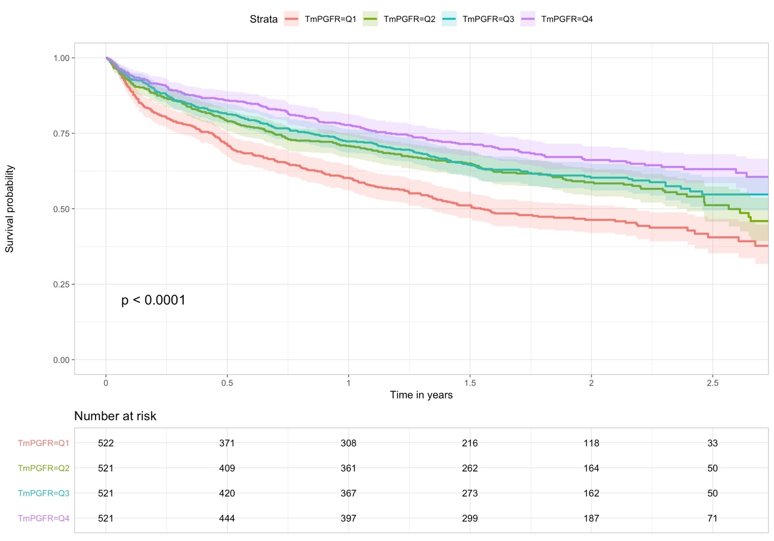

Kaplan Meier curves for the combined end point stratified by quartiles of TmP/GFR. The indicators TmPGFR=Q1 to TmPGFR=Q4 represent the first quartile of TmP/GFR to fourth quartile of TmP/GFR, respectively. The thick lines represent the survival curves with their corresponding 95% confidence intervals in a lighter shade.
Abbreviations: TmP/GFR, tubular maximum phosphate reabsorption capacity

Supplemental Figure 2. Kaplan-Meier curves according to low/high TmP/GFR and presence of CKD predicting the combined end point

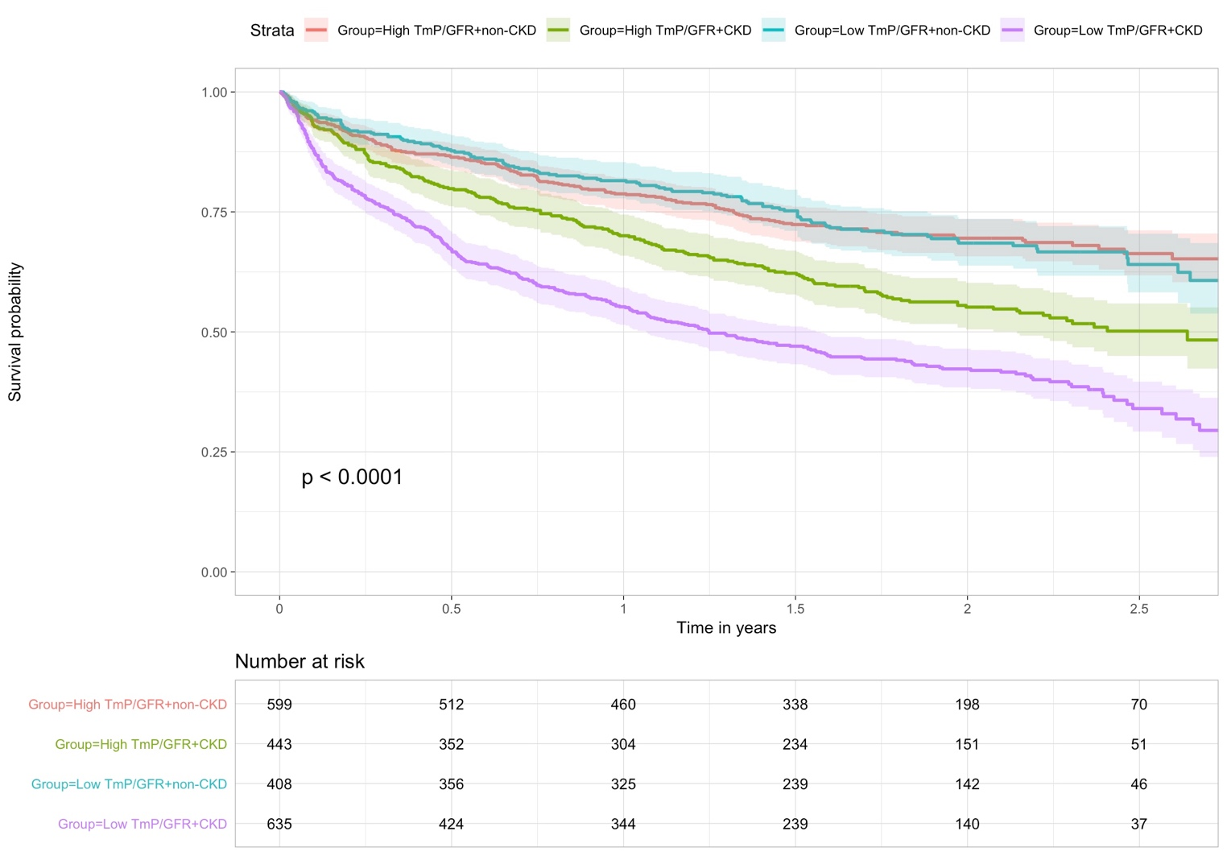

Kaplan Meier curves for the combined end point stratified by TmP/GFR above or below the median and presence versus absence of CKD. “High TmP/GFR” indicates TmP/GFR above the median, whereas “low TmP/GFR” indicates TmP/GFR below the median. The thick lines represent the survival curves with their corresponding 95% confidence intervals in a lighter shade.
Abbreviations: CKD, chronic kidney disease; TmP/GFR, tubular maximum phosphate reabsorption capacity

Supplemental Figure 3. Correlation plot of TmP/GFR with fractional excretion of lithium
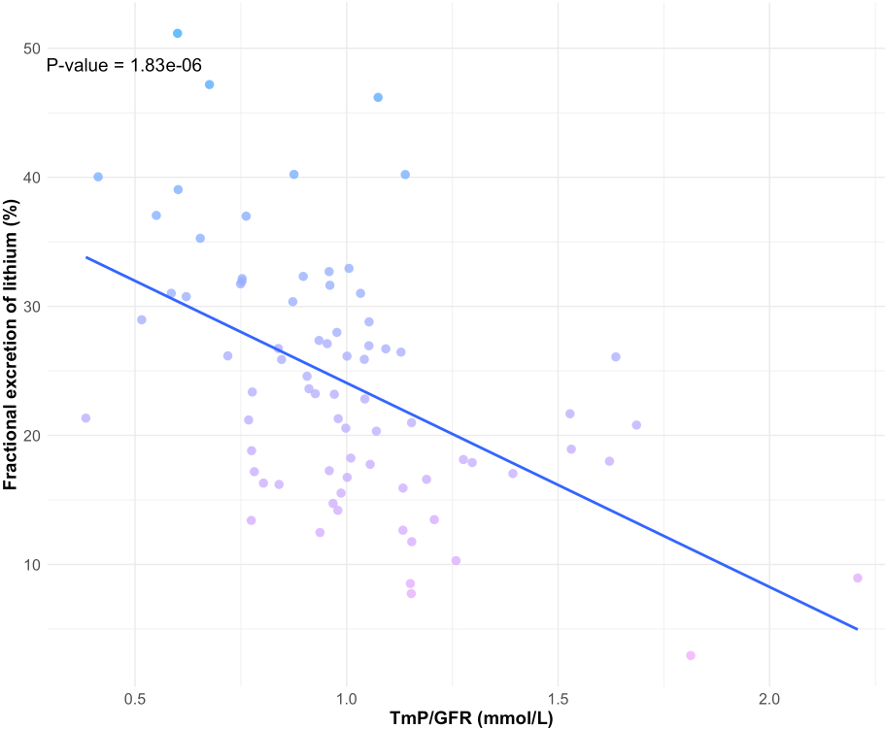

Correlation coefficient (Pearson): -0.513
Complete case analysis N=87.

