Supplemental Material

Table of contents:
Supplemental Table 1. Characteristics of 36 kidney transplant recipients with seroconversion after standard two-dose COVID-19 vaccination.
Supplemental Table 2. Cutoff values for defining positivity for antibodies against different SARS-CoV-2 target epitopes by a bead-based multiplex assay.
Supplemental Figure 1. Antibodies against different SARS-CoV-2 target epitopes in kidney transplant recipients and healthy controls with different SARS-CoV-2 two-dose vaccination regimens.

Supplemental Table 1. Characteristics of 36 kidney transplant recipients with seroconversion after standard two-dose COVID-19 vaccination.
Seroconverted kidney transplant recipients after standard
two-dose COVID-19 vaccination (N=36)
Vaccine | mRNA/mRNA (N=29) | AZ/AZ  (N=4) | AZ/mRNA  (N=3)
Sample collection, days after vaccination (IQR) | 21 (20–23)
Vaccine interval, days (IQR) | 40 (26–42)
Age, years (IQR) | 52 (39–58)
Females, N (%) | 12 (33)
Transplant-related data¹

Time since transplantation, years (IQR) | 14 (7–16)
First transplant, N (%) | 28 (88)
Deceased donor, N (%) | 16 (50)
Current immunosuppressive medication
CNI, N (%) | 33 (92)
MPA, N (%) | 21 (58)
Azathioprine, N (%) | 4 (11)
mTOR Inhibitor, N (%) | 4 (11)
Belatacept, N (%) | 0 (0)
Steroids, N (%) | 34 (94)

AZ, AstraZeneca; CNI, calcineurin inhibitor; IQR, interquartile range; MPA, mycophenolic acid; mTOR, mammalian target of rapamycin; N, number
¹ – no transplant-related data available for 4 patients

Supplemental Table 2. Cutoff values for defining positivity for antibodies against different SARS-CoV-2 target epitopes by a bead-based multiplex assay.
Target | Cutoff (MFI)
SARS-CoV-2 Spike | 6800
SARS-CoV-2 Spike S1 | 2700
SARS-CoV-2 Spike RBD | 3800
SARS-CoV-2 Spike S2 | 3200
SARS-CoV-2 Nucleocapsid Protein | 5900

MFI, mean fluorescence intensity; RBD, receptor-binding domain

Supplemental Figure 1. Antibodies against different SARS-CoV-2 target epitopes in kidney transplant recipients and healthy controls with different SARS-CoV-2 two-dose vaccination regimens.
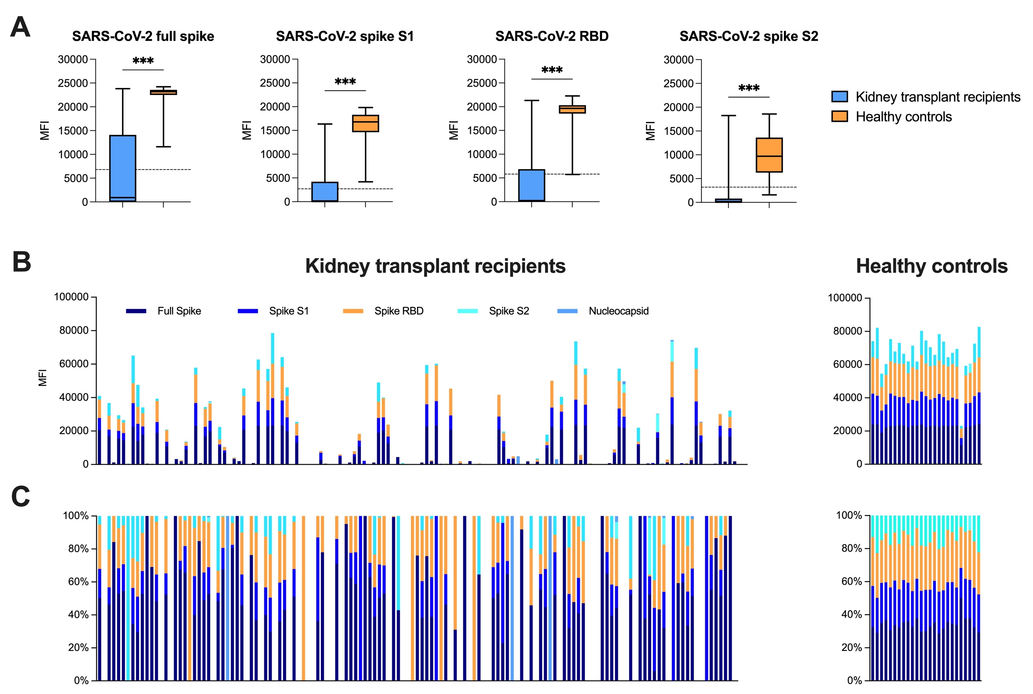
(A) Multiplex analysis of antibodies against the full spike, the S1 spike, the receptor-binding domain of the spike, and the S2 spike protein of SARS-CoV-2 in all 135 two-dose vaccinated kidney transplant recipients and 25 healthy controls matched for type of vaccine, age, and sex. The mean fluorescence intensity value of the reactivity in kidney transplant recipients and healthy controls is represented on the y-axis. The dashed black line represents the cutoff for detection for each target, respectively. (B) Multiplex analysis of antibodies against the SARS-CoV-2 full spike, the S1 spike, the receptor-binding domain of the spike, and the S2 spike protein presented as a histogram plot. The x-axis represents the sample number, the y-axis represents the mean fluorescence intensity (MFI). (C) Proportional contribution (%) of each antibody target to the total MFI value for kidney transplant recipients and healthy controls, respectively. *** P < 0.001

