Figure S1 Basic epidemiological characteristics of the 2019-nCoV and SARS-CoV outbreaks.*the Chinese annual spring festival travel surge was from Jan 17 to Feb 25 in 2003 (1.8 billion passengers) and from Jan 10 to Feb 18 in 2020 (estimated number of passengers, 3.1 billion). B-C. Fitting logistic models to the dynamics of global infection cases of SARS-CoV-2. Prediction results of cumulative cases and daily cases with upper limits of cumulative cases of 50,000, 60,000, and 70,000. t░=░0 denotes Jan 11, 2020.

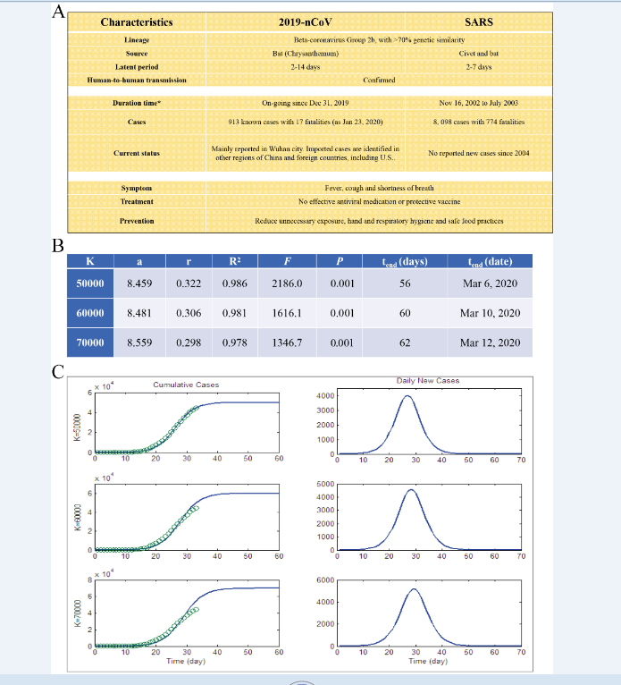

Supplementary Figure 2 (A) Human-to-human transmission was observed in the first identified cases. (B) In the ``one-to-X” human-to-human transmission clusters, 91 persons were infected via the super spreader. (C) The ``n-x-y” continuous human-to-human transmission cluster. Up to four generations of transmitted patients were observed in this cluster. (D) The two outbreaks happened around the Chinese spring festival, when billions of people travel between different locations. Red box, spring festival duration of 2020 (January 10 to February 18, 2020); Purple box, spring festival duration of 2003 (January 17 to February 25, 2003); the first official reports of the outbreaks were given in January 2, 2003, and December 27, 2019. (E) Population movement network during the spring festivals of 2003, 2019, and 2020. (F) Passenger flow surge during the spring festivals of 2003, 2019, and 2020. The total passenger numbers are 1.81, 2.91, and 3.11 billion for 2003, 2019, and 2020, respectively. The spring festival transport data for 2020 was predicted.



