SUPPLEMENTARY MARERIAL

SUNRISE group
¹Department of Critical Care Medicine (Yan Kang, Xue-Lian Liao, Bo Wang, Xiao-Dong Jin, Zhong-Wei Zhang, Xiao-Qi Xie, Wan-Hong Yin, Chang Liu, Jie Yang, Yong-Ming Tian, Huan Liu, Xiao-Jin Li, Jun Guo, Min He, Qin Wu, Jin Yang, Ai-Ping Du, Mei-Ling Dong, Jiang-Li Cheng, Ai-Jia Ma, Lu-Ping Wang, Yue Zhou, Cheng-Yong Ma, Xue-Wei Yang, Jian-Bo Li, Yan Zhang, Peng Wang, Wei Zhang, Xiang-Rong Song, Wen-Xi Xia, Bai-Xu Chen, Peng Ji); Department of Respiratory and Critical Care Medicine (Wei-Min Li, Zong-An Liang, Jun Xiao); Department of Orthopedics (Rui Shi); Department of Clinical Research Management (Xia Zou); Department of Medical Affairs (Bing-Xing Shuai); Chinese Evidence-based Medicine Center and Cochrane China Center (Wen Wang); West China Hospital, Sichuan University, Chengdu
²Department of Critical Care Medicine (Hong Chen, Qing Du), The Public Health Clinical Center of Chengdu, Chengdu
³Clinical Research Center (Zhen Li), Shanghai First Maternity and Infant Hospital, Tongji University School of Medicine, Shanghai
⁴Department of Infectious Disease (Xiao-Cui Wu); Department of Critical Care Medicine (Jian Wang, Jin Tang); Guang’an people’s hospital, Guang’an
⁵Department of Infectious Disease and Critical Care Medicine (Rui Shi, Yi Xu, Kang-Jun Ren, Qi Wang); Department of Respiratory and Critical Care Medicine (Jun Xiao); Ganzi Hospital of West China Hospital, Ganzi Tibetan Autonomous Prefeture People’s Hospital, Ganzi
⁶Department of Critical Care Medicine (Xiang-De Zhen, Wen-Lai Zhou, Chun Liu, Qing Lan), Dazhou Central Hospital, Dazhou
⁷Department of Critical Care Medicine (Mao-Juan Wang, Zhi-Xuan Wu), People's Hospital of Deyang City, Deyang
⁸Department of Critical Care Medicine (Xian-Ying Lei, Huan Wang), Affiliated Luzhou Infectious Diseases Hospital of Southwest Medical University, Luzhou
⁹Department of Critical Care Medicine (Hong-Tao Xia, Yu Gong, Xiao-Yong Hu), Suining Central Hospital,Suining
¹⁰Department of Critical Care Medicine (Sheng Lv, Hua Zhao), Panzhihua Central Hospital, Panzhihua
¹¹Department of Critical Care Medicine (Sheng Lv), People’s Hospital of Yanyuan, Liangshan Yi Autonomous Prefecture, Liang shan
¹²Department of Critical Care Medicine (Chao Jia, Jun Mo), Mianyang Central Hospital, Mianyang
¹³Department of Critical Care Medicine (Li Chen, Li Zhang), Affiliated Hospital of North Sichuan Medical College, Nan Chong
¹⁴Department of Critical Care Medicine (Juan Shang), Nanchong Central Hospital, Nanchong
¹⁵Department of Critical Care Medicine (Min Yang, Ming-Xin Xu), People's hospital of ya'an, Ya’an
¹⁶Pulmonary and Critical care medicine (Hai-Long Wei); Department of Infectious Disease (Jia-Meng Li); The People’s Hospital of Leshan, Leshan
¹⁷Department of Critical Care Medicine (Hua-Qiang Shen, Long-Wen Wang), Bazhong Central Hospital, Bazhong
¹⁸Department of Critical Care Medicine (Xiong Yang), Langzhong People’s Hospital, Langzhong
¹⁹Department of Critical Care Medicine (Xian-Hua Xiao, Li Li), The Second People’s Hospital of Neijiang, Neijiang
²⁰Department of Critical Care Medicine (Yuan-Jun Zhang, Lan-Kai Liao), The first People’s Hospital of Ziyang, Ziyang
²¹Department of Critical Care Medicine (Chao-Gui Zhang, Gui-Qiang Jin), Yibin Second People’s Hospital of Yibin, Yibin
²²Department of Critical Care Medicine (Ming-Lin Deng, Yan-Ping Li), The first people’s hospital of Liangshan Yi Autonomous Prefecture, Xichang

Supplementary Table 1: Clinical characteristics of the severe COVID-19 patients, according to outcome by D28.
Items | Total  (n=81) | Rapid Recovery  (n=53) | No Recovery  (n=10) | Prolonged Recovery  (n=18)
Epidemiological and general characteristics
Age (years) | 50.0 (39.0–65.0) | 49.0 (39.0–63.0) | 76.0 (64.0–80.0) | 48.0 (37.0–60.0)
<45 | 28 (34.6) | 20 (37.7) | 6 (60.0) | 8 (44.4)
45–64 | 30 (37.0) | 21 (39.6) | 3 (30.0) | 6 (33.4)
≥65 | 23 (28.4) | 12 (22.6) | 1 (10.0) | 4 (22.2)
Female | 30 (37.0) | 19 (35.9) | 6 (60.0) | 5 (27.8)
Current smoking | 3 (3.7) | 1 (1.9) | 1 (10.0) | 1 (5.6)
BMI (kg/m²)* | 24.0 (21.5–27.3) | 24.5 (22.3–27.7) | 25.2 (21.1–27.3) | 23.2 (20.0–25.2)
<18.5 | 8 (9.9) | 5 (9.4) | 1 (10.0) | 2 (11.1)
18.5–23.9 | 32 (39.5) | 19 (35.9) | 3 (30.0) | 10 (55.5)
24.0–27.9 | 26 (32.1) | 18 (34.0) | 5 (50.0) | 3 (16.7)
≥28.0 | 15 (18.5) | 11 (20.8) | 1 (10.0) | 3 (16.7)
Exposure to source of transmission | 62 (76.5) | 42 (79.3) | 6 (60.0) | 14 (77.8)
Family cluster | 19 (23.5) | 15 (28.3) | 1 (10.0) | 3 (16.7)
Living in or having travelled to Wuhan | 37 (45.7) | 26 (49.1) | 3 (30.0) | 8 (44.4)
Other scenarios† | 6 (7.4) | 1 (1.9) | 2 (20.0) | 3 (16.7)
Symptoms
Fever (≥37.5℃) | 39 (48.2) | 25 (47.2) | 5 (50.0) | 9 (50.0)
Non-productive cough | 40 (49.4) | 29 (54.7) | 3 (30.0) | 8 (44.4)
Productive cough | 38 (46.9) | 24 (45.3) | 3 (30.0) | 11 (61.1)
Fatigue | 30 (37.0) | 20 (37.7) | 2 (20.0) | 8 (44.4)
Dyspnea | 25 (30.9) | 17 (32.1) | 3 (30) | 5 (27.8)
Other symptoms‡ | 37 (45.7) | 27 (50.9) | 2 (20.0) | 8 (44.4)
Coexisting disorders
Any coexisting disorder | 43 (53.1) | 23 (43.4) | 10 (100.0) | 10 (55.6)
Diabetes | 18 (22.2) | 8 (15.1) | 3 (30.0) | 7 (38.9)
Hypertension | 15 (18.5) | 9 (17.0) | 4 (40.0) | 2 (11.1)
Chronic pulmonary diseases | 11 (13.6) | 5 (9.4) | 3 (30.0) | 3 (16.7)
Cardiovascular or cerebrovascular disease | 5 (6.2) | 2 (3.8) | 3 (30.0) | 0 (0.0)
Congestive heart failure | 4 (4.9) | 2 (3.8) | 1 (10.0) | 1 (5.6)
Moderate to severe renal disease | 3 (3.7) | 1 (1.9) | 2 (20.0) | 0 (0.0)
AIDS, metastatic malignancy, or moderate to severe hepatic disease | 0 (0.0) | 0 (0.0) | 0 (0.0) | 0 (0.0)
Other coexisting disorder | 34 (42.0) | 18 (34.0) | 9 (90.0) | 7 (38.9)
Clinical features on D1
SOFA score | 3.0 (3.0–5.0) | 3.0 (3.0–4.0) | 7.0 (5.0–8.0) | 3.0 (2.0–4.0)
Apache II score | 10.0 (6.0–13.0) | 10.0 (6.0–12.0) | 15.0 (11.0–17.0) | 7.0 (2.0–10.0)
Vital signs
Systolic blood pressure (mmHg) | 123.0 (114.0–137.0) | 123.0 (113.0–137.0) | 136.0 (121.0–158.0) | 121.5 (118.0–130.0)
Diastolic blood pressure (mmHg) | 74.0 (68.0–80.0) | 75.0 (68.0–84.0) | 78.5 (73.0–80.0) | 71.5 (67.0–78.0)
Heart rate (beats/min) | 88 (81–97) | 88 (81–97) | 87 (80–104) | 88 (83–95)
Respiratory rate (breaths/min) | 22 (20–25) | 22 (20–25) | 22 (20–26) | 21 (20–24)
Pulse oxygen saturation (%) | 96.0 (93.0–97.0) | 96.0 (93.0–97.0) | 96.0 (89.0–97.0) | 96.5 (95.0–97.0)
Laboratory findings
White blood cell count (× 10⁹/L) | 6.2 (4.5–7.8) | 6.3 (4.9–8.2) | 6.7 (4.9–7.4) | 5.9 (3.9–9.5)
<4.0 | 17 (21.0) | 10 (18.9) | 2 (20.0) | 5 (27.8)
>10.0 | 11 (13.6) | 7 (13.2) | 0 (0.0) | 4 (22.2)
Neutrophil count (×10⁹/L) | 5.0 (3.1–6.6) | 4.6 (3.1–6.6) | 5.4 (4.5–5.7) | 4.2 (3.1–8.4)
Lymphocyte count (×10⁹/L) | 0.8 (0.6–1.1) | 0.8 (0.6–1.1) | 0.4 (0.3–1.1) | 0.8 (0.6–1.1)
<1.5 | 69 (85.2) | 45 (84.9) | 9 (90.0) | 15 (83.3)
Platelet count (×10⁹/L) | 166.0 (136.0–217.0) | 178.0 (139.0–237.0) | 124.0 (111.0–147.0) | 169.5 (150.0–202.0)
<150 | 31 (38.2) | 19 (35.9) | 8 (80.0) | 4 (22.2)
Total bilirubin (μmol/L) | 11.7 (6.9–18.4) | 12.6 (9.0–17.5) | 7.9 (3.5–19.5) | 10.8 (6.2–19.7)
Creatinine (mg/L) | 67.8 (55.3–80.0) | 62.1 (53.8–78.9) | 80.0 (69.0–464.0) | 73.2 (59.9–84.0)
>133 | 5 (6.2) | 2 (3.8) | 3 (30.0) | 0 (0.0)
C-reactive protein (mg/L) | 40.6 (18.7–69.3) | 39.4 (24.0–71.6) | 99.5 (43.0–129.0) | 33.0 (9.92–44.6)
PaO2 (mmHg) | 69.2 (59.0–85.0) | 69.8 (58.8–84.3) | 71.6 (54.6–92.6) | 66.  7 (60.0–104.1)
FiO2 (mmHg) | 33.0 (29.0–41.0) | 33.0 (29.0–41.0) | 33.0 (29.0–57.0) | 33.0 (29.0–37.0)
D-Dimer (mg/L) | 0.8 (0.4–1.3) | 0.7 (0.4–1.2) | 1.3 (0.8–5.6) | 0.6 (0.2–1.1)
Bilateral lung infiltrates | 81 (100.0) | 52 (98.1) | 10 (100.0) | 19 (100.0)
Criteria for the diagnosis of severe illness
Dyspnea or respiratory frequency ≥30 (breaths/min) | 22 (27.2) | 16 (30.2) | 2 (20.0) | 4 (22.2)
Pulse oxygen saturation (SpO₂%) ≤93% | 54 (66.7) | 34 (64.2) | 6 (60.0) | 14 (77.8)
PaO2:FiO2 (mmHg) | 204.0 (156.8–266.5) | 204.0 (156.8–252.0) | 183.6 (115.8–255.2) | 224.8 (173.6–331.4)
<300 | 71 (87.7) | 52 (98.1) | 8 (80.0) | 11 (61.1)
<150 | 16 (19.8) | 9 (17.0) | 4 (40.0) | 3 (16.7)
Lung infiltrates >50% within 24 to 48 h | 4 (4.9) | 2 (3.8) | 2 (20.0) | 0 (0.0)
Respiratory failure, septic shock, and/or MOF§ | 17 (21.0) | 7 (13.2) | 5 (50.0) | 5 (27.8)
Main organ dysfunction
Acute respiratory distress syndrome | 30 (37.7) | 20 (37.7) | 4 (40.0) | 6 (33.3)
Acute kidney injury | 6 (7.4) | 3 (5.7) | 3 (30.0) | 0 (0.0)
Septic shock | 1 (1.2) | 0 (0.0) | 1 (10.0) | 0 (0.0)
Main organ support
No use | 5 (6.2) | 3 (5.7) | 1 (10.0) | 1 (5.6)
Conventional oxygen therapy through nasal catheter | 51 (63.0) | 34 (64.2) | 7 (70.0) | 10 (55.6)
Conventional oxygen therapy through mask | 4 (4.9) | 3 (5.7) | 0 (0.0) | 1 (5.6)
High flow nasal cannula | 8 (9.9) | 5 (9.4) | 0 (0.0) | 3 (16.7)
Non-invasive ventilation | 13 (16.0) | 8 (15.1) | 2 (20.0) | 3 (16.7)
Invasive ventilation or ECMO | 0 (0.0) | 0 (0.0) | 0 (0.0) | 0 (0.0)
Renal-replacement therapy | 5 (6.2) | 0 (0.0) | 5 (50.0) | 0 (0.0)
Vasopressors | 1 (1.2) | 0 (0.0) | 1 (10.0) | 0 (0.0)
Data were presented as median (Q₁, Q₃) or n (%). *BMI was classified into 4 groups according to the criteria for Chinese population: underweight (<18.5 kg/m²), normal (18.5-23.9 kg/m²), overweight (24-27.9 kg/m²), and obese (≥18 kg/m²). †Other scenarios included having visited a designated hospital for COVID-19 patients or being in another city with confirmed COVID-19 cases during the past 14 days. ‡Other symptoms included muscle soreness, loss of appetite, diarrhea, abdominal pain, headache, dizziness, nausea, vomiting. §Data were missing for the measurement of C-reactive protein in 12 patients (14.8%) and D-Dimer in four patients (4.9%). COVID-19: Coronavirus disease 2019; BMI: Body mass index; AIDS: Acquired immune deficiency syndrome; SOFA: Sepsis-related organ failure assessment; Apache II: Acute physiology and chronic health evaluation II; PaO₂: Partial pressure of oxygen; FiO₂: Fraction of inspired oxygen; MOF: Multiple organ failure; ECMO: Extracorporeal membrane oxygenation.

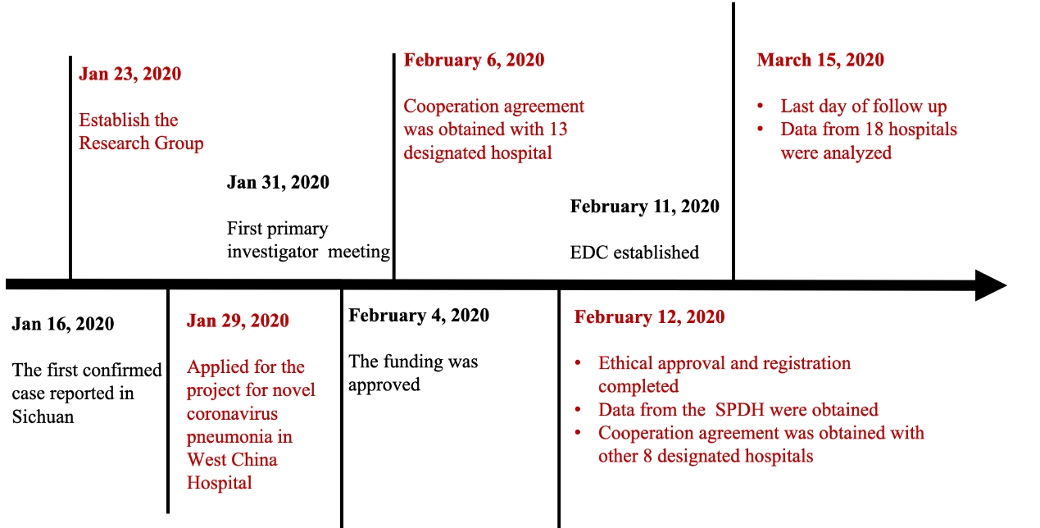
Supplementary Figure 1: Timeline of the study. EDC: Electronic data capture and analysis system; SPDH: Sichuan Provincial Department of Health.

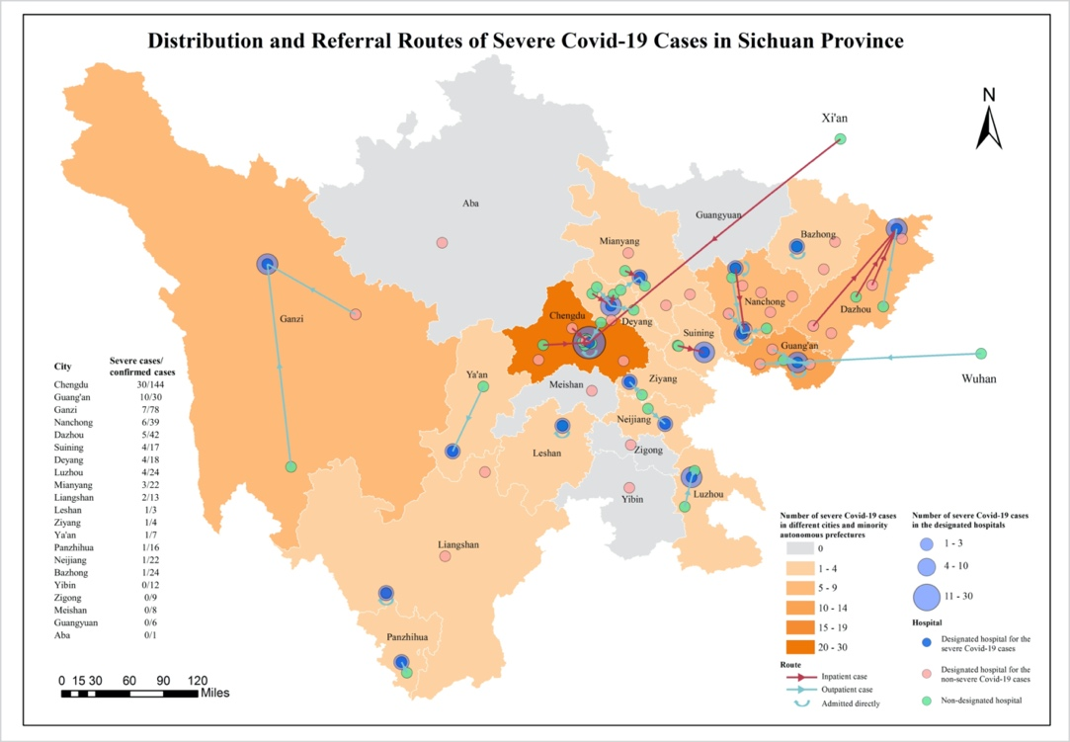
Supplementary Figure 2: Distribution and referral routes of severe COVID-19 cases in Sichuan Province. Distribution of all the 81 patients with severe COVID-19 from 13 cities and 2 minority autonomous prefectures of Sichuan province was shown in the figure. The blue dots denote the 18 designated hospital for severe cases, pink dots denote 30 designated hospital for non-severe cases, and green dots denote non-designated hospital. The red and green arrows represent the route taken by inpatient and outpatient cases, respectively. COVID-19: Coronavirus disease 2019.
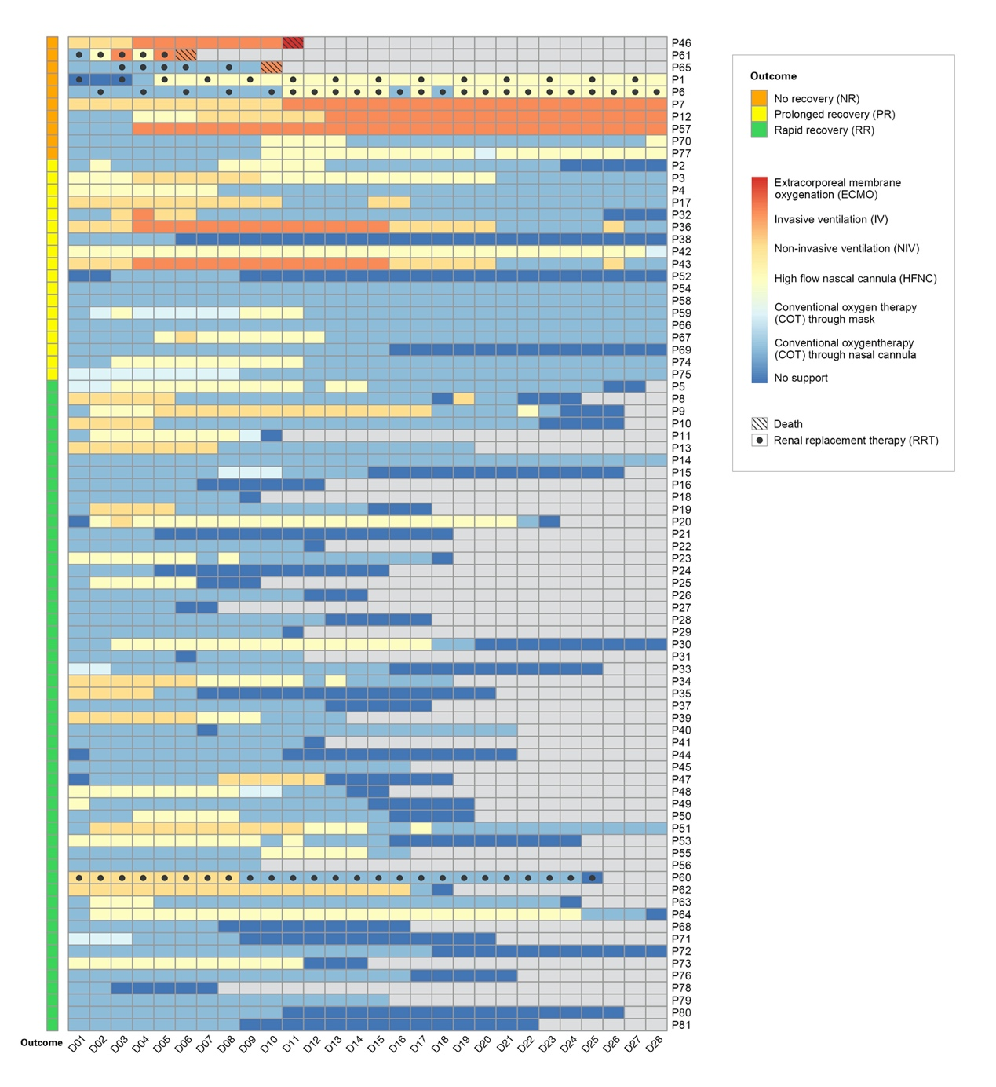 Supplementary Figure 3: Daily organ support for 81 patients with severe COVID-19 from D1 to D28. Daily organ support, including respiratory support and renal replacement therapy, for each of the 81 patients with severe COVID-19 are shown from the day diagnosed as a severe case (D1) to death, discharged from hospital, or D28. COVID-19: Coronavirus disease 2019.

