Supplementary Materials
Supplementary Table 1: Characteristics of study participants in 2007 by quartiles of 15-year cumulative systolic blood pressure levels.
Parameters | Cumulative SBP
 | Quartile 1 | Quartile 2 | Quartile 3 | Quartile 4
Age (years) | 59.1 ± 6.9 | 61.7 ± 7.9 | 62.9 ± 7.7 | 64.9 ± 7.8
Male, n (%) | 200 (32.9) | 255 (41.9) | 285 (47.0) | 302 (49.8)
BMI (kg/m²) | 23.9 ± 3.0 | 24.8 ± 3.0 | 25.4 ± 3.5 | 26.2 ± 3.7
Waist circumference (cm) | 81.8 ± 9.3 | 84.2 ± 8.9 | 85.5 ± 10.2 | 87.9 ± 9.2
FBG (mmol/L) | 5.6 ± 1.0 | 5.8 ± 1.2 | 6.0 ± 1.3 | 6.4 ± 1.8
TC (mmol/L) | 5.5 ± 1.0 | 5.4 ± 1.0 | 5.4 ± 0.9 | 5.4 ± 1.0
LDL-C (mmol/L) | 3.4 ± 0.8 | 3.4 ± 0.9 | 3.4 ± 0.8 | 3.5 ± 0.9
HDL-C (mmol/L) | 1.4 ± 0.3 | 1.4 ± 0.3 | 1.3 ± 0.3 | 1.3 ± 0.3
TG (mmol/L) | 1.4 (1.0-1.9) | 1.5 (1.1–2.1) | 1.5 (1.1–2.1) | 1.7 (1.2–2.3)
SBP (mmHg) | 119.9 ± 11.5 | 131.4 ± 11.2 | 139.7 ± 12.5 | 153.6 ± 16.9
DBP (mmHg) | 75.9 ± 8.0 | 81.0 ± 7.8 | 83.9 ± 8.5 | 88.6 ± 10.5
Smoking, n (%) | 68 (11.2) | 75 (12.3) | 80 (13.2) | 60 (9.9)
Diabetes, n (%) | 56 (9.2) | 81 (13.3) | 124 (20.4) | 163 (26.9)
Antihypertensive drug use, n (%) | 44 (7.2) | 136 (22.4) | 249 (41.0) | 400 (65.9)
Lipid-lowering drug use, n (%) | 37 (6.1) | 62 (10.2) | 48 (7.9) | 69 (11.4)
DBP: Diastolic blood pressure; FBG: Fasting blood glucose; HDL-C: High-density lipoprotein cholesterol; LDL-C: Low-density lipoprotein cholesterol; SBP: Systolic blood pressure; TC: Total cholesterol; TG: Triglycerides.
Supplementary Table 2: Characteristics of study participants in 2007 by quartiles of 15-year cumulative diastolic blood pressure levels.
Parameters | Cumulative DBP
 | Quartile 1 | Quartile 2 | Quartile 3 | Quartile 4
Age (year) | 62.0 ± 8.1 | 62.4 ± 8.1 | 62.2 ± 7.8 | 62.0 ± 7.6
Male, n (%) | 184 (30.3) | 228 (37.6) | 280 (46.1) | 350 (57.7)
BMI (kg/m²) | 23.5 ± 2.8 | 24.7 ± 3.1 | 25.6 ± 3.7 | 26.5 ± 3.2
Waist circumference (cm) | 80.8 ± 8.4 | 83.9 ± 8.5 | 86.0 ± 10.0 | 88.7 ± 9.8
FBG (mmol/L) | 5.6 ± 1.1 | 5.8 ± 1.2 | 6.0 ± 1.4 | 6.3 ± 1.7
TC (mmol/L) | 5.4 ± 1.0 | 5.5 ± 1.0 | 5.4 ± 0.9 | 5.4 ± 1.0
LDL-C (mmol/L) | 3.3 ± 0.8 | 3.5 ± 0.9 | 3.4 ± 0.9 | 3.5 ± 0.9
HDL-C (mmol/L) | 1.4 ± 0.3 | 1.4 ± 0.3 | 1.3 ± 0.3 | 1.3 ± 0.3
TG (mmol/L) | 1.3 (1.0–1.9) | 1.5 (1.1–2.1) | 1.5 (1.1-2.2) | 1.7 (1.2-2.3)
SBP (mmHg) | 124.0 ± 14.1 | 132.4 ± 14.7 | 139.2 ± 15.0 | 149.0 ± 18.0
DBP (mmHg) | 74.1 ± 7.0 | 79.7 ± 6.8 | 84.8 ± 7.6 | 90.8 ± 9.3
Smoking, n (%) | 54 (8.9) | 72 (11.9) | 76 (12.5) | 81 (13.3)
Diabetes, n (%) | 64 (10.5) | 95 (15.7) | 109 (17.9) | 156 (25.7)
Antihypertensive drug use, n (%) | 89 (14.7) | 147 (24.2) | 235 (38.7) | 358 (59.0)
Lipid-lowering drug use, n (%) | 52 (8.6) | 41 (6.8) | 69 (11.3) | 54 (8.9)
DBP: Diastolic blood pressure; FBG: Fasting blood glucose; HDL-C: High-density lipoprotein cholesterol; LDL-C: Low-density lipoprotein cholesterol; SBP: Systolic blood pressure; TC: Total cholesterol; TG: Triglycerides.

Supplementary Table 3. Hazard ratios and 95% confidence intervals for incident CVD by quartiles of 15-year cumulative blood pressure levels among 2326 participants with complete data.

Items | Cumulative SBP |  |  |  |  |  | Cumulative DBP
 | Traditional risk factors* |  |  | Traditional risk factors* + SBP |  |  | Traditional risk factors* |  |  | Traditional risk factors* + DBP
 | Hazard ratios (95% CI) | P |  | Hazard ratios (95% CI) | P |  | Hazard ratios (95%CI) | P |  | Hazard ratios (95%CI) | P
Quartile 1 | Reference |  |  | Reference |  |  | Reference |  |  | Reference
Quartile 2 | 1.15 (0.65–2.04) | 0.630 |  | 1.02 (0.57–1.82) | 0.954 |  | 1.54 (0.90–2.63) | 0.115 |  | 1.41 (0.82–2.42) | 0.218
Quartile 3 | 2.12 (1.26–3.55) | 0.004 |  | 1.71 (0.99–2.95) | 0.053 |  | 2.36 (1.42–3.92) | 0.001 |  | 2.02 (1.19–3.45) | 0.010
Quartile 4 | 3.28 (1.94–5.54) | <0.001 |  | 2.24 (1.22–4.13) | 0.010 |  | 2.65 (1.58–4.44) | <0.001 |  | 2.03 (1.12–3.67) | 0.019
CVD: Cardiovascular disease; DBP: Diastolic blood pressure; HDL-C: High-density lipoprotein cholesterol; LDL-C: Low-density lipoprotein cholesterol; SBP: Systolic blood pressure.*Classical risk factors include age, sex, smoking status, diabetes, levels of HDL-C and LDL-C, and the use of antihypertensive and lipid-lowering drugs.
Supplementary Table 4. Hazard ratios and 95% confidence intervals for incident CVD associated with levels of 2007 blood pressure and 15-year cumulative blood pressure.
BP levels | SBP |  |  |  | DBP
 | 2007 SBP | Cumulative SBP |  |  | 2007 DBP | Cumulative DBP
Per SD increase
1 SD | 1.46 (1.28–1.67) | 1.64 (1.42–1.88) |  |  | 1.34 (1.17–1.54) | 1.47 (1.27–1.70)
Quartiles
Quartile 1 | Reference | Reference |  |  | Reference | Reference
Quartile 2 | 1.45 (0.87–2.42) | 1.17 (0.67–2.04) |  |  | 1.11 (0.70–1.75) | 1.61 (0.96–2.71)
Quartile 3 | 1.71 (1.04–2.83) | 2.10 (1.27–3.48) |  |  | 1.62 (1.06–2.49) | 2.36 (1.43–3.87)
Quartile 4 | 2.71 (1.68–4.39) | 3.27 (1.97–5.43) |  |  | 1.93 (1.26–2.96) | 2.78 (1.69–4.60)
CVD: Cardiovascular disease; DBP: Diastolic blood pressure; SBP: Systolic blood pressure.

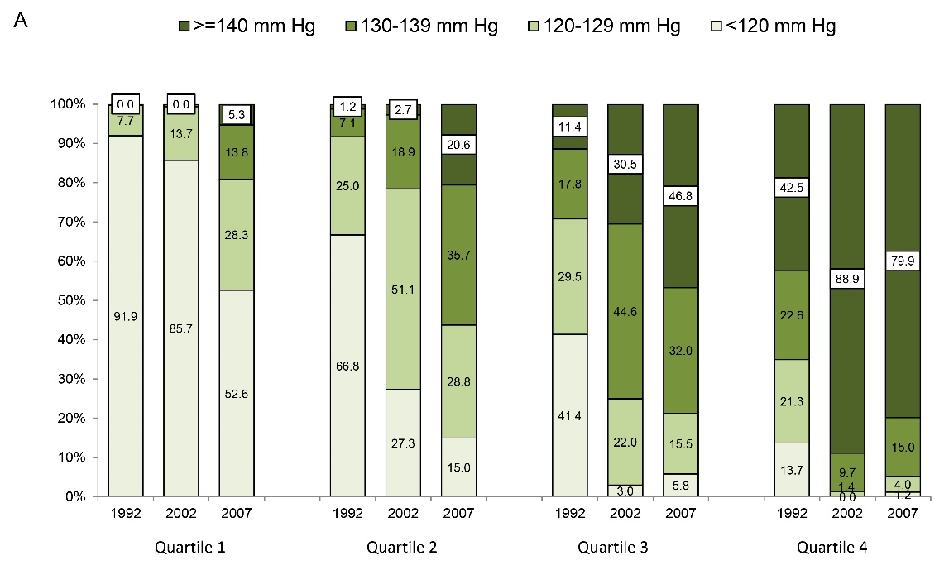
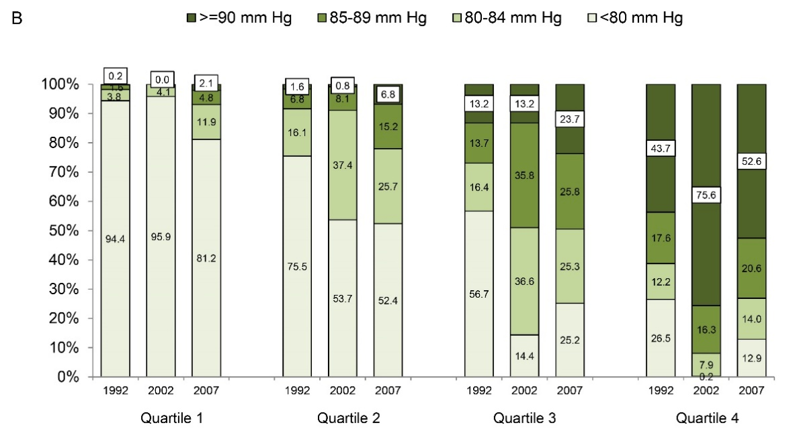
Supplementary Figure 1: Proportions of blood pressure category in 1992, 2002, and 2007 by quartiles of cumulative blood pressure levels. (A) SBP; (B) DBP. DBP: Diastolic blood pressure; SBP: Systolic blood pressure.
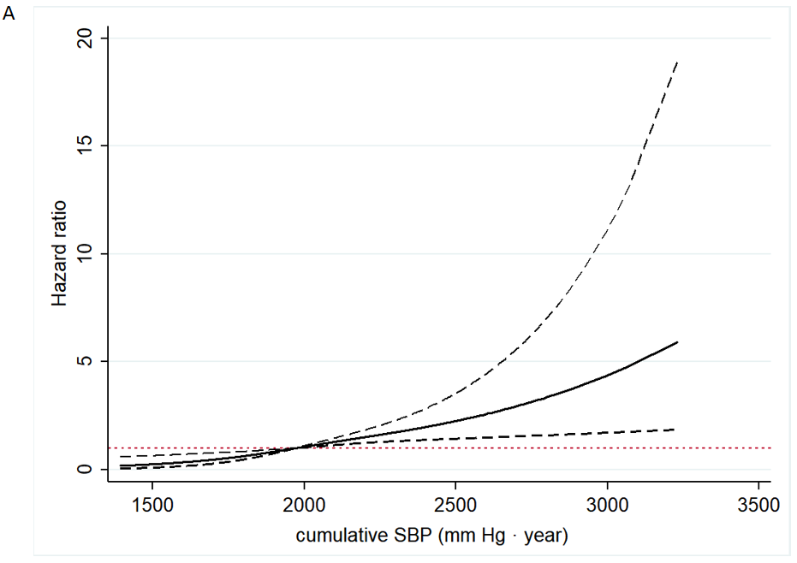
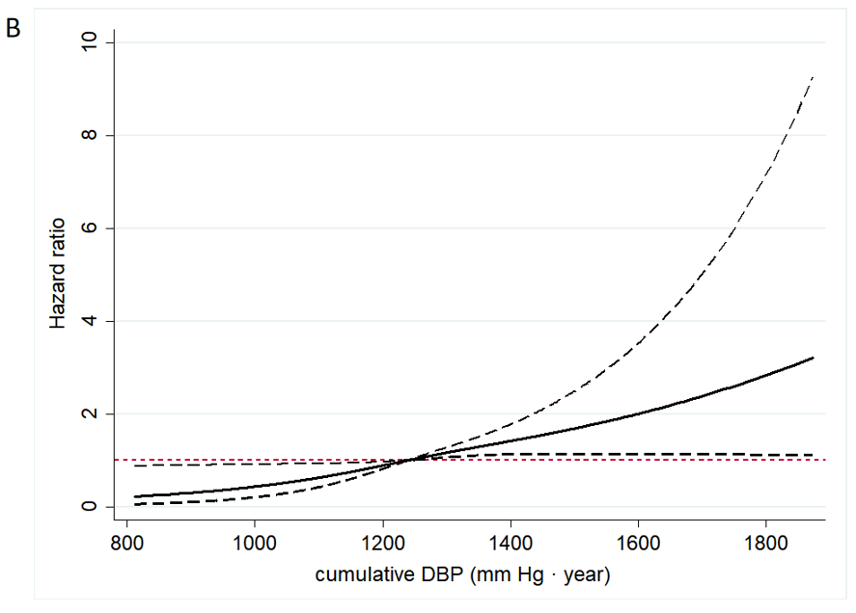
Supplementary Figure 2: Adjusted cubic spline for the hazard of incident cardiovascular disease by cumulative blood pressure levels. (A) SBP; (B) DBP. DBP: Diastolic blood pressure; SBP: Systolic blood pressure.

