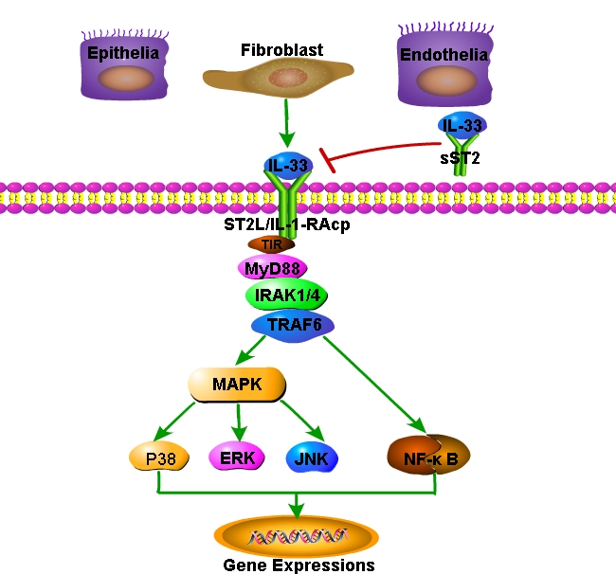
Supplementary Figure 1: Release and signaling of IL-33. ERK: Extracellular regulated protein kinase; IL-33: Interleukin-33; IL-1-RAcP: Interleukin-1R accessory protein; IRAK1/4: Interleukin-1 receptor-associated kinase 1/4; JNK: C-jun N-terminal kinase; MyD88: Myeloid differentiation primary response 88; MAPK: Mitogen-activated protein kinase; NF-κB: Nuclear transcription factor-κB; ST2L: Membrane type of suppression of tumorigenicity 2; sST2: Soluble type of suppression of tumorigenicity 2; TIR: Toll/interleukin-1 Receptor; TRAF6: Tumor necrosis factor receptor-associated factor 6.

