Figure S1 Expression level of CHCHD2 in cell and animal models.
A.Western blot analysis showed the protein level of CHCHD2 in SHSY5Y cells with lentivirus-mediated CHCHD2 overexpression.
B. RT-qPCR analysis showed mRNA level of CHCHD2 in SHSY5Y cells with lentivirus-mediated CHCHD2 overexpression. n=3, student t test was used. Data are presented as mean ± SEM. *p<0.05; †=no siginificant.
C. RT-qPCR analysis showed mRNA level of CHCHD2 in SHSY5Y cells with short hairpin RNA (ShRNA)-mediated CHCHD2 knockdown. n=3, student t test was used. Data are presented as mean ± SEM. *p<0.05; †=no siginificant.
D. The primers used in RT-qPCR analysis.
E. Immunofluorescent staining for CHCHD2-Flag (Red) and TH (Green) in the nigral dopaminergic neurons.
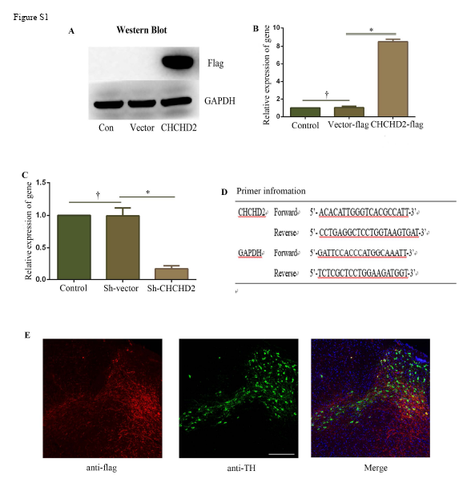

Figure S2 Co-immunoprecipitation assay of Mic60 and CHCHD3 with CHCHD2
A. Co-immunoprecipitation assays to detect the interaction between endogenous Mic60 with CHCHD2-Flag. Co-IP was performed using an anti-Mic60 antibody, followed by immunoblotting analysis with anti-Flag. IB, immunoblot; IP, immunoprecipitation.
B. Co-immunoprecipitation assays to detect the interaction between endogenous CHCHD3 with CHCHD2-Flag. Co-IP was performed using an CHCHD3 antibody, followed by immunoblotting analysis with anti-Flag. IB, immunoblot; IP, immunoprecipitation.
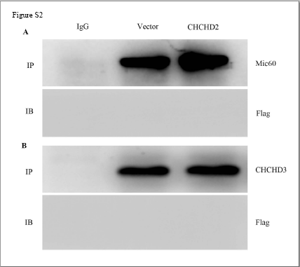

Figure S3 Effect of CHCHD2 on MPTP-induced dopaminergic neuronal loss in the substantia nigra.
Immunofluorescence image showing tyrosine hydroxylase (TH)-positive neurons in the Substantia nigra pars compacta (SNpc) of CHCHD2-Flag mice and Flag-vector mice at 7 days after saline or MPTP (20 mg/kg, i.p.) administration.

