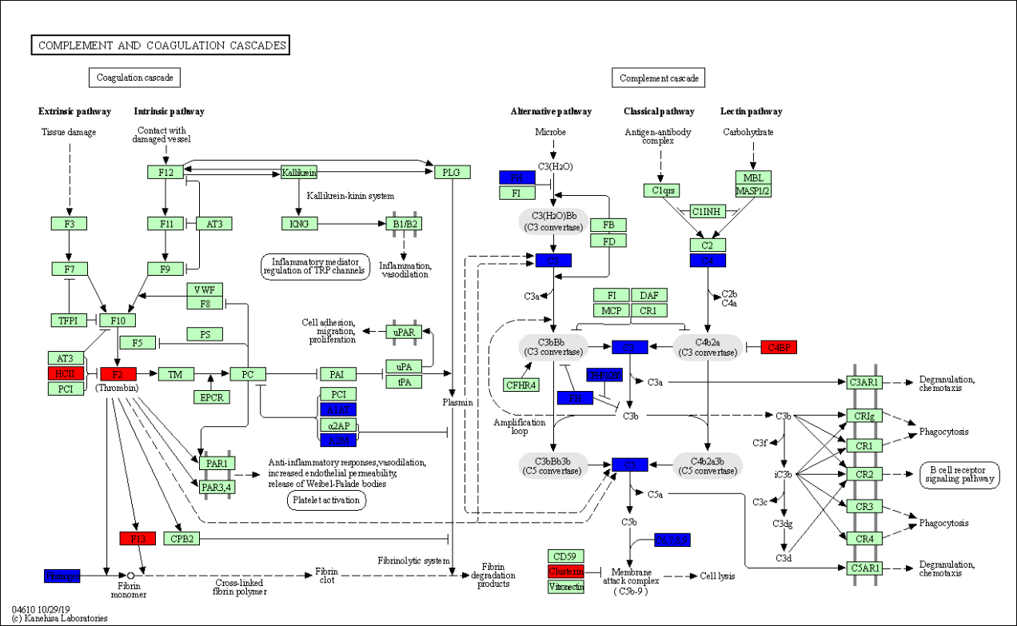
Supplementary Figure 1: The KEGG pathway that is closely associated with 15 DEPs identified in COPD patients. CFB: Complement factor B; CFHR: Complement factor H related; COPD: Chronic obstructive pulmonary disease; CR1: Complement C3b/C4b receptor 1; DAF: CD55 molecule; DEPs: Differentially expressed proteins; HCII: Serpin family D member 1; KEGG: Kyoto Encyclopedia of Genes and Genomes; KNG: Kininogen 1; MBL: Mannose binding lectin; MCP: CD46 molecule; PAI: Serpin family E member 1; PCI: Serpin family A member 5; PLG: Plasminogen; TFF: Trefoil factor 1; TM: Thrombomodulin; VWF: Von Willebrand factor.

