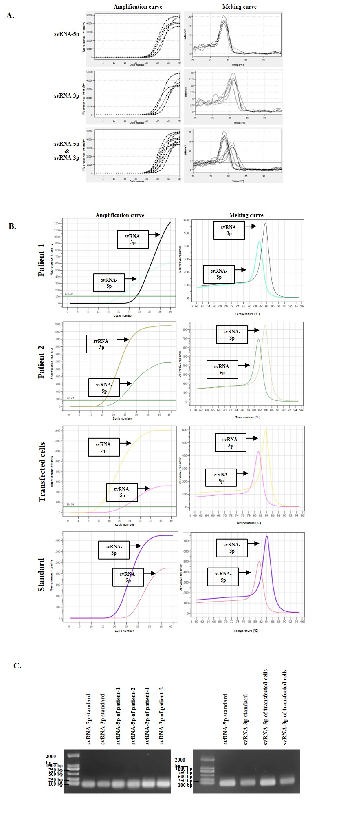

**Supplementary Figure 1:** Verification of the existence of two svRNAs encoded by SARS-CoV-2. (A) The amplification and melting curves of the two svRNAs probably maturing from the same precursor named as svRNA-5p and svRNA-3p in five nucleic acid samples from pharyngeal swabs of COVID-19 patients obtained from the Jiangsu Provincial Center for Disease Control and Prevention. The PCR reactions were run on the qTOWER³ 84 (Analytik Jena, Jena, Germany) at 95 °C for 20 s, followed by 40 cycles of 10 s at 95 °C, 20 s at 60 °C. (B) The corresponding amplification and melting curves for stem-loop RT-PCR performed in FFPE explanted lungs from lung transplantation of two COVID-19 patients, svRNAs precursor-transfected 16HBE (human bronchial epithelial cell line) cells, and svRNAs standards, respectively. The PCR reactions were run on the LineGene 9600 Plus (BIOER, Hangzhou, China) at 95 °C for 20 s, followed by 40 cycles of 10 s at 95 °C, 20 s at 60 °C. (C) The stem-loop RT-PCR products purified in agarose gels before pyrosequencing by Tsingke Biotechnology (Beijing, China). COVID-19: Coronavirus disease 2019; FFPE: Formalin-fixed paraffin-embedded; PCR: Polymerase chain reaction; RT-PCR: Reverse transcription polymerase chain reaction; SARS-CoV-2: Severe acute respiratory syndrome coronavirus 2; svRNAs: Small viral RNAs.

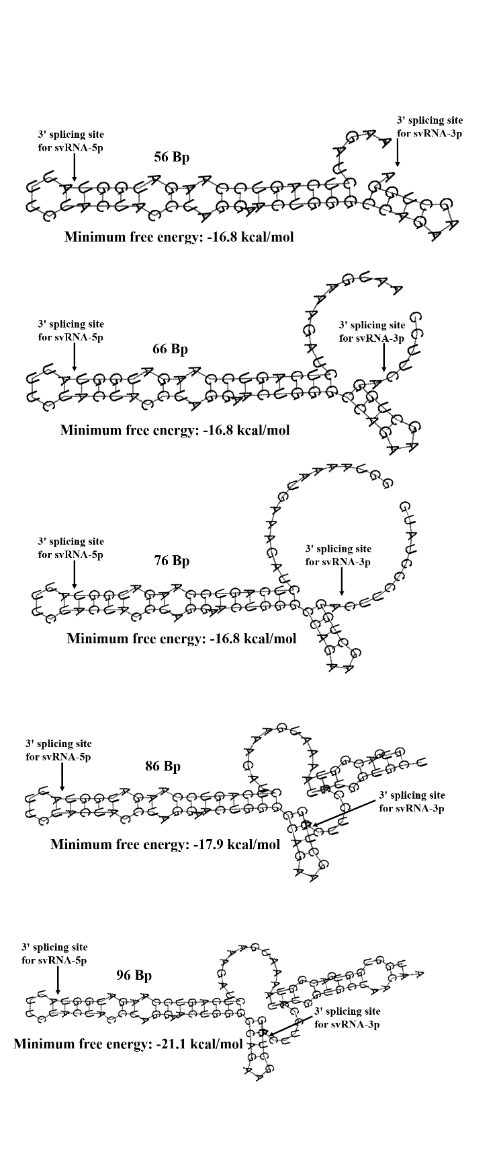

**Supplementary Figure 2:** The secondary structure of svRNAs precursor with the different lengths (from 56 bp to 96 bp), predicted by RNAfold webserver based on minimum free energy, showed that the splicing sites of the two SARS-CoV-2 encoded svRNAs (svRNA-5p and svRNA-3p) were always stable, no matter with the length of svRNA precursor. svRNAs: Small viral RNAs; SARS-CoV-2: Severe acute respiratory syndrome coronavirus 2.

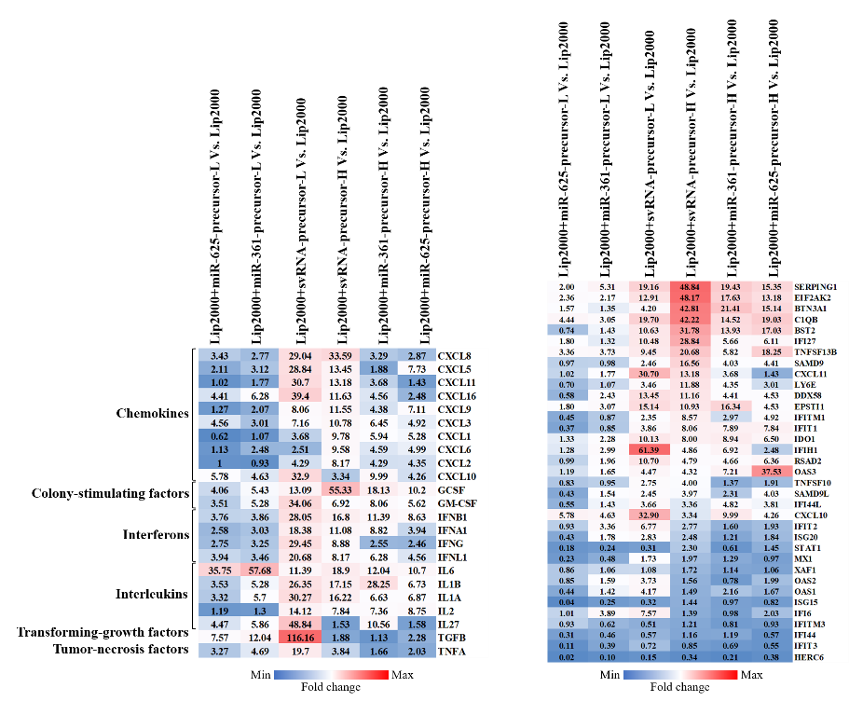

**Supplementary Figure 3:** 16HBE (human bronchial epithelial cell line) cells were transfected with control endogenous short RNA precursors and svRNAs precursor at the high (H) and low (L) dosage of 40 pmol and 80 pmol, respectively. The heatmaps showed all the RT-qPCR assay analysis on cells at 48 h post-infection of different dosages of short RNA precursors. The intensity of the color scheme was scaled to relative expression values (fold change). However, no obvious dose dependence between svRNA precursor and inflammation reaction at the transcriptional level was observed. svRNAs: Small viral RNAs; RT-qPCR: Reverse transcription quantitative polymerase chain reaction.

**Supplementary Table 1: Proposal of six potential svRNAs encoded by SARS-CoV-2.**



These six potential svRNAs derived from the SARS-CoV-2 genome showed significant similarity with those encoded by SARS-CoV-1 in both nucleic acid sequences and virus genome positions via basic local alignment search tool (BLAST) analysis, and served as candidate SARS-CoV-2-encoded svRNAs for further verification. svRNAs: Small viral RNAs; SARS-CoV-2: Severe acute respiratory syndrome coronavirus 2; SARS-CoV-1: Severe acute respiratory syndrome coronavirus 1; BLAST: Basic local alignment search tool.

**Supplementary Table 2: The sequence of forward primers of Poly(A) RT-PCR for the six potential svRNAs encoded by SARS-CoV-2.**



The RNA from nasopharyngeal swabs underwent Poly(A) RT-PCR using the miDETECT A Track™ microRNA (miRNA) RT-PCR Kit (Ribobio, Guangzhou, Guangdong, China) containing the commercial miDETECT A Track™ Uni-RT primer and Uni-Reverse primer, while the forward primers for the above six potential svRNAs encoded by SARS-CoV-2 were synthesized by Tsingke Biotechnology (Beijing, China). The products of the Poly(A) RT-PCR were then pyrosequenced to verify the existence of the above six potential svRNAs derived from SARS-CoV-2 genome. Poly(A) RT-PCR: Poly(A) polymerase tailing followed by reverse transcription polymerase chain reaction; SARS-CoV-2: Severe acute respiratory syndrome coronavirus 2; svRNAs: Small viral RNAs.

**Supplementary Table 3: The primer sequences of SYBR Green-based stem-loop RT-PCR for the two identified svRNAs.**



Total RNA of FFPE explanted lungs was extracted through RNAprep Pure FFPE Kit (TIANGEN, Beijing, China). The stem-loop RT primers and PCR primers for svRNAs were synthesized by Tsingke Biotechnology (Beijing, China). The products of the stem-loop RT-PCR were then pyrosequenced to further confirm the existence of the two identified svRNAs derived from SARS-CoV-2 genome. FFPE: Formalin-fixed paraffin-embedded; RT-PCR: Reverse transcription-polymerase chain reaction; SARS-CoV-2: Severe acute respiratory syndrome coronavirus 2; svRNAs: Small viral RNAs.

**Supplementary Table 4: The potential sequence of svRNA precursor with different lengths for RNAfold web server to predict the secondary structures.**



The sequence of the two verified mature svRNAs was shown in red. svRNAs: Small viral RNAs.

**Supplementary Table 5: The GEO accession IDs, sample characteristics, and experiment types of the nine datasets associated with COVID-19.**



COVID-19: Coronavirus disease 2019; GEO: Gene Expression Omnibus; SARS-CoV-2: Severe acute respiratory syndrome coronavirus 2.

**Supplementary Table 6: The sequence of primers for genes of the characteristic expression profiling of COVID-19.**



Glyceraldehyde-3-phosphate dehydrogenase (GAPDH) and 18S rRNA were considered as reference genes for normalization. COVID-19: Coronavirus disease 2019.

**Supplementary Table 7: The sequence of primers for 23 cytokine genes covering most of the members of the cytokine storm potentially associated with COVID-19.**



Glyceraldehyde-3-phosphate dehydrogenase (GAPDH) and 18S rRNA were considered as reference genes for normalization. COVID-19: Coronavirus disease 2019.

**Supplementary Table 8: Differential analysis of the characteristic expression profiling in the lung tissues between the two COVID-19 patients and the controls.**



The differential expression level was shown through the average FC between the two COVID-19 patients and the controls. Specifically, FC>1.5 (red) and FC<0.66 (green) were considered as up-regulated and down-regulated in COVID-19, respectively.

COVID-19: Coronavirus disease 2019; FC: Fold changes.

**Supplementary Table 9: The differential expression analysis of the 23 cytokine genes in the lung tissues between the two COVID-19 patients and the controls.**



The differential expression level was shown through the average FC between the two COVID-19 patients and the controls. Specifically, FC>1.5 (red) and FC<0.66 (green) were considered as up-regulated and down-regulated in COVID-19, respectively.

COVID-19: Coronavirus disease 2019; FC: Fold changes.

**Supplementary Table 10: The sequences of sense and antisense ssDNA to form the DNA templates for T7 RNA synthesis.**



The precursor of the two verified SARS-CoV-2-encoded svRNAs and control endogenous miRNA precursors were synthesized by *in vitro* transcription using T7 RNA polymerase with synthetic DNA templates obtained from Tsingke Biotechnology (Beijing, China). The sequence of T7 promoter region was shown in red. The sequence of the mature short RNAs was shown in blue. The mature svRNAs (svRNA-5p and svRNA-3p) and control were also synthesized by Tsingke Biotechnology. miRNA: MicroRNA; SARS-CoV-2: Severe acute respiratory syndrome coronavirus 2; ssDNA: Single-stranded DNA; svRNAs: Small viral RNAs.

.