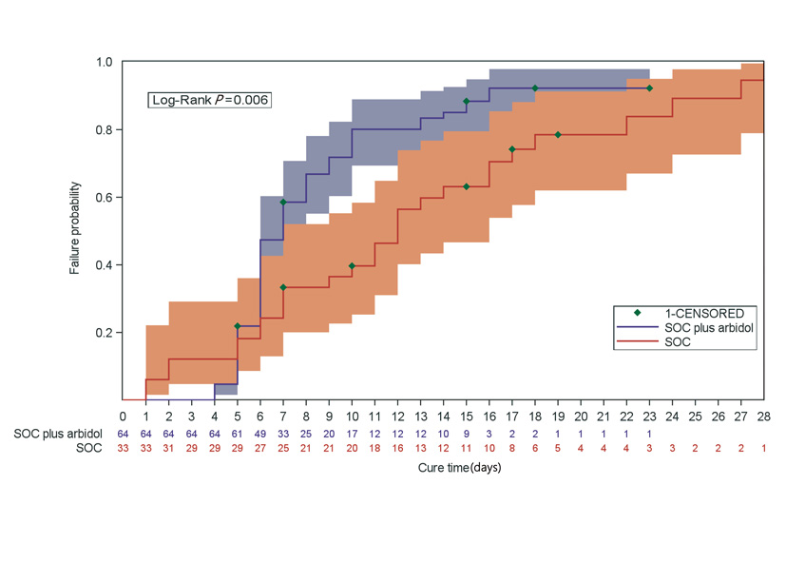
Supplementary Figure 1: Kaplan-Meier curve of the time to clinical recovery in SOC plus arbidol tablets versus SOC group. SOC: Standard of care.

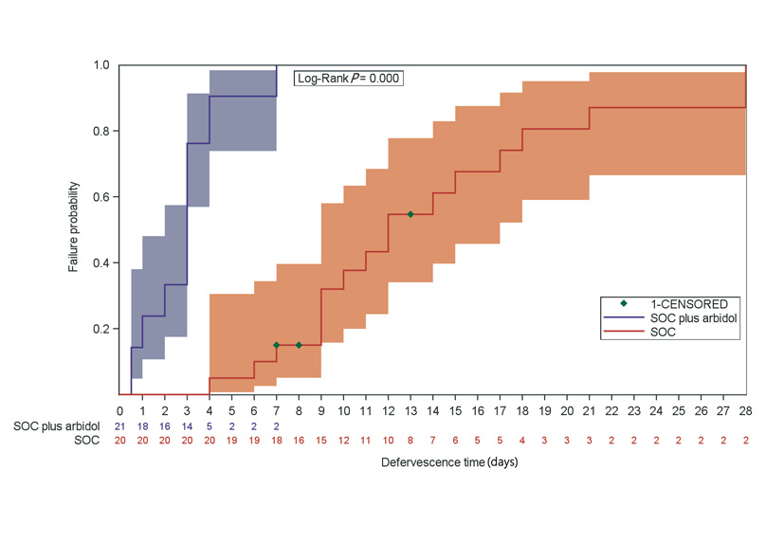
Supplementary Figure 2: Kaplan-Meier curve of the time to defervescence in SOC plus arbidol tablets versus SOC group. SOC: Standard of care.
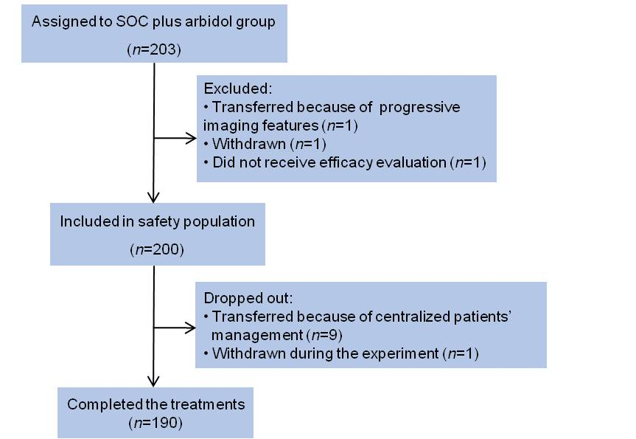
Supplementary Figure 3: Flow diagram of the extra single-arm analysis. SOC: Standard of care.

Supplementary Table 1: Baseline characteristics of the patients in the single-arm analysis.
Characteristics | SOC plus arbidol  (N=200)
Age (years) | 48.00±12.13
Gender  Male | 74/200 (37.0)
Han nationality | 200 (100.0)
Disease severity
Mild | 45/200 (22.5)
Moderate | 109/200 (54.5)
Severe | 46/200 (23.0)
Coexisting diseases | 59/200 (29.5)
Temperature (℃) | 36.61±0.46
Symptoms
Fever | 36/200 (18.0)
Acute hypoxia | 28/200 (14.0)
Oxygen therapy | 47/200 (23.5)
Lab examination abnormal ratio
WBC | 15/169 (8.9)
LYMPH | 28/169 (16.6)
PLT | 9/169 (5.3)
ALT | 43/160 (26.9)
AST | 20/160 (12.5)
ALB | 22/160 (13.8)
LDH | 12/160 (7.5)
CK | 6/157 (3.8)
CK-MB | 3/157 (1.9)
BUN | 11/160 (6.9)
CRE | 10/160 (6.3)
CRP | 34/167 (20.4)
CT abnormal | 168/180 (93.3)

Data are presented as mean ± standard deviation or n (%). ALB: Albumin; ALT: Alanine aminotransferase; AST: Aspartate aminotransferase; BUN: Blood urea nitrogen; CK: Creatine kinase; CRE: Creatinine; CRP: C-reactive protein; CT: Computed tomography; LDH: Lactate dehydrogenase; LYMPHN: Lymphocyte count; PLT: Platelet count; SOC: Standard of care; WBC: White blood cell.

