Supplementary Material

Interview Description
We included specific questions on the topic and recorded conversations during the interview by every participant. One researcher presided over the interview. The dialogue prompts used in the focus group interview comprised the following: 1) “Please introduce yourself first, including age, expertise, time involved in arthroscopic lateral epicondylalgia surgery, and the number of surgical cases.” 2) “Please discuss the development of arthroscopic lateral epicondylalgia surgery in our department.” 3) “What is your opinion on arthroscopic surgery for refractory lateral epicondylalgia?” The interview was conducted in two rounds; the first round was preliminary investigation, and the second round was further inquiry on specific issues. The interview was conducted in the participants’ conference room, which was quiet and without interruption. The interview audio was recorded and transcribed verbatim.
The Chinese transcripts were analysed through thematic analysis using an inductive approach. NVivo 11(QSR international Pty. Ltd., Australia) was used to assist in the analysis of the data. The analysts discussed and agreed on the coding and categorisation after reviewing one-fifth of the whole transcripts. The two researchers subsequently coded the remaining transcripts. Member checking was used to share the results with the participants in a discussion meeting. Comments from responding participants identified no concerns with our interpretations.
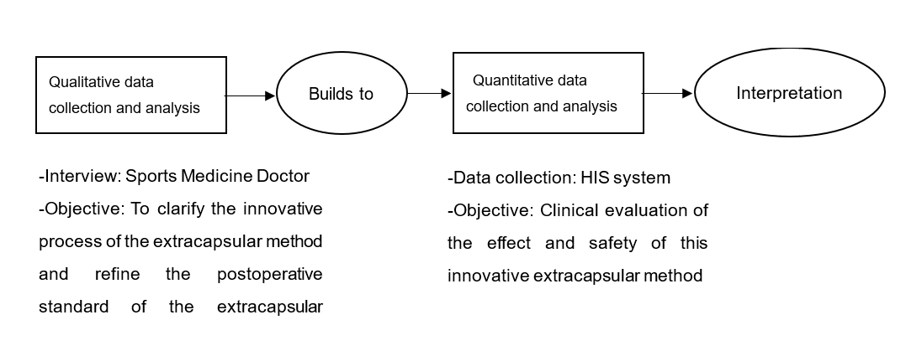
Figure S1. Research on Mixed-Methods through Exploratory Sequence Design
Table S1. Characteristics of participants in the focus group discussion
No. | Gender | Age | Years of surgery | Cumulative operation
1 | Male | 53 | 30 | 12,000
2 | Male | 49 | 26 | 7,800
3 | Female | 42 | 18 | 7,200
4 | Male | 41 | 18 | 7,200
5 | Male | 40 | 17 | 5,100
6 | Male | 40 | 17 | 5,100
7 | Male | 37 | 10 | 3,000

Table S2. The development of refractory tennis elbow treatment
Project | The first stage | The second stage | The third stage
Development content | Tennis elbow incision | Arthroscopic intra-articular treatment of tennis elbow | Arthroscopic Extracapsular Treatment of Tennis Elbow
Reports of International Papers | In 1926, Hohmann invented an international operation to release the tendon of extensor carpi radialis brevis. | In 1995, Grifka reported arthroscopic treatment of tennis elbow | In 2005, Rubenthaler reported on their previous exploration in this area in 2005. The artificial subcutaneous space was created to complete tendon treatment outside the joint capsule
Technology Application of the institute | In 1973, the institute carried out the first open surgery of tennis elbow. | Arthroscopic treatment of tennis elbow began in 2002. | In 2005, extra-articular arthroscopy (referred to herein as "extra-capsular method") was started to treat refractory tennis elbow.

Table S3. Disadvantages of Intracapsular Method and Corresponding Improvement of Extracapsular Method
 | Items | Intracapsular method | Extracapsular method
Safety | Nerve injury | The probability of vascular and nerve bundle injury through the approach is relatively high. | There is almost no possibility of damaging vascular nerve bundles.
 | Damage to articular capsule | The tendon injury cannot be directly seen (28%-37.5% have joint capsule tear, which is relatively convenient for observation; others need to open or even remove the joint capsule first) | Most of them do not need to open or remove the joint capsule.
 | Tendon suture | Rupture of tendon and joint capsule is difficult to suture and joint fluid extravasation is easy to occur. | Convenient suture to reduce extravasation of joint fluid
Convenience | Patient posture | The lateral position is generally required, the positioning of the body position is relatively complicated and takes a long time. The patient’s comfort is not good. | Supine position is sufficient, saving time and labour, and the comfort of patients is better.
 | Doctor’s perspective | From the observation inside the joint capsule, it is not easy to distinguish the anatomical structure of several tendons of the extensor total tendon, therefore, it is more suitable for tendon release operation, and tendon cleaning operation is not easy. | Observing from the surface of extensor tendon, it is easier to see the anatomical structure clearly, so it is more suitable for cleaning the tendon injury focus.
 |  | External epicondylar drilling (microfracture) and decortication (due to the limitation of the conventional anterior medial observation approach, the tendon insertion bone bed is observed from the medial side of the joint, not directly) | Observation from tendon surface to joint direction is direct vision.
 | Learning curve | High technical threshold and long learning curve | The technical threshold is relatively lower and the learning curve is relatively shorter.

Table S4. Basic Demographics of Patients
Items | N | Value
Age（m±sd） | 43 | 44.4±5.2
Gender
Male | 14 | 32.6%
Female | 29 | 67.4%
Preoperative diagnosis
Left tennis elbow | 12 | 27.9%
Right tennis elbow | 31 | 72.1%

Table S5. Prognostic Evaluation of Arthroscopic Extracapsular Therapy for Refractory Tennis Elbow
Items | N | mean | Standard deviation | Minimum value | Maximum value | Median
Preoperative MAYO score | 43 | 54.44 | 21.37 | 0 | 95 | 58
Preoperative DASH score | 43 | 54.74 | 23.30 | 11.67 | 100 | 56.67
Preoperative VAS score | 43 | 6.91 | 1.78 | 2 | 10 | 7
Time for complete pain elimination (months) | 39 | 4.70 | 5.27 | 0 | 24.00 | 3.00
Time to resume daily activities (weeks) | 42 | 7.68 | 6.74 | 1.0 | 32.0 | 6.00
MAYO score 3 months after surgery | 40 | 83.00 | 14.52 | 26.0 | 100.0 | 85.00
DASH score 3 months after operation | 40 | 24.05 | 19.53 | 1.67 | 88.33 | 21.25
VAS score 3 months after operation | 40 | 2.80 | 1.81 | 0.0 | 8.0 | 3.00
MAYO score 12 months after surgery | 39 | 96.41 | 6.17 | 85.0 | 100.0 | 100.00
DASH score 12 months after operation | 39 | 7.53 | 8.23 | 0.0 | 30.83 | 3.33
VAS score 12 months after operation | 39 | 1.00 | 1.30 | 0.0 | 4.0 | 0
Occurrence of complications | 39 | 0 | 0 | 0 | 0 | 0

Footnote: MAYO: Mayo Elbow Performance Score; DASH: Disability of Arm, Shoulder and Hand Score; VAS: Visual Analog Scale.

