Supplementary Table 1: Demographic and laboratory data of all patients, with comparisons between groups of different severity of uremic pruritus.
Parameters | All patients  - (n = 195) | Pruritus severity |  | P-value
 |  | No or mild  VAS < 4 (n = 125) | Moderate to severe  VAS ≥ 4 (n = 70)
Male (%) | 57.90 | 53.60 | 65.70 | 0.10
Age (years) | 55.04 ± 14.17 | 55.34 ± 14.82 | 54.51 ± 13.00 | 0.70
HD duration (months) | 57.97(17.90, 132.30) | 53.55 (17.18, 134.26) | 61.3 (17.9, 126.40) | 0.48
Use of high-flux dialyzer (%) | 22.10 | 21.60 | 22.90 | 0.41
Diabetes (%) | 20.50 | 21.60 | 18.60 | 0.62
Hepatitis B (%) | 9.70 | 8.00 | 12.90 | 0.27
Hepatitis C (%) | 8.70 | 5.60 | 14.30* | 0.04
Platelet counts (10⁹/L) | 193.27 ± 60.65 | 203.30 ± 60.87 | 175.37 ± 56.37† | <0.01
MPV (fL) | 10.12 ± 0.96 | 10.08 ± 0.94 | 10.20 ± 0.98 | 0.39
PDW (fL) | 11.84 ± 2.40 | 11.45 ± 1.95 | 12.00 ± 2.60 | 0.20
Platelet-large cell rate (%) | 25.91 ± 7.43 | 25.50 ± 7.40 | 26.65 ± 7.47 | 0.32
PCT (%) | 0.20 ± 0.06 | 0.21 ± 0.06 | 0.18 ± 0.06* | 0.01
Hs-CRP (mg/L) | 2.66 (0.99, 6.05) | 2.32 (0.89, 5.34) | 3.08 (1.33, 7.46) | 0.15
WBC (10⁹/L) | 6.57 ± 1.84 | 6.60 ± 1.85 | 6.52 ± 1.83 | 0.80
Hemoglobin (g/L) | 111.38 ± 19.91 | 112.04 ± 19.80 | 110.21 ± 20.20 | 0.54
Serum calcium (mmol/L) | 2.40 (2.20, 2.50) | 2.30 (2.20, 2.50) | 2.40 (2.20, 2.50) | 0.09
Serum phosphorus (mmol/L) | 1.94 ± 0.58 | 1.88 ± 0.51 | 2.05 ± 0.68* | 0.05
iPTH (pg/mL) | 319.50  (155.30, 547.00) | 283.50  (143.15, 502.75) | 371.65  (158.15, 958.65) | 0.05
Serum albumin (g/L) | 37.80 ± 3.30 | 37.80 ± 3.53 | 37.81 ± 2.87 | 0.98
Total cholesterol (mmol/L) | 4.27 ± 1.05 | 4.39 ± 1.13 | 4.07 ± 0.85 | 0.10
Total triglyceride (mmol/L) | 1.32 (0.93, 2.07) | 1.29 (0.90, 2.08) | 1.38 (0.95, 2.05) | 0.73
Serum uric acid (umol/L) | 496.48 ± 95.29 | 486.74 ± 98.28 | 513.89 ± 87.73 | 0.06
Serum creatinine (umol/L) | 1051.65 ± 258.23 | 1031.44 ± 261.91 | 1087.73 ± 249.30 | 0.15
Serum ferritin (μg/L) | 257.50  (97.98, 470.10) | 246.10  (96.50, 416.13) | 279.40  (108.28, 558.55) | 0.11
β2-microglobulin (mg/L) | 37.91 ± 10.70 | 37.43 ± 11.48 | 38.76 ± 9.20 | 0.16
Kt/V | 1.29 (1.14, 1.41) | 1.31 (1.16, 1.42) | 1.28 (1.13, 1.38) | 0.28
Data were expressed as percentages, means ± standard deviations, or medians with interquartile ranges.*P < 0.05.†P < 0.01.HD: Hemodialysis; Hs-CRP: high-sensitivity C-reactive protein; iPTH: Intact parathyroid hormone; MPV: Mean platelet volume; PCT: Plateletcrit; PDW: Platelet distribution width; VAS: Visual analogue scale; WBC: White blood cell.
Supplementary Table 2: Characteristics of patients according to tertiles of platelet counts.
Variables | Platelet count tertiles |  |  | P-value
 | Tertile 1 (n = 64) | Tertile 2 (n = 65) | Tertile 3 (n = 66)
Male (%) | 37.20 | 32.70 | 30.10 | 0.26
Age (years) | 54.11 ± 13.28 | 56.15 ± 14.62 | 54.85 ± 14.67 | 0.78
HD duration (months) | 69.25  (17.06, 141.74) | 55.13  (18.55, 126.99) | 57.40  (16.77, 124.37) | 0.85
Use of high-flux dialyzer (%) | 25.00 | 24.60 | 16.70 | 0.65
Moderate to severe pruritus (%) | 50.00† | 30.80 | 27.30 | 0.02
Diabetes (%) | 10.90* | 23.10 | 27.30 | 0.06
Hepatitis B (%) | 12.50 | 9.20 | 7.60 | 0.63
Hepatitis C (%) | 14.10 | 7.70 | 4.50 | 0.15
Platelets (10⁹/L) | 130.88 ± 26.43† | 187.31 ± 14.25† | 259.65 ± 41.95 | <0.01
Hs-CRP(mg/L) | 1.85 (0.83, 3.56)† | 2.37 (1.19, 4.14)* | 4.53 (1.05, 14.71) | <0.01
WBC (10⁹/L) | 5.64 ± 1.32† | 6.56 ± 1.59* | 7.47 ± 2.06 | <0.01
Hemoglobin (g/L) | 113.70 ± 17.01 | 111.83 ± 19.44 | 108.70 ± 22.77 | 0.62
Serum calcium (mmol/L) | 2.40 (2.20, 2.50) | 2.30 (2.20, 2.50) | 2.40 (2.20, 2.50) | 0.37
Serum phosphorus (mmol/L) | 1.89 ± 0.53 | 1.92 ± 0.62 | 2.01 ± 0.60 | 0.59
iPTH (pg/mL) | 315.05  (130.48, 571.15) | 322.50  (160.95, 610.10) | 286.75  (167.80, 510.50) | 0.98
Serum albumin (g/L) | 37.90 ± 2.57 | 38.64 ± 2.93† | 36.89 ± 4.01 | 0.02
Total cholesterol (mmol/L) | 4.11 ± 0.98 | 4.15 ± 0.80 | 4.57 ± 1.27 | 0.13
Total triglyceride (mmol/L) | 1.19 (0.85, 1.71) | 1.38 (0.97, 2.15) | 1.31 (1.05, 2.12) | 0.14
Serum uric acid (umol/L) | 520.50 ± 87.07 | 478.06 ± 84.46 | 491.33 ± 108.61 | 0.03
Serum creatinine (umol/L) | 1078.83 ± 248.45 | 1055.98 ± 279.02 | 1021.02 ± 246.65 | 0.35
Serum ferritin (μg/L) | 331.20  (136.35, 540.05) | 225.00  (80.1, 461.85) | 255.60  (89.50, 463.65) | 0.16
β2-microglobulin (mg/L) | 38.40 ± 9.76 | 37.95 ± 10.43 | 36.44 ± 12.44 | 0.84
Kt/V | 1.28 (1.14, 1.38) | 1.30 (1.15, 1.42) | 1.29 (1.12, 1.39) | 0.70

Data were expressed as percentages, means ± standard deviations, or medians with interquartile ranges.*Compared with the tertile 3 of platelet count, P < 0.05.†Compared with the tertile 3 of platelet count, P < 0.01.HD: Hemodialysis; Hs-CRP: High-sensitivity C-reactive protein; iPTH: Intact parathyroid hormone; WBC: White blood cell.
Supplementary Table 3: Characteristics of patients according to tertiles of PCT.
Variables | PCT tertiles |  |  | P-value
 | Tertile 1 (n = 63) | Tertile 2 (n = 53) | Tertile 3 (n = 75)
Male (%) | 71.40* | 50.90 | 52.00 | 0.03
Age (years) | 54.40 ± 12.97 | 55.64 ± 14.28 | 55.28 ± 15.20 | 0.86
HD duration (months) | 65.78  (17.59, 135.38) | 59.02  (26.94, 130.37) | 56.4  (16.77, 117.33) | 0.85
Use of high-flux dialyzer (%) | 28.60 | 22.60 | 17.30 | 0.29
Moderate to severe pruritus (%) | 49.20* | 28.30 | 28.00 | 0.02
Diabetes (%) | 15.90 | 17.00 | 28.00 | 0.15
Hepatitis B (%) | 12.70 | 5.70 | 8.00 | 0.39
Hepatitis C (%) | 15.90* | 1.90 | 5.30 | 0.01
PCT (%) | 0.14 ± 0.02† | 0.18 ± 0.01† | 0.25 ± 0.05 | <0.01
Hs-CRP(mg/L) | 1.78 (0.96, 3.87)† | 1.89 (0.91, 3.87)† | 4.61 (1.80, 11.05) | 0.001
WBC (10⁹/L) | 5.46 ± 1.16† | 6.50 ± 1.61† | 7.53 ± 1.95 | <0.01
Hemoglobin (g/L) | 112.40 ± 17.75 | 112.45 ± 20.70 | 109.99 ± 21.41 | 0.77
Serum calcium (mmol/L) | 2.40 (2.20, 2.50) | 2.30 (2.20, 2.50) | 2.40 (2.20, 2.50) | 0.40
Serum phosphorus (mmol/L) | 1.89 ± 0.58 | 1.95 ± 0.58 | 1.98 ± 0.60 | 0.57
iPTH (pg/mL) | 289.20  (127.10, 511.30) | 319.50  (151.55, 561.85) | 322.10  (176.70, 579.20) | 0.75
Serum albumin (g/L) | 38.20 ± 2.63 | 38.10 ± 3.39 | 37.20 ± 3.72 | 0.17
Total cholesterol (mmol/L) | 4.09 ± 0.93 | 4.33 ± 0.84 | 4.45 ± 1.23 | 0.27
Total triglyceride (mmol/L) | 1.17 (0.79, 1.71) | 1.33 (0.96, 2.04) | 1.37 (1.12, 2.16) | 0.06
Serum uric acid (μmol/L) | 518.60 ± 93.48 | 475.02 ± 79.33 | 491.33 ± 104.39 | 0.03
Serum creatinine (μmol/L) | 1081.65 ± 273.94 | 1064.43 ± 235.07 | 1028.39 ± 254.62 | 0.43
Serum ferritin (μg/L) | 284.10  (133.90, 523.80) | 261.30  (80.10, 540.75) | 248.95  (80.10, 429.75) | 0.37
β2-microglobulin (mg/L) | 39.50 ± 10.31 | 37.10 ± 8.98 | 37.17 ± 12.17 | 0.58
Kt/V | 1.28 (1.14, 1.38) | 1.31 (1.15, 1.43) | 1.29 (1.14, 1.40) | 0.81
Data were expressed as percentages, means ± standard deviations, or medians with interquartile ranges.*Compared with the tertile 3 of PCT, P < 0.05.†Compared with the tertile 3 of PCT, P < 0.01.HD: Hemodialysis; Hs-CRP: High-sensitivity C-reactive protein; iPTH: Intact parathyroid hormone; PCT: Plateletcrit; WBC: White blood cell.
Supplementary Table 4: Relationship of platelet morphology indices with clinical, biochemical parameters (Spearman rank correlation analysis).
Variables | PC | PCT | MPV | PDW | P-LCR
PC | 1 | 0.93† | −0.30† | −0.29† | −0.33†
PCT | 0.93† | 1 | NS | −0.15* | NS
MPV | −0.30† | NS | 1 | 0.61† | 0.98†
PDW | −0.29† | −0.15* | 0.61† | 1 | 0.81†
P-LCR | −0.33† | NS | 0.98† | 0.81† | 1
VAS score | −0.28† | −0.25† | NS | 0.16* | NS
Diabetes | 0.16* | 0.15* | NS | NS | NS
Hepatitis C | −0.16* | −0.17* | NS | NS | NS
Moderate to severe pruritus | −0.22† | −0.21† | NS | NS | NS
Hs-CRP | 0.26† | 0.26† | NS | NS | NS
WBC | 0.47† | 0.49† | NS | NS | NS
BUN | −0.18* | −0.17* | NS | NS | NS
Total cholesterol | 0.18* | NS | NS | NS | NS
Triglyceride | NS | 0.16* | NS | NS | NS
*Correlation is significant at the 0.05 level (two-tailed).†Correlation is significant at the 0.01 level (two-tailed).BUN: Blood urea nitrogen; Hs-CRP: High-sensitivity C-reactive protein; MPV: Mean platelet volume; NS: Not significant; PC: Platelet count; PCT: Plateletcrit; PDW: Platelet distribution width; P-LCR: Platelet-large cell ratio; VAS: Visual analog scale; WBC: White blood cell.

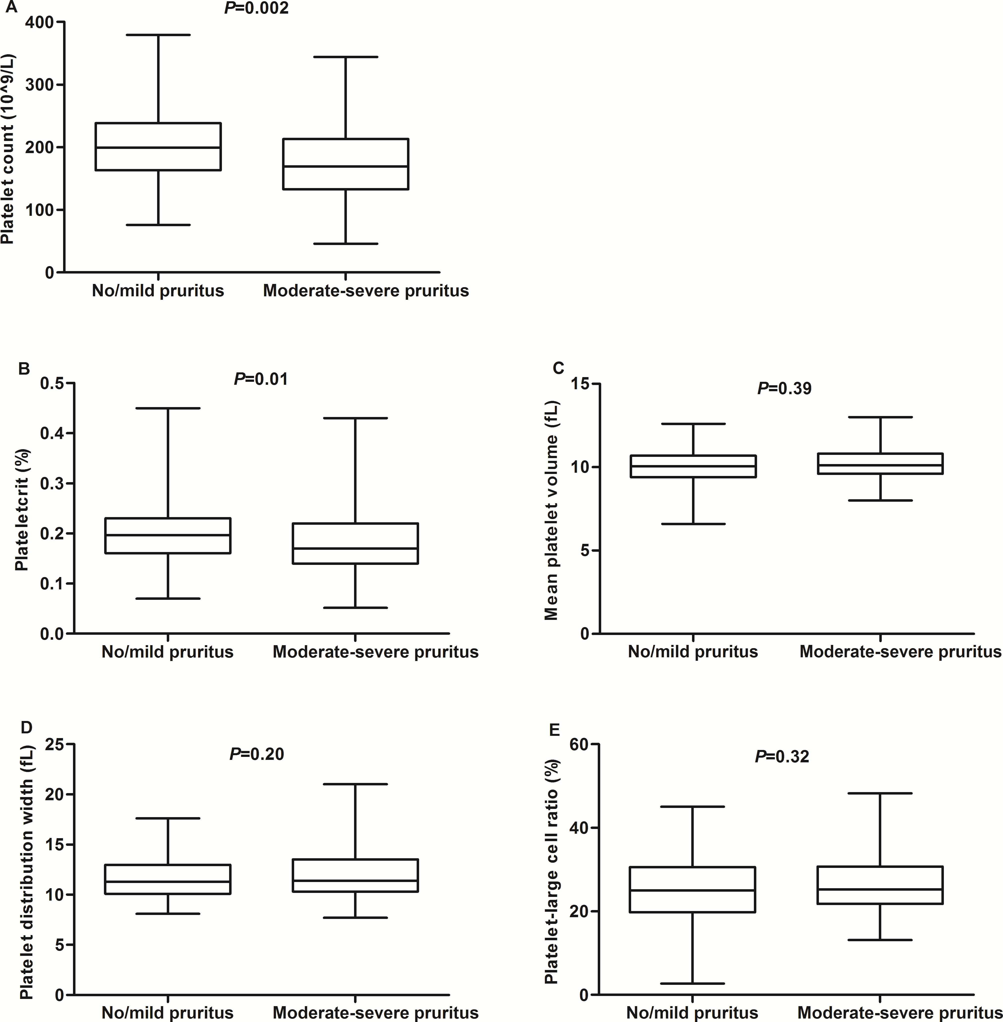
Supplementary Figure 1: Differences of platelet indices according to the severity of uremic pruritus. (A) Platelet count. (B) PCT. (C) MPV. (D) PDW.(E) P-LCR.
PCT: Plateletcrit; MPV: Mean platelet volume; PDW:Platelet distribution width. P-LCR: Platelet-large cell ratio.

