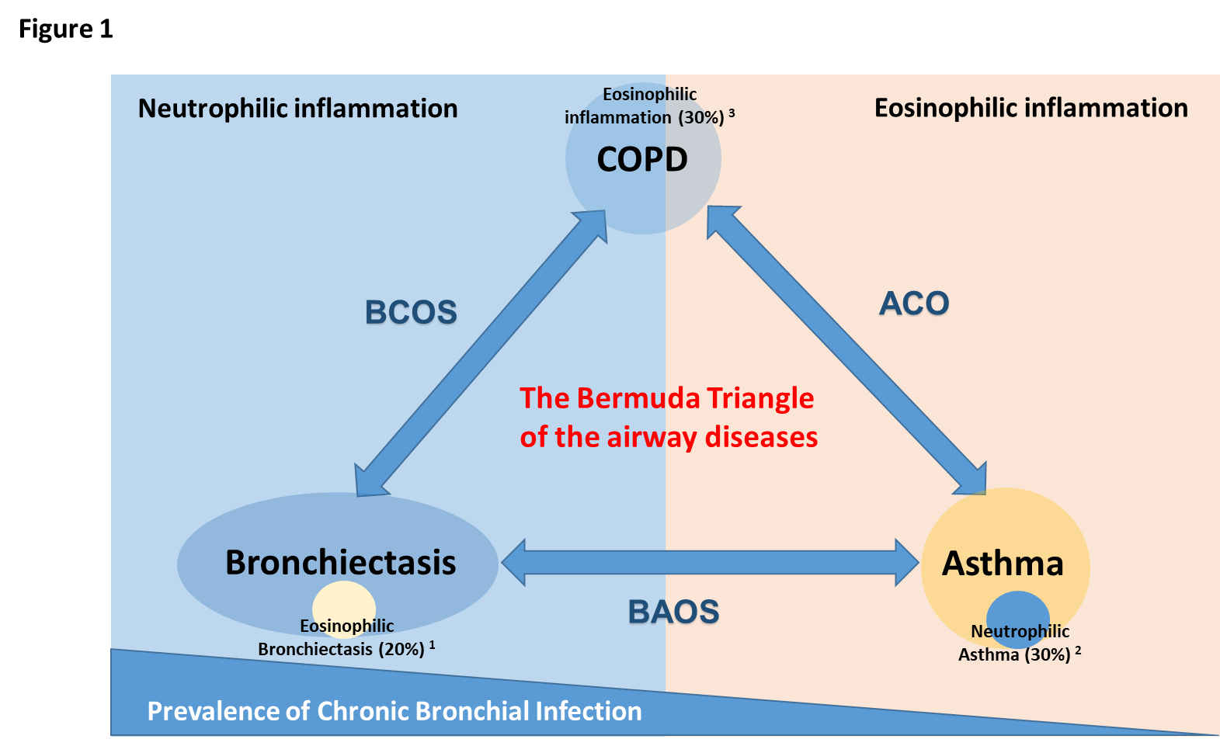

Supplementary Figure 1: The Bermuda Triangle of airway diseases. Although COPD and bronchiectasis usually have a neutrophilic bronchial inflammation profile, and asthma has an eosinophilic profile, a number of patients have other typus of inflammation (30% of asthmatic patients have a neutrophilic asthma and 20% and 30% of bronchiectasis and COPD patients have an eosinophilic inflammation, respectively).

References
1. Shoemark A, Shteinberg M, De Soyza A, Haworth C, Richardson H, Gao Y, et al. Characterisation of Eosinophilic Bronchiectasis: A European Multicohort Study. Am J Respir Crit Care Med 2022. doi: 10.1164/rccm.202108-1889OC.
2. Simpson JL, Scott R, Boyle MJ, Gibson PG. Inflammatory subtypes in asthma: assessment and identification using induced sputum. Respirology 2006;11:54-61. doi: 10.1111/j.1440-1843.2006.00784.x.
3. Hosseini M, Almasi-Hashiani A, Sepidarkish M, Maroufizadeh S. Global prevalence of asthma-COPD overlap (ACO) in the general population: a systematic review and meta-analysis. Respir Res 2019;20:229. doi: 10.1186/s12931-019-1198-4.

