Supplementary Table 1: Demographic and clinical features.
Variables | N = 134
Gender (F/M) | 122/12
Age at diagnosis, median (IQR) (years) | 50.0 (43.0, 55.0)
ANA, n (%) | 133/134 (99.2)
AMA, n (%) | 77/134 (57.5)
Anti-SMA*, n (%) | 1/32 (3.1)
Anti-LKM, n (%) | 1/134 (0.7)
Anti-SLA, n (%) | 7/134 (5.2)
Anti-LC-1, n (%) | 2/134 (1.5)
gp210†, n (%) | 8/28 (28.6)
sp100, n (%) | 4/28 (14.3)
Cirrhosis, n (%) | 72/134 (53.7)
*Anti-SMA was measured in 32 patients. †gp210 and sp100 were measured in 28 patients. AIH: Autoimmune hepatitis; AMA: Anti-mitochondrial antibody; IQR: Interquartile range; IS: Immunosuppressors; PBC: Primary biliary cholangitis/cirrhosis; UDCA: Ursodeoxycholic acid.
Supplementary Table 2: Comparison of baseline clinical features of PBC-AIH OS patients treated with UDCA plus immunosuppressant therapy by the response.
Variables | Responder (n = 69) | Non-responder (n = 65) | P-value
Jaundice | 18/69 (26.1) | 28/65 (43.1) | 0.038
Fatigue | 10/69 (14.5) | 9/65 (13.8) | 0.915
Bloating | 7/69 (10.1) | 10/65 (15.4) | 0.362
Pruritus | 5/69 (7.2) | 10/65 (15.4) | 0.135
Swelling of the legs | 4/69 (5.8) | 2/65 (3.1) | 0.732
Anorexia | 4/69 (5.8) | 3/65 (4.6) | 0.999
Data were presented as n (%). AIH: Autoimmune hepatitis; OS: Overlap syndrome; PBC: Primary biliary cholangitis; UDCA: Ursodeoxycholic acid.
Supplementary Table 3: Comparison of baseline clinical features of PBC-AIH OS patients treated with UDCA plus immunosuppressant therapy by the response.
Variables | Responder (n = 69) | Non-responder (n = 65) | P-value
Age at accession, median (IQR) (years) | 52.0 (41.5, 57.0) | 49.0 (43.0, 53.0) | 0.230
Gender (F/M) | 65/4 | 57/8 | 0.187
Presence of other autoimmune diseases (%) | 18/69 | 17/65 | 0.591
TBIL level, median (IQR) (μmol/L) | 29.4 (16.0, 50.2) | 44.0 (27.5, 67.2) | 0.003
ALT level, median (IQR) (IU/L) | 145.0 (89.5, 228.0) | 148.0 (103.0, 207.0) | 0.735
AST level, median (IQR) (IU/L) | 140.0 (89.0, 244.5) | 149.0 (116.0, 187.0) | 0.826
ALP level, median (IQR) (IU/L) | 273.0 (169.0, 434.0) | 397.0 (287.0, 621.5) | <0.001
GGT level, median (IQR) (IU/L) | 279.0 (152.0, 427.5) | 454.0 (217.0, 763.0) | 0.001
Albumin level, median (IQR) (g/L) | 39.5 (35.3, 43.7) | 38.8 (32.5, 42.6) | 0.228
Globulin level, median (IQR) (g/L) | 40.1 (34.1, 47.6) | 38.8 (33.4, 46.3) | 0.356
IgG level, median (IQR) (g/L) | 21.9 (17.0, 27.3) | 20.6 (16.0, 26.1) | 0.457
IgM level, median (IQR) (g/L) | 2.9 (1.8, 4.8) | 3.8 (2.1, 5.9) | 0.157
TG (mmol/L) | 1.3 (1.0, 1.8) | 1.4 (1.1, 1.9) | 0.262
CHOL (mmol/L) | 4.9 (4.0, 6.2) | 6.9 (5.4, 9.9) | <0.001
AMA positive (N, %) | 32/69 | 45/65 | 0.007
Cirrhosis (N, %) | 29/69 | 43/65 | 0.001
AIH: Autoimmune hepatitis; ALP: Alkaline phosphatase; ALT: Alanine aminotransferase; AMA: Anti-mitochondrial antibody; AST: Aspartate aminotransferase; CHOL: Cholesterol; GGT: g-glutamyltranspeptidase; IgG: Immunoglobulin G; IgM: Immunoglobulin M; IQR: Interquartile range; OS: Overlap syndrome; PBC: Primary biliary cholangitis; TBIL: Total bilirubin; TG: Triglyceride; UDCA: Ursodeoxycholic acid.
Supplementary Table 4: Histological features of PBC-AIH OS patients.
Variables | Responder (n = 69) | Non-responder (n = 65) | P-value
Moderate or severe interface hepatitis, n (%) | 44 (63.8) | 44 (67.7) | 0.633
Lymphoplasmacytic infiltrate, positivity, n (%) | 68 (100.0)* | 64 (100.0)† | –
Rosettes, n (%) | 50 (73.5)* | 42 (65.6)† | 0.588
Ductopenia, positivity, n (%) | 29 (42.6)* | 47 (73.4)† | <0.001
Bile duct proliferation, positivity, n (%) | 49 (72.1)* | 43 (67.2)† | 0.543
Bile duct injury, positivity, n (%) | 33 (48.5)* | 31 (48.4)† | 0.992
G 0/1/2/3/4 | 0/5/37/27/0 | 0/6/31/25/3 | 0.377
S 0/1/2/3/4 | 1/17/23/21/7 | 0/8/20/26/11 | 0.196
*Only 68 patients were evaluated in the responder group. †Only 64 patients were evaluated in the non-responder group. AIH: Autoimmune hepatitis; OS: Overlap syndrome; PBC: Primary biliary cholangitis.
Supplementary Table 5: Risk factors for poor response to corticosteroids in PBC-AIH OS patients.
Variables | P-value | Odds ratio | 95% CI
High ALP levels (IU/L) | 0.764 | 1.000 | 0.998–1.002
High GGT levels (IU/L) | 0.059 | 1.002 | 1.000–1.004
Positive for AMA | 0.149 | 1.915 | 0.792–4.626
High TBIL levels (μmol/L) | 0.346 | 1.004 | 0.995–1.014
High CHOL levels (mmol/L) | 0.001 | 1.431 | 1.149–1.82
Ductopenia | 0.006 | 3.466 | 1.420–8.458
Presence of cirrhosis | 0.003 | 4.546 | 1.679–12.308
AIH: Autoimmune hepatitis; ALP: Alkaline phosphatase; AMA: Anti-mitochondrial antibody; CHOL: Cholesterol; GGT: g-glutamyltranspeptidase; OS: Overlap syndrome; PBC: Primary biliary cholangitis; TBIL: Total bilirubin.
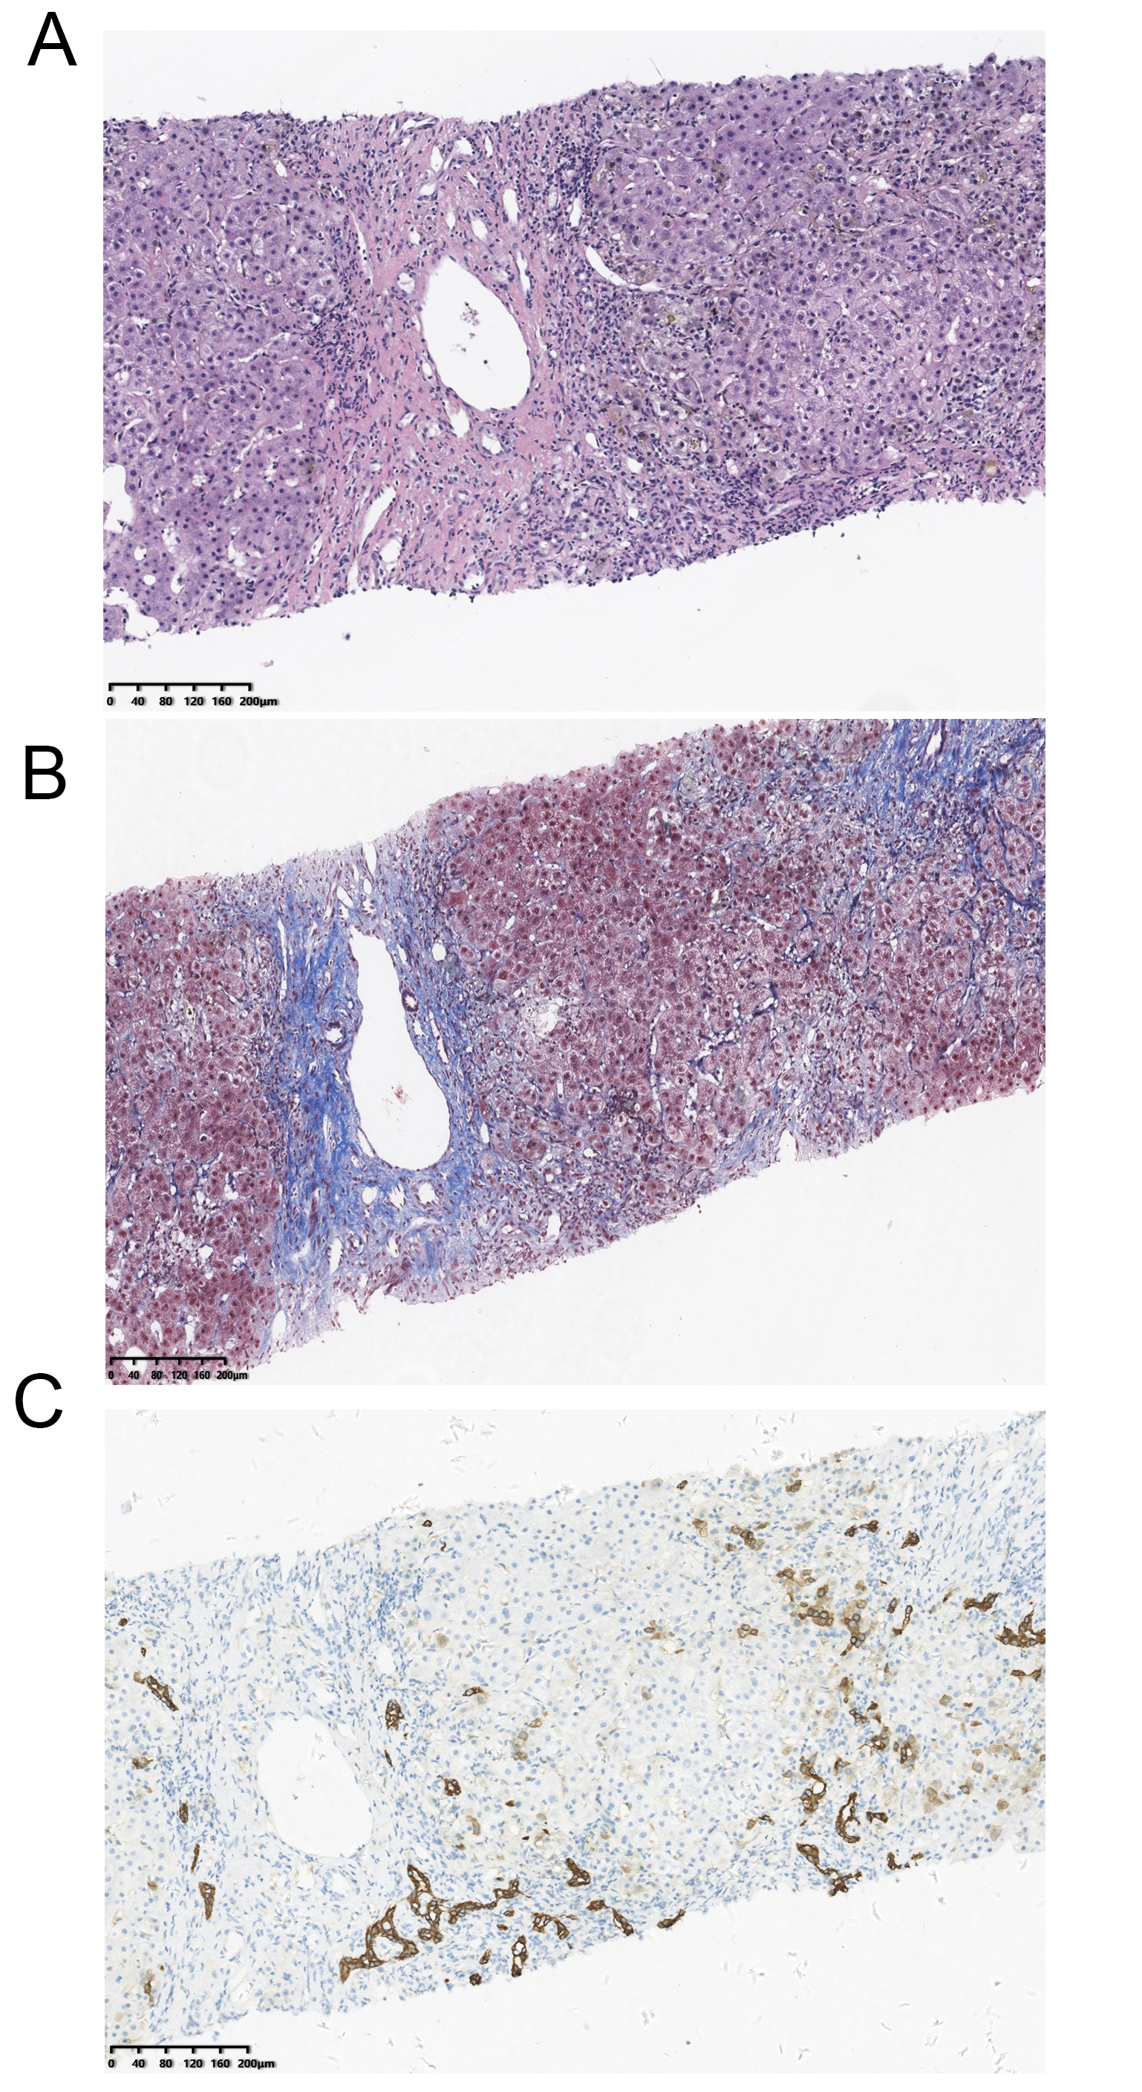
Supplementary Figure 1: A histological features of a PBC-AIH OS patient. (A) Prominent interface hepatitis with numerous plasma cells and typical rosetting of hepatocytes; (B) Masson staining showed hyperplasia of fibrous tissue and enlargement of the portal area; (C) interlobular bile duct loss with a ductular reaction (CK7 staining). AIH: Autoimmune hepatitis; OS: Overlap syndrome; PBC: Primary biliary cholangitis.
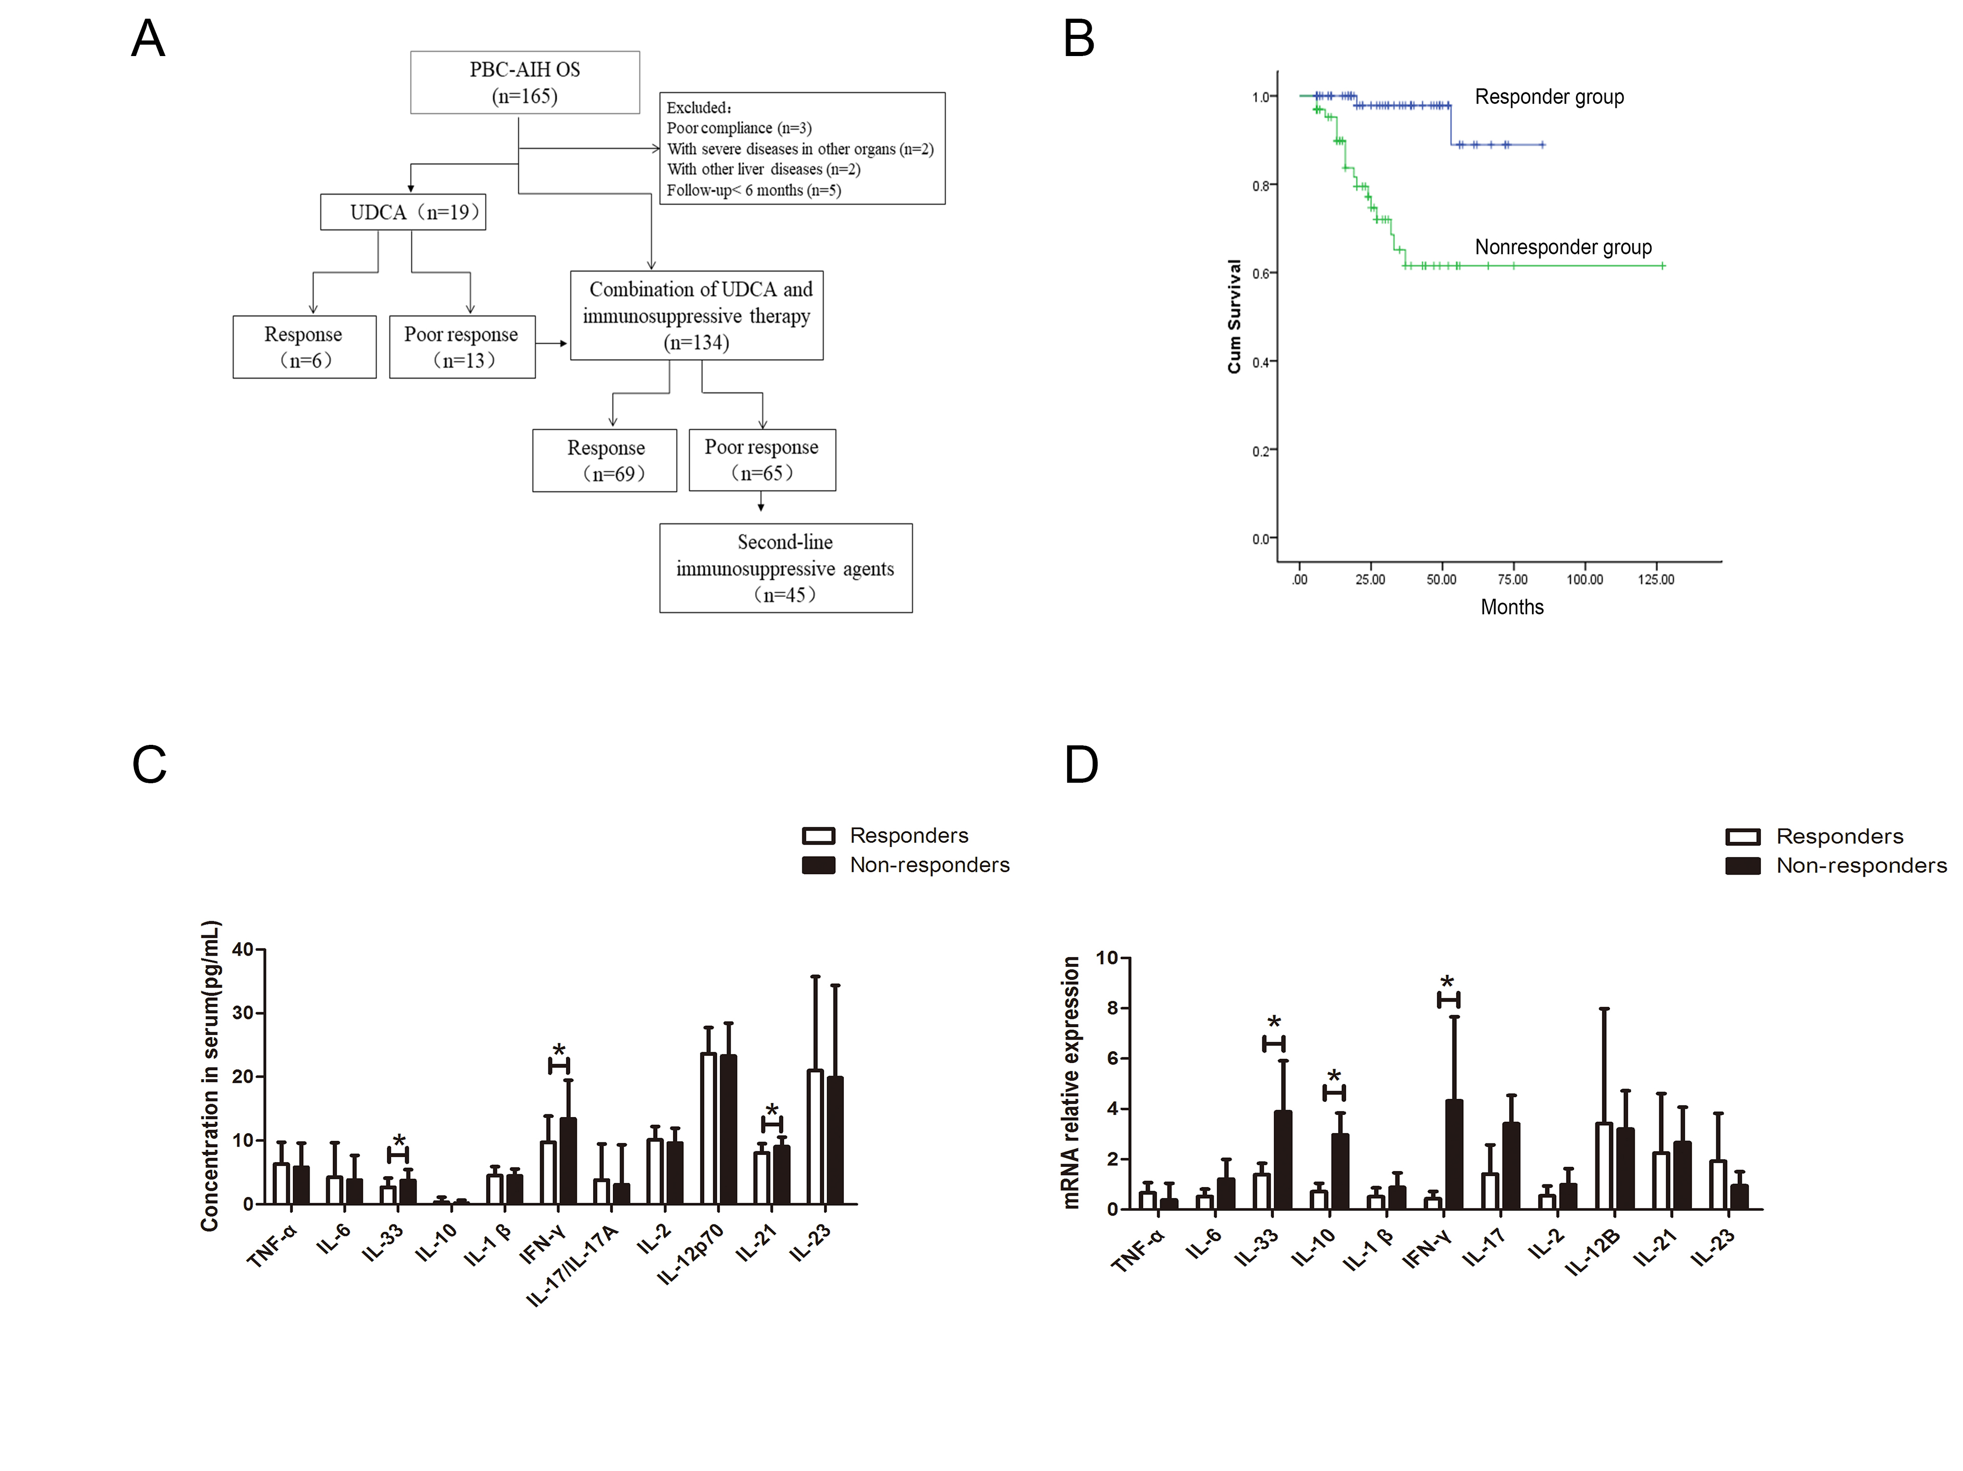
Supplementary Figure 2: (A) The flowchart of the case inclusion; (B) Kaplan–Meier analysis was analyzed between the responders and non-responders; (C) 11 cytokines were detected in serum from 27 responders and 35 non-responders in the two groups by Luminex assays, respectively; (D) RT-qPCR was conducted to determine the mRNA levels of those cytokines in liver tissues. *P < 0.05. RT-qPCR: Real-time qPCR.

