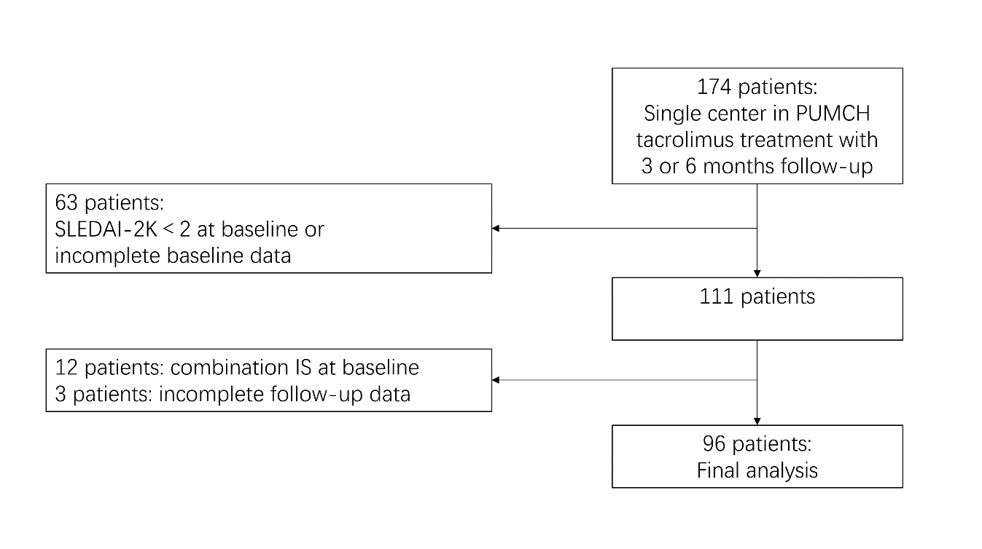

Supplementary Figure 1: Screening flowchart of patients included in the final analysis. IS: Immunosuppressive; PUMCH: Peking Union Medical College Hospital; SLE: Systemic lupus erythematosus; SLEDAI-2K: Systemic Lupus Erythematosus Disease Activity Index 2000.

Supplementary Figure 2: Efficacy of tacrolimus in active SLE patients. (A) SLEDAI-2K score change (5.7 ± 3.5, 3.2 ± 3.1, and 2.8 ± 2.4 at baseline and at months 3 and 6); (B) PGA score change (0.76 ± 0.49, 0.50 ± 0.41, and 0.43 ± 0.35 at baseline and at months 3 and 6); (C) daily dose change of prednisone required for controlling disease (21.8 ± 18.2 mg/day, 13.9 ± 8.4 mg/day, 10.2 ± 5.5 mg/day at baseline and at months 3 and 6); (D) patients achieved remission or LLDAS at baseline and 6 months (N = 0 [0%] and = 12 [22.2%] vs. N = 4 [7.4%] and = 18 [33.3%], respectively, P < 0.05); (E) change of serum C3 (0.757 ± 0.237 g/L, 0.849 ± 0.257 g/L, and 0.857 ± 0.255 g/L at baseline and at months 3 and 6); (F) change of serum C4 (0.130 ± 0.066 g/L, 0.151 ± 0.075 g/L, and 0.141 ± 0.059 g/L at baseline and at months 3 and 6); (G) change of anti-dsDNA antibody titer (359 ± 236 IU/mL, 270 ± 292 IU/mL, and 215 ± 219 IU/mL at baseline and at months 3 and 6); (H) change of 24-h urine protein (1.97 ± 1.55 g/24 h, 1.04 ± 0.98 g/24 h, and 0.64 ± 0.43 g/24 h at baseline and at months 3 and 6). SLE: Systemic lupus erythematosus; SLEDAI-2K: Systemic Lupus Erythematosus Disease Activity Index 2000; PGA: Physician Global Assessment; LLDAS: Lupus Low Disease Activity State; C3: Complement 3; C4: Complement 4; *P < 0.05; **P < 0.01; ***P < 0.001.

Supplementary Table 1: The studies of tacrolimus in SLE patients with various organ involvement.
Study | Study location | Study type | Number enrolled | Study duration (months) | Organ involvement, n/N (%) |  |  |  |  |  | SLEDAI |  | Steroid dosage (prednisone, mg/day) |  | Adverse events, n/N (%)
 |  |  |  |  | Skin | Arthritis | Haemalogical | thrombocytopenia | Serositis | Nephritis | Baseline | End of study | Baseline | End of study
Our study | Single center in China | Prospective real-world study | 96 | 6 | 6/96 (6.3) | 4/96 (4.2) | 30/96 (31.3) | 14/96 (14.6) | NA | 65/96 (72.1) | 5.7 ± 3.5 | 2.8 ± 2.4 | 21.8 ± 18.2 | 10.2 ± 5.5 | 9/96 (9.4)
Kusunoki et al^{[1]} | Single center in Japan | Retrospective pilot study | 10 | 12 | 4/10 (40) | 6/10 (60) | 3/10 (30) | 1/10 (10) | 0 | 0 | 6.8 ± 3.1 | 3.4 ± 0.9 | 16.8 ± 8.6 | 9.3 ± 4.6 | 4/10 (40)
Suzuki et al^{[2]} | Single center in Japan | Open-label prospective study | 21 | 6 | 5/21 (23.8) | 8/21 (38.1) | 2/21 (9.5) | 0 | 0 | 5/21 (23.8) | 4.2 ± 2.0 | 1.2 ± 1.6 | 13.4 ± 8.3 | 10.3 ± 6.7 | 5/21 (23.8)
Watanabe et al^{[3]} | Single center in Japan | Retrospective study | 14 in TAC group; 20 in GC group | 12 | 4/14 (28.6) | 6/14 (42.9) | 3/14 (21.4) | Not mentioned | 0 | 5/14 (35.7) | 7.5 ± 0.43 | 4.5 | 7.18 ± 0.63 | Not mentioned | 1/14 (7.1)
Tani et al^{[4]} | Three European centers in Italy, Spain and France | Retrospective study | 29 | 12 | 2/29 (6.9) | 4/29 (13.8) | 6/29 (20.7) | 1/29 (3.4) | 2/29 (6.9) | 24/29 (82.8) | 8 (5.5–12) | 3 (2–8) | 7.5 (3.75–12.5) | Not mentioned | 3/29 (10.3)
SLEDAI: Systemic Lupus Erythematosus Disease Activity Index.
References
1. Kusunoki Y, Tanaka N, Kaneko K, Yamamoto T, Endo H, Kawai S. Tacrolimus therapy for systemic lupus erythematosus without renal involvement: A preliminary retrospective study. Mod Rheumatol 2009;19:616–621. doi: 10.1007/s10165-009-0220-y.
2. Suzuki K, Kameda H, Amano K, Nagasawa H, Takei H, Nishi E, et al. Single center prospective study of tacrolimus efficacy and safety in the treatment of various manifestations in systemic lupus erythematosus. Rheumatol Int 2011;31:757–763. doi: 10.1007/s00296-010-1366-9.
3. Watanabe H, Yamanaka R, Sada KE, Zeggar S, Katsuyama E, Katsuyama T, et al. The efficacy of add-on tacrolimus for minor flare in patients with systemic lupus erythematosus: A retrospective study. Lupus 2016;25:54–60. doi: 10.1177/0961203315600538.
4. Tani C, Elefante E, Martin-Cascon M, Belhocine M, Lavilla Olleros C, Vagelli R, et al. Tacrolimus in non-Asian patients with SLE: A real-life experience from three European centres. Lupus Sci Med 2018;5:e000274. doi: 10.1136/lupus-2018-000274.

Supplementary Table 2: Baseline characteristics of the 96 SLE patients treated by tacrolimus.
Items | Mean ± SD or N (%)  N = 96
Age (years) | 33.0 ± 9.3
Female | 91 (94.8%)
Duration of SLE (years) | 6.8 ± 5.6
SLEDAI-2K | 5.7 ± 3.5
2–4 | 47 (48.9%)
5–9 | 35 (36.5%)
≥10 | 14 (14.6%)
PGA | 0.76 ± 0.49
Clinical manifestations
Mucocutaneous | 6 (6.3%)
Arthritis | 4 (4.2%)
LN | 65 (72.1%)
Hematologic disorder | 30 (31.3%)
Thrombocytopenia | 14 (14.6%)
Pulmonary hypertension | 28 (29.2%)
Immunologic indices
ANA | 96 (100%)
Anti-dsDNA | 56 (58.3%)
Anti-Sm | 37 (38.5%)
Anti-RNP | 48 (50.0%)
Anti-SSA | 57 (59.4%)
Anti-SSB | 14 (14.6%)
Anti-rRNP | 24 (25.0%)
Antiphospholipid antibody | 31 (32.3%)
Hypocomplementemia | 61 (63.5%)
Concomitant medications
Prednisone | 87 (90.6%)
Daily dose (mg) | 21.8 ± 18.2
Hydroxychloroquine | 81 (84.4%)
ACEI/ARB | 21 (21.9%)
Tacrolimus alone | 77 (80.2%)
No previous IS agents | 53 (55.2%)
Switch therapy | 24 (25.0%)
Mycophenolate mofetil | 8 (8.1%)
Cyclophosphamide | 6 (5.4%)
Azathioprine | 4 (4.5%)
Methotrexate | 2 (1.8%)
Sirolimus | 2 (1.8%)
Cyclosporin A | 2 (1.8%)
Add-on therapy | 19 (19.8%)
Cyclophosphamide | 7 (7.3%)
Mycophenolate mofetil | 5 (5.2%)
Azathioprine | 4 (4.2%)
Methotrexate | 1 (1.0%)
Leflunomide | 1 (1.0%)
Tofacitinib | 1 (1.0%)
ACEI: Angiotensin-converting enzyme inhibitor; ARB: Angiotensin receptor blocker; IS: Immunosuppressive; LN: Lupus nephritis; PGA: Physician Global Assessment; SLE: Systemic lupus erythematosus; SLEDAI-2K: Systemic Lupus Erythematosus Disease Activity Index 2000.

Supplementary Table 3: The RHC results of the patients with SLE-PAH.
ID | RHC | PASP (mmHg) | PADP (mmHg) | mPAP (mmHg) | PAWP (mmHg) | CO (L/min) | CI (L ⋅ min ⋅ m²) | PVR (WU)
001095 | Y | 53 | 23 | 33 | 9 | 4 | 2.51 | 6.5
004533 | Y | 34 | 13 | 20 | 8 | 5.7 | NA | 2.6
004636 | Y | 89 | 44 | 61 | NA | 3.9 | NA | 13.59
034856 | Y | 64 | 28 | 42 | 14 | 4.16 | 2.74 | 6.11
037753 | N
062459 | Y | 61 | 27 | 41 | 10 | 4.1 | 2.53 | 7.56
072331 | Y | 49 | 22 | 31 | 5 | 4.23 | 3.18 | 5.91
127845 | N
169552 | N
004878 | N
004989 | Y | 73 | 36 | 48 | 7 | 3.2 | NA | NA
010423 | Y | 70 | 32 | 47 | 11 | NA | 2.9 | 7.2
027602 | Y | 53 | 26 | 38 | 15 | 5.4 | 3.38 | 4.25
034551 | Y | 93 | 34 | 50 | 9 | 7.71 | 5.28 | 6.22
050574 | Y | 73 | 31 | 46 | 7 | 4 | 2.5 | 9.75
056879 | Y | 61 | 24 | 36 | 5 | 3.8 | 2.38 | 8.5
058937 | Y | 76 | 44 | 55 | 10 | 2.83 | 1.66 | 16.25
059550 | Y | 50 | 24 | 33 | 8 | 5.64 | 3.3 | 6.2
081942 | N
061001 | Y | 79 | 31 | 47 | 15 | 5.19 | 2.78 | 6.55
062672 | Y | 51 | 14 | 31 | 6 | 5 | 3.2 | 6.3
088623 | N
123175 | N
143139 | N
146357 | N
002018 | Y | 63 | 33 | 43 | 12 | 2.7 | 1.77 | 11.9
138052 | N
004539 | Y | 38 | 16 | 26 | 4 | 6.1 | NA | 3.6
SLE-PAH: Systemic lupus erythematosus-pulmonary arterial hypertension.

