Supplementary Table 1: Extent of the missing data.
Variables | n (all = 25) | %
Gender (male [%]) | 0 | 0.0
Age (years) | 0 | 0.0
BMI (kg/m²) | 18 | 72.0
HF duration >18 months | 0 | 0.0
Current smoking | 0 | 0.0
Diabetes mellitus | 0 | 0.0
COPD | 3 | 12.0
NYHA class | 4 | 16
β-blocker | 0 | 0.0
ACEI/ARB | 0 | 0.0
SBP (mmHg) | 0 | 0.0
Creatinine (µmol/L) | 2 | 8.0
LVEF (%) | 13 | 52.0
ACEI: Angiotensin-converting enzyme inhibitor; ARB: Angiotensin receptor blocker; BMI: Body mass index; COPD: Chronic obstructive pulmonary disease; HF: Heart failure; LVEF: Left ventricular ejection fraction; NYHA: New York Heart Association; SBP: Systolic blood pressure.
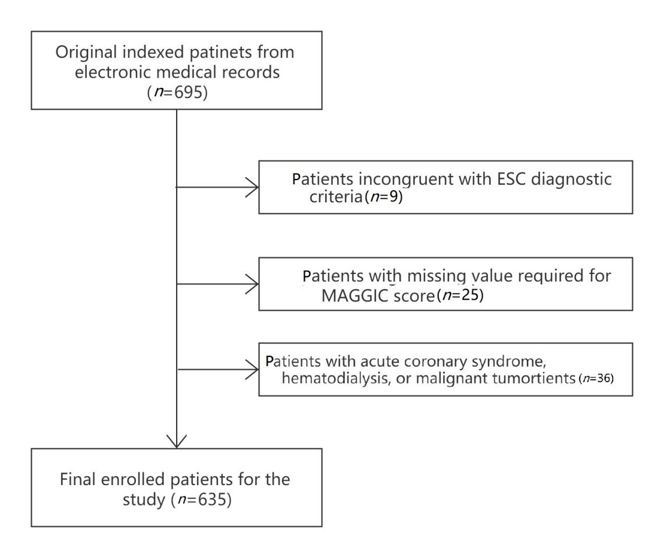
Supplementary Figure 1: Selection of the study population. ESC: European Society of Cardiology; MAGGIC: Meta-Analysis Global Group in Chronic Heart Failure.

Supplementary Figure 2: Comparison histograms of age, gender, LVEF, and one-year mortality in four studies. LVEF: Left ventricular ejection fraction.

