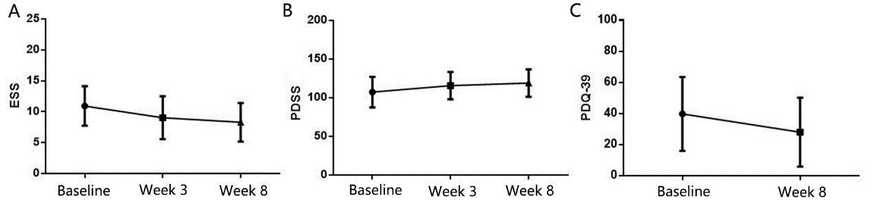
Supplementary Figure 1: Improvement of the ESS, PDSS, and PDQ-39 scores after treatment with selegiline in PD patients with EDS. EDS: Excessive daytime sleepiness; ESS: Epworth Sleepiness Scale; PD: Parkinson’s disease; PDQ-39: Parkinson’s Disease Quality of Life Questionnaire 39; PDSS: Parkinson’s Disease Sleep Scale.

Supplementary Table 1: Parkinson’s disease patients with motor fluctuation and dyskinesia at baseline and after 8 weeks of treatment, n (%).
Item | Baseline | Week 8 | P-value
Motor fluctuation |  |  | 0.022
Yes | 50 (41.3) | 42 (34.7)
No | 71 (58.7) | 79 (65.3)
Motor fluctuation improvement |  |  | 0.037
0 | 71 (58.7) | 79 (65.3)
1%–25% | 34 (28.1) | 30 (24.8)
26%–50% | 13 (10.7) | 9 (7.4)
51%–75% | 1 (0.8) | 1 (0.8)
76%–100% | 2 (1.7) | 2 (1.7)
Dyskinesia |  |  | 1.000
Yes | 8 (6.6) | 8 (6.6)
No | 113 (93.4) | 113 (93.4)
Dyskinesia improvement |  |  | 1.000
0 | 113 (93.4) | 113 (93.4)
1%–25% | 8 (6.6) | 8 (6.6)
26%–50% | 0 | 0
51%–75% | 0 | 0
76%–100% | 0 | 0

