Supplementary Materials
Supplementary Table 1: Absolute quantification of plasma AAs.
Metabolites (µmol/L) | NC (n = 57) | HCM (n = 109) | Z values | P values | HNCM (n = 52) | HOCM (n = 57) | Z values | P values
Glutamate | 79.49 (51.19, 106.50) | 86.06 (64.34, 117.37) | −1.546 | 0.122 | 87.33 (64.25, 117.46) | 83.54 (64.92, 115.73) | −0.206 | 0.837
Glycine | 450.19 (325.36, 654.68) | 413.62 (288.56, 574.23) | −2.104 | 0.035 | 470.93 (319.09, 601.28) | 389.39 (282.96, 478.21) | −1.935 | 0.053
Lysine | 165.09 (134.98, 182.75) | 160.02 (143.38, 187.49) | −0.269 | 0.788 | 159.72 (143.08, 187.61) | 161.07 (143.19, 188.43) | −0.400 | 0.689
Aspartate | 24.19 (6.28, 51.24) | 26.36 (8.16, 48.44) | −0.575 | 0.565 | 34.23 (8.06, 52.64) | 24.23 (7.97, 36.13) | −0.928 | 0.353
Arginine | 56.51 (46.20, 75.75) | 63.00 (50.78, 77.24) | −1.425 | 0.154 | 57.26 (39.92, 70.35) | 70.06 (56.04, 85.21) | −3.258 | 0.001
Serine | 116.29 (100.87, 137.15) | 104.59 (90.40, 120.84) | −2.797 | 0.005 | 105.56 (92.15, 119.99) | 103.54 (89.91, 121.30) | −0.382 | 0.702
Methionine | 24.40 (20.53, 28.82) | 25.62 (21.85, 28.85) | −0.837 | 0.403 | 25.20 (22.10, 28.79) | 25.86 (21.69, 29.28) | −0.067 | 0.947
Phenylalanine | 63.29 (57.54, 70.15) | 64.68 (56.96, 73.45) | −0.612 | 0.541 | 68.83 (60.55, 78.48) | 60.28 (53.70, 68.56) | −3.422 | 0.001
Tyrosine | 65.10 (56.16, 72.32) | 60.77 (53.81, 72.12) | −0.901 | 0.368 | 64.33 (57.07, 77.62) | 57.83 (52.36, 68.62) | −2.366 | 0.018
Leucine | 62.32 (46.62, 113.42) | 58.71 (49.85, 97.20) | −0.487 | 0.626 | 63.00 (49.70, 102.81) | 57.34 (50.09, 91.77) | −0.874 | 0.382
Isoleucine | 94.90 (57.78, 129.78) | 104.49 (63.03, 132.76) | −0.820 | 0.412 | 107.56 (64.57, 135.23) | 99.07 (59.64, 132.35) | −0.212 | 0.832
Histidine | 124.62 (76.41, 164.86) | 134.38 (80.71, 168.11) | −0.891 | 0.373 | 133.02 (81.93, 167.23) | 141.90 (78.06, 169.54) | −0.346 | 0.729
Proline | 345.59 (226.75, 480.80) | 237.55 (167.32, 399.20) | −2.787 | 0.005 | 300.35 (195.70, 478.27) | 186.62 (149.34, 364.97) | −2.973 | 0.003
Valine | 265.17 (231.47, 313.63) | 287.80 (242.01, 321.17) | −1.210 | 0.226 | 283.21 (243.61, 323.62) | 287.88 (233.14, 313.84) | −0.752 | 0.452
Threonine | 122.14 (92.78, 150.28) | 114.93 (95.01, 129.99) | −1.630 | 0.103 | 118.79 (95.40, 131.56) | 112.73 (95.01, 128.48) | −0.959 | 0.338
Alanine | 223.21 (147.33, 509.47) | 195.51 (158.34, 444.56) | −0.545 | 0.586 | 226.50 (175.75, 521.83) | 179.65 (144.23, 408.16) | −2.451 | 0.014
Asparagine | 57.14 (48.63, 71.46) | 58.47 (47.68, 68.73) | −0.212 | 0.832 | 63.92 (50.30, 72.56) | 55.39 (47.09, 63.95) | −2.111 | 0.035
Creatine | 29.62 (21.09, 40.25) | 29.72 (22.42, 41.66) | −0.185 | 0.853 | 26.00 (19.31, 36.34) | 33.28 (24.24, 44.77) | −2.396 | 0.017
Citrulline | 30.18 (24.18, 38.57) | 38.22 (31.26, 46.10) | −4.148 | <0.001 | 38.82 (30.29, 46.12) | 36.24 (31.80, 46.10) | −0.309 | 0.757
Glutamine | 568.14 (194.08, 795.86) | 750.06 (235.08, 855.58) | −2.928 | 0.003 | 746.28 (225.64, 878.45) | 779.15 (238.15, 829.21) | −0.388 | 0.698
Cysteine | 1.81 (0.39, 2.74) | 2.48 (0.62, 3.33) | −2.968 | 0.003 | 2.39 (0.49, 3.67) | 2.50 (0.67, 3.22) | −0.504 | 0.615
Creatinine | 27.75 (23.20, 36.25) | 36.36 (26.38, 41.59) | −3.230 | 0.001 | 36.97 (26.65, 42.87) | 34.88 (25.23, 40.81) | −1.122 | 0.262
Tryptophan | 58.88 (49.71, 69.69) | 58.89 (47.89, 72.35) | −0.178 | 0.859 | 65.91 (52.36, 77.48) | 52.61 (45.20, 66.62) | −3.325 | 0.001
Hydroxyproline | 95.02 (11.59, 240.70) | 171.62 (13.97, 292.19) | −1.617 | 0.106 | 201.06 (13.70, 306.31) | 168.31 (14.59, 292.19) | −0.249 | 0.804
Ornithine | 91.22 (65.70, 109.93) | 80.71 (58.47, 108.99) | −1.284 | 0.199 | 96.55 (85.05, 120.79) | 62.81 (50.45, 81.92) | −5.351 | <0.001
Taurine | 17.38 (14.20, 21.80) | 16.65 (10.27, 24.20) | −0.783 | 0.434 | 17.59 (13.67, 24.30) | 14.92 (6.47, 24.25) | −1.377 | 0.168
Cystine | 145.40 (115.22, 191.75) | 177.90 (132.72, 240.23) | −2.817 | 0.005 | 181.97 (132.56, 256.11) | 174.33 (134.22, 231.77) | −0.516 | 0.606
Choline | 461.43 (410.26, 520.69) | 546.39 (467.05, 643.79) | −4.457 | <0.001 | 569.67 (489.85, 718.88) | 519.63 (437.50, 624.40) | −2.160 | 0.031
Aminoadipic acid | 1.37 (0.85, 1.64) | 1.54 (1.16, 1.95) | −2.716 | 0.007 | 1.54 (1.18, 1.94) | 1.54 (1.13, 1.97) | −0.176 | 0.860
Data are presented as median (Q₁, Q₃). AAs: Amino acids; HCM: Hypertrophic cardiomyopathy; HNCM: Non-obstructive HCM; HOCM: Obstructive HCM; NC: Normal control.

Supplementary Table 2: Comparison of differential AA expression between HCM patients without HP and NC
Metabolites (µmol/L) | NC (n = 57) | HCM (without HP) (n = 69) | Z values | P values
Serine | 116.29 (100.87, 137.15) | 102.54 (89.63, 119.08) | -2.801 | 0.005
Glycine | 450.19 (325.36, 654.68) | 409.87 (305.78, 574.20) | -2.228 | 0.031
Proline | 345.59 (226.75, 480.80) | 215.41 (159.99, 374.46) | -2.953 | 0.003
Citrulline | 30.18 (24.18, 38.57) | 38.59 (32.71, 46.98) | -4.291 | <0.001
Glutamine | 568.14 (194.08, 795.86) | 750.06 (225.94, 862.08) | -2.713 | 0.007
Cystine | 145.40 (115.22, 191.75) | 172.39 (132.60, 220.37) | -2.394 | 0.017
Creatinine | 27.75 (23.20, 36.25) | 35.79 (26.38, 40.92) | -3.125 | 0.002
Cysteine | 1.81 (0.39, 2.74) | 2.82 (0.68, 3.63) | -3.340 | 0.001
Choline | 461.43 (410.26, 520.69) | 553.24 (476.01, 658.35) | -4.311 | <0.001
Aminoadipic acid | 1.37 (0.85, 1.64) | 1.51 (1.14, 1.88) | -2.316 | 0.021
Data are presented as median (Q₁, Q₃). AA: Amino acid; HCM: Hypertrophic cardiomyopathy; HP: Hypertension; NC: Normal control.
Supplementary Table 3: Comparison of differential AA expression between HCM with HP and without HP.
Metabolites (µmol/L) | HCM (with HP) (n = 40) | HCM (without HP) (n = 69) | Z values | P value
Serine | 111.01 (94.53, 121.73) | 102.54 (89.63, 119.08) | -1.578 | 0.115
Glycine | 422.00 (246.53, 582.59) | 409.87 (305.78, 574.20) | -0.572 | 0.567
Proline | 294.92 (171.86, 452.00) | 215.41 (159.99, 374.46) | -1.088 | 0.277
Citrulline | 36.07 (29.70, 44.13) | 38.59 (32.71, 46.98) | -1.389 | 0.165
Glutamine | 754.88 (251.07, 853.14) | 750.06 (225.94, 862.08) | -0.258 | 0.797
Cystine | 184.08 (136.74, 286.62) | 172.39 (132.60, 220.37) | -1.151 | 0.250
Creatinine | 37.17 (25.89, 42.72) | 35.79 (26.38, 40.92) | -0.138 | 0.890
Cysteine | 2.36 (0.46, 2.82) | 2.82 (0.68, 3.63) | -1.701 | 0.089
Choline | 544.67 (455.91, 629.25) | 553.24 (476.01, 658.35) | -0.503 | 0.615
Aminoadipic acid | 1.62 (1.16, 2.11) | 1.51 (1.14, 1.88) | -0.836 | 0.403
Data are presented as median (interquartile range). AA: Amino acid; HCM: Hypertrophic cardiomyopathy; HP: Hypertension.

Supplementary Table 4: DeLong test of the three ROCs.
Model | AUC (95% CI) | Delong test (P*) | Delong test (P†)
AUC (overall) | 0.82 (0.75–0.89) | – | 0.739
AUC (HCM without HP) | 0.84 (0.76–0.91) | 0.739 | –
AUC (HCM with HP) | 0.79 (0.69–0.89) | 0.636 | 0.463
P*: Compared with overall AUC. P†: Compared with AUC of HCM without HP. AUC: Area under the ROC curve; CI: Confidential interval; HCM: Hypertrophic cardiomyopathy; HP: Hypertension; ROCs: Receiver operating characteristics.

Supplementary Figure 1: The ion chromatogram of AAs and derivatives. (A) Total ion chromatogram of AAs and derivatives in all samples. (B) Total ion chromatogram of AAs and derivatives in QC samples. AAs: Amino acids; QC: Quality control.

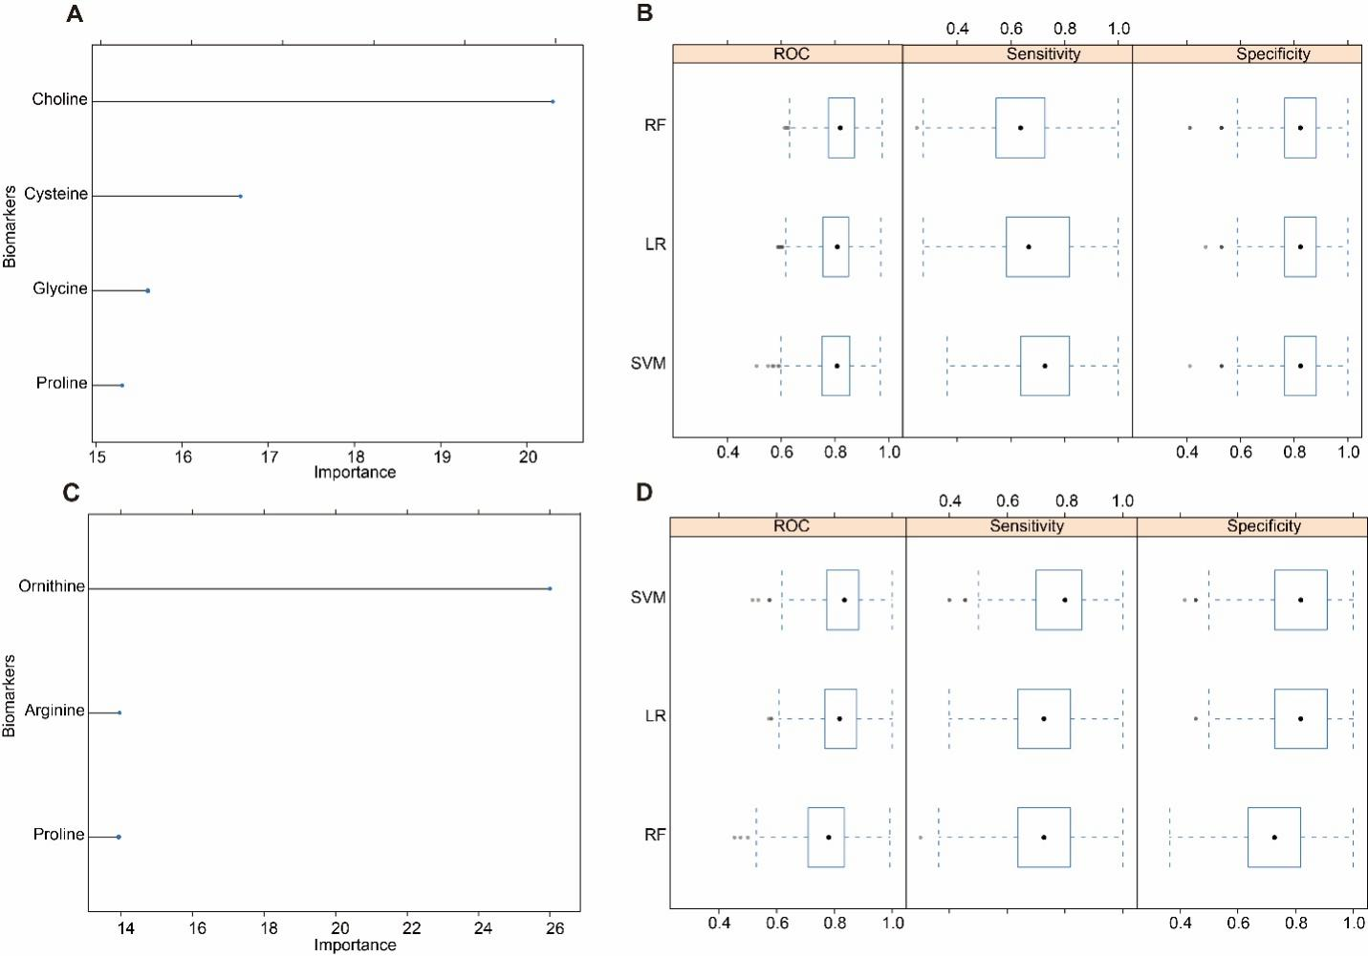
Supplementary Figure 2: Assessment of the two screening models with RF, LR, and SVM. (A) Importance ranking of biomarkers by RF for HCM vs. NC (Panel A). (B) Based on 5-fold cross-validation, ROC, sensitivity, and specificity were calculated by RF, LR, and SVM for HCM vs. NC (Panel A). (C) Importance of biomarkers were calculated by RF for HOCM vs. HNCM (Panel B). (D) Based on 5-fold cross-validation, ROC, sensitivity, and specificity of Panel B were calculated by RF, LR, and SVM for HOCM vs. HNCM. HCM: Hypertrophic cardiomyopathy; HNCM: Non-obstructive HCM; HOCM: Obstructive HCM; LR: Logistic regression; NC: Normal control; RF: Random Forest; ROC: Receiver operating characteristic; SVM: Support vector machine.
Supplementary Figure 3: Correlogram of selected AAs and derivatives in each panel. (A) Correlation of the four AAs and derivatives (choline, proline, cysteine, and glycine) in Panel A. (B) Correlation of the three AAs (ornithine, proline, and arginine) in Panel B. AAs: Amino acids; R: Coefficient of correlation.
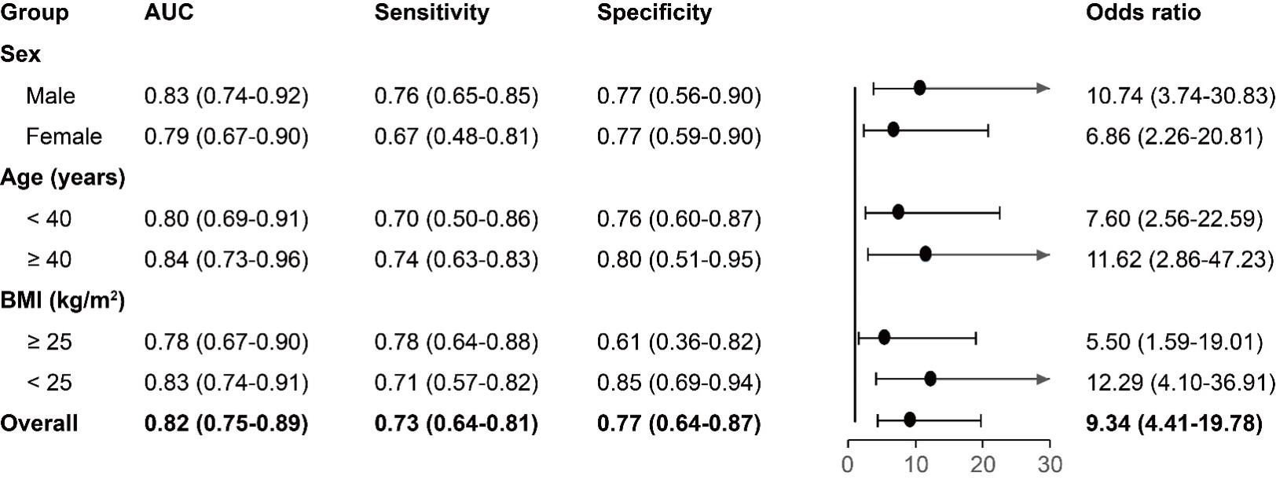
Supplementary Figure 4: Forest plot demonstrating AUC, sensitivity, specificity, and odds ratio for sex, age and BMI subgroups. AUC: Area under the receiver operating characteristic (ROC) curve; BMI: Body mass index.

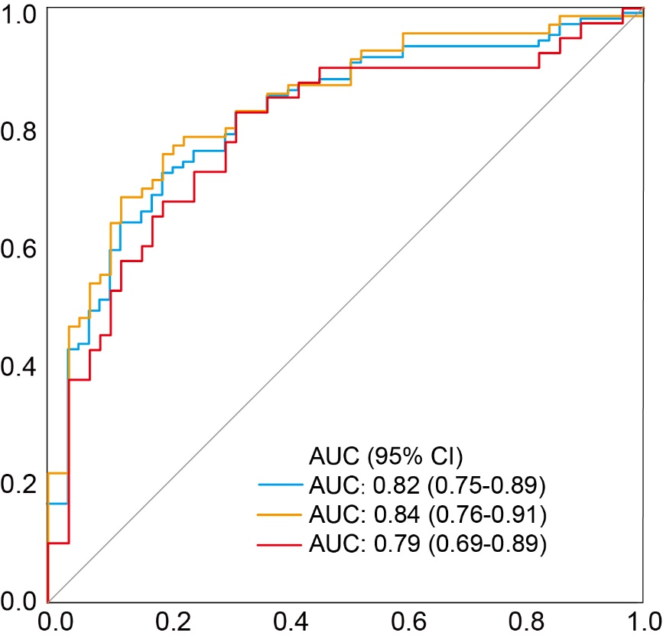
Supplementary Figure 5: Receiver operating characteristic (ROC) curves of Panel A in in HCM patients with or without HP. The blue line showed the overall AUC of HCM vs. NC. The red line showed the AUC of HCM with a previous history of HP vs. NC. The yellow line showed the AUC of HCM without HP history vs. NC. AUC: Area under the ROC curve; HCM: Hypertrophic cardiomyopathy; HP: Hypertension; NC: Normal control; ROC: Receiver operating characteristic.

