Supplementary Materials
This supplement has been provided by the authors to give readers additional information about their work.
Supplementary Table 1: Association of blood Cd with CKD among the oldest old, stratified by sex, marital status, and education level.*
Variables | Q1 | Q2 | Q3 | Q4 | P-interaction
Sex |  |  |  |  | <0.01
Male (n = 640)
N (case/control) | 53/107 | 76/84 | 85/75 | 89/71
OR (95% CI) | 1.00 | 1.58 (0.98–2.55) | 1.95 (1.19–3.22) | 2.53 (1.53–4.19)
Female (n = 895)
N (case/control) | 132/91 | 142/81 | 154/71 | 151/73
OR (95% CI) | 1.00 | 1.05 (0.70–1.59) | 1.44 (0.95–2.19) | 1.39 (0.91–2.11)
Marital status |  |  |  |  | 0.13
Married (n = 412)
N (case/control) | 34/69 | 42/58 | 52/54 | 52/51
OR (95% CI) | 1.00 | 1.33 (0.71–2.49) | 1.75 (0.92–3.32) | 2.47 (1.28–4.80)
Unmarried (n = 1123)
N (case/control) | 157/121 | 175/107 | 186/95 | 184/98
OR (95% CI) | 1.00 | 1.29 (0.90–1.85) | 1.66 (1.14–2.41) | 1.54 (1.06–2.25)
Education level |  |  |  |  | 0.81
Illiteracy (n = 1092)
N (case/control) | 147/123 | 165/107 | 181/96 | 175/98
OR (95% CI) | 1.00 | 1.24 (0.86–1.80) | 1.60 (1.10–2.34) | 1.61 (1.09–2.36)
Literacy (n = 443)
N (case/control) | 40/70 | 53/58 | 54/57 | 67/44
OR (95% CI) | 1.00 | 1.55 (0.87–2.77) | 1.70 (0.93–3.12) | 3.19 (1.71–5.93)
BMI: Body mass index; CI: Confidence interval; CKD: Chronic kidney disease; HDLC: High-density lipoprotein cholesterol; OR: Odds ratio; TG: Triglyceride.
Quartiles for each metal were defined as shown in Table 2.
*All stratified models adjusted for age, sex, education level, marital status, residence, health insurance, smoking status, alcohol intake status, TG, HDLC, BMI, hypertension, diabetes, cardiovascular diseases, and heart disease.
Supplementary Table 2: Association of blood Hg with CKD among the oldest old, stratified by sex, marital status, and education level.*
Variables | Q1 | Q2 | Q3 | Q4 | P-interaction
Sex |  |  |  |  | 0.19
Male (n = 640)
N (case/control) | 55/103 | 75/85 | 94/67 | 79/82
OR (95% CI) | 1.00 | 1.36 (0.83–2.22) | 2.49 (1.53–4.07) | 2.13 (1.30–3.49)
Female (n = 895)
N (case/control) | 135/86 | 158/68 | 140/82 | 146/80
OR (95% CI) | 1.00 | 1.42 (0.92–2.18) | 1.06 (0.69–1.61) | 1.18 (0.77–1.80)
Marital status |  |  |  |  | 0.61
Married (n = 412)
N (case/control) | 31/72 | 47/56 | 54/49 | 48/55
OR (95% CI) | 1.00 | 1.66 (0.88–3.13) | 2.17 (1.16–4.05) | 2.14 (1.14–4.01)
Unmarried (n = 1123)
N (case/control) | 159/118 | 184/100 | 180/101 | 179/102
OR (95% CI) | 1.00 | 1.23 (0.85–1.78) | 1.20 (0.83–1.73) | 1.33 (0.91–1.94)
Education level |  |  |  |  | 0.68
Illiteracy (n = 1092)
N (case/control) | 145/128 | 181/92 | 179/93 | 163/111
OR (95% CI) | 1.00 | 1.38 (0.94–2.02) | 1.45 (1.00–2.12) | 1.30 (0.89–1.89)
Literacy (n = 443)
N (case/control) | 42/66 | 55/57 | 54/55 | 63/51
OR (95% CI) | 1.00 | 1.36 (0.76–2.44) | 1.52 (0.85–2.72) | 2.20 (1.22–3.95)
BMI: Body mass index; CI: Confidence interval; CKD: Chronic kidney disease; HDLC: High-density lipoprotein cholesterol; OR: Odds ratio; TG: Triglyceride.
Quartiles for each metal were defined as shown in Table 2.
*All stratified models adjusted for age, sex, education level, marital status, residence, health insurance, smoking status, alcohol intake status, TG, HDLC, BMI, hypertension, diabetes, cardiovascular diseases, and heart disease.
Supplementary Table 3: Association of urine Cd with CKD among the oldest old, stratified by sex, marital status, and education level.ª
Variables | Q1 | Q2 | Q3 | Q4 | P-interaction
Sex |  |  |  |  | 0.01
Male (n = 508)
N (case/control) | 46/81 | 53/74 | 66/61 | 78/49
OR (95% CI) | 1.00 | 1.15 (0.66–1.99) | 1.73 (0.99–3.03) | 2.52 (1.38–4.59)
Female (n = 668)
N (case/control) | 103/64 | 113/54 | 117/50 | 120/47
OR (95% CI) | 1.00 | 1.31 (0.80–2.13) | 1.45 (0.88–2.38) | 1.50 (0.90–2.51)
Marital status |  |  |  |  | 0.42
Married (n = 337)
N (case/control) | 29/56 | 32/51 | 38/46 | 51/34
OR (95% CI) | 1.00 | 0.97 (0.47–1.98) | 1.27 (0.62–2.63) | 2.80 (1.32–5.94)
Unmarried (n = 839)
N (case/control) | 117/92 | 130/80 | 150/61 | 149/60
OR (95% CI) | 1.00 | 1.14 (0.75–1.75) | 1.79 (1.15–2.78) | 1.50 (0.95–2.37)
Education level |  |  |  |  | 0.76
Illiteracy (n = 815)
N (case/control) | 113/91 | 128/76 | 132/71 | 144/60
OR (95% CI) | 1.00 | 1.05 (0.67–1.63) | 1.23 (0.79–1.92) | 1.43 (0.89–2.27)
Literacy (n = 361)
N (case/control) | 28/63 | 42/47 | 52/39 | 57/33
OR (95% CI) | 1.00 | 1.91 (0.99–3.69) | 2.44 (1.24–4.80) | 3.99 (1.94–8.21)
BMI: Body mass index; CI: Confidence interval; CKD: Chronic kidney disease; HDLC: High-density lipoprotein cholesterol; OR: Odds ratio; TG: Triglyceride.
Quartiles for each metal were defined as shown in Table 2.
*All stratified models adjusted for age, sex, education level, marital status, residence, health insurance, smoking status, alcohol intake status, TG, HDLC, BMI, hypertension, diabetes, cardiovascular diseases, and heart disease.
Supplementary Table 4: Association of urine Hg with CKD among the oldest old, stratified by sex, marital status, and education level.*
Variables | Q1 | Q2 | Q3 | Q4 | P-interaction
Sex |  |  |  |  | <0.01
Male (n = 508)
N (case/control) | 47/80 | 62/65 | 68/59 | 66/61
OR (95% CI) | 1.00 | 1.63 (0.95–2.79) | 1.77 (1.01–3.08) | 1.82 (1.04–3.19)
Female (n = 668)
N (case/control) | 104/63 | 115/52 | 119/48 | 115/52
OR (95% CI) | 1.00 | 1.37 (0.83–2.25) | 1.57 (0.95–2.61) | 1.24 (0.76–2.04)
Marital status |  |  |  |  | 0.53
Married (n = 337)
N (case/control) | 28/56 | 35/50 | 45/39 | 42/42
OR (95% CI) | 1.00 | 1.44 (0.71–2.92) | 2.70 (1.30–5.62) | 2.19 (1.07–4.46)
Unmarried (n = 839)
N (case/control) | 119/90 | 144/66 | 140/70 | 143/67
OR (95% CI) | 1.00 | 1.58 (1.03–2.44) | 1.39 (0.90–2.13) | 1.27 (0.82–1.98)
Education level |  |  |  |  | 0.64
Illiteracy (n = 815)
N (case/control) | 110/93 | 142/63 | 131/73 | 134/69
OR (95% CI) | 1.00 | 2.05 (1.31–3.20) | 1.63 (1.04–2.54) | 1.60 (1.03–2.48)
Literacy (n = 361)
N (case/control) | 38/53 | 38/52 | 54/35 | 49/42
OR (95% CI) | 1.00 | 0.78 (0.41–1.50) | 2.19 (1.14–4.22) | 1.60 (0.82–3.10)
BMI: Body mass index; CI: Confidence interval; CKD: Chronic kidney disease; HDLC: High-density lipoprotein cholesterol; OR: Odds ratio; TG: Triglyceride.
Quartiles for each metal were defined as shown in Table 2.
*All stratified models adjusted for age, sex, education level, marital status, residence, health insurance, smoking status, alcohol intake status, TG, HDLC, BMI, hypertension, diabetes, cardiovascular diseases, and heart disease.
Supplementary Table 5: Sensitivity analyses with recalculating eGFR level using the MDRD equation.*
Metals | Quartiles of metals†
 | Q1 | Q2 | Q3 | Q4
Blood Cd (μg/L) | 1.00 | 1.20 (0.88–1.62) | 1.77 (1.30–2.41) | 1.84 (1.34–2.53)
Blood Hg (μg/L) | 1.00 | 1.50 (1.10–2.04) | 1.63 (1.20–2.22) | 1.44 (1.06–1.96)
Urine Cd (μg/g cre) | 1.00 | 1.23 (0.87–1.75) | 1.51 (1.06–2.16) | 2.12 (1.45–3.08)
Urine Hg (μg/g cre) | 1.00 | 1.24 (0.87–1.76) | 1.55 (1.09–2.22) | 1.58 (1.11–2.26)
BMI: Body mass index; CIs: Confidence intervals; HDLC: High-density lipoprotein cholesterol; MDRD: Modification of diet in renal disease; TG: Triglyceride.
*Hazard ratios and 95% CIs were estimated with the use of logistic regression. Recalculating eGFR using the MDRD equation level in this study.
†Adjusted for age, sex, education level, marital status, residence, health insurance, smoking status, alcohol intake status, TG, HDLC, BMI, hypertension, diabetes, cardiovascular diseases, and heart disease.
Supplementary Table 6: Sensitivity analyses with excluding participants who had hypertension, diabetes, cerebrovascular disease, or heart disease.*
Metals | Quartiles of metals†
 | Q1 | Q2 | Q3 | Q4
Blood Cd (μg/L) | 1.00 | 1.41 (0.94–2.12) | 1.66 (1.09–2.51) | 1.68 (1.10–2.57)
Blood Hg (μg/L) | 1.00 | 1.38 (0.91–2.07) | 1.65 (1.09–2.49) | 1.48 (0.99–2.23)
Urine Cd (μg/g cre) | 1.00 | 1.06 (0.66–1.69) | 1.53 (0.94–2.49) | 2.51 (1.50–4.20)
Urine Hg (μg/g cre) | 1.00 | 1.16 (0.72–1.84) | 1.68 (1.04–2.69) | 1.39 (0.86–2.26)
BMI: Body mass index; CIs: Confidence intervals; HDLC: High-density lipoprotein cholesterol; TG: Triglyceride.
*Hazard ratios and 95% CIs were estimated with the use of logistic regression. Excluded the participants with hypertension, diabetes, cerebrovascular disease, or heart disease.
†Adjusted for age, sex, education level, marital status, residence, health insurance, smoking status, alcohol intake status, TG, HDLC, and BMI.
Supplementary Table 7: Sensitivity analyses with further adjustment for vegetable consumption, fruit consumption, cancer, dementia, and respiratory disease.*
Metals | Quartiles of metals†
 | Q1 | Q2 | Q3 | Q4
Blood Cd (μg/L) | 1.00 | 1.24 (0.91–1.71) | 1.78 (1.28–2.46) | 1.81 (1.30–2.54)
Blood Hg (μg/L) | 1.00 | 1.36 (0.99–1.89) | 1.28 (0.93–1.78) | 1.55 (1.12–2.14)
Urine Cd (μg/g cre) | 1.00 | 1.28 (0.88–1.85) | 1.68 (1.15–2.45) | 2.05 (1.37–3.05)
Urine Hg (μg/g cre) | 1.00 | 1.36 (0.94–1.97) | 1.62 (1.12–2.36) | 1.36 (0.93–1.98)
BMI: Body mass index; CIs: Confidence intervals; HDLC: High-density lipoprotein cholesterol; TG: Triglyceride.
*Hazard ratios and 95% CIs were estimated with the use of logistic regression.
†Adjusted for age, sex, education level, marital status, residence, health insurance, smoking status, alcohol intake status, TG, HDLC, BMI, hypertension, diabetes, cardiovascular diseases, heart disease, vegetable consumption, fruit consumption, cancer, dementia, and respiratory disease.
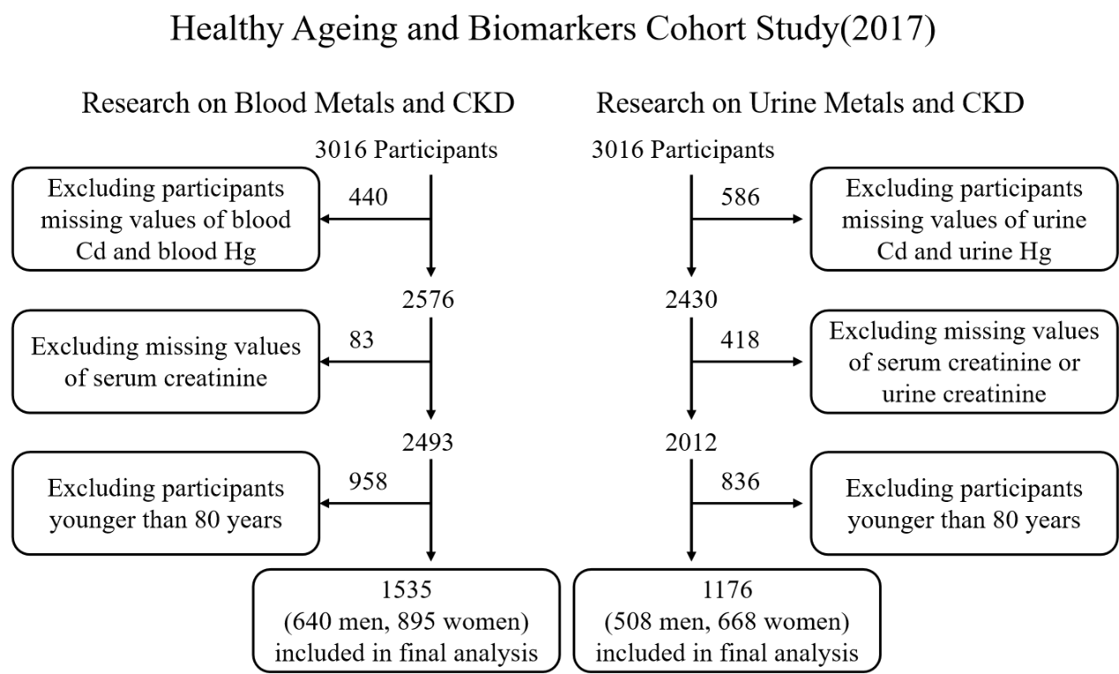
Supplementary Figure 1: Flowchart of the inclusion of study participants. Urinary creatinine was used as a correction parameter for the concentration of urine metals, we did not exclude participants with missing value of urine creatinine in our study of associations of blood metals and CKD. CKD: Chronic kidney disease.
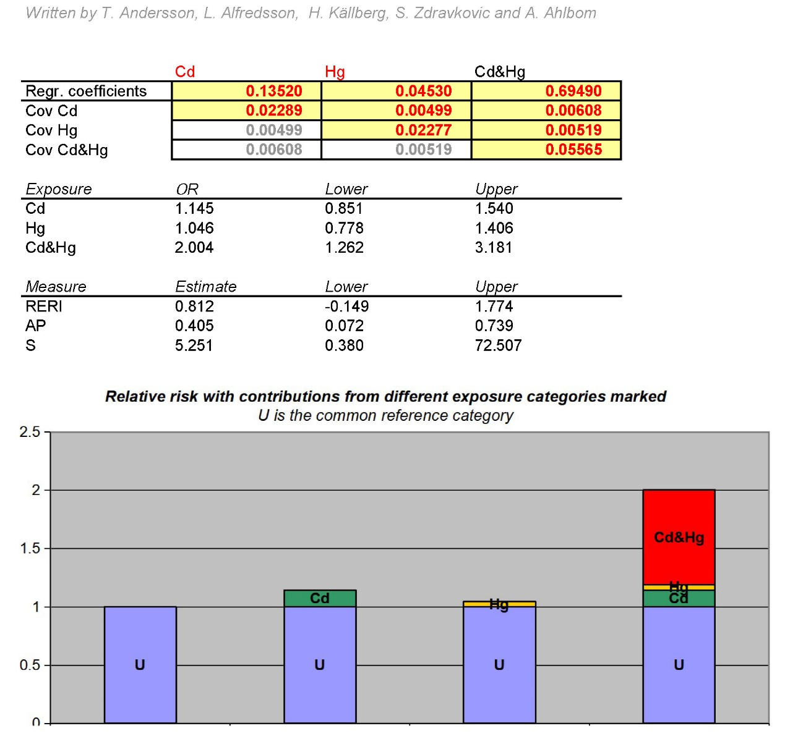
Supplementary Figure 2: The additive interaction for the associations of blood metals and CKD. CKD: Chronic kidney disease; Regr. Coefficients: Regression coefficient; Cov: Covariance.
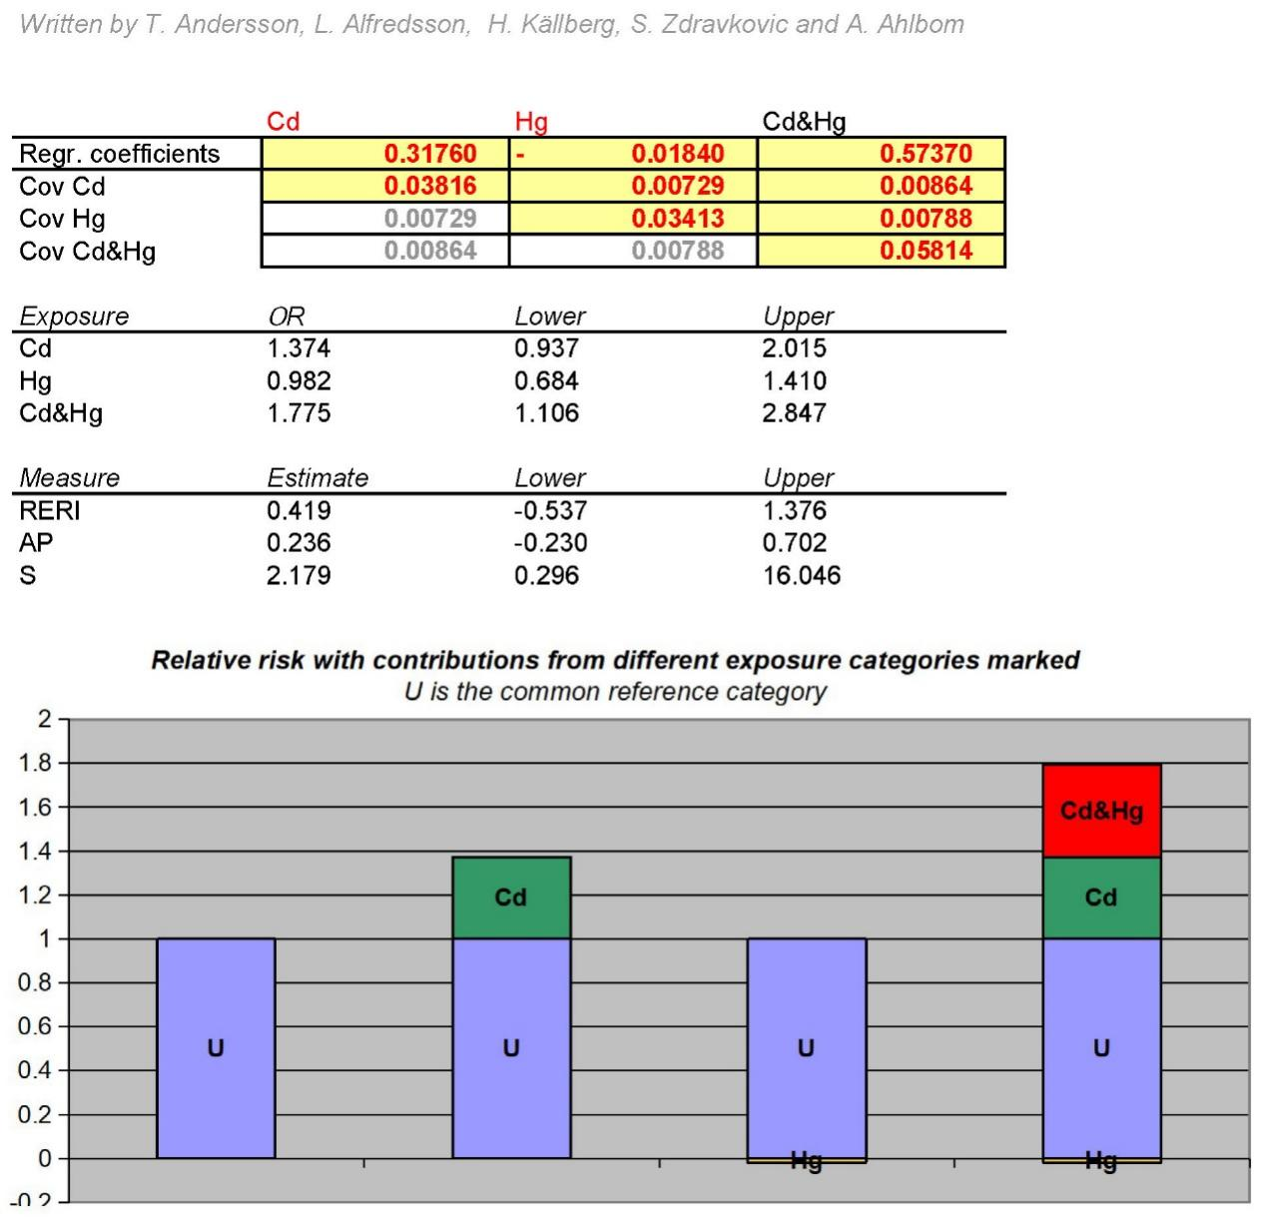
Supplementary Figure 3: The additive interaction for the associations of urine metals and CKD. CKD: Chronic kidney disease; Regr. Coefficients: Regression coefficient; Cov: Covariance.

