Supplementary Table 1: Basic characteristics of COPD patients with or without OSA.
Characteristics | Total | COPD without OSA | COPD with OSA | Statistics | P-value*
Number of participants, n (%) | 109 (100.0) | 45 (41.3) | 64 (58.7)
Gender, n (%) |  |  |  | 2.513* | 0.158
Male | 94 (86.2) | 36 (38.3) | 58 (61.7)
Female | 15 (13.8) | 9 (60.0) | 6 (40.0)
Age (years), Median (IQR) | 66.0 (12.5) | 68.0 (11.0) | 65.0 (13.3) | 0.240† | 0.549
BMI (kg/m²), Median (IQR) | 23.9 (4.5) | 23.5 (5.1) | 24.0 (4.5) | 0.398† | 0.562
Smoking status, n (%) |  |  |  | 5.105* | 0.078
Never smoker | 14 (12.8) | 4 (28.6) | 10 (71.4)
Former smoker | 68 (62.4) | 25 (36.8) | 43 (63.2)
Current smoker | 27 (24.8) | 16 (59.3) | 11 (40.7)
Smoke packs per year (packs/year), Median (IQR) | 31.7 (34.2) | 25.0 (50.0) | 21.5 (38.5) | 0.670† | 0.475
Cooking oil fumes, n (%) |  |  |  | 0.417* | 0.539
No | 74 (67.9) | 29 (39.2) | 45 (60.8)
Yes | 35 (32.1) | 16 (45.7) | 19 (52.7)
Occupation exposure, n (%) |  |  |  | 1.999* | 0.172
No | 64 (58.7) | 30 (46.9) | 34 (53.1)
Yes | 45 (41.3) | 15 (33.3) | 30 (66.7)
Drug therapy, n (%) |  |  |  | 12.918* | 0.012
LAMA | 15 (13.8) | 7 (46.7) | 8 (53.3)
LABA + ICS | 33 (30.3) | 11 (33.3) | 22 (66.7)
LAMA + LABA + ICS | 41 (37.6) | 12 (29.3) | 29 (70.7)
Theophylline | 13 (11.9) | 10 (76.9) | 3 (23.1)
Other drugs | 7 (6.4) | 5 (71.4) | 2 (28.6)
Lung function, Median (IQR)
FVC (L) | 2.9 (1.0) | 3.3 (1.2) | 2.8 (1.0) | 0.722† | 0.102
FEV₁ (L) | 1.9 (1.1) | 2.1 (1.2) | 1.9 (1.1) | 0.367† | 0.998
FEV₁/FVC (%) | 77.9 (25.2) | 82.0 (19.5) | 76.1 (29.2) | 0.051† | 0.828
GOLD stage, n (%) |  |  |  | 1.334* | 0.721
GOLD 1 | 24 (22.0) | 9 (37.5) | 15 (62.5)
GOLD 2 | 54 (49.5) | 25 (46.3) | 29 (53.7)
GOLD 3 | 24 (22.0) | 8 (33.3) | 16 (66.7)
GOLD 4 | 7 (6.4) | 3 (42.9) | 4 (57.1)
*χ² value; †Z value. BMI: Body mass index; COPD: Chronic obstructive pulmonary disease; FEV₁: Forced expiratory volume in 1 s; FVC: Forced vital capacity; GOLD: Global Initiative for Chronic Obstructive Lung Disease; ICS: Inhaled corticosteroids; LABA: Long-acting beta 2 agonists; LAMA: Long-acting antimuscarinic antagonists; IQR: Interquartile range; OSA: Obstructive sleep apnea.
Supplementary Table 2: Distributions of daily average concentrations of air pollutants and meteorological data.
Air pollutants | Mean ± SD | Min | P₂₅ | P₅₀ | P₇₅ | Max | IQR
PM_{2.5} (μg/m³) | 64.6 ± 67.5 | 5.0 | 23.5 | 39.0 | 83.5 | 364.0 | 60.0
PM₁₀ (μg/m³) | 93.3 ± 80.6 | 0 | 43.5 | 72.0 | 118.5 | 550.0 | 75.0
SO₂ (μg/m³) | 9.2 ± 8.9 | 2.0 | 3.0 | 6.0 | 11.0 | 42.0 | 8.0
CO (mg/m³) | 1.1 ± 1.1 | 0.2 | 0.5 | 0.8 | 1.1 | 7.5 | 0.6
NO₂ (μg/m³) | 48.5 ± 26.5 | 10.0 | 31.0 | 41.0 | 53.0 | 153.0 | 22.0
O₃ (μg/m³) | 92.3 ± 65.7 | 0 | 43.5 | 74.0 | 141.5 | 262.0 | 98.0
Temperature (°C) | 11.8 ± 11.4 | -4.0 | 1.0 | 11.0 | 23.5 | 31.0 | 22.5
RH (%) | 48.0 ± 18.5 | 14.0 | 35.0 | 44.0 | 64.5 | 88.0 | 29.5
CO: Carbon monoxide; IQR: Interquartile range; Max: Maximum; Min: Minimum; NO₂: Nitrogen dioxide; O₃: Ozone; PM₁₀: Particulate matter with aerodynamic diameter <10 μm; PM_{2.5}: Particulate matter with aerodynamic diameter <2.5 µm; RH: Relative humidity; SD: Standard deviation; SO₂: Sulfur dioxide.

Supplementary Table 3: Spearman’s correlation coefficients among air pollutants and meteorological parameters.
Air pollutants | PM_{2.5} | PM₁₀ | SO₂ | CO | NO₂ | O₃ | Temperature | RH
PM_{2.5} | 1.000 | 0.837‡ | 0.625‡ | 0.876‡ | 0.682‡ | -0.105 | -0.055 | 0.568‡
PM₁₀ |  | 1.000 | 0.625‡ | 0.712‡ | 0.699‡ | 0.012 | -0.014 | 0.306‡
SO₂ |  |  | 1.000 | 0.688‡ | 0.689‡ | -0.389‡ | -0.508‡ | -0.036
CO |  |  |  | 1.000 | 0.717‡ | -0.282† | -0.208* | 0.544‡
NO₂ |  |  |  |  | 1.000 | -0.401‡ | -0.352‡ | 0.265†
O₃ |  |  |  |  |  | 1.000 | 0.854‡ | -0.014
Temperature |  |  |  |  |  |  | 1.000 | 0.256†
RH |  |  |  |  |  |  |  | 1.000
CO: Carbon monoxide; NO₂: Nitrogen dioxide; O₃: Ozone; PM₁₀: Particulate matter with aerodynamic diameter <10 μm; PM_{2.5}: Particulate matter with aerodynamic diameter <2.5 µm; RH: Relative humidity; SO₂: Sulfur dioxide. *P<0.05; †P<0.01; ‡P<0.001.

Supplementary Table 4: Associations between ambient air pollutants and sleep parameters in two-pollutant models.
Sleep parameters | Air pollutants | Two-pollutant model with PM_{2.5} | Two-pollutant model with PM₁₀ | Two-pollutant model with NO₂ | Two-pollutant model with SO₂ | Two-pollutant model with O₃ | Two-pollutant model with CO
ODI | PM_{2.5}-lag05 |  | 0.87% (-0.02%,1.77%) | 0.74% (-0.22%,1.71%) | 0.68% (-0.22%,1.59%) | 0.65% (-0.22%,1.52%) | 0.26% (-0.76%,1.28%)
 | PM₁₀-lag07 | 0.62% (-0.57%,1.81%) |  | 0.12% (-0.17%,0.40%) | 0.1% (-0.18%,0.39%) | -0.52% (-1.02%,0.02%) | 0.06% (-0.23%,0.35%)
 | SO₂-lag07 | 6.12% (-8.43%,22.99%) | 9.02% (-5.56%,25.85%) | 8.4% (-6.14%,25.20%) |  | 8.02% (-6.59%,24.92%) | 3.89% (-10.62%,20.74%)
 | O₃-lag07 | -0.26% (-1.07%, 0.54%) | -0.29% (-1.11%,0.52%) | -0.59% (-1.46%,0.23%) | 0.28% (-0.53%,1.10%) |  | -0.28% (-1.09%,0.53%)*
Base SpO₂ | PM_{2.5}-lag01 |  | -0.01% (-0.04%,0.04%) | 0.002% (-0.16%,0.02%) | 0.01% (-0.004%,0.02%) | 0.01% (-0.04%,0.019%) | -0.012% (-0.04%,0.014%)
 | PM₁₀-lag06 | 0.18% (-0.15%,0.50%) |  | 0.23% (-0.05%,0.52%) | 0.22% (-0.06%,0.51%) | 0.21% (-0.07%,0.50%) | 0.19% (-0.10%,0.47%)
Min SpO₂ | PM₁₀-lag06 | -0.88% (-2.49%,0.72%) |  | 0.14% (-0.15%,0.43%) | 0.13% (-0.16%,0.42%) | 0.13% (-0.16%,0.27%) | 0.09% (-0.20%,0.38%)
T90 | PM_{2.5}-lag04 |  | -1.13% (-3.03%,0.77%) | -1.15% (-2.43%, -0.12%) | -0.93% (-1.85%, -0.02%) | -0.92% (-1.62%, -0.21%) | -0.13% (-1.88%, 1.62%)
 | PM₁₀-lag04 | 0.20% (-1.35%,1.76%) |  | -0.63% (-1.62%, 0.34%) | -0.58% (-1.26%,0.09%) | -0.66% (-1.24%, -0.09%) | 0.26% (-0.76%,1.28%)
CIs: Confidence intervals; CO: Carbon monoxide; NO₂: Nitrogen dioxide; O₃: Ozone; ODI: Oxygen desaturation index; PM₁₀: Particulate matter with aerodynamic diameter <10 μm; PM_{2.5}: Particulate matter with aerodynamic diameter <2.5 µm; SO₂: Sulfur dioxide; SpO₂: Oxygen saturation; T90: Percentage of total sleep time with oxygen saturation < 90%.

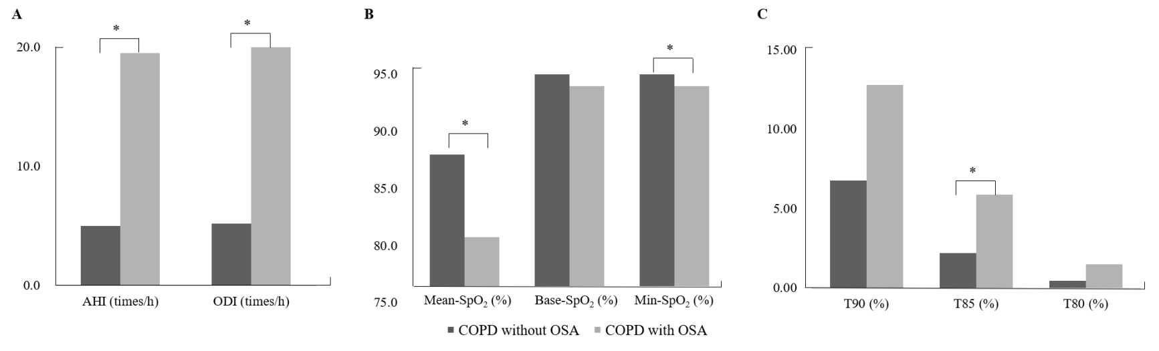
Supplementary Figure 1: The differences in health indicators AHI and ODI (A), SpO₂ (B) and T90, T85 and T80 (C) of COPD with or without OSA group. AHI: Apnea-hypopnea Index; COPD: Chronic Obstructive Pulmonary Disease; ODI: Oxygen Desaturation Index; OSA: Obstructive sleep apnea; SpO₂: Oxygen saturation; T80: Percentage sleep time with < 80% saturation; T85: Percentage sleep time with < 85% saturation; T90: Percentage of total sleep time with oxygen saturation < 90%. *P <0.05.

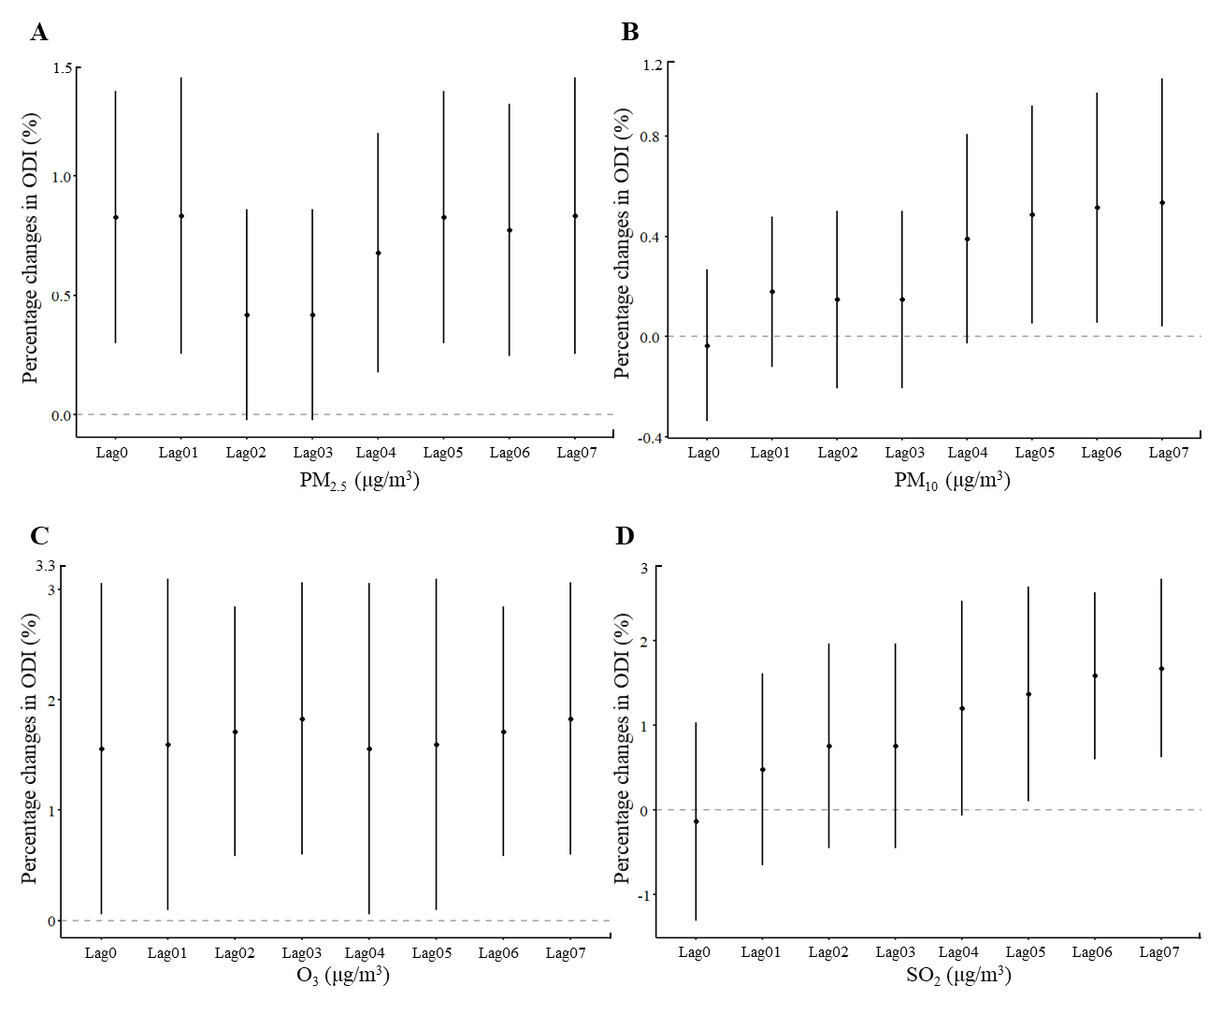
Supplementary Figure 2: Associations between exposure to air pollutants and ODI among all participants using MLR model (an IQR increase in PM_{2.5} [A], PM₁₀ [B], O₃ [C] and SO₂ [D]). The MLR model adjusted for confounders including gender, age, body mass index (BMI), smoking status, occupational exposure, cooking oil fumes exposure, GOLD stage, temperature, and RH. GOLD: Global initiative for chronic obstructive lung disease; IQR: Interquartile range; MLR: Multiple linear regression; O₃: Ozone; ODI: Oxygen desaturation index; PM₁₀: Particulate matter with aerodynamic diameter <10 μm; PM_{2.5}: Particulate matter with aerodynamic diameter <2.5 µm; RH: Relative humidity; SO₂: Sulfur dioxide.

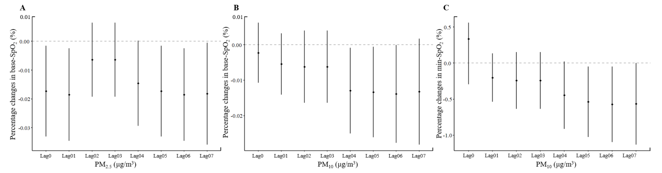
Supplementary Figure 3: Associations between exposure to PM_{2.5} and base-SpO₂ (A), PM₁₀ and base-SpO₂ (B), and PM₁₀ and min-SpO₂ (C) among all participants using MLR model (an IQR increase in PM_{2.5}, PM₁₀). The MLR model adjusted for confounders including gender, age, body mass index (BMI), smoking status, occupational exposure, cooking oil fumes exposure, GOLD stage, temperature, and RH. GOLD: Global initiative for chronic obstructive lung disease; IQR: Interquartile range; MLR: Multiple linear regression; PM₁₀: Particulate matter with aerodynamic diameter <10 μm; PM_{2.5}: Particulate matter with aerodynamic diameter <2.5 µm; RH: Relative humidity; SpO₂: Oxygen saturation.

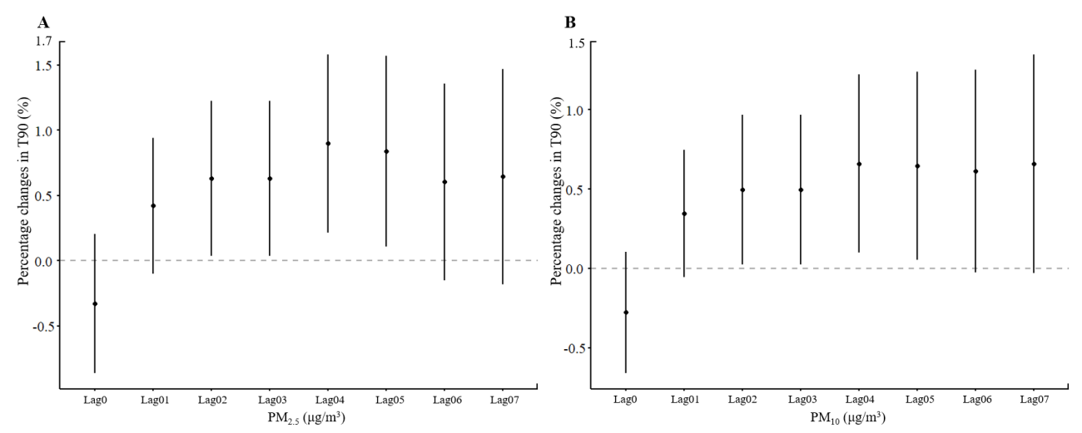
Supplementary Figure 4: Associations between exposure to air pollutants PM_{2.5} (A), PM₁₀ (B) and T90 among all participants using MLR model (an IQR increase in PM_{2.5}, PM₁₀). The MLR model adjusted for confounders including gender, age, body mass index (BMI), smoking status, occupational exposure, cooking oil fumes exposure, GOLD stage, temperature, and RH. GOLD: Global initiative for chronic obstructive lung disease; IQR: Interquartile range; MLR: Multiple linear regression; PM₁₀: Particulate matter with aerodynamic diameter <10 μm; PM_{2.5}: Particulate matter with aerodynamic diameter <2.5 µm; RH: Relative humidity; T90: Percentage of total sleep time with oxygen saturation < 90%.

