Supplementary Figure 1: P₂X7 receptor is expressed in circulating monocytes and alveolar macrophages. Panel A shows the purity analysis of enriched Ly6G⁻CD11b⁺ monocytes from mice peripheral blood before (left) and after (right) flow cytometry-based cell sorting. Panel B shows the immunofluorescent staining of P₂X7 receptor on circulating monocytes. Panel C shows the immunofluorescent staining of P₂X7 receptor on alveolar macrophages from mice BALF. CD: cluster of differentiation; DAPI: 4,6-diamidino-2-phenylindole; FITC: fluorescein isothiocyanate; P₂X7R: P2 type 7 purinergic receptors.
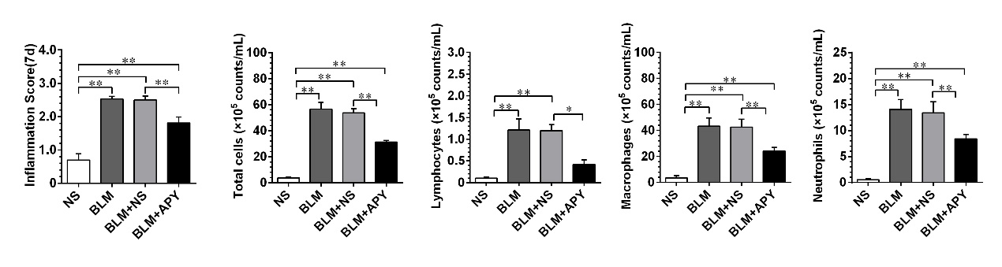
Supplementary Figure 2: The semi-quantitative inflammation scores according to H&E staining and the differential cell counting of BALF on day 7. BLM: Bleomycin; NS: Normal saline; APY: Apyrase. *P<0.05; **P<0.01 (n = 5 for each group).

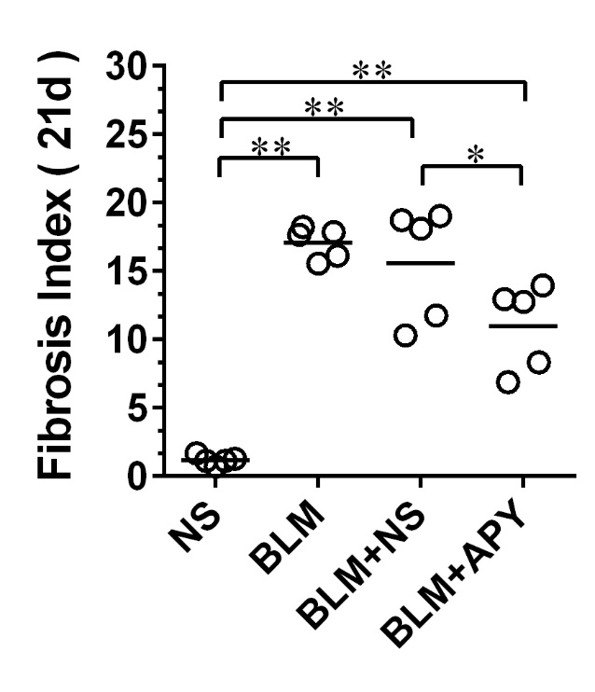
Supplementary Figure 3: The semi-quantitative fibrosis index according to Masson’s trichrome staining on day 21. BLM: Bleomycin; NS: Normal saline; APY: Apyrase. *P<0.05; **P<0.01 (n = 5 for each group).

