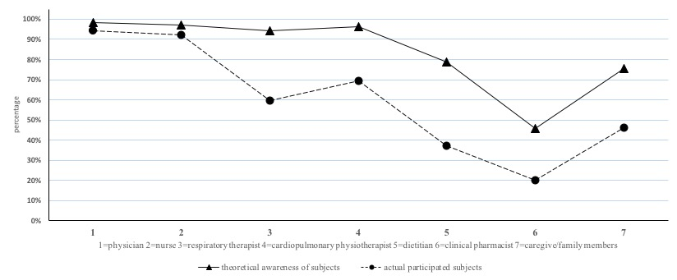
Supplementary Figure 2: Awareness and actual participation of early rehabilitation in patients with critical illness

