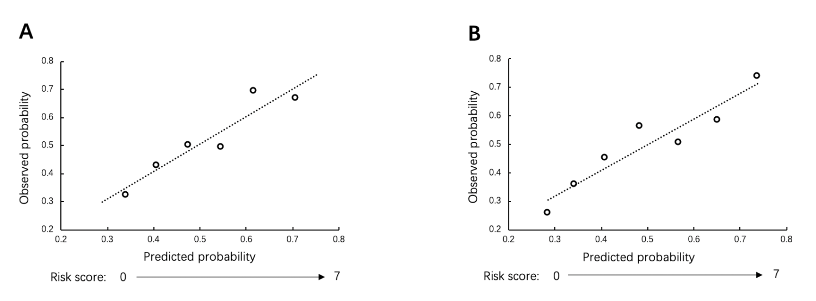
Supplementary Figure 1: (A) Calibration plots for the probability of CINV in the optimized model development set. (B) Calibration plots for the probability of CINV in the optimized model validation set. CINV: Chemotherapy-induced nausea and vomiting.

Appendix A. Inclusion Criterion of Patients and Data Collection Procedure
Inclusion criterion of patients
Patients were selected from Tianjin Medical University General Hospital and Tianjin Medical University Cancer Institute and Hospital, China. All the patients were Chinese. The patient should be older than 18 years old. Their primary diseases included solid tumors or lymphoma. Patients who were scheduled to receive highly emetogenic chemotherapy (HEC), moderately emetogenic chemotherapy (MEC), and low emetogenic chemotherapy (LEC) were all eligible to include for analysis. The regimens were classified as HEC, MEC, or LEC based on National Comprehensive Cancer Network (NCCN), European Society for Medical Oncology (ESMO), and Chinese Society of Clinical Oncology (CSCO) guidelines.^{[1–3]} Patients were excluded if they were about to receive abdominal or pelvic radiotherapy concurrently with chemotherapy, if they vomited 24 h before chemotherapy, if they had symptomatic brain metastasis, or were receiving systemic corticosteroids chronically.
Procedure and data collection
Patients eligible for analysis were provided with a daily diary designed according to Multinational Association of Supportive Care in Cancer (MASCC) Antiemesis Tool to record patients’ appetite changes, number of vomiting episodes, vomiting visual analog scale (VAS) scoring, intensity, and times of nausea from the first day to the 14th day of chemotherapy. The use of both prescribed and non-prescribed antiemetic drugs at home was also required to be recorded on diary. The National Cancer Institute-Common Terminology Criteria for Adverse Events (NCI-CTCAE) (v5.0) was used to describe the grade of nausea and vomiting according to the patients’ reactions and feelings. When the patient experiences ≥grade 2 chemotherapy-induced nausea and vomiting (CINV) or VAS ≥4 or number of nausea ≥2–5 times/day, he/she had to report and upload the diary to our Follow-up System and were advised for treatment for the breakthrough CINV. Patients were contacted on the 15th day after chemotherapy to ensure that the diary had been completed and up-loaded to the Follow-up System.
According to the existing predictive model, before each cycle of chemotherapy, the following CINV predictive factors were collected by nurses: patients’ age, anticipatory nausea and vomiting, sleep hours the night before chemotherapy, history of morning sickness, use of non-prescribed antiemetics at home, platinum- or anthracycline-based chemotherapy, nausea or vomiting in the prior cycle, chemotherapy cycle number. Chemotherapy regimens, preventive antiemetic treatments, as well as a breakthrough treatment for CINV were also recorded. Our electronic Follow-up System collected both patients’ general information and records of CINV after chemotherapy.
Appendix B. Procedure of Re-building the Risk Scoring System
To re-build the risk scoring system according to the optimized model, the contribution of each predictor was weighed by the multiply regression coefficients according to the multiply generalized estimating equation (GEE) results. To simplify calculations by these weights, the coefficients were transformed by multiplying each by a constant (derived by trial and error) and then rounding to the nearest unit value (odds ratio [OR]).^{[4]} The total risk score assigned for each patient was calculated by adding up all the transformed coefficient values of each predictor they possessed.
Appendix C. Reasons of the Uncertainty of Some CINV Predictors in Chinese Patients and Clinical Practice
This validation found several factors demonstrating opposite predictive value as compared with the existing CINV predictive model in the Chinese population. The first one is the “cycle number” of chemotherapy. Based on the existing predictive model, cycle number was a negative predictor of CINV, which means the risk probability of CINV will reduce along with increased cycles of chemotherapy. However, in our validation, we found the incidence of CINV did not decrease from the first cycle to the seven cycles. A previous study reported that CINV risk was increased by at least six-fold in subsequent cycle if poorly controlled in the prior one.^{[5]} Correspondingly, we found only 20% of patients with breakthrough CINV received antiemetic prevention adjustment in their following cycle of chemotherapy. High ratio of the antiemetic prevention adjustment may reduce the incidence of CINV in the following cycles of chemotherapy. So “cycle number” is not a reliable predictor as it depends on antiemetic prevention adjustment ratio according to CINV in the previous cycles. Second, “platinum or anthracycline-based chemotherapy” was a positive predictor for CINV in the existing predictive model. However, in our clinical practice, platinum-based chemotherapies usually comprised lobaplatin or oxaliplatin-based regimens which were defined as MEC according to CINV guidelines. Inclusion of MEC agents may reduce the weight of “platinum or anthracycline-based chemotherapies” as a positive predictor of CINV. Limiting “platinum-based chemotherapy” to HEC, such as cisplatin or carboplatin, may be a more precision way to modify. Considering the uncertainty of these risk factors, we removed them from the existing predictive model in order to optimize a model that suits our clinical practice and patients.
References
1. Roila F, Molassiotis A, Herrstedt J, Aapro M, Gralla RJ, Bruera E, et al. 2016 MASCC and ESMO guideline update for the prevention of chemotherapy- and radiotherapy-induced nausea and vomiting and of nausea and vomiting in advanced cancer patients. Ann Oncol 2016;27(Suppl 5):v119–v133. doi: 10.1093/annonc/mdw270.
2. Antiemesis. National comprehensive cancer network, NCCN Clinical Practice Guidelines in Oncology, 2021. Available from: http://www.nccn.org. [Last accessed on March 1, 2021].
3. Prevention & treatment of nausea and vomiting caused by antitumor therapies. Guidelines of Chinese Society of Clinical Oncology (CSCO), 2019. Available from: http://www.csco.org.cn [Last accessed on March 1, 2021].
4. Dranitsaris G, Molassiotis A, Clemons M, Roeland E, Schwartzberg L, Dielenseger P, et al. The development of a prediction tool to identify cancer patients at high risk for chemotherapy-induced nausea and vomiting. Ann Oncol 2017;28:1260–1267. doi: 10.1093/annonc/mdx100.
5. Molassiotis A, Lee PH, Burke TA, Dicato M, Gascon P, Roila F, et al. Anticipatory nausea, risk factors, and its impact on chemotherapy-induced nausea and vomiting: results from the pan European emesis registry study. J Pain Symptom Manage 2016;51:987–993. doi: 10.1016/j.jpainsymman.2015.12.317.

Patient characteristics | Group 1 (n=367) | Group 2 (n=201)
Age (range) | 64 (21-83) | 62.1 (20-85)
Female gender | 133 (36.2) | 88（43.7）
Type of cancer
Lung | 174 (47.4) | 85 (42.3)
Colorectal | 50 (13.6) | 28 (13.8)
Gastric | 34 (9.3) | 29 (14.4)
Esophageal | 7 (1.9) | 3 (1.5)
Pancreatic | 7 (1.9) | 4 (2.0)
Breast | 8 (2.1) | 9 (4.5)
Gynecological | 17 (4.6) | 12 (6.0)
Lymphoma | 6 (1.6) | 0 (0.0)
Others | 64 (17.4) | 31 (15.4)
History of morning sickness | 52 (14.1) | 50 (24.8)
Supplementary Table 1: Demographic and clinical characteristics of included patients for predictive model validation and development.
Data are presented as median (range) or n (%).

Supplementary Table 2: Treatments and treatment related variables of included patients for predictive model validation and development.

Patient characteristics | Group 1 (n=904) | Group 2 (n=452)
Anticipatory nausea and vomiting | 372 (41.2) | 145 (32.1)
Sleep <7 h the night before chemotherapy | 278 (30.8) | 147 (32.5)
Median number of cycles (range) | 2 (1-7) | 2 (1-6)
Cycle number
Cycle 1 | 409 (45.2) | 244 (53.9)
Cycle 2 | 257 (28.4) | 100 (22.1)
Cycle 3 | 151 (16.7) | 64 (14.2)
Cycle 4 | 62 (6.9) | 30 (6.6)
Cycle 5 | 20 (2.2 ) | 11 (2.4)
Cycle 6 | 3 (0.3) | 3 (0.7)
Cycle 7 | 2 (0.2) | 0 (0)
Types of chemotherapy
Cisplatin based | 236 (26.1) | 114 (25.2)
Carboplatin based | 180 (19.9) | 75 (16.6)
Oxaliplatin based | 211 (23.3) | 89 (19.7)
Lobaplatin based | 20 (2.2) | 11 (2.4)
Anthracycline based | 41 (4.5) | 21 (4.6)
Others | 216 (23.9) | 142 (31.4)
Pre-chemotherapy anti-emetics
Aprepitant+Tropisetron+Dexamethasone | 318 (35.2) | 188 (41.6)
Tropisetron+Dexamethasone | 578 (63.9) | 253 (56.0 )
Tropisetron alone | 7 (0.8) | 10 (2.2)
Dexamethasone alone | 1 (0.1) | 1 (0.2)
Data are presented as number of cycles (%).

Supplementary Table 3: Predictors and their risks in the existing CINV predictive model and validation results in Chinese populations.
Predictive factors | Predictive value and risks in the existing CINV predictive model |  |  | Validation results in Chinese populations
 | Predictive value | Risk score |  | Odds ratio | 95% CI | P values
Age <60 years | Positive | 1 |  | 1.411 | 1.030–1.932 | 0.032
Anticipatory nausea and vomiting | Positive | 1 |  | 1.166 | 0.668–1.700 | 0.790
Sleep <7 h the night before chemotherapy | Positive | 1 |  | 0.691 | 0.465–1.027 | 0.067
History of morning sickness | Positive | 1 |  | 1.094 | 0.556–1.567 | 0.795
Use of non-prescribed antiemetics at home | Positive | 3 |  | 1.228 | 0.831–1.814 | 0.302
Platinum- or anthracycline-based chemotherapy | Positive | 2 |  | 0.678 | 0.517–0.889 | 0.005
Nausea or vomiting in the prior cycle | Positive | 5 |  | 1.903 | 1.354–2.674 | 0
Cycle number (vs. cycle 1)
Cycle 2 | Negative | -5 |  | 1.125 | 0.792–1.598 | 0.512
≥Cycle 3 | Negative | -6 |  | 1.321 | 0.929–1.879 | 0.122

CI: Confidence interval; CINV: Chemotherapy-induced nausea and vomiting.

