Supplementary Table 1: Follow-up schedule and data to be collected.
Items | Induction treatment stage |  | Randomized stage |  |  |  |  | Early exit
Visit | S1 | S2–4 | V0 | V1–2 | V3 | V4–8 | V9
 | Wk0 | Wk 4\8\12 | Wk0 | Wk4–8 | Wk12 | Wk20–52 | Wk60
ICF | √
Demographic data | √
Past history and medication history collection | √
Physical examination | √ | √ | √ | √ | √ | √ | √ | √
Urine βHCG  (if applicable) | √
BCC, renal and liver function, ESR, CRP, RF | √ | √ | √ | √ | √ | √ | √ | √
Assessment committee examination | √ | √ | √ | √ | √ | √ | √ | √
IC/EC judgement | √
Randomization |  |  | √
Hand X-ray | √ |  | √ |  |  |  | √ | √
Ultrasound of double hands | √ |  | √ |  |  |  | √ | √
Anti-CCP antibody | √ |  | √ |  |  |  | √ | √
Cost record | √ |  | √ | √ | √ | √ | √ | √
HAQ-DI/EQ-5D | √ |  | √ |  | √ |  | √ | √
Study Medication record | √ | √ | √ | √ | √ | √ | √ | √
Concomitant medication record | √ | √ | √ | √ | √ | √ | √ | √
AE record | √ | √ | √ | √ | √ | √ | √ | √
Note: ICF: Informed Consent Form; BCC: Blood cells count; ESR: Erythrocyte sedimentation rate; CRP: C-reactive protein; RF: rheumatoid factor; IC/EC: inclusion criteria/exclusion criteria; Anti-CCP antibody: anti-cyclic citrullinated peptide antibody; HAQ-DI/EQ-5D: Health Assessment Questionnaire Disability Index/ Euro Qol five dimensions questionnaire; AE: Adverse event. WK: Week.

Supplementary Table 2: The multiple logistic regression analysis of predictive factors of
LDA/remission achievement in 12 weeks.
Items | Odds Ratio | Exp (B) 95%CI | P | B
Gender (Female) | 0.049 | 0.005–0.471 | 0.009 | –3.022
Disease duration | 0.997 | 0.993–1.002 | 0.217 | –0.003
Baseline TJC | 0.834 | 0.719–0.968 | 0.017 | –0.182
Baseline DAS28-CRP | 1.011 | 0.107–9.543 | 0.992 | 0.011
Baseline DAS28-ESR | 0.836 | 0.289–2.419 | 0.741 | –0.179
Baseline SDAI | 0.881 | 0.667–1.165 | 0.375 | –0.126
Baseline CDAI | 1.233 | 0.949–1.603 | 0.117 | 0.210
Baseline HAQ | 0.984 | 0.941–1.029 | 0.483 | –0.016
Note: TJC: tender joint count; DAS: disease activity score; CRP: C-reactive protein; ESR: erythrocyte sedimentation rate; SDAI: simplified disease; activity index; CDAI: clinical disease activity index; HAQ-DI: Health Assessment Questionnaire-Disability Index.

Supplementary Table 3: Comparison of disease activity, HAQ-DI and EQ-5D in patients not relapsed at the end of 60 weeks among three groups.
Items | Group A (n=12) | Group B (n=13) | Group C (n=3) | P | F/χ²
DAS28-CRP  (mean±SD) | 2.53±1.30 | 2.08±0.54 | 2.17±1.19 | 0.526 | 0.660
DAS28-ESR  (mean±SD) | 2.78±1.55 | 2.26±0.84 | 1.26±2.19 | 0.213 | 1.645
SDAI  (mean±SD) | 7.20±11.25 | 3.61±2.31 | 4.00±4.58 | 0.454 | 0.816
CDAI  (mean±SD) | 7.72±11.85 | 3.04±2.37 | 4.51±5.10 | 0.409 | 0.928
HAQ-DI  [median (min-max)] | 1 (0–1.95) | 0 (0–0.9) | 0 (0–0.1) | 0.658 | 0.837
EQ-5D  [median (min-max)] | 0.961 (0.321–0.961) | 0.961 (0.530–0.961) | 0.862 (0.610–0.869) | 0.311 | 2.337
Note: DAS: disease activity score; CRP: C-reactive protein; ESR: erythrocyte sedimentation rate; SDAI: simplified disease; activity index; CDAI: clinical disease activity index; HAQ-DI: Health Assessment Questionnaire-Disability Index; EQ-5D: Euro Qol five dimensions questionnaire.

Supplementary Table 4: Comparison of proportion of patients with subclinical synovitis between randomization and week 60 in the three groups.
Items | Patients with PD ≥0 |  |  |  | Patients with GS ≥1
 | Week 0 | Week 60 | P | χ² | Week 0 | Week 60 | P | χ²
Group A  (n=17) | 5/17 | 3/8 | 1.000 | 0.000 | 12/17 | 5/8 | 1.000 | 0.000
Group B  (n=16) | 12/16 | 0/10 (0) | 0.000 | 17.895 | 13/16 | 6/10 | 0.463 | 0.539
Group C  (n=15) | 8/15 | 0/2 | 0.095 | 2.78 | 10/15 | 1/2 | 1.000 | 0.000
Note: PD: power Doppler; GS: gray scale

Supplementary Table 5: Comparison of ultrasound scores between randomization and week 60 in the three groups.
Items | Total PD score |  |  |  | Total GS score
 | Week 0 | Week 60 | P | Z | Week 0 | Week 60 | P | Z
Group A  (n=17) | 0 (0–4) | 0 (0–3) | 0.842 | –0.283 | 4 (0–15) | 3 (0–4) | 0.009 | –2.587
Group B  (n=16) | 1.5 (0–27) | 0 (0–0) | 0.001 | –3.452 | 4 (0–40) | 2 (0–6) | 0.001 | –3.275
Group C  (n=15) | 1 (1–5) | 0 (0–0) | 0.294 | –1.294 | 2 (2–23) | 1 (0–2) | 0.235 | –1.291
Note: PD: power Doppler; GS: gray scale

Supplementary Table 6: Cost-effectiveness analysis of the three groups.
Items | Probability  of not relapse | Direct costs, ¥ | C/E, direct costs | ICER, direct costs, ¥/relapse rate | Total costs, ¥ | C/E, total costs | ICER, total costs, ¥/relapse rate
Group A  (n=24) | 0.55 | 20459 | 37198 | 7141 | 21146 | 38447 | 7626
Group B  (n=21) | 0.65 | 61069 | 93952 | 406095*/86934** | 62567 | 96257 | 414205*/88862**
Group C  (n=22) | 0.15 | 17602 | 117347 | 0 | 18136 | 120907 | 0
Note: ICER:incremental cost-effectiveness ratio; C/E: cost effectiveness ratio.*ICER against group A, **ICER against group C.

Supplementary Table 7: Cost-utility analysis of the three groups.
Items | QALYs  (60 weeks) | Direct costs, ¥ | C/U, direct costs | ICUR, direct costs, ¥/QALY | Total costs, ¥ | C/U, total costs | ICUR, total costs, ¥/QALY
Group A  (n=24) | 0.67775 | 20459 | 30187 | 10383.69 | 21146 | 31200 | 10944.41
Group B  (n=21) | 0.69085 | 61069 | 88367 | 3097597.25*  /150822.35** | 62567 | 90565 | 3159454.61*  /154167.25**
Group C  (n=22) | 0.40265 | 17602 | 43715 | 0 | 18136 | 45041 | 0
Note: ICUR: incremental cost-utility ratio; C/U: cost utility ratio; QALY: quality-adjusted life years. *ICUR against group A, **ICUR against group C.

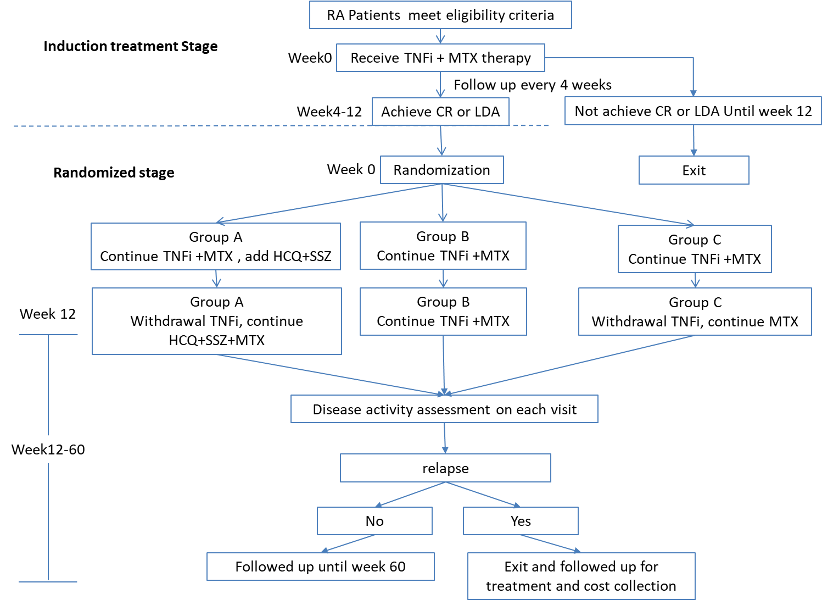Supplementary Figure 1: The flow-chart of the study.
Note: For patients who relapsed during follow up, the study treatment was stopped and patients were referred to appropriate alternative treatments and followed up for cost data collection. csDMARDs: conventional synthetic disease-modifying antirheumatic drugs; MTX: methotrexate; CR: clinical remission; LDA: low disease activity; HCQ: hydroxychloroquine; SSZ: sulfasalazine.
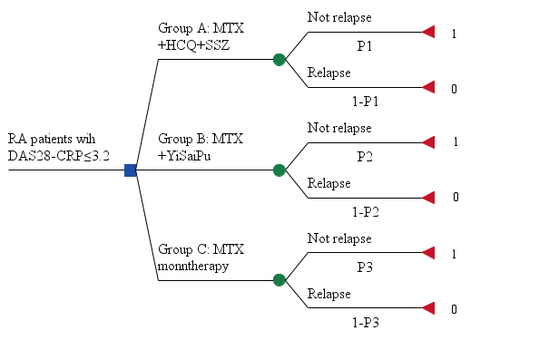
Supplementary Figure 2: The decision tree model of the study. RA: Rheumatoid Arthritis; MTX: methotrexate; HCQ: hydroxychloroquine; SSZ: sulfasalazine; YiSaiPu: Brand name of recombinant human tumor necrosis factor receptor II: IgG Fc fusion protein.

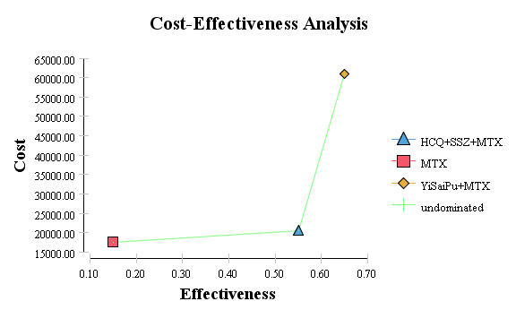
B

A

Supplementary Figure 3: Direct cost-effectiveness analysis (A) and total cost-effectiveness analysis (B). MTX: methotrexate; HCQ: hydroxychloroquine; SSZ: sulfasalazine; YiSaiPu: Brand name of recombinant human tumor necrosis factor receptor II: IgG Fc fusion protein.
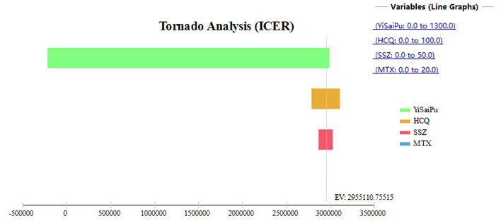
Supplementary Figure 4: Tornado chart of one-way sensitivity analysis of cost of each drug. MTX: methotrexate; HCQ: hydroxychloroquine; SSZ: sulfasalazine; YiSaiPu: Brand name of recombinant human tumor necrosis factor receptor II: IgG Fc fusion protein.

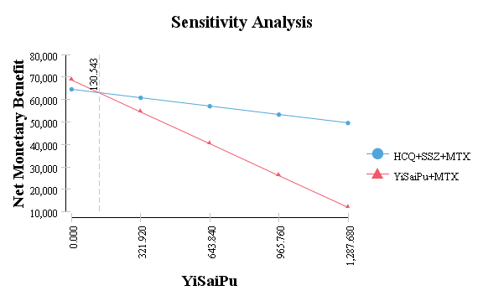
Supplementary Figure 5: One-way sensitivity analysis of cost of YiSaiPu of net monetary benefit of utility in group A (HCQ+SSZ+MTX) and group B (YiSaiPu+MTX). MTX: methotrexate; HCQ: hydroxychloroquine; SSZ: sulfasalazine; YiSaiPu: Brand name of recombinant human tumor necrosis factor receptor II: IgG Fc fusion protein.
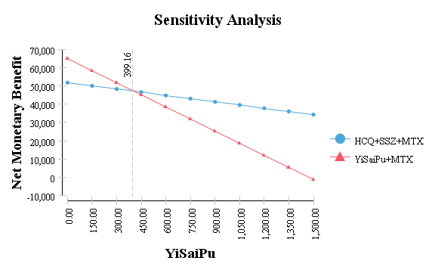
Supplementary Figure 6: One-way sensitivity analysis of cost of YiSaiPu of net monetary benefit of effectiveness in group A (HCQ+SSZ+MTX) and group B (YiSaiPu+MTX). MTX: methotrexate; HCQ: hydroxychloroquine; SSZ: sulfasalazine; YiSaiPu: Brand name of recombinant human tumor necrosis factor receptor II: IgG Fc fusion protein.
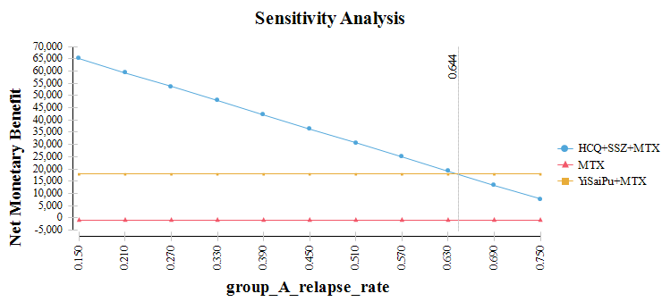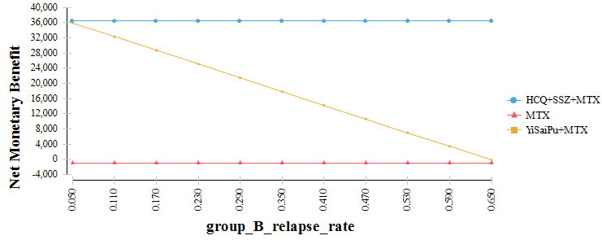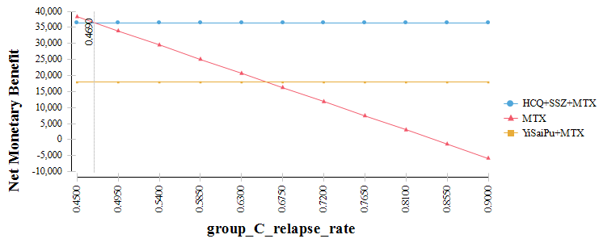
C
B

A

Supplementary Figure 7: One-way sensitivity analysis by varying the relapse rate difference by 30% of the base case among three groups. MTX: methotrexate; HCQ: hydroxychloroquine; SSZ: sulfasalazine; YiSaiPu: Brand name of recombinant human tumor necrosis factor receptor II: IgG Fc fusion protein.

