Supplementary Materials
Details of the AI-assisted polyp detection system
Our AI-assisted polyp detection system is developed on the RetinaNet network model structure. Its core components are a feature pyramid network (FPN), which is combined with the ResNet-50 network, and two submodels, a classification submodel and a regression submodel. The FPN combined with the ResNet-50 network is used to extract features of the input image. The classification submodel is used to identify polyps in the image, and the regression submodel is used for bounding box regression to give the exact position of the polyp. After system training and testing of a total of 117,048 frame images, the sensitivity, specificity, and false-positive per image of our model reached 81.9%, 98.4%, and 6.7%, respectively, and the area under curve (AUC) of the receiver operating characteristic curve was 0.939.
During the detection process, the AI-assisted polyp detection system first works on the current frame image from the colonoscopy video stream, removing the exogenous information thereon for polyp detection [Supplementary Figure 1A]. Immediately thereafter, it begins identifying polyps and recording their pixel coordinates, simultaneously displaying the position on the screen in real time [Supplementary Figure 1B]. Currently, the time to detect a video image on the GeForce GTX 1080 Ti graphics card is 25.8 ms using our system. As the video continues while processing, the system skips two frames for next processing to keep up with the video. The frame skipping method does not affect the polyp imaging or the operator’s visual continuity, for the adjacent frame images are almost same.
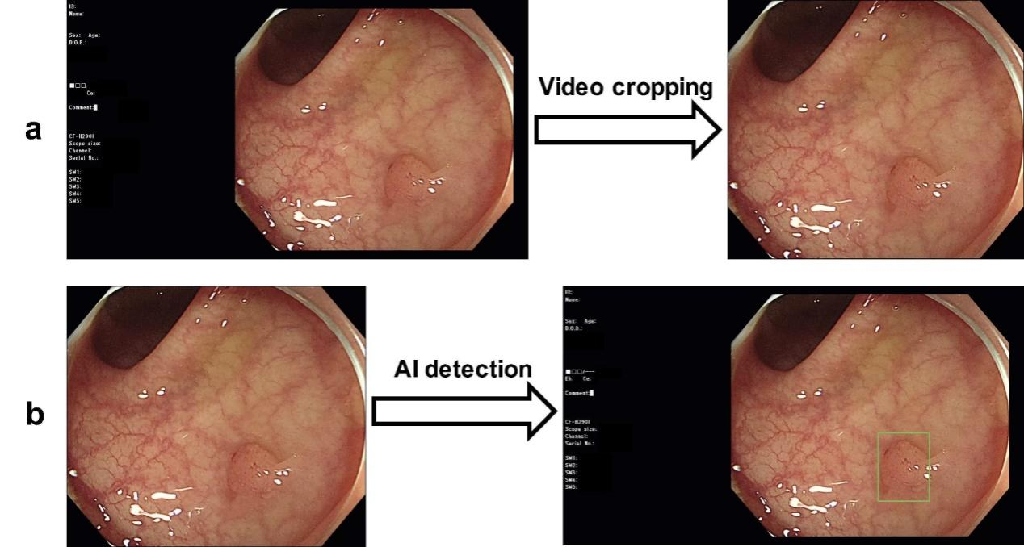
Supplementary Figure 1: (A) Example of video cropping. On the left is an unprocessed video image, and on the right is the sample for polyp detection after removing the exogenous information. (B) Diagram of AI-assisted polyp detection. The left image is a cropped colonoscopy image ready for detection, and the right image shows the real-time feedback during colonoscopy video analysis with a green box indicating the polyp position. AI: Artificial intelligence.

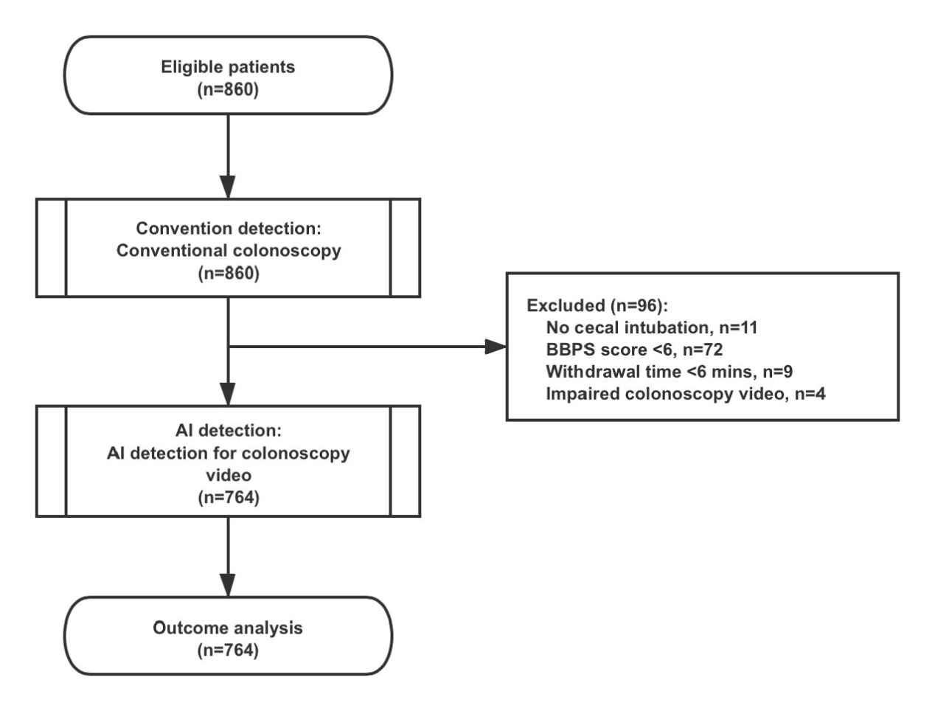

Supplementary Figure 2: Flowchart of patient inclusion. A total of 860 patients were considered for inclusion and underwent conventional colonoscopy (convention detection) at Ningbo Hospital of Zhejiang University, but 96 of them were excluded due to incomplete colonoscopy, poor bowel preparation, short withdrawal time, and impaired colonoscopy video. After that, the colonoscopy videos of 764 patients were analyzed using an AI-assisted polyp detection system (AI detection), and these patients were included in the final outcome analysis. AI: Artificial intelligence; BBPS: Boston bowel preparation scale.
Supplementary Table 1: Patient characteristics.
Clinical features | Descriptive measures
Total patient number, n | 764
Gender (male %) | 56.4%
Age | 51.0
Symptom
None, n (%) | 691 (90.4%)
Abdominal pain, n (%) | 7 (0.9%)
Diarrhea, n (%) | 10 (1.3%)
Constipation, n (%) | 4 (0.1%)
Bloody stools, n (%) | 4 (0.1%)
Mixed symptoms, n (%) | 7 (0.9%)
Other gastrointestinal symptoms, n (%) | 33 (4.3%)
Non-digestive system specific symptoms, n (%) | 8 (1.0%)
Supplementary Table 2: Characteristics of detected polyps.
Features | Convention detection | AI detection | P-value
Polyp location |  |  | 0.286
Right colon, n (%) | 117 (21.1%) | 144 (17.7%)
Transverse colon, n (%) | 121 (21.8%) | 182 (22.4%)
Left colon and rectum, n (%) | 316 (57.0%) | 487 (59.9%)
Polyp size |  |  | <0.001
1–5 mm, n (%) | 357 (64.4%) | 611 (75.2%)
6–9 mm, n (%) | 113 (20.4%) | 117 (14.4%)
≥10 mm, n (%) | 84 (15.2%) | 85 (10.5%)
Polyp morphology* |  |  | <0.001
Ip, n (%) | 26 (4.7%) | 31 (3.8%)
Isp, n (%) | 47 (8.5%) | 53 (6.5%)
Is, n (%) | 409 (73.8%) | 488 (60.0%)
Flat, n (%) | 72 (13.0%) | 241 (29.6%)
*Polyp morphology was categorized according to the Paris classification scheme. Ip stands for protruded and pedunculated, Isp for protruded and subpedunculated, and Is for protruded and sessile.
AI: Artificial intelligence.

Supplementary Table 3: Polyp detection rate by subgroups of operator expertise.
Subgroups* | Convention detection | AI detection | P-value
Junior operators | 34.2% | 43.9% | <0.001
Senior operators | 37.0% | 47.6% | <0.001
*Based on colonoscopy experience, the operators were divided into junior operators (500–1000 colonoscopies) and senior colonoscopists (>10,000 colonoscopies).
AI: Artificial intelligence.

