Supplementary Methods
Bioinformatics analysis
Homology analysis of TMPRSS4 in humans (NP_001167022.1 in protein and NM_001173551.1 in gene in GenBank) and other species was conducted from the National Center for Biotechnology Information (NCBI) (https://www.ncbi.nlm.nih.gov/homologene/80930). The gene and protein expressions of TMPRSS4 in the normal and cancer tissues were performed in the Human Protein Atlas (HPA) (https://www.proteinatlas.org/ENSG00000137648-TMPRSS4).^{[1,2]} The TMPRSS4 expression in different cancer tissues and corresponding normal tissues, isoform, distribution, and domain structures were analyzed using GEPIA 2 (Gene Expression Profiling Interactive Analysis 2) (http://gepia2.cancer-pku.cn/#analysis).^{[3,4]} Survival analysis for cancer patients and TMPRSS4 expression were performed using GEPIA 2.
Cell lines and reagents
The cell lines were purchased from American Type Culture Collection (ATCC). The TMPRSS4 antibody was purchased from Santa Cruz Biotechnology (SCBT) ([A-3], cat #: sc-376415, Dallas, Texas, USA). β-actin was purchased from Sigma-Aldrich (cat #: T0198, Shanghai, China). The HSP70 was purchased from Santa Cruz Biotechnology (SCBT) (cat #: sc-32239, Dallas, Texas, USA. The anti-mouse horseradish peroxidase (HRP) was purchased from Cell Signaling Technology (cat #:7076S, Boston, USA). Cordycepin (CD) (cat #: A0682) and thymoquinone (TQ) were purchased from Chengdu Must Bio-Technology Co. Ltd (Chengdu, Sichuan, China). N⁶,N⁶-dimethyladenosine (m⁶₂A) (cat #: 2620-62-4) was purchased from BOC Sciences (Shirley, NY, USA). The Tween 20 was purchased from Chengdu Kelong Chemical Reagent Factory (cat #:9065-64-5, Chengdu, Sichuan, China). The protease and phosphatase inhibitor cocktail was purchased from Roche (cat #:4693132001, Basel, Switzerland).
Cell cultures
Cancer cell lines H1975, MCF7, 22RV1, and H460 were cultured with 10% serum and 1% penicillin–streptomycin (Gibco) of dulbecco’s modified eagle medium (DMEM) or RPM1640 in 12-well plates. Total RNA or whole protein was extracted after CD, TQ, or m⁶₂A treatment with indicated concentrations for 24 h (0, 10, 20, 40 µmol/L for CD or m⁶₂A, and 0, 5, 10, 20 µmol/L for TQ, respectively). The cells were lysed by 1×EBC buffer (20 mmol/L Tris–HCl, pH 8.0, 125 mmol/L NaCl, 2 mmol/L ethylene diamine tetraacetic acid (EDTA), and 0.5% Nonidet P 40 (NP-40) containing protease and phosphatase inhibitor cocktail. The harvested protein was kept in tubes and stored at −20°C until further processing.
Western blotting
Eight percentage sodium dodecyl sulfate-polyacrylamide gel electrophoresis (SDS-PAGE）gel was used for western blotting. After electrophoresis at 100 V for 100 min, the proteins were transferred to the membrane at 100 V for about 90 min. Then, the membrane was blocked with freshly prepared 5% fat-free milk at room temperature for 2 h. Primary antibodies for TMPRSS4, β-actin, or heat shock protein 70 (HSP70) were incubated in the freshly prepared 2% fat-free milk at 4℃ for overnight, respectively. Washed three times with 1×TBST (Tris-buffered saline containing 0.1% Tween 20) for 15 min each, and the blots were incubated in an anti-mouse HRP secondary antibody with 1:5000 dilutions in 2% fat-free milk for another 2 h; then, washed another three times with 1×TBST for 15 min each. Finally, the blots were exposed and pictures were taken. All experiments were repeated three times.
Semi-quantitative RT-PCR
Primers for TMPRSS4 (NM_019894.4) were as follows: RT-TMPRSS4-5: 5′-ctgaacagcctcgatgtcaa-3′, RT-TMPRSS4-3: 5′-caagggacagtccagctctc-3′. The product size is 225 bp. The ACTB gene served as an internal control. The harvested total RNA was revere transcripted into complementary deoxyribonucleic acid (cDNA). The protocols for semi-quantitative RT-PCR using cDNA were previously described.^{[5]} All experiments were repeated three times.
References
1. Uhlen M, Fagerberg L, Hallstrom BM, Lindskog C, Oksvold P, Mardinoglu A, et al. Proteomics. Tissue-based map of the human proteome. Science 2015;347:1260419. doi: 10.1126/science.1260419.
2. Uhlen M, Zhang C, Lee S, Sjostedt E, Fagerberg L, Bidkhori G, et al. A pathology atlas of the human cancer transcriptome. Science 2017;357:eaan2507. doi: 10.1126/science.aan2507.
3. Tang Z, Li C, Kang B, Gao G, Li C, Zhang Z. GEPIA: A web server for cancer and normal gene expression profiling and interactive analyses. Nucleic Acids Res 2017;45:W98–W102. doi: 10.1093/nar/gkx247.
4. Tang Z, Kang B, Li C, Chen T, Zhang Z. GEPIA2: An enhanced web server for large-scale expression profiling and interactive analysis. Nucleic Acids Res 2019;47:W556–W560. doi: 10.1093/nar/gkz430.
5. Fu J, Zhou B, Zhang L, Balaji KS, Wei C, Liu X, et al. Expressions and significances of the angiotensin-converting enzyme 2 gene, the receptor of SARS-CoV-2 for COVID-19. Mol Biol Rep 2020;47(6):4383-4392. doi: 10.1007/s11033-020-05478-4.

Supplementary figures:
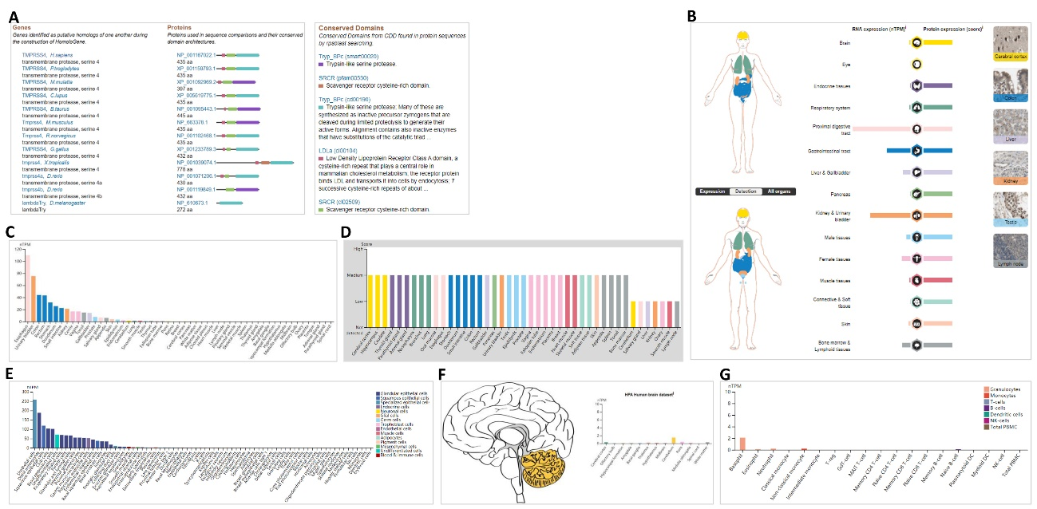

Supplementary Figure 1: The conservation and expression for TMPRSS4. (A) Conservation of TMPRSS4 across different species. (B) An overview of the TMPRSS4 expression and distribution across different human tissues. (C) The expression of TMPRSS4 mRNA in human tissues from the consensus data set. (D) The expression of TMPRSS4 protein in tissues based on the scores of immunohistochemistry. (E) The expression of TMPRSS4 mRNA in human tissues in single-cell types. (F) The expression of TMPRSS4 mRNA in human brain tissues. (G) The expression of TMPRSS4 mRNA in human immune cells. TMPRSS: Transmembrane serine protease.

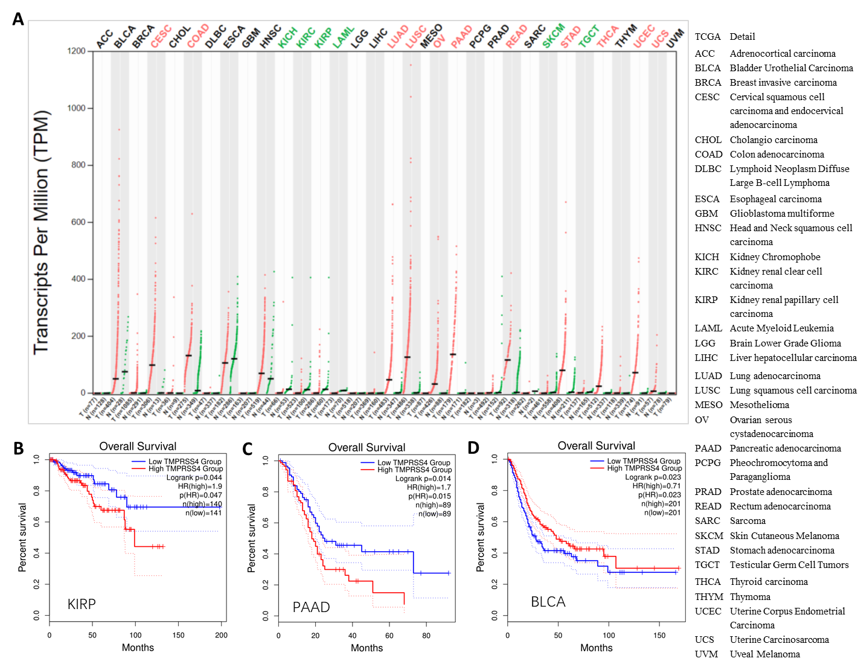
Supplementary Figure 2: The expression of TMPRSS4 across human cancer tissues and corresponding normal tissues. (A) The expression of TMPRSS4 in human cancers and corresponding normal tissues. (B) The overall survival and TMPRSS4 expression in KIRP patients. (C) The overall survival and TMPRSS4 expression in PAAD patients. (D) The overall survival and TMPRSS4 expression in BLCA patients. Right panel indicates the full description of cancer types. Log-rank P-value<0.05 was considered as significant. BLCA: Bladder urothelial carcinoma; KIRP: Kidney renal papillary cell carcinoma; PAAD: Pancreatic adenocarcinoma. TMPRSS: Transmembrane serine protease.

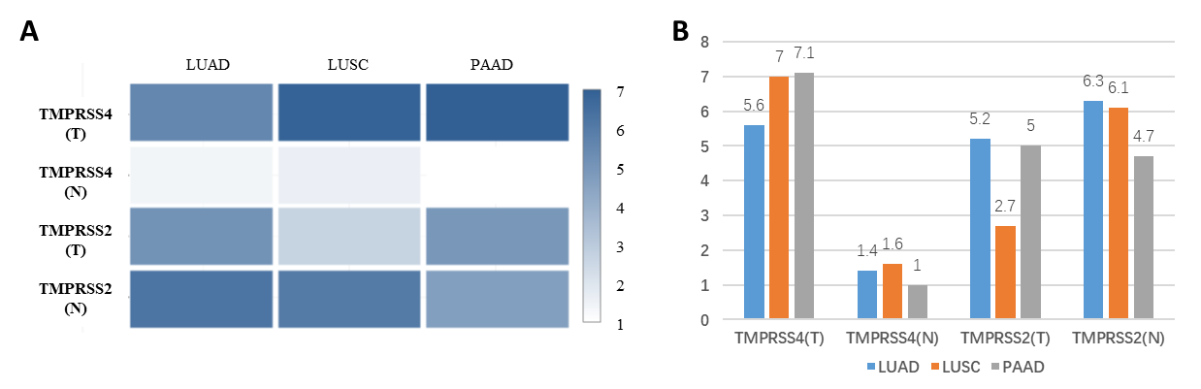
Supplementary Figure 3: The comparisons between TMPRSS4 and TMPRSS2 expressions in LUAD, LUSC, PAAD tissues, and their corresponding normal tissues. (A) The comparisons between TMPRSS4 and TMPRSS2 expressions in LUAD, LUSC, PAAD tissues, and their matched normal tissues. The density of color in each block represents the median expression value in both genes from indicated tissues, normalized by the maximum median expression value across all blocks. Log₂ (TPM + 1) transformed expression data were used to plot quantitative values for the comparisons between TMPRSS4 and TMPRSS2 expressions in LUAD, LUSC, PAAD tissues, and their corresponding normal tissues. (B) Quantitative values for comparisons between TMPRSS4 and TMPRSS2 expressions in LUAD, LUSC, PAAD tissues, and their matched normal tissues. “T” represents tumor tissues for LUAD, LUSC, PAAD, respectively; “N” represents the corresponding normal tissues for LUAD, LUSC, PAAD, respectively. PAAD: Pancreatic adenocarcinoma; LUSC: Lung squamous cell carcinoma; LUAD: Lung adenocarcinoma; TMPRSS: Transmembrane serine protease; TPM: Transcripts per million.

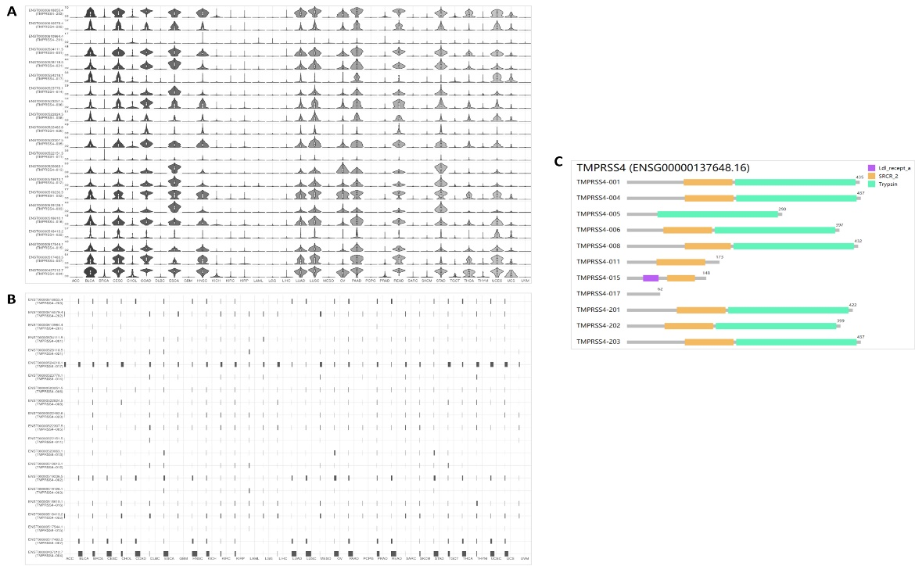
Supplementary Figure 4: The isoforms expression distribution and usage, structure, mutation of TMPRSS4 across pan-cancer tissues. (A) The profiles for the expression of TMPRSS4 isoforms (violin plot). (B) The profiles for the TMPRSS4 isoforms’ distribution (bar plot). (C) TMPRSS4 isoform distribution across pan-cancer tissues. There is not 10 isoforms' information in Figure 4C, including ENST00000517483.5, ENST00000518413.2, ENST00000518610.1, ENST00000519126.1, ENST00000519236.5, ENST00000519813.1, ENST00000520063.1, ENST00000522462.6, ENST00000523770.1, and ENST00000528118.5. ACC: Adrenocortical carcinoma; BLCA: Bladder Urothelial Carcinoma; BRCA: Breast invasive carcinoma; CESC: Cervical squamous cell carcinoma and endocervical adenocarcinoma; CHOL: Cholangio-carcinoma; COAD: Colon adenocarcinoma; DLBC: Lymphoid neoplasm diffuse large B-cell lymphoma; ESCA: Esophageal carcinoma; GBM: Glioblastoma multiforme; HNSC: Head and neck squamous cell carcinoma; KICH: Kidney chromophobe; KIRC: Kidney renal clear cell carcinoma; KIRP: Kidney renal papillary cell carcinoma; LAML: Acute myeloid leukemia; LGG: Brain lower grade glioma; LIHC: Liver hepatocellular carcinoma; LUAD: Lung adenocarcinoma; LUSC: Lung squamous cell carcinoma; MESO: Mesothelioma; OV: Ovarian serous cystadenocarcinoma; PAAD: Pancreatic adenocarcinoma; PCPG: Pheochromocytoma and paraganglioma; PRAD: Prostate adenocarcinoma; READ: Rectum adenocarcinoma; SARC: Sarcoma; SKCM: Skin cutaneous melanoma; STAD: Stomach adenocarcinoma; TGCT: Testicular germ cell tumors; THCA: Thyroid carcinoma; THYM: Thymoma; UCEC: Uterine corpus endometrial carcinoma; UCS: Uterine carcinosarcoma; UVM: Uveal melanoma.

