Supplementary Figure 1. Identification of candidate genes for signature construction. (A) Co-expression of m7G RNA regulators and m7G-related lncRNAs. (B) Venn diagram to visualize DEGs with prognostic values. (C) Heat map to show the DEGs. (D) The prognostic values of candidate genes.
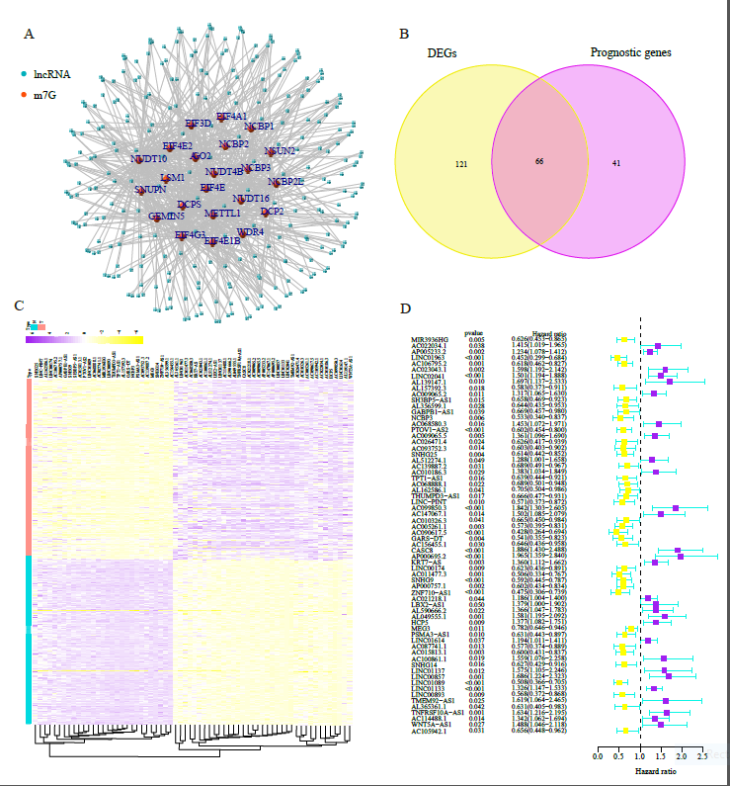

Supplementary Figure 2. Consensus clustering identification of molecular subtypes of PAAD patients. (A) Consensus clustering matrix for k░=░2. (B) Kaplan–Meier overall survival curves for 177 PAAD patients. (C) The distribution of clinicopathological characteristics in cluster 1 and 2 populations was compared. (D) The volcano graphic depicts the DEGs that exist between the cluster 1 and 2 populations. Functional annotation of the DEGs using gene ontology terms involving (E) BP, CC, and MF and (F) KEGG pathway. *P░<░0.05, **P░<░0.01, and ***P░<░0.001.
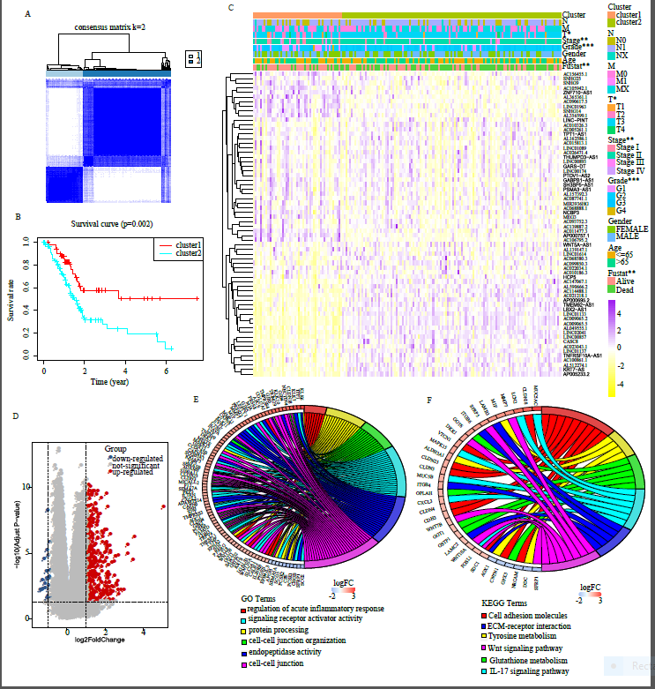

Supplementary Figure 3. Variables screening for construction of m7G-related prognostic signature (A–C) Four genes selected by Least absolute shrinkage and selection operator-Cox regression analysis.

Supplementary Figure 4. Signature construction in train cohort. (A) Grouping of train cohort based on its median signature score. (B) Prognostic indicators and signature score distributes in the train cohort. (C) Survival curve of train cohort. (D) Distributions of the expression profile of four genes used for signature constrcution in the train cohort. The link between clinicopathological variables (including the signature score) and prognostic indicators of PAAD patients in the train cohort was studied using (E) univariate and (F) multivariate Cox regression. (G) AUC values of the time-dependent ROC curves in train cohort.
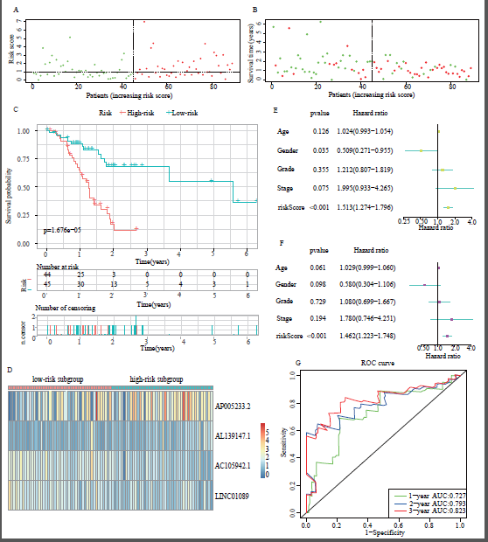

Supplementary Figure 5. Internal validation of the signature in test1 cohort. (A) Grouping of test1 cohort based on train cohort’s median signature score. (B) Prognostic indicators and signature score distributes in the test1 cohort. (C) Survival curve of test1 cohort. (D) Distributions of the expression profile of four genes used for signature constrcution in the test1 cohort. The link between clinicopathological variables (including the risk score) and prognostic indicators of PAAD patients in the test1 cohort was studied using (E) univariate and (F) multivariate Cox regression. (G) AUC values of the time-dependent ROC curves in test1 cohort.
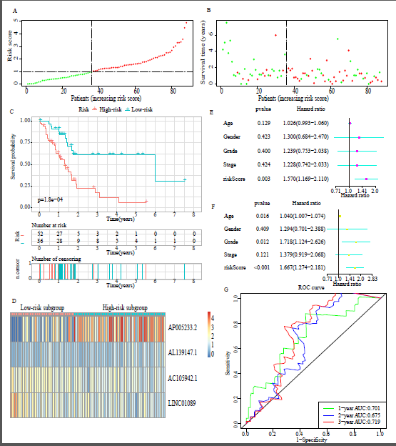

Supplementary Figure 6. Internal validation of the signature in test2 cohort. (A) Grouping of test2 cohort based on train cohort’s median signature score. (B) Prognostic indicators and signature score distributes in the test2 cohort. (C) Survival curve of test2 cohort. (D) Distributions of the expression profile of four genes used for signature constrcution in the test2 cohort. The link between clinicopathological variables (including the risk score) and prognostic indicators of PAAD patients in the test2 cohort was studied using (E) univariate and (F) multivariate Cox regression. (G) AUC values of the time-dependent ROC curves in test2 cohort.
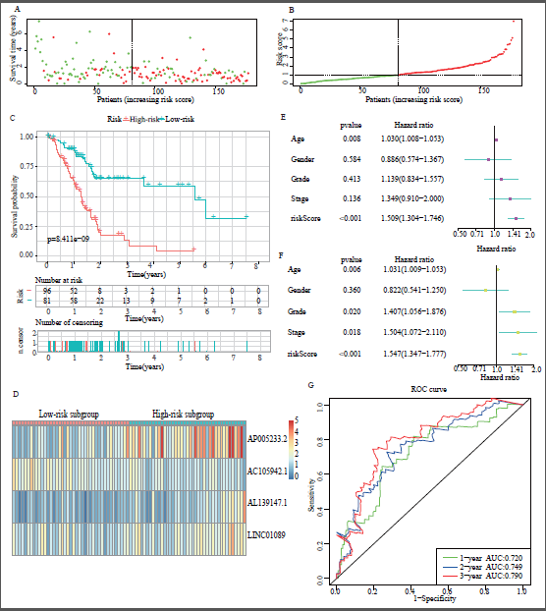

Supplementary Figure 7. External validation of the signature in test3 cohort. (A) Grouping of test3 cohort based on train cohort’s median signature score. (B) Prognostic indicators and signature score distributes in the test3 cohort. (C) Distributions of the expression profile of four genes used for signature constrcution in the test3 cohort. (D) Survival curve of test3 cohort. (E) AUC values of the time-dependent ROC curves in test3 cohort.
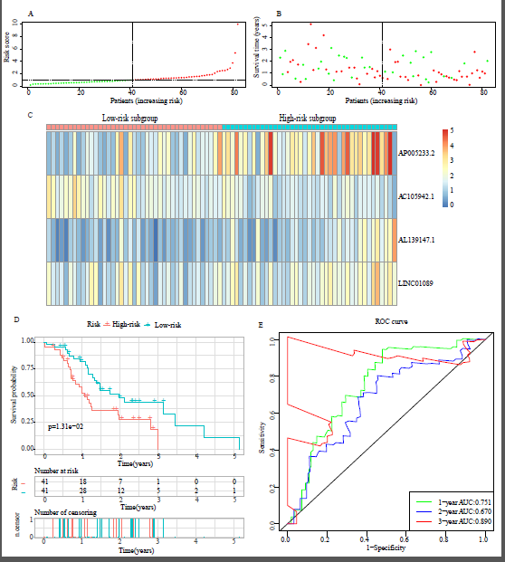

Supplementary Figure 8. The discrepancies in immune cell infiltration and immune checkpoint genes. (A–C) The infiltration landscape of immunocytes in train, test1, and test2 cohorts, respectively. (D–F) Differential expression analysis of immune checkpoint genes in train, test1, and test2 cohorts, respectively.


