Supplementary materials

Methods
Cell culture
The neocortex of p1–p3 rats was separated and put into Dulbecco's modified eagle medium (DMEM, Gibco, Grand Island, NY) with trypsin. After incubation for 30 min in a 37 °C water bath, the mixture was centrifuged for 5 min at 200 g. The cells pellet was suspended in DMEM with 10% fetal bovine serum (FBS, Gibco) and cultured in a 37 °C, 5% CO₂ incubator. The astrocytes were identified by immunofluorescence staining with glial fibrillary acidic protein (GFAP).
Construction of lentiviral vector of GJA1-20k and transduction
The sequence of GJA1-20k gene was constructed and inserted into lentiviral vector (GenScript, Nanjing, China). Five micrograms of LV-GJA1-20k and 1 µL viral packaging vectors were co-transfected into 293T cells. The viral supernatant was taken and filtered by a 0.45 µm filter after a 48 h transduction. The precipitate was obtained by centrifuging 25 min at 3500 g and suspended in phosphate-buffered saline (PBS, 500 µL). The recombinant LV-GJA1-20k was stored at −80 °C. In transduction of LV-GJA1-20k to astrocytes, Lipofectamine™ 2000 (Invitrogen Inc., Carlsbad, CA, USA) was used.
Immunofluorescence staining
Astrocytes were fixed with 4% paraformaldehyde for 20 min and washed thrice with PBS. TritonX-100 (0.3%, Sigma-Aldrich, St. Louis, MO, USA) was applied to break the cell membrane and 1% bovine serum albumin buffer with 5% anti-goat serum was used to block at room temperature for 1 h. The primary antibody of GFAP (1:100, ab7260, Abcam, Cambridge, MA, USA) was incubated with the cells at 4 °C overnight. The secondary-antibody (Goat Anti-Rabbit IgG H&L [Alexa Fluor® 488], ab150077, Abcam) with immunofluorescence was put at 37 °C for 1 h. The images were taken by an Olympus confocal microscope (Olympus, Tokyo, Japan).
Exosome isolation
The astrocytes were cultured in a medium containing 10% exosome-free serum for 48–72 h. The supernatant was used for exosome extraction with differential centrifugation. All the procedures were performed on ice or at 4 ºC.^{[23]} After several times of centrifugation at different speeds, the final pellet was resuspended in 50–100 µL PBS and stored at −80 ºC. The size of the extracted exosomes was measured by Nanosight. The identification of the exosome marker protein was performed by Western blot.
The exosomes (5 µL) resuspended in 4% paraformaldehyde were dropped into the electron microscope mesh for 20 min in a dry environment. After washing with PBS, the exosomes were incubated with 1% glutaraldehyde for 5 min. Then, after washing with distilled water, the exosomes were incubated with uranyl oxalate solution (pH = 7.0) for 5 min, and then with hydroxypropyl methylcellulose on ice for 10 min. After absorbing the excess liquid and waiting for 5–10 min, the exosomes were observed under a transmission electron microscope (TEM).
Establishment of TBI model in rats
A total of 120 adult male Sprague-Dawley rats (300–350 g) were kept in a light (12 h light–dark cycle) controlled room (23 ± 2 °C) and allowed free access to food and water. Fluid percussion injury (FPI) was used for establishment of TBI rat model. The rat was anesthetized by 2% isoflurane with oxygen. After slicing the skin and periosteum along the brain midline, the parietal bone was exposed. A surgical drill was applied to open a small hole at 3.5 mm behind the coronal suture and 3 mm to the sagittal suture. Then the hydraulic equipment was attached to the cortex through the hole with a 3 atm pressure. Next, the skull hole was sealed with wax and the scalp was sutured with thread. The same surgery was performed on the sham rat but without pressure destruction. All experiments and procedures of animals in this research were examined and approved by the animal use committee of the First Affiliated Hospital of Nanchang University.
Animal groups and exosome administration
All the animals were randomly divided into five groups, including Sham group, Sham + Exosome-LV-GJA1-20k group, TBI group, TBI + Exosome-control group, and TBI + LV-GJA1-20k group. Neurological impairment score was tested on the day before TBI and on day 3, day 7, and day 14 after TBI (n = 6 for each group). Brain edema test was performed 3 days after TBI (n = 6 for each group). Lesioned cortices were dissected on day 7 after TBI for Western blot and quantitative reverse transcription polymerase chain reaction (qRT-PCR) (n = 3 for each group). The water maze test was performed on day 19, day 20, and day 21 after TBI (n = 10 for each group). The day of surgery for TBI was set as day 0. Exosomes were administrated once a day from day 0 (the first administration was conducted at 30 min after surgery) to day 7 at the dose of 20 µg/mL in PBS with tail vein injection. Rats in the exosome groups were treated with different exosomes, while rats in the sham and TBI groups were treated with equal volume of PBS.
Measurement of neurological impairment score
Neurological deficit was evaluated by a modified neurological severity score (mNSS). Rats were subjected to exercise (muscular state and abnormal action), sensation (visual, tactile, and balance), and reflex examinations and assigned a mNSS that was recorded when a task was failed to be completed or when the corresponding reflex was lost. The mNSS score was graded on a scale of 0–18, where a total score of 18 points indicated severe neurological deficits and a score of 0 indicated normal performance, 13–18 points indicated severe injury, 7–12 indicated mean-moderate injury, and 1–6 indicated mild injury. When a task was failed to be completed or when the corresponding reflex was lost, a score was assigned and recorded. Neurological function was measured at different time points by investigators who were blinded to group information.
Morris water maze
The experiment was conducted on day 19–day 22 after TBI. The experiment lasted for 4 days and all rats were scheduled to be trained four times a day for a fixed period of time. During the first 3 days’ training, the rats were placed in the pool through four inlet points. The time that the rats took to enter the water to find the underwater concealed platform and stand on it was recorded as the escape latency. The swimming speed was also recorded. The rats were maintained to stay on the plat if they could find it by themselves. If the rats failed to find the platform in 60 s, they were gently pulled onto the platform for 10 s. Each rat was placed in the pool through four water inlet points with a 30 s interval between training sessions. On the fourth day, the rats were placed in the water at the same water inlet point in each quadrant and the number of times that the rats crossed the target quadrant platform in 60 s was recorded and used to evaluate the spatial localization ability of the rats. Ten rats were used for each group. This behavioral experiment was conducted by an experienced person but without knowledge of the experiment design.
Measurement of brain edema
Brain edema was calculated by weighting the wet and dry weight (DW) of the rat brain on day 3 after TBI. Animals were euthanized and the brains without brain stem and cerebellum were weighed immediately to obtain the wet weight (WW), and then put in an oven at 100 °C for 3 days to acquire the DW. The formula was as follows: (WW–DW)/WW × 100%.
RT-PCR
Total RNA was extracted and conducted according to the PrimeScript™ RT reagent kit (Takara, Dalian, China). Glyceraldehyde-3-phosphate dehydrogenase (GAPDH) was set as an internal reference and messenger RNA (Mrna) expression was assayed by SYBR Premix Ex Taq (Takara) with a standard real-time qPCR protocol. The primers were listed as follows. Bax (5′-3′) Forward: GTTTCATCCAGGATCGAGCAG, Reverse: CATCTTCTTCCAGATGGTGA; Bcl-2 (5′-3′) Forward: CCTGTGGATGACTGAGTACC, Reverse: GAGACAGCCAGGAGAAATCA; GAPDH (5′-3′) Forward: GTGAAGGTCGGTGTGAACGG, Reverse: GTTTCCCGTTGATGACCAG.
Western blot
Total proteins were extracted with lysis buffer (Santa Cruz, Dallas, TX, USA) and 20 µg Proteins were separated by sodium dodecyl sulfate–polyacrylamide gel electrophoresis. After being transferred to polyvinylidene fluoride membranes, the membranes was incubated with primary antibodies against primary antibodies of B cell lymphoma (Bcl)-2 (1:400, sc-7382, Santa Cruz), Bax (1:200, sc-7480, Santa Cruz), cleaved-caspase-3 (1:1000, #9661, Cell Signaling, Danvers, MA, USA), Beclin-1 (1:1000, #3495, Cell Signaling), ATG-3 (1:1000, #3415, Cell Signaling), ATG-7 (1:1000, #2631, Cell Signaling), LC3 I/II (1:400, #4108, Abcam), GJA1-20k (1:1000, SAB2900237, Sigma), CD63 (1:500, sc-5275, Santa Cruz), Alix (1:500, sc-53540, Santa Cruz), Tsg101 (1:500, sc-7964, Santa Cruz), and GAPDH (1:5000, #8884, Cell Signaling), respectively, at 4 °C overnight and under the corresponding horseradish peroxidase-linked secondary antibodies at room temperature for 1 h the next day. The protein bands were visualized by enhanced chemiluminescence reagent and analyzed by Image J Software (ImageJ, NIH, Bethesda, MD).
Statistical analysis
The data were shown as the mean ± standard deviation (SD) from at least three repeated experiments. P < 0.05 was considered as statistical significance. Mann–Whitney test, Dunn’s multiple comparisons test, and Tukey’s multiple comparisons test were applied in statistical analysis.

Supplementary figures
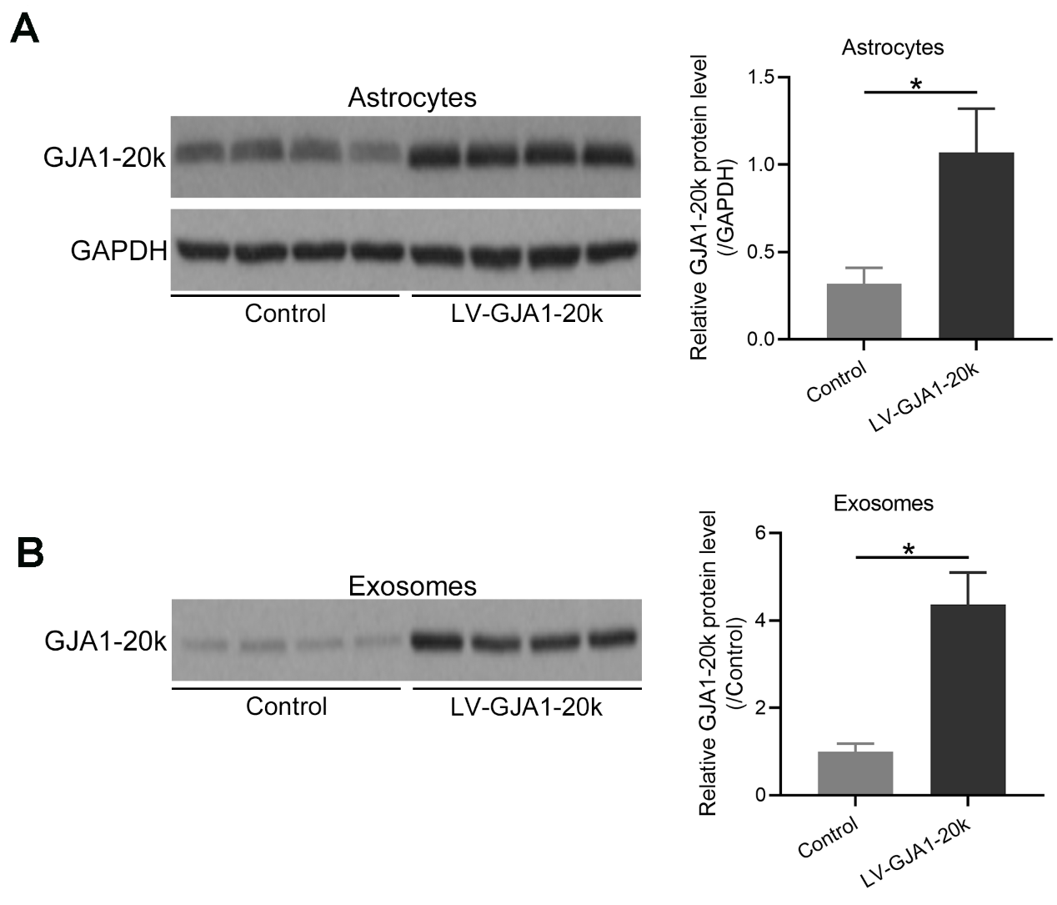
Supplementary Figure 1: Lentiviral vector transduction of GJA1-20k into primary astrocytes upregulated the expressions of GJA1-20k in both primary astrocytes and astrocyte-derived exosomes. Detection of the protein expression of GJA1-20k in primary astrocytes (A) and astrocyte-derived exosomes (B) by Western blotting analysis. N = 4. Data were presented as mean ± SD. ∗P < 0.001; Mann–Whitney test. SD: Standard deviation.
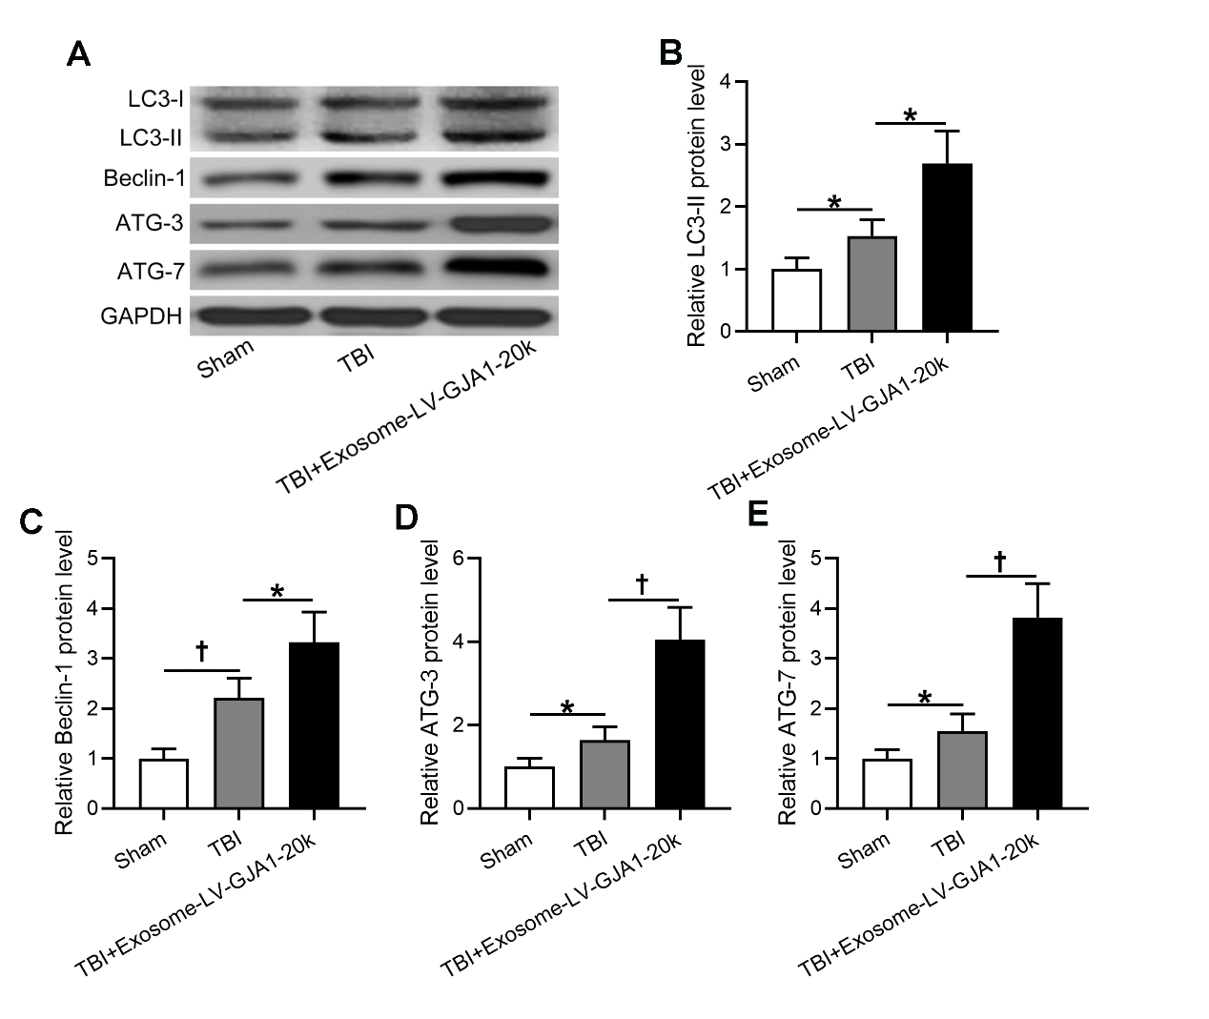
Supplementary Figure 2: Astrocyte-derived exosome-transported GJA1-20k promoted autophagy in the lesioned cortices’ tissues of experimental TBI rats. (A) Western blotting was used to analyze the proteins levels of LC3 I/II, Beclin-1, ATG-3, and ATG-7 in the lesioned cortices’ tissues of experimental rats at 7 days post-injury. The quantifications are shown in (B–E). Data are presented as mean ± SD. N = 3 (10 mixed tissues for each group). ∗P < 0.05, †P < 0.01. One-way ANOVA followed Dunn’s multiple comparisons test. SD: Standard deviation; TBI: Traumatic brain injury.

