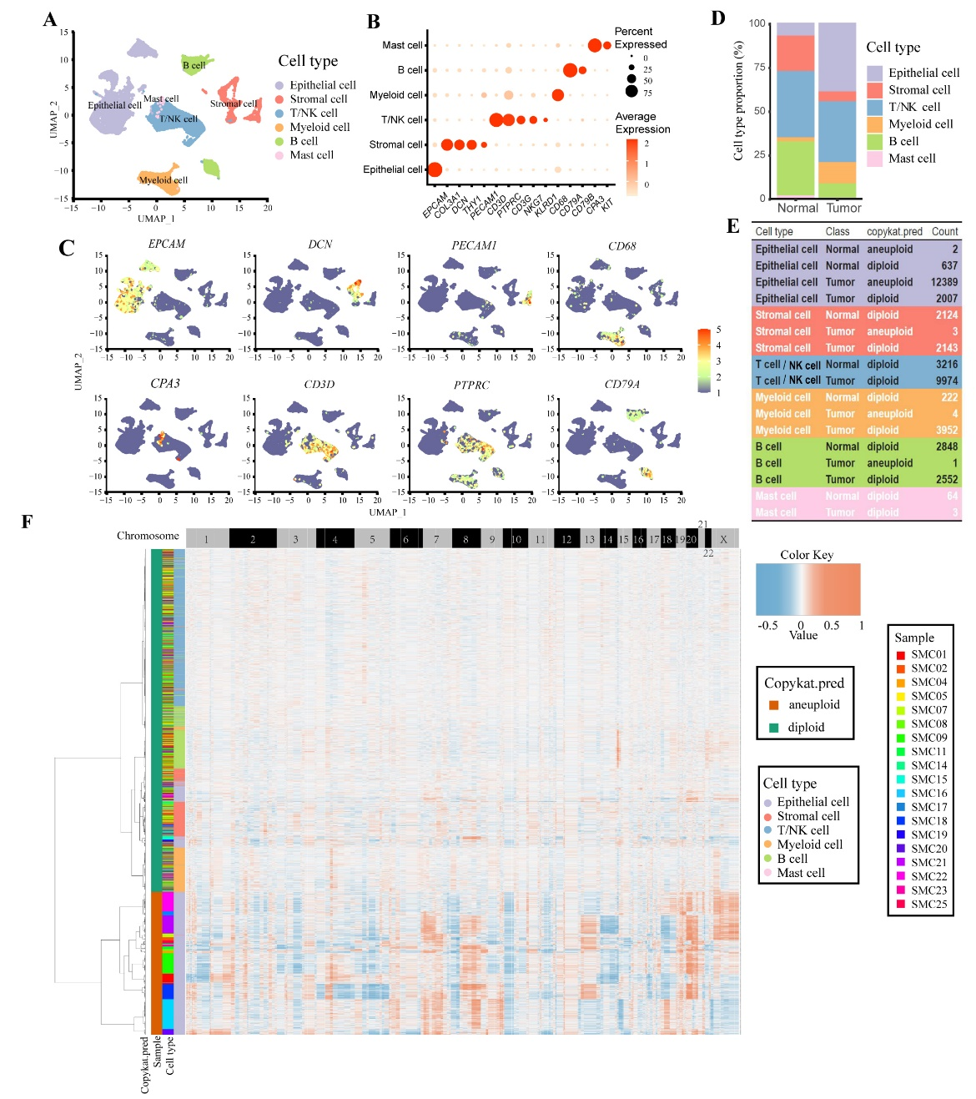
Supplementary Figure 1: Identification of multiple cell types and SCNA heterogeneity in the SMC dataset. (A) 51482 cells in the SMC dataset were clustered into six groups (UMPA plot). (B) Dot plot depicts the expression of known marker genes in these six clusters. (C) The cell type-specific marker genes was used to identify the clusters. (D) Proportions of these six cell types in tumor and normal tissues. (E) Copy number prediction results for all cells obtained through CopyKAT filtering. (F) Heatmap shows the copy number profile of the SMC dataset. NK cell: Natural killer cell; SCNA: Somatic copy number alteration; SMC: The Samsung Medical Center; UMAP: Uniform manifold approximation and projection.

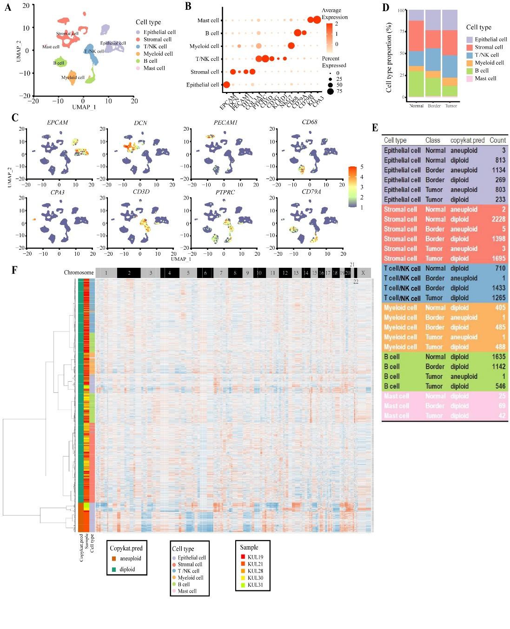
Supplementary Figure 2: Identification of multiple cell types and SCNA heterogeneity in the KUL3 dataset. (A) 21351 cells in the KUL3 were clustered into six groups (UMPA plot). (B) Dot plot depicts the expression of known marker genes in these six clusters. (C) The cell type-specific marker genes was used to identify the clusters. (D) Proportions of these six cell types in tumor, border area of tumor and normal tissues. (E) Copy number prediction results for all cells obtained through CopyKAT filtering. (F) Heatmap shows the copy number profile of the KUL3 dataset. KUL3: The Katholieke Universiteit Leuven 3; NK cell: Natural killer cell; SCNA: Somatic copy number alteration; UMAP: Uniform manifold approximation and projection.

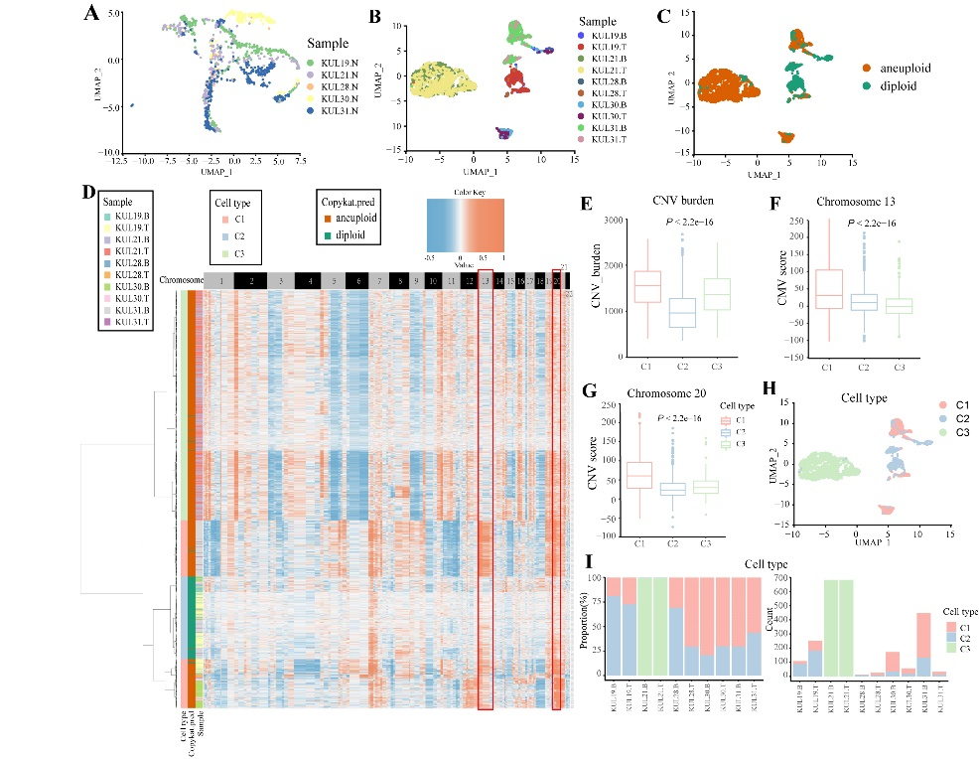
Supplementary Figure 3: Epithelial cells of normal, border area of tumor and tumor tissues in the KUL3 dataset. (A) UMAP plot depicts the spatial distribution of epithelial cells in normal tissue for various samples. (B) UMAP plot depicts the spatial distribution of epithelial cells in tumor and border area of tumor tissue for different samples. (C) UMAP plot shows the spatial distribution of aneuploid and diploid cells in tumor tissue. (D) SCNA heatmap of tumor and border area of tumor cells in the KUL3 dataset. (E) Total CNV burden in three tumor cell cluster. (F) CNV scores of chromosome 13 in three tumor cell cluster. (G) CNV scores of chromosome 20 in three tumor cell cluster.
(H) UMAP plot shows the spatial distribution of clusters C1–C3. (I) Comparison of the cell proportions of the three tumor cell clusters in each sample (left); comparison of the cell numbers of three tumor cell clusters in each sample (right). “B” indicate as border area of tumor tissue; CNV: Copy number variation; “N” indicate as normal tissue; “T” indicate as tumor tissue; KUL3: The Katholieke Universiteit Leuven 3; SCNA: Somatic copy number alteration; UMAP: Uniform manifold approximation and projection.

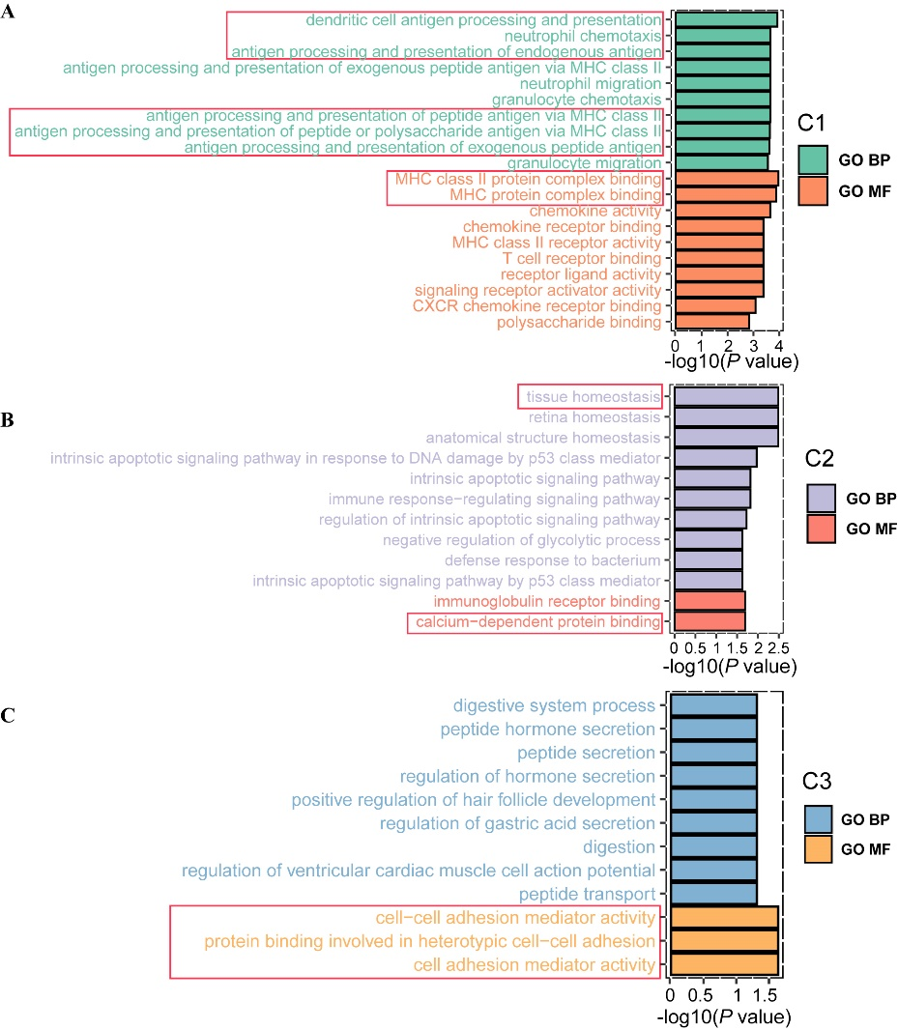
Supplementary Figure 4: Differentially expressed gene analysis of the three SCNA patterns in the SMC dataset. (A) Gene ontology biological process (upper) and molecular function (lower) enrichment terms for upregulated genes in C1. (B) Gene ontology biological process (upper) and molecular function (lower) enrichment terms for upregulated genes in C2. (C) Gene ontology biological process (upper) and molecular function (lower) enrichment terms for upregulated genes in C3. BP: Biological process; MF: Molecular function; SCNA: Somatic copy number alteration; SMC: The Samsung Medical Center.
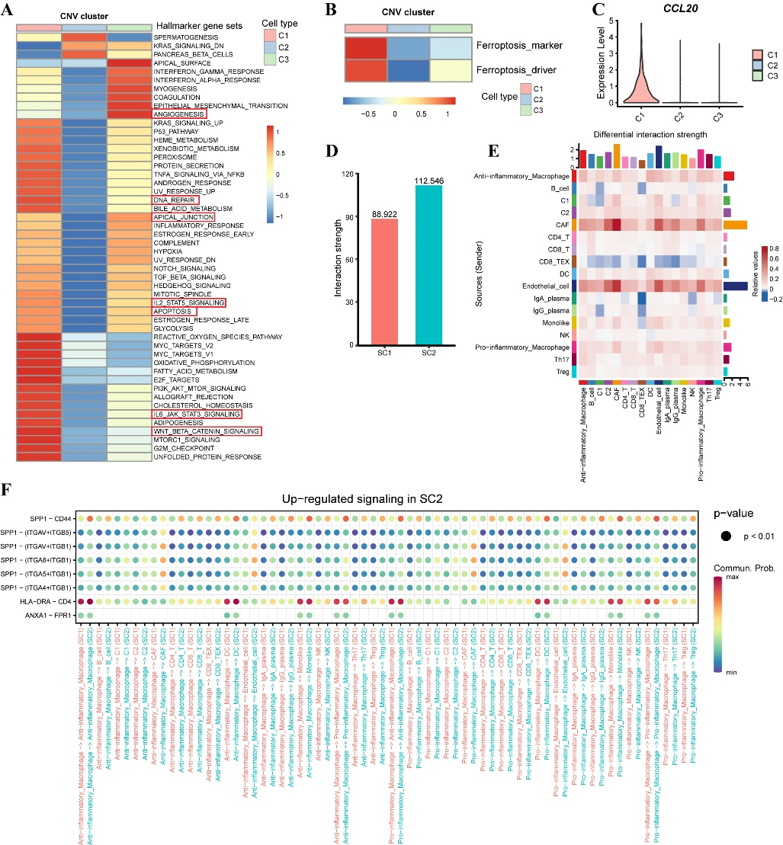
Supplementary Figure 5: Characteristics of the three SCNA clusters in the KUL3 dataset and cell-cell communication differences between SC2 and SC1 in the SMC dataset. (A) Heatmap shows expression of different hallmark gene sets pathways of the three SCNA clusters in GSVA analysis and is colored based on GSVA scores. (B) Heatmap shows expression of different ferroptosis gene sets of the three SCNA clusters by GSVA analysis and is colored by GSVA scores. (C) The gene expression level of CCL20 among three SCNA clusters. (D) Interaction strengths of cells in SC2 and SC1. (E) Heatmap shows differential interaction strength between SC2 and SC1. (F) Dot plot shows upregulated signaling of proinflammatory and anti-inflammatory macrophages in SC2 compared to SC1. KUL3: The Katholieke Universiteit Leuven 3; GSVA: Gene set variation analysis; IL-2: Interleukin 2; IL-6: Interleukin 6; NK cell: natural killer cell; SCNA: somatic copy number alteration; SMC: The Samsung Medical Center; STAT: Signal transducer and activator of transcription.

