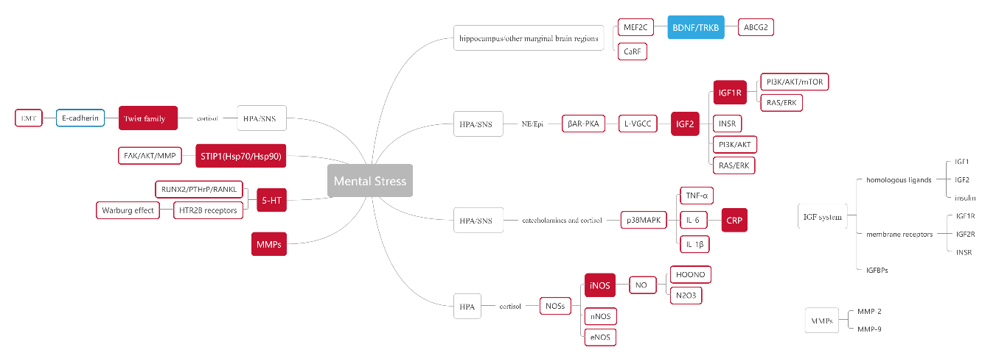

Supplementary Figure 1: The link between mental stress and tumor occurrence and development. ABCG2: ATP binding cassette G2; βAR-PKA: β-adrenergic receptor-protein kinase A; BDNF: Brain-derived neurotrophic factor; CaRF: Calcium response factor; CRP: C-reactive protein; EMT: Epithelial-mesenchymal transition; eNOS: Endothelial-type nitric oxide synthase; HOONO: Peroxynitrite; HPA: Hypothalamic-pituitary-adrenal; Hsp: Heat shock protein; 5-HT: Serotonin; HTR: Serotonin receptor; IGF: Insulin-like growth factor; IGFBPs: IGF-binding proteins; IL: Interleukin; iNOS: Inducible nitric oxide synthase; INSR: Insulin receptor; L-VGCC: L voltage-gated calcium channel; MEF2C: Myocyte enhancer factor 2C; MMPs: Matrix metalloproteinases; nNOS: Neuronal-type nitric oxide synthase; NO: Nitric oxide; NOSs: Nitric oxide synthases; N2O3: Nitrogen trioxide; p38 MAPK: p38 mitogen-activated protein kinase; PI3K: Phosphatidyl inositol 3-kinase; SNS: Sympathetic nervous system; STIP1: Stress-induced phosphoprotein 1; TNF-α: Tumor necrosis factor-α; TRKB: Tyrosine kinase receptor 2.

