Supplementary Materials
Methods
Study design and selection of participants
This study employed a cross-sectional study design. A total of 835 residents aged ≥60 years were recruited from three villages in Doumen town, Shaoxing, and Zhejiang Province between May 1, 2019, and September 1, 2019. People with malignancies, chronic liver or renal diseases, gout, or amputation and (b) important information deficits were excluded. Following the inclusion and exclusion criteria, 633 older people were include in analysis. Of all study subjects, 80% of participants (n =507) were randomly selected as the training dataset, and the remaining 20% (n =126) consisted the validating dataset. Sarcopenia was diagnosed according to diagnostic criteria published by Asian Working Group for Sarcopenia (AWGS) in 2019: Grip strength <28 kg in men and <18 kg in women were defined as low handgrip strength; 6 m walking speed <1 m/s was defined as low gait speed; appendicular skeletal muscle mass index <7.0 kg/m² in men and <5.7 kg/m² in women detected by bioelectrical impedance analysis were defined as low muscle mass. People with low muscle mass plus either low handgrip strength or low gait speed got diagnosed with sarcopenia.
Data collection
The protocol of data extraction in this study was based on the Strengthening the Reporting of Observational studies in Epidemiology (STORBE ) guideline. Demographic data such as age and gender were collected. The grip strength and 6 m walking speed were measured. The appendicular skeletal muscle mass (ASM) was evaluated using bioelectrical impedance analysis (BIA). The appendicular skeletal muscle mass index was derived from ASM (kg) divided by height (m) squared. In order to make the sarcopenia screening more practical, we collected the routine healthy checkup items in China, including liver function (alanine aminotransferase [ALT], aspartate aminotransferase [AST], and cholinesterase); renal function (serum urea nitrogen, and creatinine); proteometabolism (total serum protein, albumin, and prealbumin); purine metabolism (uric acid [UA]); glycometabolism (glycated hemoglobin, fasting blood glucose, and fasting insulin), and lipid metabolism (high-density lipoprotein, low-density lipoprotein, triglyceride, and cholesterol).
Measurement of grip strength and walk speed
Grip strength was measured using hydraulic gripper. The walking distance was set as 6 m, and 10 m of measuring space was reserved, i.e., there were 2 m of acceleration or deceleration buffer zones before the starting point and after the end point, respectively. The timer start when participants' one foot cross the starting point and stop when one foot cross the finish line. The measure was repeated twice, and the average was the result of 6 m walking speed.
Statistical analysis
All statistical analyses were performed using SPSS statistical software package (version 25.0) and R software (version 4.0.2). First, we checked all data for missing values (missing abundances ＜20%), then the k-nearest neighbor algorithm was used to fill the missing values. Kolmogorov–Smirnov test was used for the normality test in continuous variables. Descriptive characteristics were presented as mean ± standard deviation (SD) for normal distribution of continuous variables, medians with the 25th percentile and 75th percentile for non-normal distribution of continuous variables, and count with percentage for categorical variables. Continuous data were evaluated using t-test (normal distribution) or Mann–Whitney U-test (non-normal distribution), and categorical variables were evaluated using the chi-squared test or fisher’s exact test. To identify independent diagnostic factors, we performed multivariate logistic regression analyses with a forward stepwise method based on the training dataset. A nomogram was constructed based on the final selected prognostic factors to predict the probability of getting sarcopenia by using regplot package of R (version 4.0.2). The regression coefficient of each independent factor in the model was used to assign scores to each factor, and then the total score was obtained by adding all scores. Finally, the predicted value of the outcome event was calculated through the function conversion relationship between the total score and the probability of the outcome event. The discrimination capacity of the model was accessed by calculating the area under the receiver operating characteristic (ROC) curve (AUC). Models are generally interpreted as excellent for test AUC > 0.90, good for 0.80 < AUC < 0.90, acceptable for 0.70 < AUC < 0.80, bad for 0.60 < AUC < 0.70 and invalid for 0.50 < AUC < 0.60. And the calibration capacity, representing the difference between the predicted value of the model and the actual value, was evaluated by the Hosmer–Lemeshow test. Data were considered statistically significant at P < 0.05.

Supplementary Table 1: Clinical and laboratory characteristics of participants enrolled in the training dataset.

Items | All participants (n = 507) | Non-sarcopenia (n = 410) | Sarcopenia (n = 97) | t/Z/χ² | P-value
Age (years) | 69.0 (64.0–73.0) | 69.0 (64.0–72.0) | 71.0 (66.0–75.0) | 3.7‡ | <0.001
Male | 246 (48.5) | 189 (46.1) | 57 (58.8) | 5.0§ | 0.025
With coexisting disorders* | 372 (73.4) | 305 (74.4) | 67 (69.1) | 1.1§ | 0.287
BMI (kg/m²) | 23.4 ± 3.0 | 24.3 ± 2.5 | 19.7 ± 1.5 | 17.2† | <0.001
Grip strength (kg) | 20.4 (15.1–27.0) | 22.2 (16.3–28.9) | 15.8 (11.6–19.4) | 7.4‡ | <0.001
6 m walking speed (m/s) | 1.1 (0.9–1.2) | 1.1 (1.0–1.2) | 1.0 (0.8–1.2) | 2.8‡ | 0.005
^{c}ASMI (kg/m²) | 7.1 (6.2–8.0) | 7.4 (6.7–8.2) | 5.5 (5.1–6.3) | 12.9‡ | <0.001
Blood routine examination
White blood cell count (×10⁹/L) | 5.7 (4.9–6.8) | 5.8 (5.0–6.8) | 5.3 (4.4–6.3) | 3.4‡ | 0.001
Red blood cell count (×10¹²/L) | 4.5 (4.3–4.8) | 4.6 (4.3–4.9) | 4.3 (4.1–4.6) | 5.3‡ | <0.001
Hemoglobin (g/L) | 140.0 (131.0–151.0) | 142.0 (132.0–153.0) | 135.0 (125.5–143.0) | 4.9‡ | <0.001
Platelet count (×10⁹/L) | 213.2 ± 53.4 | 213.3 ± 52.2 | 212.6 ± 58.5 | 0.1† | 0.909
Glycometabolism
Glycated hemoglobin (%) | 5.6 (5.3–5.8) | 5.6 (5.3–5.9) | 5.5 (5.2–5.7) | 2.7‡ | 0.006
Fasting blood glucose (mmol/L) | 5.2 (4.8–5.7) | 5.2 (4.9–5.8) | 5.1 (4.8–5.6) | 1.5‡ | 0.140
Fasting insulin (mmol/L) | 4.6 (2.8–7.7) | 5.0 (3.1–8.3) | 3.1 (2.2–4.5) | 6.2‡ | <0.001
Liver function
ALT (U/L) | 18.0 (14.1–23.7) | 18.7 (14.9–24.1) | 14.9 (11.0–20.3) | 4.9‡ | <0.001
AST (U/L) | 21.3 (18.3–25.4) | 21.4 (18.5–25.4) | 21.0 (17.8–25.9) | 1.2‡ | 0.212
Cholinesterase (U/L) | 7986.3 ± 1674.4 | 8155.8 ± 1648.1 | 7270.0 ± 1601.4 | 5.4† | <0.001
Renal function
Serum urea nitrogen (mmol/L) | 5.3 (4.5–6.3) | 5.3 (4.5–6.3) | 5.4 (4.5–6.3) | 0.1‡ | 0.958
Creatinine (μmol/L) | 66.0 (57.0–74.0) | 66.0 (58.0–74.3) | 60.0 (52.0–70.0) | 3.2‡ | 0.002
Purine metabolism
UA (μmol/L) | 338.0 (292.0–392.0) | 350.0 (304.0–401.0) | 289.0 (241.5–341.5) | 7.5‡ | <0.001
Proteometabolism
Total serum protein (g/L) | 74.7 (71.4–77.2) | 74.8 (71.5–77.4) | 74.1 (71.2–77.1) | 1.0‡ | 0.331
Albumin (g/L) | 47.3 ± 2.3 | 47.4 ± 2.3 | 47.1 ± 2.3 | 1.1† | 0.293
Prealbumin (mg/L) | 255.0 (228.0–286.0) | 260.0 (231.0–290.0) | 234.0 (199.5–264.5) | 4.8‡ | <0.001
Lipid metabolism
High-density lipoprotein (mmol/L) | 1.3 (1.1–1.5) | 1.2 (1.1–1.4) | 1.4 (1.2–1.6) | 4.4‡ | <0.001
Low-density lipoprotein (mmol/L) | 2.7 (2.2–3.2) | 2.8 (2.3–3.3) | 2.6 (2.1–3.1) | 1.8‡ | 0.072
Triglyceride (mmol/L) | 1.3 (0.9–1.9) | 1.4 (0.9–1.9) | 1.0 (0.7–1.4) | 4.5‡ | <0.001
Cholesterol (mmol/L) | 4.7 ± 0.9 | 4.8 ± 0.9 | 4.6 ± 0.9 | 1.3† | 0.195

* Coexisting disorders including hypetension, diabetes, cardiovascular disease, chronic obstructive pulmonary disease, and gastrointestinal diseases；†t values; ‡ Z values; §χ² values;
BMI: Body mass index; ASMI: Appendicular skeletal muscle mass index. ALT: Alanine aminotransferase; AST: aspartate aminotransferase; UA: Uric acid.

Supplementary Table 2: Multivariable associations between the predictor variables and sarcopenia.
Parameters | Beta | Wals χ² value | OR (95% CI) | P-value
BMI (kg/m²) | −1.417 | 63.231 | 0.242 (0.171–0.344) | <0.001
Age (years) | 0.187 | 23.024 | 1.206 (1.117–1.301) | <0.001
*Gender | 1.402 | 8.543 | 4.063 (1.587–10.402) | 0.003
ALT (U/L) | −0.035 | 4.699 | 0.966 (0.936–0.997) | 0.030
UA (μmol/L) | −0.013 | 11.956 | 0.987 (0.980–0.994) | 0.001
*Females were assigned as “0” and males were assigned as “1”. ALT: Alanine aminotransferase; BMI: Body mass index; CI: Confidence interval; OR: Odd ratio; UA: Uric acid.
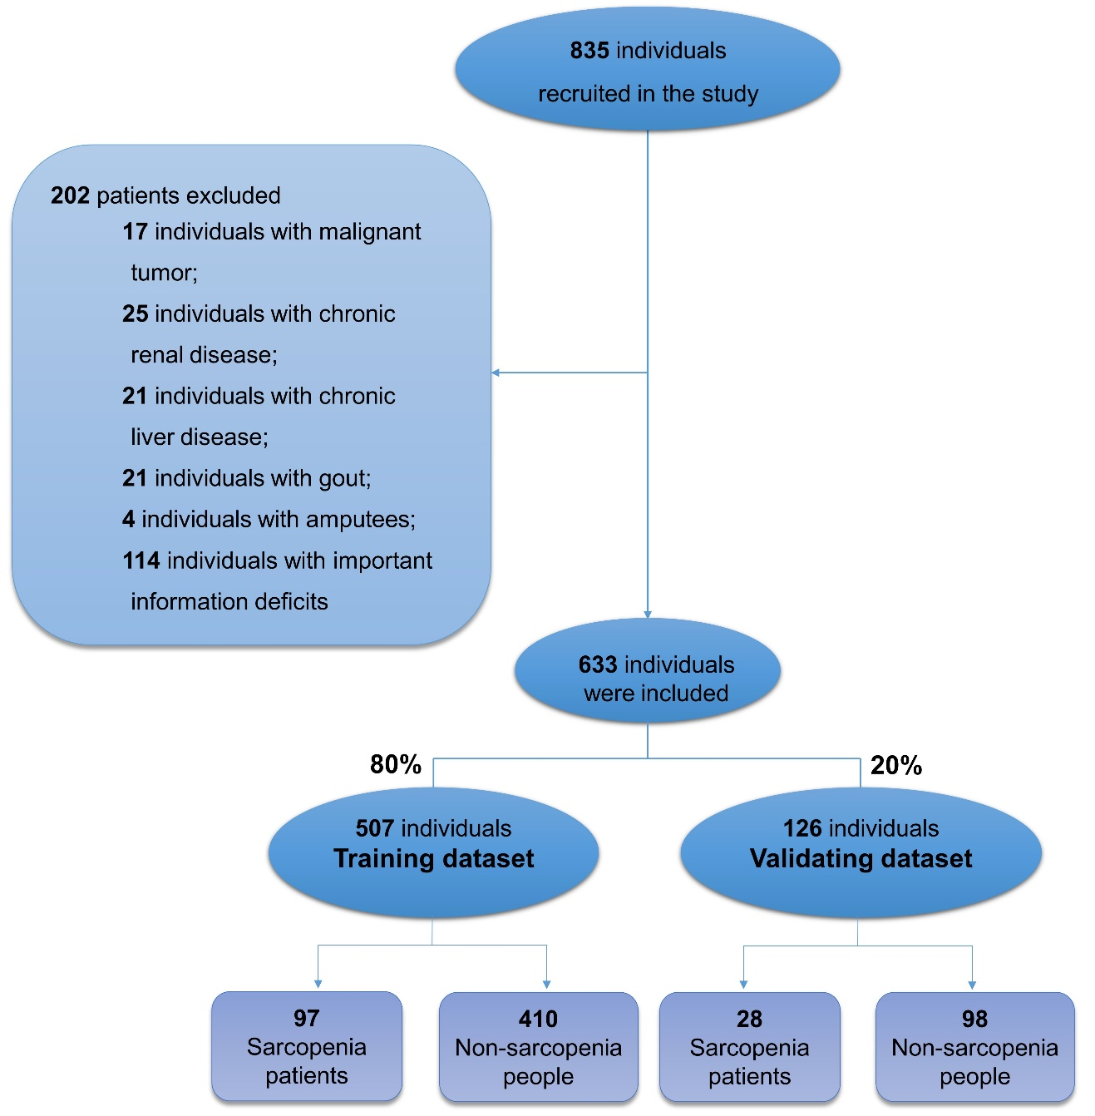
Supplementary Figure 1: Flow chart of participants screening.

