Complete (N = 86)
Quit the test (N = 6)
Reasons:
- Death (N = 6)

Group B (N = 156)
Group A (N = 156)

PPS set: Group B (N = 93)
PPS set: Group A (N = 92)
Eliminate nonconformances (N = 64):
Reasons:
- 1. Unsatisfactory effect (N = 19)
- 2. Intolerable adverse events (N = 3)
- 3. Lost to follow-up (N = 12)
- 4. Subject withdrawal (N = 5)
- 5. Subjects have poor compliance (N = 10)
- 6. Use of prohibited drugs (N = 5)
- 7. Other (N = 10)
Eliminate nonconformances (N=63):
Reasons:
- 1. Unsatisfactory effect (N = 10)
- 2. Intolerable adverse events (N = 8)
- 3. Lost to follow-up (N = 18)
- 4. Subject withdrawal (N = 4)
- 5. Subjects have poor compliance (N = 11)
- 6. Use of prohibited drugs (N = 4)
- 7. Other (N = 8)

The treatment was double-blind (N = 312)
Screening (N = 312)
Screening of failure (N = 0)
Untreated (N = 0)

Randomization (N = 312)
Complete (N = 77)
Quit the test (N = 16)
Reasons:
- 1. Tracheotomy (N = 2)
- 2. Death (N = 13)
- 3. Fall off (N = 1)

Supplementary Figure 1: Study flow chart.
PPS：per protocol set
，

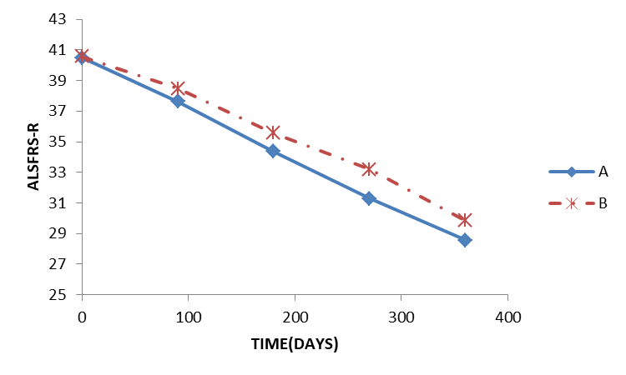
Supplementary Figure 2: Changes in ALSFRS-R scores at different visits in the two groups (A: placebo group, B: NBP group). ALSFRS-R: Revised Amyotrophic Lateral Sclerosis Functional Rating Scale; NBP: DL-3-n-butylphthalide.
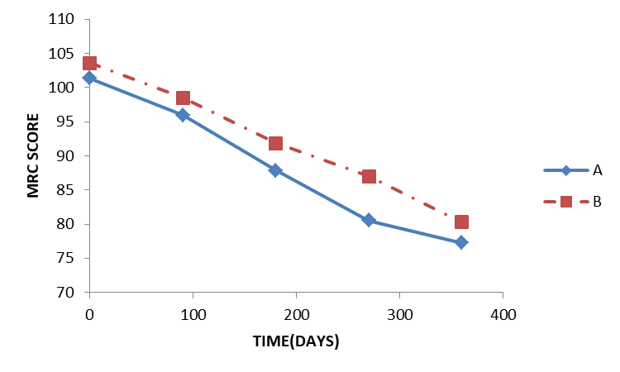
Supplementary Figure 3: Changes in MRC scores at different visits in the two groups (A: placebo group, B: NBP group). MRC: Medical Research Council; NBP: DL-3-n-butylphthalide.
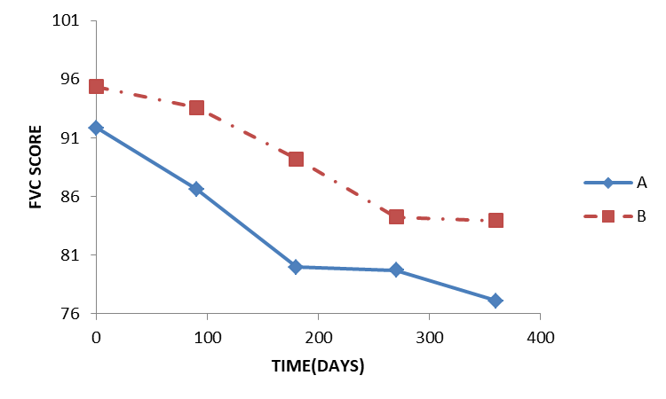
Supplementary Figure 4: Changes in predicted percentages of FVC at different visits in the two groups (A: placebo group, B: NBP group). FVC: Forced vital capacity; NBP: DL-3-n-butylphthalide.
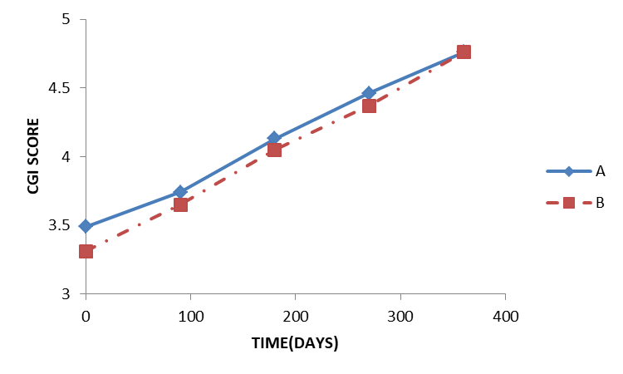
Supplementary Figure 5: Changes in CGI scores at different visits in the two groups (A: placebo group, B: NBP group). CGI: Clinical global impression; NBP: DL-3-n-butylphthalide.

Supplementary Table 1: Baseline characteristics of patients with ALS in the two groups.
Clinical features | NBP (n = 93) | Placebo (n = 92) |  | P-value
Gender ratio (M/F) | 61/32 | 70/22 | χ²⁼2.46 | 0.12
Age at the first visit | 54.87 ± 10.39 | 52.80 ± 10.20 | Z = 1.35 | 0.18
Duration from onset to presentation (day) | 11.90± 4.60 | 11.60 ± 4.30 | Z = 0.44 | 0.67
Site of onset (upper/lower/both limb) | 38/10/45 | 37/10/45 | χ² = 0.01 | 0.10
Bulbar involved at the first visit (Y/N) | 37/56 | 34/58 | χ² = 0.16 | 0.690
BMI (kg/m²) | 23.84 ± 3.37 | 23.70 ± 3.41 | Z = 0.14 | 0.89
ALS-FRS | 40.58 ± 3.88 | 40.49 ± 4.28 | Z = 0.06 | 0.95
FVC | 95.36 ± 13.88 | 91.82 ± 15.01 | Z = 1.65 | 0.10
Total MRC score | 103.57 ± 11.44 | 101.34 ± 10.33 | Z = 1.90 | 0.06
CGI 1 | 3.31 ± 0.86 | 3.49 ± 0.87 | Z = 1.28 | 0.20
ALS: Amyotrophic lateral sclerosis; ALSFRS-R: Revised Amyotrophic Lateral Sclerosis Functional Rating Scale; BMI: Body mass index; CGI: Clinical Global Impression; FVC: Forced vital capacity; MRC: Medical Research Council; NBP: DL-3-n-butylphthalide.
Supplementary Table 2: Changes in ALSFRS-R scores between the two groups at different visits.
ALSFRS-R # (n1/n2) | NBP (mean ± SD) | Placebo (mean ± SD) |  | P-value
ALSFRS-R 1 (93/92) | 40.58 ± 3.88 | 40.49 ± 4.28 | Z = 0.06 | 0.95
ALSFRS-R 2 (87/92) | 38.48 ± 5.28 | 37.63 ± 5.72 | Z = 0.98 | 0.33
ALSFRS-R 3 (86/89) | 35.57 ± 6.58 | 34.35 ± 6.66 | Z = 1.25 | 0.21
ALSFRS-R 4 (80/87) | 33.18 ± 8.24 | 31.28 ± 7.40 | Z = 1.71 | 0.09
ALSFRS-R 5 (76/84) | 29.83 ± 9.13 | 28.55 ± 7.95 | Z = 0.90 | 0.37
ALSFRS-R: Revised Amyotrophic Lateral Sclerosis Functional Rating Scale; NBP: DL-3-n-butylphthalide; SD: Standard deviation.
ALSFRS-R 1: before treatment; ALSFRS-R 2: 3 months after treatment; ALSFRS-R 3: 6 months after treatment; ALSFRS-R 4: 9 months after treatment; ALSFRS-R5: 12 months after treatment; n1: Number of patients in the NBP group; n2: Number of patients in the placebo group.
Supplementary Table 3: Differences in total MRC scores between the two groups at different visits.
Total MRC score # (n1/n2) | NBP (mean ± SD) | Placebo (mean ± SD) |  | P-value
Total MRC score 1 (93/92) | 103.57 ± 11.44 | 101.34 ± 10.33 | Z = 1.90 | 0.06
Total MRC score 2 (83/91) | 98.46 ± 14.87 | 95.92 ± 13.22 | Z = 1.56 | 0.12
Total MRC score 3 (81/84) | 91.83 ± 17.9 | 87.81 ± 16.28 | Z = 1.72 | 0.08
Total MRC score 4 (71/77) | 87.01 ± 19.92 | 80.51 ± 18.65 | Z = 2.16 | 0.03
Total MRC score 5 (55/63) | 80.27 ± 22.10 | 77.25 ± 16.88 | Z = 0.88 | 0.38
MRC: Medical Research Council; NBP: DL-3-n-butylphthalide; SD: Standard deviation.
n1: Number of patients in the NBP group; n2: Number of patients in the placebo group; Total MRC score 1: Before treatment; Total MRC score 2: 3 months after treatment; Total MRC score 3: 6 months after treatment; Total MRC score 4: 9 months after treatment; Total MRC score 5: 12 months after treatment.
Supplementary Table 4: Differences in predicted percentages of FVC between the two groups at different visits.
%FVC # (n1/n2) | NBP (mean ± SD) | Placebo (mean ± SD) |  | P-value
%FVC 1 (86/89) | 95.36 ± 13.88 | 91.82 ± 15.01 | Z = 1.65 | 0.10
%FVC 2 (63/72) | 93.57 ± 15.10 | 86.61 ± 17.35 | Z = 2.65 | 0.01
%FVC 3 (62/63) | 89.20 ± 18.96 | 79.98 ± 21.86 | Z = 2.83 | 0.01
%FVC 4 (54/51) | 84.25 ± 17.57 | 79.69 ± 25.38 | Z = 1.20 | 0.23
%FVC 5 (43/39) | 83.94 ± 18.99 | 77.08 ± 22.86 | Z = 1.52 | 0.13
FVC: Forced vital capacity; NBP: DL-3-n-butylphthalide; n1: Number of patients in the NBP group; n2: Number of patients in the placebo group; SD: Standard deviation.
%FVC: Percentage of predicted FVC; %FVC 1: Before treatment; %FVC 2: 3 months after treatment; %FVC 3: 6 months after treatment; %FVC 4: 9 months after treatment; %FVC 5: 12 months after treatment.
Supplementary Table 5: Differences in CGI between the two groups at different visits.
CGI # (n1/n2) | NBP (mean ± SD) | Placebo (mean ± SD) |  | P-value
CGI 1(93/92) | 3.31 ± 0.86 | 3.49 ± 0.87 | Z = 1.28 | 0.20
CGI 2 (84/91) | 3.65 ± 0.88 | 3.74 ± 0.80 | Z = 0.76 | 0.45
CGI 3 (82/84) | 4.05 ± 0.93 | 4.13 ± 0.94 | Z = 0.34 | 0.73
CGI 4 (75/78) | 4.37 ± 0.94 | 4.46 ± 1.00 | Z = 0.38 | 0.71
CGI 5 (67/71) | 4.76 ± 1.10 | 4.76 ± 1.05 | Z = 0.06 | 0.95
NBP: DL-3-n-butylphthalide; SD: Standard deviation.
CGI: Self-administered Clinical Global Impression scale; CGI 1: Before treatment; CGI 2: 3 months after treatment; CGI 3: 6 months after treatment; CGI 4: 9 months after treatment; CGI 5: 12 months after treatment; n1: Number of patients in the NBP group; n2: Number of patients in the placebo group.
Supplementary Table 6: Most common adverse events in the two groups.
Adverse event | NBP group (n = 93) | Placebo group (n = 92) | P-value
Diarrhea | 2 (2.15) | 2 (2.17) | 1.00
Dry mouth | 2 (2.15) | 1 (1.09) | 1.00
Lower limb edema | 2 (2.15) | 1 (1.09) | 1.00
Dizzy | 2 (2.15) | 3 (3.26) | 0.99
Cough | 1 (1.08) | 2 (2.17) | 0.99
Oropharyngeal pain | 1 (1.08) | 2 (2.17) | 0.99
rash | 1 (1.08) | 3 (3.26) | 0.61
ALT elevated | 18 (19.35) | 11 (11.96) | 0.17
AST elevated | 4 (4.30) | 7 (7.61) | 0.34
CK elevated | 14 (15.05) | 17 (18.48) | 0.53
ALT: Alanine transaminase; AST: Aspartate transaminase; CK: Creatine kinase; NBP: DL-3-n-butylphthalide.
Data were presented as n (%).

