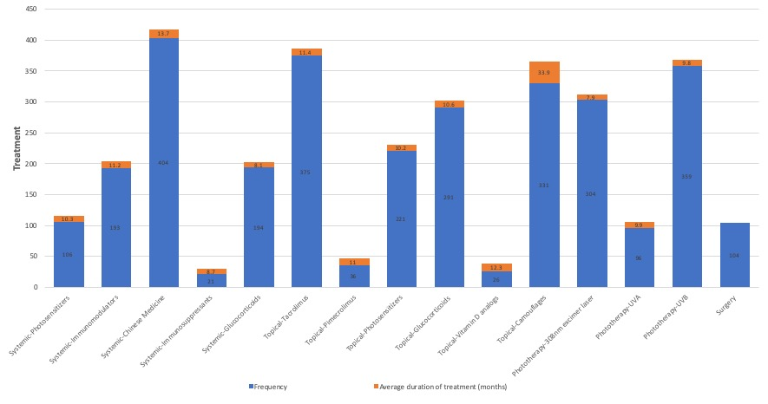
Supplementary Figure 1: Frequency of the different treatment options administered and mean of treatment duration/months.

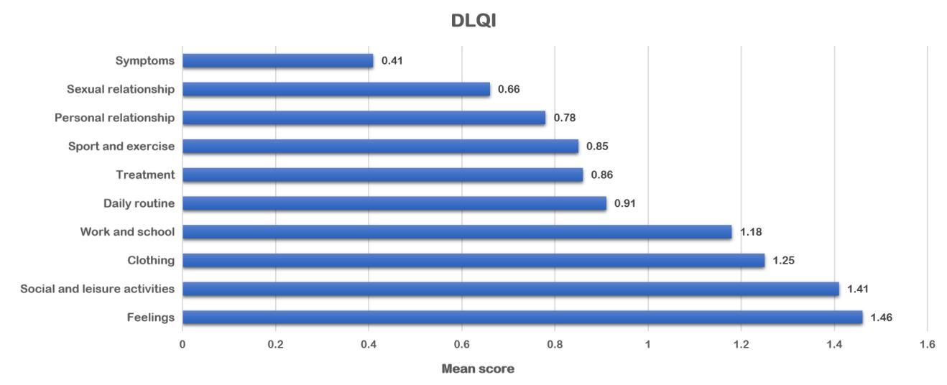
Supplementary Figure 2: DLQI as ordered by mean scores obtained for each item. DLQI: Dermatology Life Quality Index.

Supplementary Table 1: Demographic characteristics of the patients.
Demographic characteristics | Total (n = 1662) | Males (n = 823) | Females (n = 839)
Age (years), mean (SD) | 38.8 (11.5) | 37.7 (11.2) | 39.9 (11.7)∗
Civil status, n (%)
Married or have a spouse | 1273 (76.6) | 607 (73.8) | 666 (79.4)∗
Unmarried or no spouse | 389 (23.4) | 216 (26.2)∗ | 173 (20.6)
Educational level, n (%)
≤High school | 802 (48.3) | 343 (41.7) | 459 (54.7)∗
>High school | 860 (51.7) | 480 (58.3)∗ | 380 (45.3)
Residence, n (%)
City | 1282 (77.1) | 625 (75.9) | 657 (78.3)
Village | 380 (22.9) | 198 (24.1) | 182 (21.6)
Work and study status, n (%)
Currently working or studying | 1218 (73.3) | 688 (83.6)∗ | 530 (63.2)
Have no work or retired | 444 (26.7) | 135 (16.4) | 309 (36.8)∗
Monthly income (RMB), n (%)
≤3k | 653 (39.3) | 214 (26.0) | 439 (52.3)∗
3k–10k | 902 (54.3) | 537 (65.2)∗ | 365 (43.5)
>10k | 107 (6.4) | 72 (8.7)∗ | 35 (4.2)
∗Significance at <0.05.

Supplementary Table 2: Clinical characteristics of the patients.
Clinical characteristics | Total (n = 1662) | Male (n = 823) | Female (n = 839)
Age of onset (years), mean (SD) | 24.3 (12.8) | 24.0 (11.2) | 24.6 (14.2)
Disease duration (years), mean (SD) | 14.6 (10.9) | 13.7 (10.1) | 15.4 (11.6)∗
Affected body surface area, n (%)
BSA <1% | 828 (49.8) | 415 (50.4) | 413 (49.2)
BSA 1–10% | 607 (36.5) | 319 (38.8) | 288 (34.4)
BSA >10% | 227 (13.7) | 89 (10.8) | 138 (16.4)∗
Involve sites, n (%)
Exposed | 921 (55.4) | 457 (55.5) | 464 (55.3)
Non-exposed | 741 (44.6) | 366 (44.5) | 375 (44.7)
Disease type, n (%)
Acrofacial | 526 (31.6) | 295 (35.8)∗ | 231 (27.5)
Vulgaris | 490 (29.5) | 234 (28.4) | 256 (30.5)
Generalized | 194 (11.7) | 84 (10.2) | 110 (13.1)
Localized | 375 (22.6) | 180 (21.9) | 195 (23.2)
Segmental | 77 (4.6) | 30 (3.6) | 47 (5.6)
Disease stage, n (%)
Stable | 679 (40.9) | 345 (41.9) | 334 (39.8)
Progressive | 894 (53.8) | 433 (52.6) | 461 (54.9)
Regressive | 89 (5.4) | 45 (5.5) | 44 (5.2)
Onset season, n (%)
Winter (December–February) | 99 (6.0) | 52 (6.3) | 47 (5.6)
Summer (June–August) | 708 (42.6) | 371 (45.1)∗ | 337 (40.2)
Spring (March–May) | 664 (40.0) | 296 (36.0) | 368 (43.9)∗
Autumn (September–November) | 191 (11.5) | 104 (12.6) | 87 (10.4)
Family history, n (%)
Yes | 217 (13.1) | 102 (12.4) | 115 (13.7)
No | 1445 (86.9) | 721 (87.6) | 724 (86.3)
Use of systemic medication, n (%) | 907 (54.6) | 412 (50.1) | 495 (59.0)∗
Use of topical medication, n (%) | 1262 (75.9) | 599 (72.7) | 663 (79.0)∗
Use of phototherapy and surgery, n (%) | 859 (51.7) | 411 (49.9) | 449 (53.5)
∗Comparisons of column proportions significant at <0.05.

