Supplementary Figure 1

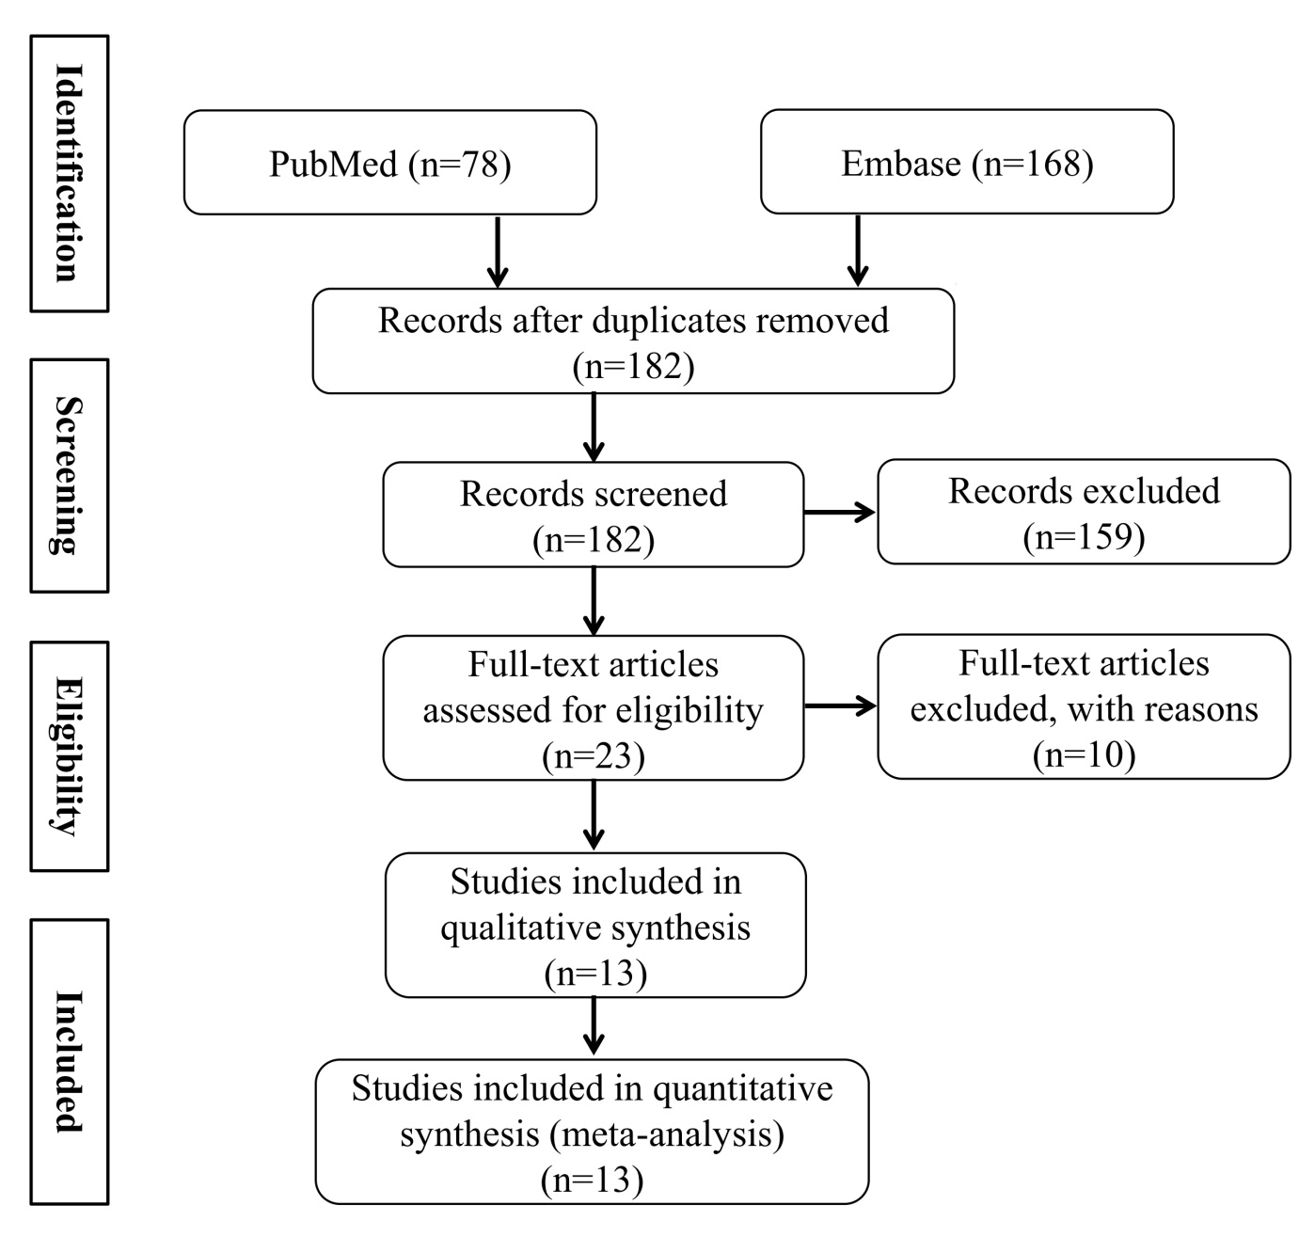

Supplementary Figure 2
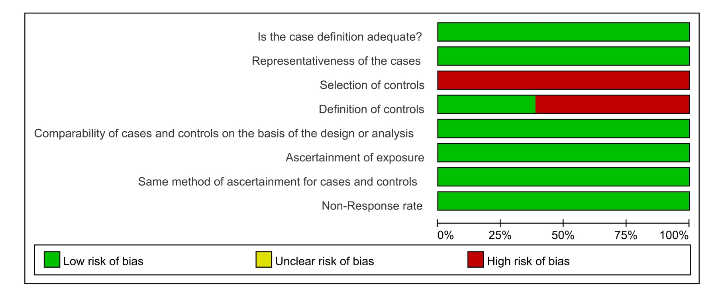

Table 1. Characteristics of the included studies

Author, year (Study period) | Country | Sample No. (Control/Cases) | Gender （male/female, %Female) |  | Age (mean[SD]/ range), year |  | BMI (mean[SD]/ range) |  | Specimen source | Detection  method of HMGB1 | NOS score
 |  |  | Control | Cases | Control | Cases | Control | Cases
Wu, 2022 (NA) | China | 67 (16/51) | 8/8 (50.0) | 15/36 (70.6) | 38.19 ± 6.48 | 39.22 ± 12.56 | 22.08 ± 2.49 | 22.09 ± 2.65 | bronchial brushings, biopsies | PCR, IF | 8
Lu, 2022 (NA) | China | 61 (28/33) | 13/15 (53.6) | 18/15 (45.5) | 50.86 ± 1.43 | 47.72 ± 2.31 | 24.53 ± 0.66 | 22.75 ± 0.50 | Serum | ELISA | 8
Sliman, 2020 (2019) | Egypt | 40 (15/25) | 7/8 (53.3) | 12/13 (52) | 46.53 ± 7.10 | 45.802 ± 7.10 | 34.25 ± 2.22 | 36.83 ± 3.11 | Serum | ELISA | 7
Huang, 2019 (NA) | China | 149 (62/87) | 32/30 (48.4) | 48/39 (44.8) | 54.23 ± 1.74 | 51.40 ±1.65 | 23.10± 0.80 | 22.08 ±0.46 | Sputum | ELISA | 7
Di Candia, 2017 (NA) | United Kingdom | 60 (18/42) | 7/11 (61.1) | 23/19 (45.2) | 53.0 ± 3.20 | 57.44 ± 2.87 | / | / | Sputum | ELISA | 7
Manti, 2017 (2013) | Italy | 74 (44/30) | 22/22 (50.0) | 18/12 (40.0) | 11.07 ± 2.12 | 10.56 ±0.32 | 17.49 | 17.38 ± 0.23 | Sputum | ELISA | 8
Cuppari, 2015 (2013) | Italy | 94 (44/50) | 22/22 (50.0) | 28/22 (44.0) | 11.07 ± 2.12 | 11.56 ± 1.41 | 17.49 | 17.38 ± 0.28 | Sputum | ELISA | 8
Shim, 2012 (NA) | South Korea | 65 (15/50) | 8/7 (46.7) | 21/29 (58.0) | 28.60 ± 6.70 | 47.90 ± 11.20 | / | / | Serum | ELISA | 7
Sukkar, 2012 (NA) | Australia | 34 (18/16) | 6/7 (66.7) | 6/10 (62.5) | 53 ± 21 | 62 ± 16.16 | / | / | BALF | ELISA | 7
Zhou, 2012 (NA) | China | 102 (30/72) | 15/15 (50.0) | 34/38 (52.8) | 37 ± 5.70 | 40.10 ± 4.20 | / | / | Sputum | ELISA | 8
Hou, 2011 (NA) | China | 95 (34/61) | 22/12 (63.9) | 34/27 (44.3) | 44 (25–70) | 39 (25–56) | 22.13 ± 4.35 | 22.08 ± 2.80 | Plasma, Sputum | ELISA | 7
Watanabe, 2011 (2007-2009) | Japan | 59 (15/44) | 7/8 (53.3) | 21/23 (52.2) | 42 (31-54) | 34 (23-51) | / | / | Sputum | ELISA | 7
Cheng, 2011 (2007-2009) | China | 77 (20/57) | 5/15 (75.0) | 32/25 (43.9) | 43 ± 10 | 45 ± 6 | / | / | Sputum | ELISA | 7
Table 2. Subgroup analysis of the included studies.

 | Subgroup | Studies | Mean Difference (95%CI) | P | I²
Country
 | Asia | 8 | 63.14 (58.07, 68.20) | ＜0.001 | 100%
 | Non-Asia | 4 | 77.45 (16.13, 138.76) | ＜0.001 | 100%
The percentage of females
 | ≤50% | 1 | 2.89 (2.78, 3.00) | ＜0.001 | 100%
 | ＞50% | 4 | 89.67 (19.53, 159.82) | ＜0.001 | 100%
 | Others | 7 | 82.78 (39.64, 125.93) | ＜0.001 | 100%
Age
 | ≥40 years | 6 | 0.08 (-2.56, 2.72) | ＜0.001 | 93%
 | ＜40 years | 3 | 0.00 (-0.85, 0.86) | 0.12 | 53%
 | Others | 4 | 2.26 (-7.56, 12.07) | ＜0.001 | 97%
BMI
 | ＜18.5 kg/m² | 2 | -0.11 (-0.17, -0.05) | 1.000 | 0%
 | 18.5-24 kg/m² | 3 | -0.98 (-1.20, -0.76) | 0.200 | 39%
 | ≥24 kg/m² | 1 | 2.58 (0.92, 4.24) | 0.002 | 100%
 | Others | 1 | -1.78 (-2.08, -1.48) | ＜0.001 | 100%
FEV1% predicted
 | Asthma VS. Control | 10 | -25.14 (-28.42, -21.87) | ＜0.001 | 93%
 | Mild-moderate asthma VS. Control | 4 | -14.87 (-32.78, 3.05) | ＜0.001 | 98%
 | Severe asthma VS. Control | 4 | -31.20 (-49.06, -13.33) | ＜0.001 | 96%
 | Severe asthma VS. Mild-moderate asthma | 4 | -16.17 (-35.31, 2.97) | ＜0.001 | 96%

