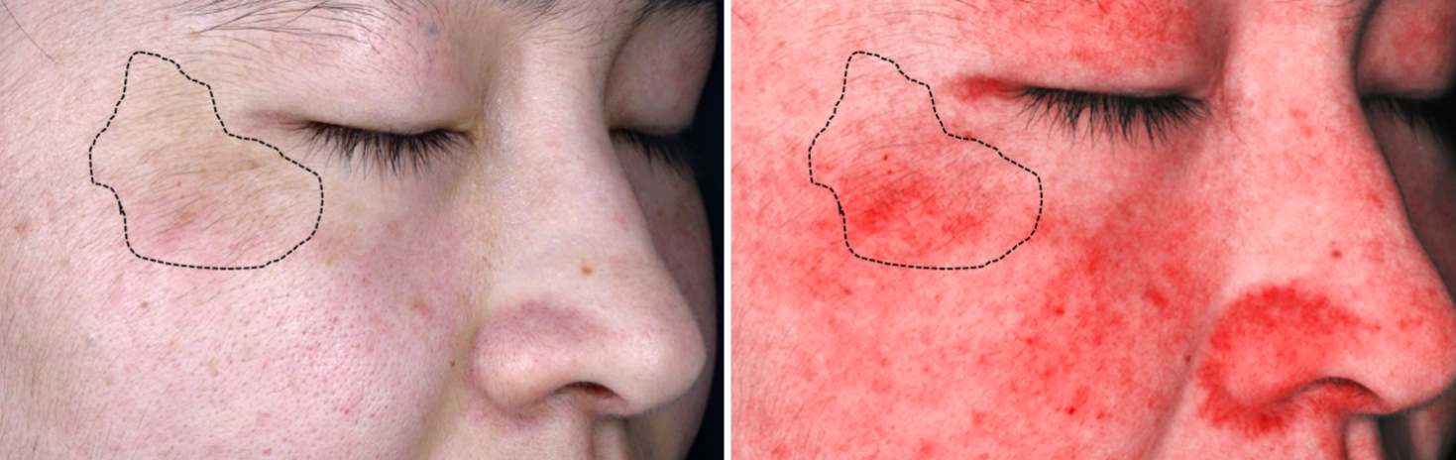

Supplementary Figure 1: Photographs showing melasma with underlying prominent vascular component detected by spectrocolorimetry. The area of hyperpigmentation indicated by the black dotted line was associated with vascularization.

