Supplementary Appendix
- Inclusion criteria
Patients aged 18 years and older with atopic dermatitis and lesion area 3%–20% of body surface area with an Investigator Global Assessment (IGA) score ≥3 at baseline were eligible for enrollment. All the participants in this trail have signed the informed consent.

- Exclusion criteria
The criteria for patient exclusion are as follows:
- Women during pregnancy, lactation or planned pregnancy;
- Patients with any systemic disease or other active skin disease that may affect the evaluation of the test results, or have scars, fetal spots, tattoos, etc. on the affected part that may affect the evaluation of skin diseases;
- Skin lesions are only confined to hands and feet;
- Patients with local bacterial, viral and fungal infections in the skin;
- Systemic non-biologic psoriasis therapy or phototherapy (within 4 weeks of baseline), certain classes of topical psoriasis treatment (within two weeks of baseline), previous biologic therapies (within 36 weeks).
- Severe diseases of central nervous system, cardiovascular system, kidney liver digestive tract, respiratory system, metabolism, skeletal and muscular system.
- Patients with mental illness or other reasons that may interfere with the participants in the test;
- Patients with history of malignant tumor;
- The level of ALT or AST in serum more than 2 times than the upper limit of normal value, or the level of creatinine higher than the upper limit of normal value.
- Allergic to ingredients of research drugs.
- Alcoholism, drug abuse and known drug dependence;
- Participated in any clinical studies within 12 weeks before baseline visit.
- Patients who were not able to complete this study for other reasons, or the researchers did not consider it appropriate to participate in this study.
- Exit criteria
The criteria for patient exit included voluntary exit, failure to use test drugs on time or in quantity, failure to follow up, new diseases or more severe atopic dermatitis, use of prohibited drugs or therapies, pregnancy, or the researchers considered it appropriate to terminated. Results were recorded when patients terminated this trail for the above reasons. Patients who exit due to adverse events were followed up until the symptoms returned to the state before the start of this trail or reached a stable state.

- Details of Efficacy Endpoints
The primary and major secondary endpoints were collected at weeks 0, 2, 4, and 6. The severity of atopic dermatitis is deﬁned by the Investigator Global Assessment (IGA) score by evaluation of overall lesions.

- Statistical Analysis
Study enrolment was planned for approximately 120 patients randomized 1: 1: 1: 1 into treatment groups. Briefly, the demographic and baseline evaluating data were based on the full analysis set (FAS). Drug compliance and concomitants were performed on the basis of FAS and safety set (SS). The primary efficacy endpoints were analyzed by the χ² test or Fisher exact test along with two-sided 95% confidence intervals (CIs) to compare the statistically significant differences among these drug intervention groups. The subgroup analysis was performed according to the percentage of lesion area mentioned above. Both the primary efficacy endpoints and subgroup analysis were performed on the basis of FAS and per-protocol set (PPS). The secondary efficacy indicators were compared through analysis of variance (ANOVA) on FAS and safety analysis was provided on SS basis. Missing data in the primary efficacy endpoint would be replenished by the method of last observation carried forward (LOCF) while those in the baseline comparison, secondary efficacy variables and safety analysis would not be.

The level of significance was 0.05 (two-sided) with two-sided confidence intervals. All statistical analyses were performed by SAS (version 9.4; SAS Institute Inc., Cary, USA).
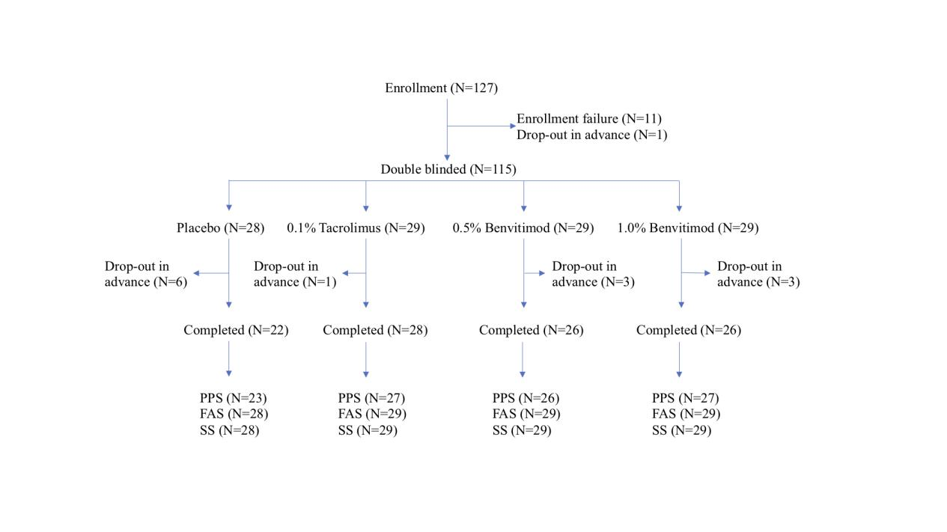
- Figure S1. Patient disposition.

FAS, full analysis set; SS, safety set; PPS, per-protocol set.
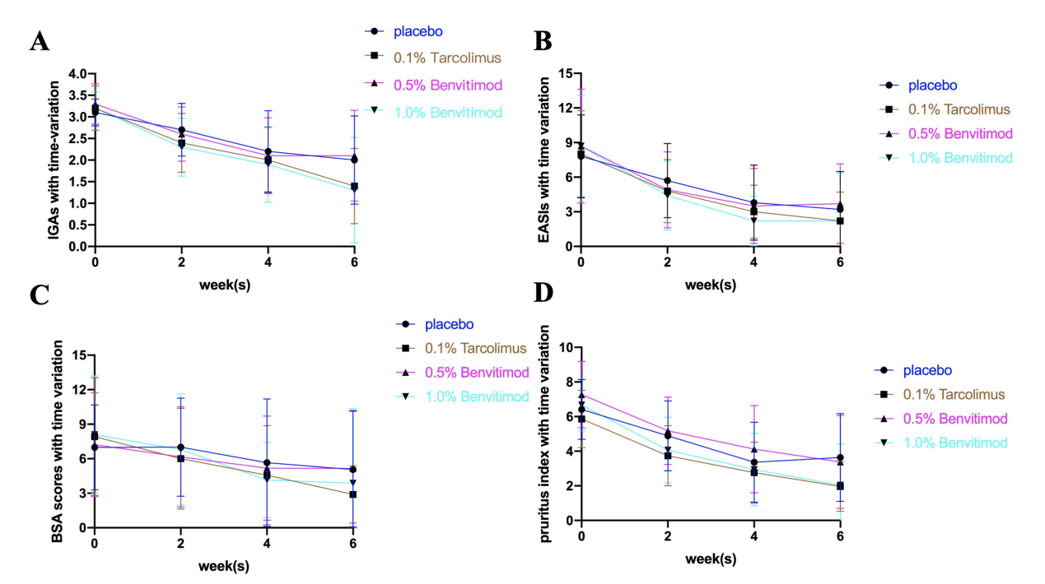
- Figure S2. Efficacy outcomes after 6-week treatment
Efficacy outcomes based on mean change from baseline in (A) IGA score, (B) EASI score, (C) BSA, (D) VAS score at 0, 2, 4, and 6 weeks.

- Table S1. Demographic and Clinical Characteristics of Patients at Baseline
 | placebo | 0.1% tacrolimus | 0.5% benvitimod | 1.0% benvitimod
 | (N=28) | (N=29) | (N=29) | (N=29)
Age, yr
Mean±SD | 42.8±14.9 | 35.2±13.4 | 42.6±15.6 | 39.4±17.0
Median | 41.0 | 32.0 | 45.0 | 36.0
Sex
Female | 15(53.6) | 8(27.6) | 16(55.2) | 11(37.9)
Male | 13(46.4) | 21(72.4) | 13(44.8) | 18(62.1)
IGA scores
Mean±SD | 3.1±0.3 | 3.2±0.5 | 3.3±0.5 | 3.2±0.4
Median | 3.0 | 3.0 | 3.0 | 3.0
IGA, n (%)
3-moderate | 25(89.3) | 23(79.3) | 20(69.0) | 24(82.8)
4-severe | 3(10.7) | 5(17.2) | 9(31.0) | 5(17.2)
5-more severe | 0(0) | 1(3.4) | 0(0) | 0(0)
EASI scores
Mean±SD | 7.8±3.6 | 8.0±3.8 | 8.7±4.9 | 8.7±4.4
Median | 8.0 | 8.0 | 8.0 | 7.0
BSA (%)
Mean±SD | 6.98±3.68 | 7.92±5.11 | 7.22±4.52 | 8.09±5.10
Median | 6.00 | 6.00 | 6.00 | 6.00
Itch/priritus indices
Mean±SD | 6.41±1.73 | 5.86±1.66 | 7.27±1.92 | 6.67±1.49
Median | 7.00 | 6.00 | 7.80 | 7.00
Compliance
70%~130% | 26(100.0) | 28(96.6) | 27(100.0) | 28(100.0)
≤70% or ≥130% | 0(0) | 1(3.4) | 0(0) | 0(0)
Duration of AD
Mean | 88.2 | 73.1 | 84.8 | 84.8
Median | 64.5 | 48.0 | 70.0 | 36.0

