Supplementary Table 1: Characteristics of the participants classified by NAFLD status.
Variables | No NAFLD  n = 2640 | NAFLD  n = 1355 | P-value
Age (years) | 49.16 ± 0.51 | 54.79 ± 0.53 | <0.001
Male (%) | 46.83 (1.11) | 53.13 (2.01) | 0.010
Marriage (%) | 62.56 (1.42) | 61.55 (2.28) | 0.687
Education levels (%) |  |  | <0.001
Under high school | 13.52 (1.23) | 21.53 (1.83)
High school | 20.03 (1.31) | 20.58 (1.55)
Above high school | 66.44 (2.18) | 57.89 (2.06)
Family poverty income ratio (PIR) | 3.09 ± 0.07 | 2.86 ± 0.08 | 0.003
Waist circumference (cm) | 93.11 ± 0.40 | 115.11 ± 0.66 | <0.001
BMI (kg/m²) | 26.44 ± 0.15 | 34.86 ± 0.31 | <0.001
Systolic blood pressure (mmHg) | 120.47 ± 0.45 | 127.32 ± 0.62 | <0.001
Diastolic blood pressure (mmHg) | 69.14 ± 0.36 | 71.13 ± 0.57 | 0.002
Alanine aminotransferase (U/L) | 21.30 ± 0.28 | 30.44 ± 0.58 | <0.001
Aspartate aminotransferase (U/L) | 23.48 ± 0.34 | 26.80 ± 0.57 | <0.001
γ-Glutamyl transpeptidase (U/L) | 18.97 ± 0.30 | 36.43 ± 1.00 | <0.001
Fasting triglyceride (mg/dL) | 97.91 ± 1.41 | 163.75 ± 4.45 | <0.001
Total cholesterol (mmol/L) | 4.98 ± 0.03 | 4.93 ± 0.04 | 0.339
High density lipoprotein (HDL)-cholesterol (mmol/L) () | 1.49 ± 0.01 | 1.19 ± 0.01 | <0.001
Uric acid (μmol/L) | 304.78 ± 1.66 | 360.09 ± 3.45 | <0.001
Fasting blood glucose (mmol/L) | 5.56 ± 0.03 | 6.91 ± 0.07 | <0.001
Fasting insulin (pmol/L) | 46.53 ± 0.72 | 147.17 ± 4.80 | <0.001
Homeostasis model assessment-insulin resistance (HOMA-IR, score) | 1.92 ± 0.03 | 7.92 ± 0.34 | <0.001
Serum total folate (nmol/L) | 48.13 ± 1.01 | 43.21 ± 0.85 | <0.001
5-MTHF (nmol/L) | 45.51 ± 0.98 | 40.73 ± 0.80 | <0.001
UMFA( nmol/L) | 1.18 ± 0.10 | 1.01 ± 0.06 | 0.185
Dietary folate intake (DFE) (μg) | 553.71 ± 9.69 | 511.25 ± 13.25 | 0.007
Total folate intake (DFE) (μg) | 809.75 ± 18.52 | 723.83 ± 22.49 | <0.001
Dietary folate supplement use (%) | 36.74 (1.54) | 30.57 (1.85) | 0.002
Total energy intake (kcal) | 2068.50 ± 23.46 | 2048.44 ± 23.72 | 0.476
Total carbohydrate intake (% energy) | 49.16 ± 0.29 | 48.14 ± 0.37 | 0.014
Total fat intake (% energy) | 34.48 ± 0.22 | 35.71 ± 0.30 | 0.001
Saturated fat intake (% energy) | 11.10 ± 0.08 | 11.67 ± 0.12 | <0.001
Total cholesterol intake (mg) | 279.02 ± 4.67 | 294.56 ± 6.36 | 0.048
Metabolic syndrome (%) | 12.93 (0.83) | 64.27 (1.85) | <0.001
5-MTHF: 5-methyltetrahydrofolate; BMI: Body mass index; DFE: Dietary folate equivalents; NAFLD: Non-alcoholic fatty liver disease; UMFA: Unmetabolized folic acid.
Continuous variables were presented as the weighted mean ± standard error (SE) and compared by Survey regression models.
Categorical variables were presented as weighted percent (SE) and compared by using the Rao–Scott χ² test.
Supplementary Table 2: Subgroup analyses between serum total folate levels and the risk of NAFLD.
Subgroups | Serum total folate (aOR [95% CI])
 | Q1 | Q2 | Q3 | Q4 | P_{trend} | P_{interaction}
Age (years) |  |  |  |  |  | 0.511
≤50 | 1 (reference) | 0.67 (0.40–1.13) | 0.95 (0.51–1.77) | 0.30 (0.15–0.57) | 0.011
>50 | 1 (reference) | 0.71 (0.44–1.14) | 0.65 (0.39–1.09) | 0.43 (0.28–0.68) | <0.001
Gender |  |  |  |  |  | 0.238
Male | 1 (reference) | 0.60 (0.38–0.94) | 0.56 (0.33–0.94) | 0.37 (0.22–0.61) | <0.001
Female | 1 (reference) | 0.81 (0.42–1.56) | 0.97 (0.53–1.76) | 0.38 (0.22–0.68) | 0.001
PIR |  |  |  |  |  | 0.424
Low | 1 (reference) | 0.53 (0.33–0.85) | 0.65 (0.39–1.1) | 0.36 (0.19–0.69) | 0.005
Middle | 1 (reference) | 0.68 (0.37–1.25) | 0.91 (0.48–1.75) | 0.41 (0.23–0.73) | 0.008
High | 1 (reference) | 0.89 (0.49–1.59) | 0.76 (0.41–1.41) | 0.43 (0.23–0.80) | 0.004
Education levels,% |  |  |  |  |  | 0.478
Under high school | 1 (reference) | 0.45 (0.23–0.87) | 0.60 (0.30–1.21) | 0.20 (0.09–0.47) | 0.001
High school | 1 (reference) | 0.78 (0.31–1.97) | 0.75 (0.34–1.68) | 0.60 (0.27–1.37) | 0.207
Above high school | 1 (reference) | 0.79 (0.50–1.25) | 0.84 (0.52–1.36) | 0.45 (0.27–0.75) | 0.001
Marriage |  |  |  |  |  | 0.774
Married | 1 (reference) | 0.66 (0.38–1.15) | 0.72 (0.37–1.42) | 0.42 (0.24–0.73) | 0.009
Others | 1 (reference) | 0.68 (0.41–1.12) | 0.82 (0.52–1.30) | 0.39 (0.24–0.63) | <0.001
BMI status |  |  |  |  |  | 0.127
Normal | 1 (reference) | 0.12 (0.01–1.25) | 0.28 (0.06–1.46) | 0.13 (0.04–0.42) | 0.009
Overweight and obese | 1 (reference) | 0.75 (0.54–1.04) | 0.84 (0.59–1.21) | 0.44 (0.31–0.62) | <0.001
Hypertension |  |  |  |  |  | 0.228
No | 1 (reference) | 0.68 (0.45–1.05) | 0.72 (0.45–1.17) | 0.36 (0.23–0.58) | <0.001
Yes | 1 (reference) | 0.69 (0.39–1.21) | 0.83 (0.46–1.50) | 0.46 (0.26–0.79) | 0.009
Diabetes |  |  |  |  |  | <0.001
No | 1 (reference) | 0.64 (0.43–0.94) | 0.74 (0.45–1.23) | 0.35 (0.23–0.53) | <0.001
Yes | 1 (reference) | 0.84 (0.39–1.82) | 0.84 (0.37–1.87) | 0.56 (0.23–1.36) | 0.183
aOR: Adjusted odds ratio; BMI: Body mass index; CI: Confidence interval; NAFLD: Non-alcoholic fatty liver disease; P_{trend}: p for trend; P_{interaction}: p for interaction.
Adjusted covariates: age, gender, race/ethnicity, family PIR, education levels, marital status, BMI, alanine aminotransferase, fasting triglyceride, total cholesterol, and uric acid. The total folate levels were used for quartiles in study population: ≤26.5 nmol/L (quartile 1), 26.6–38.7 ng/mL (quartile 2), 38.8–56.9 ng/mL (quartile 3), and >56.9 ng/mL (quartile 4).
Supplementary Table 3: Dietary folate intake and risk of NAFLD.
Quartile (range, DFE, μg) | OR (95% CI) | P_{trend}
Model 1 |  | <0.001
Q1 (≤358.5) | 1.00 (reference)
Q2 (358.6–575.0) | 0.79 (0.58–1.06)
Q3 (575.1–980.0) | 0.65 (0.49–0.85)
Q4 (>980.0) | 0.56 (0.44–0.71)
Model 2 |  | 0.009
Q1 | 1.00 (reference)
Q2 | 1.02 (0.72–1.43)
Q3 | 0.88 (0.63–1.23)
Q4 | 0.69 (0.49–0.98)
BMI: Body mass index; CI: Confidence interval; DFE: Dietary folate equivalent; NAFLD: Non-alcoholic fatty liver disease; OR: Odds ratio.
Total folate intake (DFE, μg) was calculated as the sum of dietary and supplement folate intake.
Model 1 was adjusted for demographic and socio-economic factors (age, gender, race/ethnicity, family PIR, education levels, and marital status).
Model 2 was adjusted for Model 1 plus BMI, total energy intake, saturated fat intake (% energy), total carbohydrate intake (% energy), total cholesterol intake, and total VB₁₂ intake.
Supplementary Table 4: Subgroup analyses between dietary folate intake and the risk of NAFLD.
Subgroups | Total folate intake (aOR [95% CI])
 | Q1 | Q2 | Q3 | Q4 | P_{trend} | P_{interaction}
Age (years) |  |  |  |  |  | 0.310
≤50 | 1 (reference) | 0.86 (0.48–1.54) | 0.87 (0.47–1.63) | 0.46 (0.22–0.98) | 0.063
>50 | 1 (reference) | 1.22 (0.78–1.92) | 0.90 (0.56–1.45) | 0.88 (0.57–1.38) | 0.303
Gender |  |  |  |  |  | 0.365
Male | 1 (reference) | 0.88 (0.57–1.34) | 0.73 (0.48–1.12) | 0.69 (0.41–1.17) | 0.141
Female | 1 (reference) | 1.17 (0.69–1.99) | 1.00 (0.65–1.55) | 0.62 (0.43–0.89) | 0.005
PIR |  |  |  |  |  | 0.496
Low | 1 (reference) | 0.86 (0.59–1.26) | 0.66 (0.39–1.12) | 0.50 (0.25–1.00) | 0.039
Middle | 1 (reference) | 0.80 (0.40–1.59) | 1.28 (0.66–2.47) | 0.76 (0.42–1.38) | 0.654
High | 1 (reference) | 1.43 (0.69–2.97) | 0.69 (0.31–1.58) | 0.69 (0.33–1.44) | 0.071
Education levels (%) |  |  |  |  |  | 0.344
Under high school | 1 (reference) | 0.70 (0.39–1.23) | 0.79 (0.39–1.60) | 0.45 (0.20–1.04) | 0.090
High school | 1 (reference) | 0.87 (0.45–1.69) | 0.92 (0.48–1.73) | 0.95 (0.48–1.85) | 0.912
Above high school | 1 (reference) | 1.20 (0.68–2.11) | 0.87 (0.51–1.50) | 0.69 (0.42–1.13) | 0.021
Marriage |  |  |  |  |  | 0.145
Married | 1 (reference) | 1.13 (0.58–2.19) | 1.26 (0.69–2.32) | 0.71 (0.39–1.28) | 0.288
Others | 1 (reference) | 0.93 (0.61–1.41) | 0.69 (0.44–1.06) | 0.65 (0.44–0.96) | 0.011
BMI status |  |  |  |  |  | 0.018
Normal | 1 (reference) | 1.28 (0.32–5.23) | 1.34 (0.37–4.84) | 0.33 (0.06–1.91) | 0.127
Overweight and obese | 1 (reference) | 1.00 (0.71–1.40) | 0.85 (0.59–1.22) | 0.72 (0.51–1.02) | 0.038
Hypertension |  |  |  |  |  | <0.001
No | 1 (reference) | 0.87 (0.49–1.54) | 0.63 (0.37–1.09) | 0.42 (0.22–0.79) | 0.002
Yes | 1 (reference) | 1.20 (0.76–1.91) | 1.45 (0.85–2.49) | 1.22 (0.74–2.02) | 0.410
Diabetes |  |  |  |  |  | <0.001
No | 1 (reference) | 0.96 (0.60–1.56) | 0.86 (0.54–1.37) | 0.60 (0.37–0.98) | 0.025
Yes | 1 (reference) | 1.15 (0.52–2.55) | 1.14 (0.59–2.20) | 1.17 (0.49–2.78) | 0.735
aOR: Adjusted odds ratio; BMI: Body mass index; CI: Confidence interval; DFE: Dietary folate equivalent; NAFLD: Non-alcoholic fatty liver disease; P_{trend}: p for trend; P_{interaction}: p for interaction.
Adjusted covariates: age, gender, race/ethnicity, family PIR, education levels, marital status, BMI, total energy intake, saturated fat intake (% energy), total carbohydrate intake (% energy), and total VB12 intake. The total folate intake were used for quartiles in study population: ≤358.5 μg DFE (quartile 1), 358.6–575.0 μg DFE (quartile 2), 575.1–980.0 μg DFE (quartile 3), and >980.0 μg DFE (quartile 4).
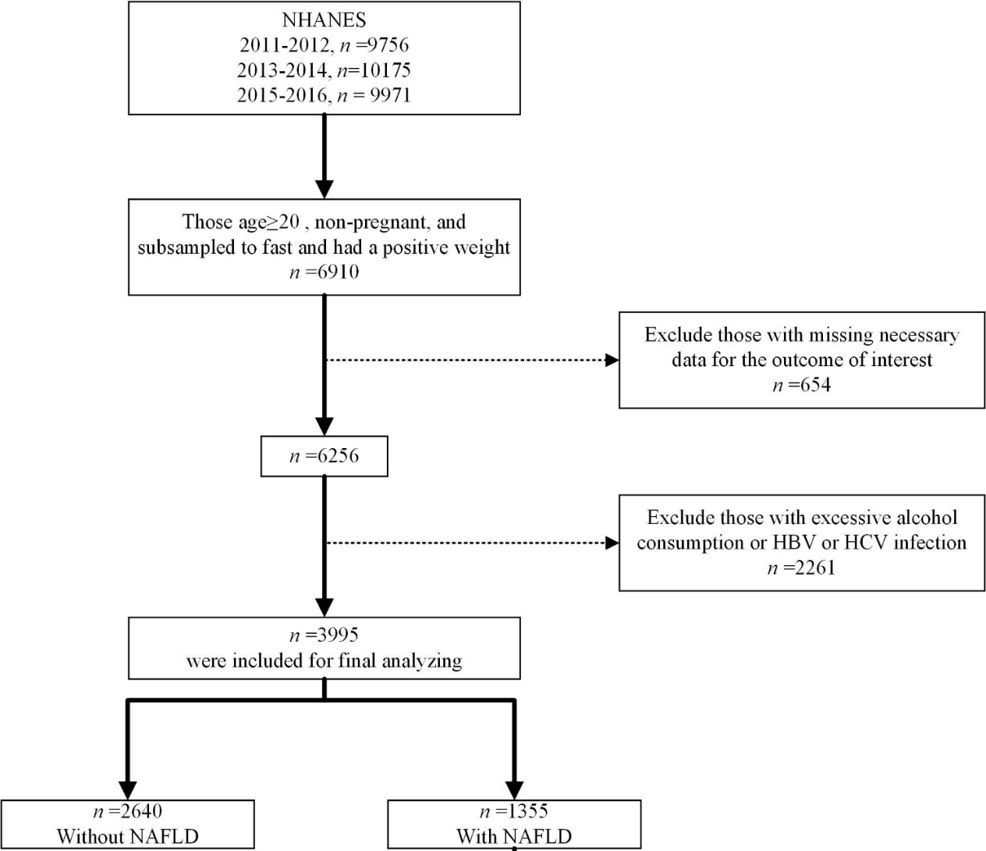
Supplementary Figure 1: Flow chart of the inclusion criteria from NHANES 2011–2016. NHANES: National Health and Nutrition Examination Survey.

