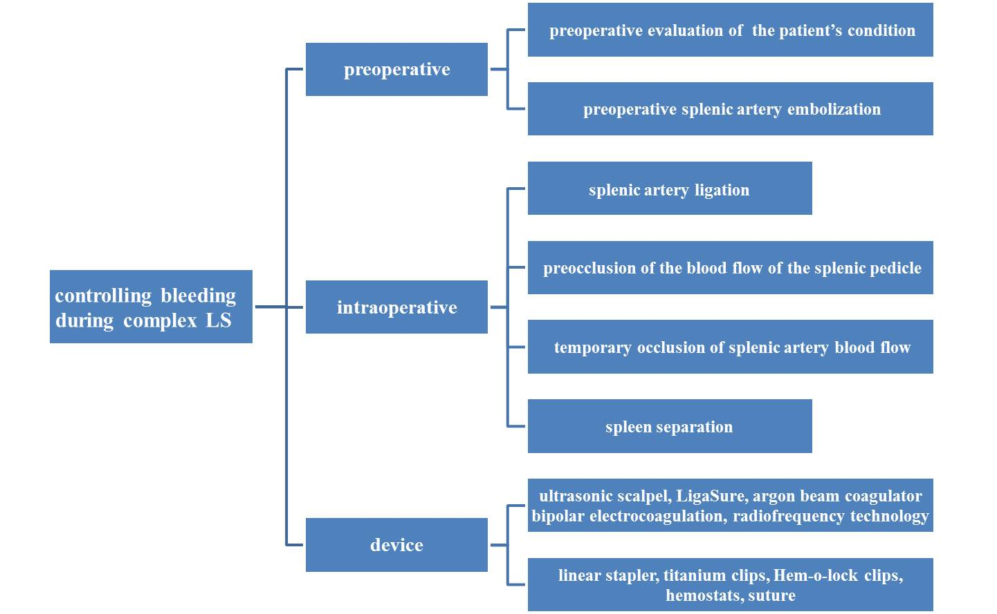
Supplementary Figure 1: Bleeding control during complex LS. LS: Laparoscopic splenectomy.

