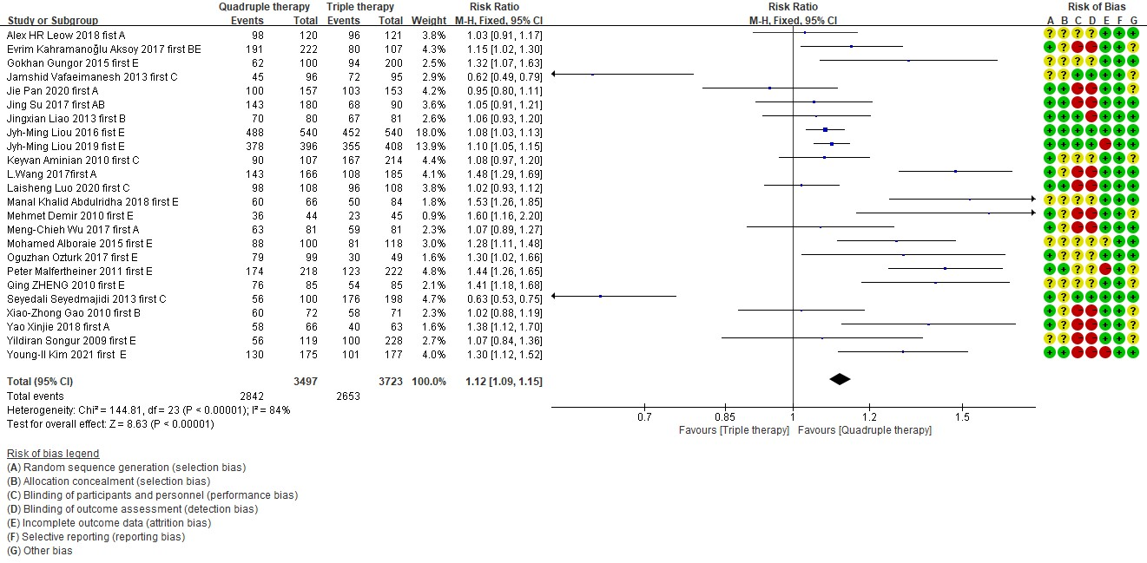
Supplementary Figure 1. Bismuth quadruple therapy vs. triple therapy.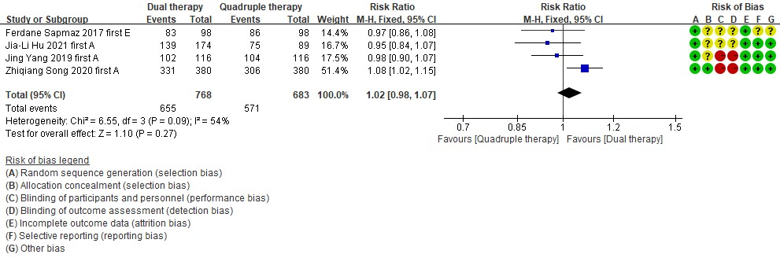
Supplementary Figure 2. Bismuth quadruple therapy vs. high dose dual therapy.
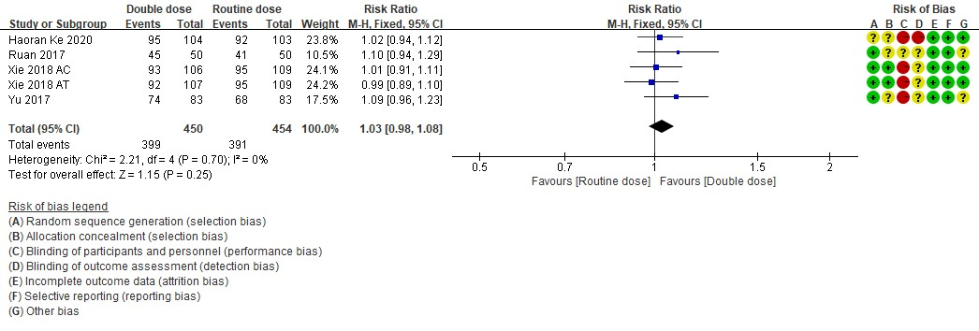
Supplementary Figure 3. Double dose PPI vs. standard dose PPI in bismuth quadruple therapy.
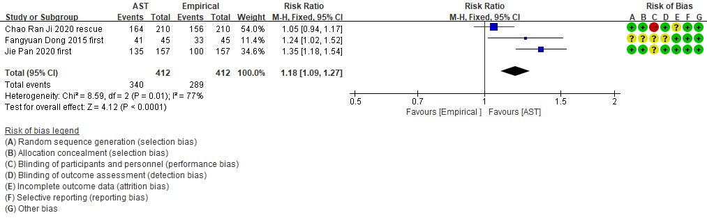
Supplementary Figure 4: Antibiotic susceptibility test guided therapy vs. empirical therapy.
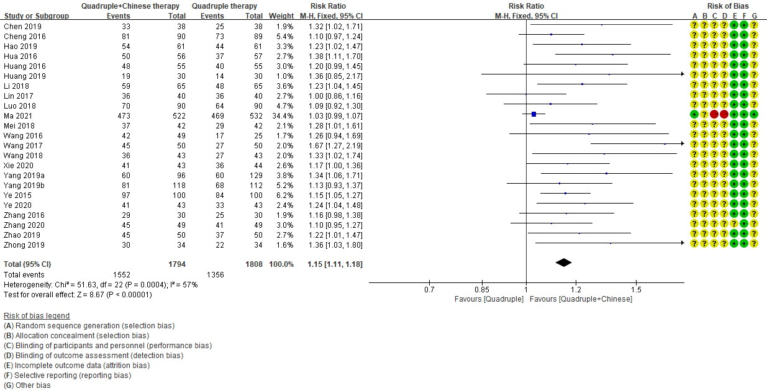
Supplementary Figure 5: Quadruple therapy combined with traditional Chinese medicine vs. quadruple therapy alone.
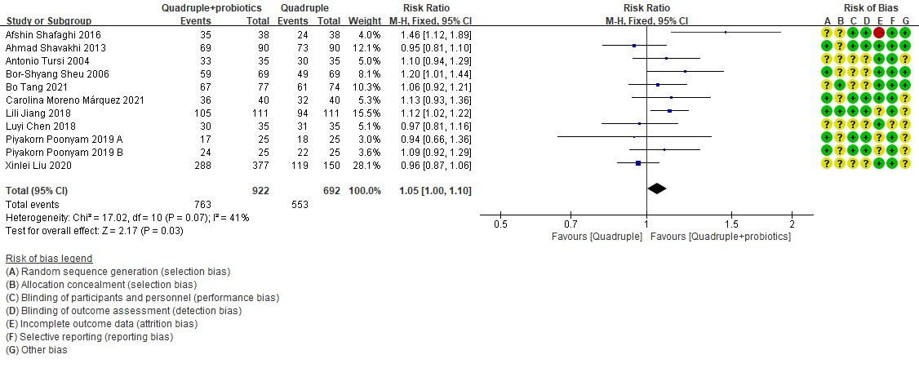
Supplementary Figure 6: Quadruple therapy with probiotics vs. quadruple therapy alone.

