Supplementary Materials
Questionnaire
We sincerely invite you to participate in the “National Survey on Quality of Life of Patients with Lupus Erythematosus” conducted by the Department of Rheumatology and Immunology, Peking University People’s Hospital.
This survey mainly investigates the menstrual, pregnancy, and reproduction status of female patients of childbearing age.
Throughout the investigation, we will not disclose any of your private information to any third party, and your answers will be stored in a protected database. Completing the questionnaire implies consent and your participation is anonymous and voluntary.
Reminder: It will take about 10 min to complete the questionnaire; please fill it out carefully.
Are you an SLE patient or have any of your family members been diagnosed with systemic lupus erythematosus (SLE)?
□ YES □ NO
Has the patient been definitively diagnosed with systemic lupus erythematosus by the hospital?
□ YES □ NO
Access to the survey below was granted to the respondents who gave an affirmative answer to both of the above questions.
FIRST PART
- What is the gender of the patient?
□ Male □ Female
- What is the date of birth of the patient?

- What is the height (cm) of the patient?

- What is the weight (kg) of the patient?

- What is the date on which the patient was diagnosed with systemic lupus erythematosus?

- How much time did it take from the onset of symptoms to the diagnosis of the patient?
□ 0–1 month □ 1–3 months □3–6 months □ >6 months
- Which department the patient visited the first time?
□ Department of Rheumatology and Immunology □ Department of Nephrology
□ Dermatology □ Hematology □ Respiratory Department
□ Cardiology Department □ Neurology □ General Internal Medicine
□ Other: ____
- Please mention the name of the hospital where a diagnosis of SLE was made.

- Please mention the name of the city in which the hospital mentioned above is located.

- Which province does the patient live in?

SECOND PART
- Please indicate your marriage and reproduction status
□ Married and had children
□ Unmarried and did not have children
□ Married and did not have children
□ Pregnancy
□ Pregnancy preparation
□ Divorce
□ Others: ____
- Does the disease affect menstruation after the appearance of the disease? (As can be seen in Supplementary Figure 1, the estimation of menstrual flow was based on post-usage physical appearance of the device used to absorb menstrual flow; no effect is mutually exclusive with other options.)
□ No effect
□ Light menstrual bleeding (a total menstrual volume <5 mL – Please answer question 12)
□ Heavy menstrual bleeding (a total menstrual volume >80 mL – Please answer question 12)
□ Shortened menstrual bleeding (menstrual periods lasting <2 days – Please answer question 12)
□ Prolonged menstrual bleeding (menstrual periods lasting >8 days – Please answer question 12)
□ Amenorrhea (absence of menses for 3 months or for thrice the length of the previous menstrual cycle – Please answer question 12)
□ Menopause before disease onset
□ Others: ____
- Among the following drugs, indicate those that the patient has used:
□ Glucocorticoid □ Cyclophosphamide
□ Mycophenolate Mofetil □ Tripterygium wilfordii
□ Thalidomide □ Others: ____
14. Have the patients ever had any of the following adverse pregnancy outcomes?
□ Preterm delivery (birth before 37 completed weeks of gestation)
□ Miscarriage
□ Fetal growth restriction (a fetal weight or abdominal circumference, as estimated by ultrasonography, below the 10th percentile for its gestational age)
□ Placental abruption
□ Hypertensive disease of pregnancy (including gestational hypertension, preeclampsia, and eclampsia)
□ Infertility
15. Have the patients ever had any of the following adverse birth outcomes?
□ Preterm delivery (birth before 37 completed weeks of gestation)
□ Small for gestational-age (born weighing less than the 10th percentile for a completed gestational age by sex)
□ Stillbirth
□ Neonatal pathological jaundice
□ Neonatal lupus
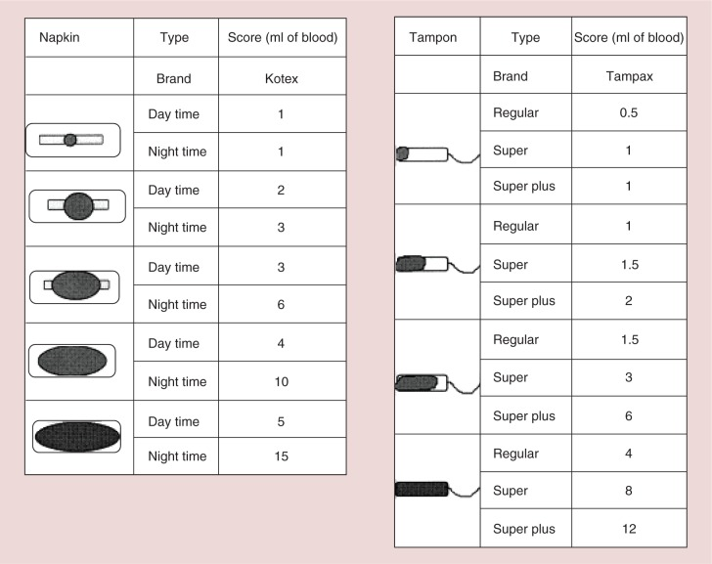
Supplementary Figure 1: The menstrual pictogram.^{[1]}
Inclusion criteria:
Patients diagnosed with Systemic lupus erythematosus (SLE) according to the 2019 EULAR/ACR classification criteria^{[2]} by rheumatologists.
Exclusion criteria:
(1) Invalid questionnaires, including those exhibiting the following characteristics:
(a) >2/3 of the total number of questions in the questionnaire have gone unanswered;
(b) the same option has been checked throughout the entire questionnaire; for example, the respondent has checked option “A” corresponding to all questions;
(c) the time to fill in the questionnaire is <1 min;
(d) a noticeable pattern of filling in answers is apparent from a prima facie scrutiny of the questionnaire; for example, the options selected are A, B, C, A, B, C, A, B, C, and so on;
(e) the questionnaire is designed with reverse questions; if there are contradictions between the positive and negative questions, it will be regarded as an invalid questionnaire;
(f) if a person fills in more than two questionnaires repeatedly, the second questionnaire completed by that person will be considered invalid.
(2) Male patients.
(3) Patients’ age ≥50 years or <15 years. Women of childbearing age were selected based on the standards outlined by the World Health Organization (female patients aged 15–49 years) for menstruation analysis^{[3]} [Supplementary Figure 1].
Operational Definitions
A normal menstrual cycle is 24–38 days long, while the flow duration is 2–8 days and 5–80 mL of blood is lost during each menstrual cycle.^{[4]} Menstrual disorders include light menstrual bleeding, heavy menstrual bleeding, shortened menstrual bleeding, prolonged menstrual bleeding, and amenorrhea. Light menstrual bleeding was defined as a total menstrual volume <5 mL. Heavy menstrual bleeding was defined as a total menstrual volume >80 mL. Shortened menstrual bleeding was defined as menstrual periods lasting <2 days. Prolonged menstrual bleeding was defined as a menstrual period >8 days. Amenorrhea was defined as the absence of menses for 3 months or for thrice the length of the previous menstrual cycle.^{[4]} A preterm delivery was any birth before 37 completed weeks of gestation.^{[5]} Fetal growth restriction (FGR) was defined as a fetal weight or abdominal circumference, as estimated by ultrasonography, below the 10th percentile for its gestational age.^{[6]} Small for gestational-age (SGA) was defined as a fetal that born weighing less than the 10th percentile for a completed gestational age by sex.^{[5]} The APO were defined as: (1) preterm delivery; (2) miscarriage; (3) FGR; (4) placental abruption; and (5) hypertensive disease of pregnancy.^{[7]} The ABO were defined as: (1) preterm delivery; (2) SGA; (3) stillbirth; (4) neonatal pathological jaundice; and (5) neonatal lupus.^{[5]}

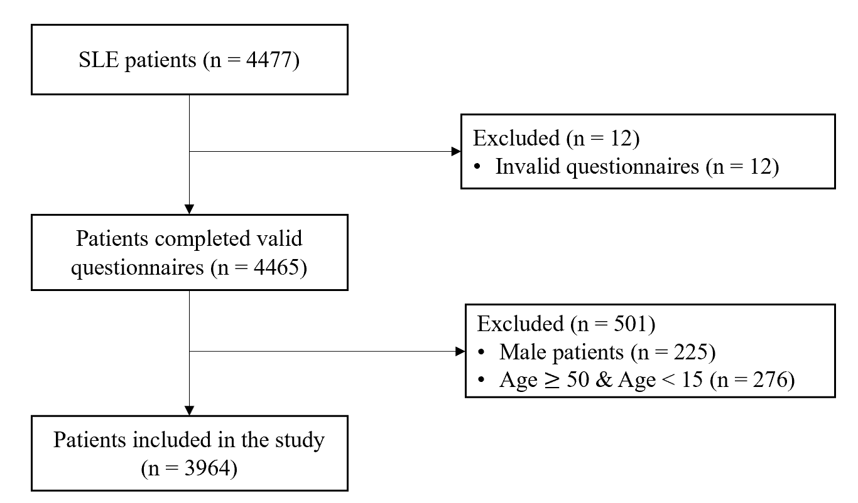
Supplementary Figure 1: Flow diagram of the study. SLE: Systemic lupus erythematosus.
Supplementary Table 1: Comparison between the normal and abnormal menstruation group (n = 3964).
Variables | Normal menstruation  (n = 969) | Abnormal menstruation  (n = 2995) | P-value
Age (years) | 28.12 ± 6.25 | 31.17 ± 7.59 | <0.001*
BMI (kg/m²) | 21.32 ± 3.46 | 21.69 ± 3.32 | 0.003*
Longer disease duration (years)  Medications (n = 2945) | 5.38 ± 4.72 | 6.28 ± 5.49 | <0.001*
CYC | 42 (21.88) | 1037 (37.67) | <0.001*
GCs | 99 (51.56) | 2088 (75.84) | <0.001*
MMF | 41 (21.35) | 1092 (39.67) | <0.001*
Thalidomide | 69 (30.73) | 247 (8.97) | <0.001*
Tripterygium glycosides | 49 (25.52) | 218 (7.92) | <0.001*
BMI: Body Mass Index; CYC: Cyclophosphamide; GCs: Glucocorticoids; MMF: Mycophenolate Mofetil; SD: Standard deviation.
Ordinal data are presented as frequency (percentage) and numerical variables are presented as mean ± SD.
*P < 0.05.

Supplementary Table 2: Demographics of the study subjects (n = 3964).
Variables | Value
Age, mean ± SD (years) | 30.42 ± 7.40
BMI, mean ± SD (kg/m²) | 21.60 ± 3.36
Disease duration, mean ± SD (years) | 6.06 ± 5.33
Menstruation, n (%)
Light menstrual bleeding | 1942 (48.99)
Heavy menstrual bleeding | 282 (7.11)
Shortened menstrual bleeding | 924 (23.31)
Prolonged menstrual bleeding | 541 (13.65)
Menopause before disease onset | 106 (2.67)
Amenorrhea | 430 (10.85)
No impact | 969 (24.45)
Medications, n (%)
GCs | 2187 (55.17)
MMF | 1133 (28.58)
CYC | 1079 (27.22)
GCs + MMF | 813 (20.51)
GCs + CYC | 955 (24.09)
MMF + CYC | 500 (12.61)
GCs + MMF + CYC | 442 (11.15)
Thalidomide | 316 (7.97)
Tripterygium glycosides | 267 (6.74)
Marital and fertility status, n (%)
Married and had children | 1762 (44.70)
Unmarried and did not have children | 1270 (32.22)
Married and did not have children | 656 (16.64)
Pregnancy | 101 (2.56)
Pregnancy preparation | 99 (2.51)
Divorce | 44 (1.12)
Pregnancy outcomes, n (%)
APO | 607 (35.11)
Preterm delivery | 243 (14.05)
Miscarriage | 172 (9.95)
FGR | 136 (7.87)
hypertensive disease of pregnancy | 76 (4.40)
Placental abruption | 39 (2.26)
Infertility | 45 (1.14)
Birth outcomes, n (%)
Full-term normal childbirth | 881 (70.48)
Preterm delivery | 243 (19.44)
SGA | 112 (8.96)
Stillbirth | 18 (1.44)
Neonatal pathological jaundice | 97 (7.76)
Neonatal lupus | 18 (1.44)
ABO: Adverse birth outcomes; APO: Adverse pregnancy outcomes; BMI: Body mass index; CYC: Cyclophosphamide; FGR: Fetal growth restriction; GCs: Glucocorticoids; MMF: Mycophenolate Mofetil; SD: Standard deviation; SGA: Small for gestational age.
The number of women with any APO/ABO does not equal the sum of yes responses to each APO/ABO, since some women had more than one APO/ABO.
Supplementary Table 3: Comparison between the groups with and without APO (n = 1729).
Variables | Non-APO group  (n = 1122) | APO group  (n = 607) | P-value
Age (years) | 34.50 ± 6.61 | 34.83 ± 6.71 | 0.326
BMI (kg/m²) | 22.21 ± 3.40 | 22.11 ± 3.18 | 0.558
Disease duration (years) | 6.06 ± 5.03 | 6.43 ± 5.37 | 0.146
Abnormal menstruation  Medications (n = 1378) | 839 (74.78) | 472 (77.76) | 0.167
CYC | 362 (40.27) | 189 (39.46) | 0.770
GCs | 655 (72.86) | 353 (73.70) | 0.739
MMF | 316 (35.15) | 182 (38.00) | 0.295
APO: Adverse pregnancy outcomes; BMI: Body mass index; CYC: Cyclophosphamide; GCs: Glucocorticoids; MMF: Mycophenolate Mofetil; SD: Standard deviation.
Ordinal data are presented as frequency (percentage) and numerical variables are presented as mean ± SD.
Supplementary Table 4: Relationship between birth outcomes and general information (n = 1251).
Variables | Non-ABO group  (n = 882) | ABO group  (n = 369) | P-value
Age (years) | 34.73 ± 6.52 | 32.59 ± 5.57 | <0.001*
BMI (kg/m²) | 22.22 ± 3.02 | 21.88 ± 3.94 | 0.099
Disease duration (years) | 6.18 ± 5.02 | 7.53 ± 5.66 | <0.001*
Abnormal menstruation | 655 (75.40) | 269 (72.90) | 0.595
APO  Medications (n = 952) | 188 (21.32) | 187 (50.68) | <0.001*
CYC | 280 (48.03) | 90 (24.39) | <0.001*
GCs | 583 (100.00) | 121 (48.79) | <0.001*
MMF | 306 (52.49) | 62 (16.80) | <0.001*
ABO: Adverse birth outcomes; APO: Adverse pregnancy outcomes; BMI: Body mass index; CYC: Cyclophosphamide; GCs: Glucocorticoids; MMF: Mycophenolate Mofetil; SD: Standard deviation.
Ordinal data are presented as frequency (percentage) and numerical variables are presented as mean ± SD.
*P < 0.05.
References
1. Quinn SD, Higham J. Outcome measures for heavy menstrual bleeding. Womens Health (Lond) 2016;12:21–26. doi: 10.2217/whe.15.85.
2. Aringer M, Costenbader K, Daikh D, Brinks R, Mosca M, Ramsey-Goldman R, et al. 2019 European league against rheumatism/American college of rheumatology classification criteria for systemic lupus erythematosus. Ann Rheum Dis 2019;78:1151–1159. doi: 10.1136/annrheumdis-2018-214819.
3. World Health Organization. Guideline: Intermittent iron and folic acid supplementation in menstruating women. Geneva: World Health Organization 2012;20:172–179.
4. Fraser IS, Critchley HO, Broder M, Munro MG. The FIGO recommendations on terminologies and definitions for normal and abnormal uterine bleeding. Semin Reprod Med 2011;29:383–390. doi: 10.1055/s-0031-1287662.
5. Regan AK, Gissler M, Magnus MC, Håberg SE, Ball S, Malacova E, et al. Association between interpregnancy interval and adverse birth outcomes in women with a previous stillbirth: An international cohort study. Lancet 2019;393:1527–1535. doi: 10.1016/s0140-6736(18)32266-9.
6. McCowan LM, Figueras F, Anderson NH. Evidence-based national guidelines for the management of suspected fetal growth restriction: Comparison, consensus, and controversy. Am J Obstet Gynecol 2018;218:S855–S868. doi: 10.1016/j.ajog.2017.12.004.
7. Kither H, Heazell A, Bruce IN, Tower C, Crocker I. Adverse pregnancy outcomes and subsequent development of connective tissue disease in the UK: An epidemiological study. BJOG 2020;127:941–949. doi: 10.1111/1471-0528.16191.

