Supplementary Material
Inclusion and Exclusion Criteria
Inclusion criteria
(1) Between the ages of 18 years and 70 years.
(2) An RA diagnosis that meets the 2010 ACR/EULAR classification criteria.
(3) Patient is receiving tofacitinib 5 mg twice daily.
(4) Patient has maintained LDA for at least 3 months, defined as a DAS28-ESR ≤3.2.
(5) Patients were allowed to take concomitant drugs only if they received a stable dose of 10–20 mg/week methotrexate or glucocorticoids (≤7.5 mg/day prednisone-equivalents).
Exclusion criteria
(1) Patients have experienced moderate to high disease activity in the last 3 months.
(2) Female patients who are pregnant or breastfeeding.
(3) Abnormal complete blood count tests:
● Hemoglobin <9 g/dL or Hematocrit <30%;
● White blood cell count <3.0 × 10⁹/L;
● Absolute neutrophil count <1.2 × 10⁹/L;
● Platelet count <100 × 10⁹/L.
(4) Has a history of, or currently has, abnormal renal function (estimated glomerular filtration rate <40 mL/min).
(5) Has a history of, or currently has, abnormal hepatic function (alanine aminotransferase or aspartate aminotransferase >1.5 times the upper limit of normal).
(6) Has a poorly controlled medical condition, including hematological, gastrointestinal, endocrine, metabolic, pulmonary, cardiac, or neurological disease.
(7) Glucocorticoids administered intramuscularly, intravenously, or intra-articular within 4 weeks.
(8) History of autoimmune and inflammatory diseases other than Sjögren’s syndrome.
(9) Cancer or cancer history (other than treated non-melanoma skin cancer and cervical carcinoma in situ).
(10) Infections that required hospitalization or antibiotic therapy within 6 months prior to the baseline visit.
(11) Active or recurrent viral infection that makes the patient unsuitable for the study, including recurrent or disseminated (even a single episode) herpes zoster, hepatitis B virus (HBV) or hepatitis C virus (HCV), or human immunodeficiency virus (HIV). Active HBV, HCV, and HIV are defined as:
● HBV: Hepatitis B surface antigen (HBsAg) positive, hepatitis B core antibody (HBcAb) positive patients, or detection of HBV DNA by PCR.
● HCV: HCV RNA detectable with anti-HCV antibody.
● HIV: anti-HIV antibody test positive.
(12) Active tuberculosis (TB), or untreated or inadequately treated latent TB.
● Active TB is defined as: positive purified protein derivative (PPD) test (≥5 mm induration between approximately 48 h and 72 h after application, regardless of vaccination history) or T-SPOT test, and/or clinical features, medical history, and chest X-ray consistent with active TB.
● Untreated or inadequately treated latent TB is defined as: positive PPD test (≥5 mm induration between approximately 48 h and 72 h after application, regardless of vaccination history) or T-SPOT test, but no clinical features, medical history, and positive chest X-ray consistent with active TB.
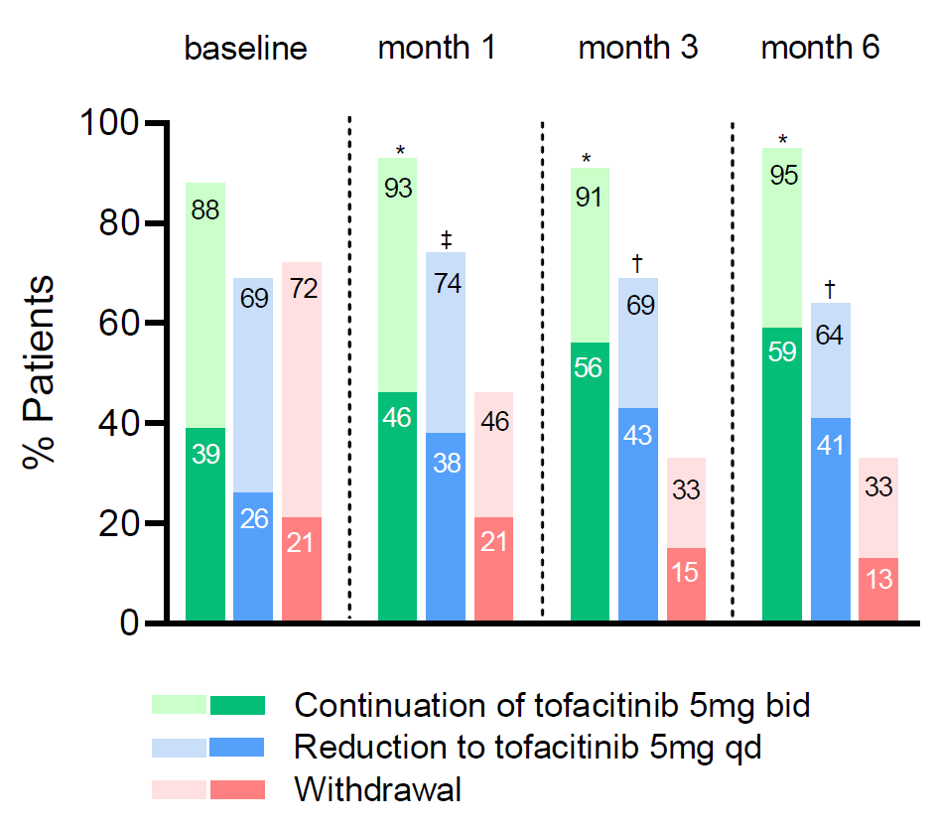
Supplementary Figure 1: Proportions of patients achieving LDA/remission based on SDAI at months 1, 3, and 6. Upper bars (lighter color) indicate LDA (SDAI ≤11); lower bars (darker color) indicate remission (SDAI <3.3). Numbers within the bars indicate the exact percentage. *Withdrawal group vs. continuation group, P < 0.0001. †Withdrawal group vs. reduction group, P < 0.0001. ‡Withdrawal group vs. reduction group, P = 0.0002. LDA: Low disease activity; SDAI: Simplified disease activity index.

