Supplementary materials
Supplementary Table 1: Regional distribution of collaborating centers and enrolled patients.
Supplementary Table 2: Demographics of patients with psoriasis in the Psoriasis Center Registry
Supplementary Table 3: Clinical manifestations of patients with psoriasis in the Psoriasis Center Registry
Supplementary Table 4: Comorbid diseases of patients with psoriasis in the Psoriasis Center Registry
Supplementary Table 5: Auxiliary examinations of patients with psoriasis in the Psoriasis Center Registry
Supplementary Table 6: Treatment strategies of patients with psoriasis in the Psoriasis Center Registry
Supplementary Figure 1: The overall disease severity distribution (A) and the occurrence of psoriatic arthritis and impactful area involvement in each disease severity level (B) in the 10,321 patients with plaque psoriasis who initiated biological therapy at enrollment.
Supplementary Figure 2: Treatment distribution of Chinese patients with psoriasis at enrollment from Aug 2020 to Feb 2021 (A) and Mar 2021 to Mar 2022 (B).

Supplementary Table 1: Regional distribution of collaborating centers and enrolled patients.
Province | Collaborating medical centers | Chinese translation | Number of patients | Total
Anhui | Lixin County People's Hospital | 利辛县人民医院 | 53 | 566
 | Huaibei People's Hospital | 淮北市人民医院 | 196
 | The Second Affiliated Hospital of Wannan Medical College | 皖南医学院第二附属医院 | 286
 | Fuyang People's Hospital | 阜阳市人民医院 | 31
Beijing | The 82nd Group Army Hospital of the People's Liberation Army | 中国人民解放军陆军第八十二集团军医院 | 81 | 3,724
 | Beijing Huaxin Hospital (The First Hospital of Tsinghua University) | 北京华信医院(清华大学第一附属医院) | 37
 | Peking University International Hospital | 北京大学国际医院 | 14
 | Peking University Shenzhen Hospital | 北京大学深圳医院 | 579
 | Peking University First Hospital | 北京大学第一医院 | 1,290
 | Peking University Third Hospital | 北京大学第三医院 | 399
 | Peking University Shougang Hospital | 北京大学首钢医院 | 1
 | Beijing Huairou Hospital | 北京怀柔医院 | 130
 | Beijing Tsinghua Changgung Hospital | 北京清华长庚医院 | 318
 | Beijing Jishuitan Hospital | 北京积水潭医院 | 179
 | Beijing Hospital of Ministry of Health | 卫生部北京医院 | 120
 | Liangxiang Hospital, Fangshan District | 房山区良乡医院 | 52
 | Xuanwu Hospital, Capital Medical University | 首都医科大学宣武医院 | 49
 | Beijing Youan Hospital affiliated to Capital Medical University | 首都医科大学附属北京佑安医院 | 15
 | Beijing Tongren Hospital, Capital Medical University | 首都医科大学附属北京同仁医院 | 21
 | Beijing Ditan Hospital affiliated to Capital Medical University | 首都医科大学附属北京地坛医院 | 6
 | Beijing Anzhen Hospital Affiliated to Capital Medical University | 首都医科大学附属北京安贞医院 | 96
 | Beijing Chaoyang Hospital Affiliated to Capital Medical University | 首都医科大学附属北京朝阳医院 | 236
 | Beijing Luhe Hospital affiliated to Capital Medical University | 首都医科大学附属北京潞河医院 | 101
Chongqing | Army Medical Center of Chinese People's Liberation Army | 中国人民解放军陆军特色医学中心 | 95 | 1,310
 | The First Affiliated Hospital of Chongqing Medical University | 重庆医科大学附属第一医院 | 654
 | The Third Affiliated Hospital of Chongqing Medical University | 重庆医科大学附属第三医院 | 45
 | Chongqing Hospital of Traditional Chinese Medicine | 重庆市中医院 | 365
 | Chongqing Fuling Central Hospital | 重庆市涪陵中心医院 | 14
 | The First Affiliated Hospital of Army Medical University | 陆军军医大学第一附属医院 | 137
Fujian | The Second Affiliated Hospital of Xiamen Medical College | 厦门医学院附属第二医院 | 303 | 1,582
 | Xiamen Changgung Hospital | 厦门长庚医院 | 294
 | Mindong Hospital, Ningde City | 宁德市闽东医院 | 22
 | Quanzhou Traditional Chinese Medicine Hospital | 泉州市中医院 | 3
 | Shishi City Hospital | 石狮市医院 | 1
 | Fuzhou Dermatology Hospital | 福州市皮肤病防治院 | 197
 | The Second Affiliated People's Hospital of Fujian University of Traditional Chinese Medicine | 福建中医药大学附属第二人民医院 | 1
 | Union Hospital Affiliated to Fujian Medical University | 福建医科大学附属协和医院 | 164
 | The First Affiliated Hospital of Fujian Medical University | 福建医科大学附属第一医院 | 357
 | The Second Affiliated Hospital of Fujian Medical University | 福建医科大学附属第二医院 | 231
 | Fuqing Hospital of Fujian Province | 福建省福清市医院 | 9
Gansu | General Hospital of Lanzhou Military Region | 兰州军区总医院 | 136 | 619
 | The First Hospital of Lanzhou University | 兰州大学第一医院 | 216
 | The Second Hospital of Lanzhou University | 兰州大学第二医院 | 148
 | Affiliated Hospital of Gansu University of Traditional Chinese Medicine | 甘肃中医药大学附属医院 | 119
Guangdong | Dongguan People's Hospital | 东莞市人民医院 | 203 | 5,471
 | Sun Yat-sen Memorial Hospital, Sun Yat-sen University | 中山大学孙逸仙纪念医院 | 11
 | The Third Affiliated Hospital of Sun Yat-sen University | 中山大学附属第三医院 | 36
 | The Sixth Affiliated Hospital of Sun Yat-sen University | 中山大学附属第六医院 | 1
 | Zhongshan Hospital of Traditional Chinese Medicine | 中山市中医院 | 259
 | Zhongshan People's Hospital | 中山市人民医院 | 156
 | The Second People's Hospital of Zhongshan | 中山市第二人民医院 | 433
 | Foshan Hospital of Traditional Chinese Medicine | 佛山市中医院 | 240
 | The First People's Hospital of Foshan | 佛山市第一人民医院 | 112
 | Union Shenzhen Hospital, Huazhong University of Science and Technology | 华中科技大学协和深圳医院 | 342
 | Hospital of Dermatology, Southern Medical University | 南方医科大学皮肤病医院 | 808
 | Affiliated Hospital of Guangdong Medical University | 广东医科大学附属医院 | 180
 | Guangdong Provincial Hospital of Traditional Chinese Medicine | 广东省中医院 | 842
 | The Second Affiliated Hospital of Guangzhou Medical University | 广州医科大学附属第二医院 | 50
 | Guangzhou Panyu District Central Hospital | 广州市番禺区中心医院 | 54
 | Guangzhou Institute of Dermatology | 广州市皮肤病防治所 | 667
 | The First Affiliated Hospital of Jinan University | 暨南大学附属第一医院 | 1
 | Meizhou Traditional Chinese Medicine Hospital | 梅州市中医医院 | 11
 | The First Affiliated Hospital of Shantou University Medical College | 汕头大学医学院第一附属医院 | 80
 | Shantou skin and venereal Disease prevention and treatment hospital | 汕头市皮肤性病防治院 | 2
 | Jiangmen Central Hospital | 江门市中心医院 | 19
 | Shenzhen People's Hospital | 深圳市人民医院 | 315
 | Shenzhen Qianhai Shekou free Trade Zone hospital | 深圳市前海蛇口自贸区医院 | 46
 | Shenzhen Baoan District Central Hospital | 深圳市宝安区中心医院 | 14
 | Shenzhen Second People's Hospital | 深圳市第二人民医院 | 49
 | Zhuhai People's Hospital | 珠海市人民医院 | 92
 | Yuebei People's Hospital | 粤北人民医院 | 105
 | Yangjiang People's Hospital | 阳江市人民医院 | 343
Guangxi | Nanning Second People's Hospital | 南宁市第二人民医院 | 67 | 1,562
 | The First Affiliated Hospital of Guangxi Medical University | 广西医科大学第一附属医院 | 231
 | The Second Affiliated Hospital of Guangxi Medical University | 广西医科大学第二附属医院 | 34
 | Guangxi Zhuang Autonomous Region People's Hospital | 广西壮族自治区人民医院 | 142
 | Nanxishan Hospital of Guangxi Zhuang Autonomous Region | 广西壮族自治区南溪山医院 | 176
 | Liuzhou Traditional Chinese Medicine Hospital | 柳州市中医院 | 72
 | Liuzhou People's Hospital | 柳州市人民医院 | 11
 | Liuzhou Workers' Hospital | 柳州市工人医院 | 386
 | Affiliated Hospital of Guilin Medical College | 桂林医学院附属医院 | 295
 | Yulin First People's Hospital | 玉林市第一人民医院 | 120
 | Hezhou People's Hospital | 贺州市人民医院 | 28
Guizhou | Affiliated Hospital of Guizhou Medical University | 贵州医科大学附属医院 | 38 | 38
Hainan | The First Affiliated Hospital of Hainan Medical College | 海南医学院第一附属医院 | 22 | 246
 | The Fifth People's Hospital of Hainan | 海南省第五人民医院 | 224
Hebei | Baoding No.1 Central Hospital | 保定市第一中心医院 | 155 | 2,507
 | Baoding Second Central Hospital | 保定市第二中心医院 | 62
 | Affiliated Hospital of North China University of Science and Technology | 华北理工大学附属医院 | 123
 | Tangshan Union Hospital | 唐山市协和医院 | 61
 | Cangzhou Central Hospital | 沧州市中心医院 | 2
 | Cangzhou people's Hospital | 沧州市人民医院 | 387
 | The First Hospital of Hebei Medical University | 河北医科大学第一医院 | 427
 | The Second Hospital of Hebei Medical University | 河北医科大学第二医院 | 704
 | The Fourth Hospital of Hebei Medical University | 河北医科大学第四医院 | 144
 | Affiliated Hospital of Hebei Engineering University | 河北工程大学附属医院 | 253
 | Hebei Provincial Hospital of Traditional Chinese Medicine | 河北省中医院 | 59
 | Tangshan Gongren Hospital, Hebei province | 河北省唐山市工人医院 | 99
 | Cangzhou Integrated Traditional Chinese and Western Medicine Hospital of Hebei province | 河北省沧州中西医结合医院 | 14
 | Qinhuangdao Hospital of Traditional Chinese Medicine | 秦皇岛市中医医院 | 17
Heilongjiang | The First Affiliated Hospital of Harbin Medical University | 哈尔滨医科大学附属第一医院 | 1,120 | 4,129
 | The Second Affiliated Hospital of Harbin Medical University | 哈尔滨医科大学附属第二医院 | 1,179
 | Daqing Oilfield General Hospital | 大庆油田总医院 | 368
 | Hongqi Hospital affiliated to Mudanjiang Medical College | 牡丹江医学院附属红旗医院 | 173
 | Heilongjiang Provincial Hospital | 黑龙江省医院 | 543
 | Qiqihar Hospital of Traditional Chinese Medicine | 齐齐哈尔市中医医院 | 671
 | The First Hospital of Qiqihar | 齐齐哈尔市第一医院 | 75
Henan | Sanmenxia Central Hospital | 三门峡市中心医院 | 447 | 6,741
 | 990th Hospital of Joint Logistic Support Force of PLA | 中国人民解放军联勤保障部队第九九零医院 | 431
 | 988th Hospital of Joint Logistic Support Force of PLA | 中国人民解放军联勤保障部队第九八八医院 | 4
 | Xinyang Central Hospital | 信阳市中心医院 | 313
 | Nanyang Central Hospital | 南阳市中心医院 | 1,381
 | Nanyang First People's Hospital | 南阳市第一人民医院 | 1,421
 | Tanghe County People's Hospital | 唐河县人民医院 | 60
 | Shangqiu First People's Hospital | 商丘市第一人民医院 | 236
 | Pingmei what medical group general hospital | 平煤神马医疗集团总医院 | 1
 | Kaifeng People's Hospital | 开封市人民医院 | 128
 | People's Hospital of Xixian County | 息县人民医院 | 71
 | Ruzhou First People's Hospital | 汝州市第一人民医院 | 4
 | The First Affiliated Hospital of Henan Polytechnic University | 河南理工大学第一附属医院 | 17
 | Henan Provincial People's Hospital | 河南省人民医院 | 501
 | The Second Affiliated Hospital of Henan University of Science and Technology | 河南科技大学第二附属医院 | 655
 | Anyang District Hospital of Puyang City | 濮阳市安阳地区医院 | 349
 | Puyang Oilfield General Hospital | 濮阳市油田总医院 | 6
 | Jiaozuo People's Hospital | 焦作市人民医院 | 149
 | Central Hospital of Jiaozuo Coal Industry (Group) Co., LTD | 焦作煤业（集团）有限责任公司中央医院 | 155
 | Yuzhou People's Hospital | 禹州市人民医院 | 72
 | Zhengzhou People's Hospital | 郑州人民医院 | 4
 | Zhengzhou First People's Hospital | 郑州市第一人民医院 | 27
 | Zhumadian Central Hospital | 驻马店市中心医院 | 14
 | Sanmenxia Hospital of the Yellow River | 黄河三门峡医院 | 295
Hubei | 991 Hospital of Joint Logistic Support Force of PLA | 中国人民解放军联勤保障部队第九九一医院 | 174 | 2,853
 | Shiyan People's Hospital | 十堰市人民医院 | 433
 | Taihe hospital of Shiyan City | 十堰市太和医院 | 397
 | Union Hospital, Tongji Medical College, Huazhong University of Science and Technology | 华中科技大学同济医学院附属协和医院 | 92
 | Tongji Hospital Affiliated to Tongji Medical College, Huazhong University of Science and Technology | 华中科技大学同济医学院附属同济医院 | 287
 | Sinopharm Dongfeng General Hospital | 国药东风总医院 | 47
 | Tianmen First People's Hospital | 天门市第一人民医院 | 150
 | Xiaogan Central Hospital | 孝感市中心医院 | 13
 | The First People's Hospital of Yichang | 宜昌市第一人民医院 | 96
 | Zhongnan Hospital of Wuhan University | 武汉大学中南医院 | 200
 | Renmin Hospital of Wuhan University | 武汉大学人民医院 | 5
 | Wuhan Hospital of Traditional Chinese Medicine | 武汉市中医医院 | 8
 | Wuhan Central Hospital | 武汉市中心医院 | 51
 | Wuhan Huarun Wugang General Hospital | 武汉市华润武钢总医院 | 6
 | Wuhan No.1 Hospital | 武汉市第一医院 | 374
 | Hubei Provincial Hospital of Traditional Chinese Medicine | 湖北省中医院 | 30
 | Jingzhou Central Hospital | 荆州市中心医院 | 63
 | Jingmen Second People's Hospital | 荆门市第二人民医院 | 19
 | Xiangyang Hospital of Traditional Chinese Medicine | 襄阳市中医医院 | 169
 | Xiangyang Central Hospital | 襄阳市中心医院 | 11
 | Xiangyang First People's Hospital | 襄阳市第一人民医院 | 1
 | Huangshi Central Hospital | 黄石市中心医院 | 227
Hunan | Third Xiangya Hospital, Central South University | 中南大学湘雅三医院 | 332 | 1,725
 | The Second Xiangya Hospital, Central South University | 中南大学湘雅二医院 | 620
 | Xiangya Hospital, Central South University | 中南大学湘雅医院 | 145
 | The First Affiliated Hospital of University of South China | 南华大学附属第一医院 | 4
 | The Second Affiliated Hospital of University of South China | 南华大学附属第二医院 | 19
 | Changde First People's Hospital | 常德市第一人民医院 | 522
 | The Second Affiliated Hospital of Hunan University of Traditional Chinese Medicine | 湖南中医学院第二附属医院 | 61
 | The First People's Hospital of Chenzhou | 郴州市第一人民医院 | 22
Jiangsu | The Second Affiliated Hospital of Nanjing Medical University | 南京医科大学第二附属医院 | 71 | 1,055
 | Affiliated Hospital of Nantong University | 南通大学附属医院 | 160
 | Taicang Hospital of Traditional Chinese Medicine | 太仓市中医医院 | 28
 | Changshu Second People's Hospital | 常熟市第二人民医院 | 188
 | Wuxi No.2 People's Hospital | 无锡市第二人民医院 | 8
 | Yancheng First People's Hospital | 盐城市第一人民医院 | 137
 | The First Affiliated Hospital of Soochow University | 苏州大学附属第一医院 | 187
 | Suzhou Traditional Chinese Medicine Hospital | 苏州市中医医院 | 276
Jiangxi | Affiliated Hospital of Jiujiang University | 九江学院附属医院 | 108 | 3,104
 | The First Affiliated Hospital of Nanchang University | 南昌大学第一附属医院 | 19
 | The Second Affiliated Hospital of Nanchang University | 南昌大学第二附属医院 | 15
 | Yichun People's Hospital | 宜春市人民医院 | 366
 | Affiliated Hospital of Jiangxi University of Traditional Chinese Medicine | 江西中医药大学附属医院 | 94
 | Jiangxi Provincial Dermatology Hospital | 江西省皮肤病专科医院 | 1,918
 | The First Affiliated Hospital of Gannan Medical College | 赣南医学院第一附属医院 | 269
 | Ganzhou People's Hospital | 赣州市人民医院 | 93
 | Ganzhou Dermatological Hospital | 赣州市皮肤病医院 | 222
Jilin | Affiliated Hospital of Beihua University | 北华大学附属医院 | 19 | 457
 | Affiliated Hospital of Jilin University of Medicine | 吉林医药学院附属医院 | 277
 | The First Hospital of Jilin University | 吉林大学第一医院 | 11
 | The Second Hospital of Jilin University | 吉林大学第二医院 | 127
 | Affiliated Hospital of Yanbian University | 延边大学附属医院 | 23
Liaoning | Donggang Central Hospital | 东港市中心医院 | 67 | 2,014
 | General Hospital of Northern Theater Command of PLA | 中国人民解放军北部战区总医院 | 231
 | 967 Hospital of Joint Logistic Support Force of PLA | 中国人民解放军联勤保障部队第九六七医院 | 156
 | Shengjing Hospital of China Medical University | 中国医科大学附属盛京医院 | 18
 | Shengjing Hospital Affiliated to China Medical University Dalian Hospital | 中国医科大学附属盛京医院大连医院 | 21
 | The First Affiliated Hospital of China Medical University | 中国医科大学附属第一医院 | 169
 | The First Affiliated Hospital of Dalian Medical University | 大连医科大学附属第一医院 | 220
 | The Second Affiliated Hospital of Dalian Medical University | 大连医科大学附属第二医院 | 206
 | Dalian Dermatological Hospital | 大连市皮肤病医院 | 350
 | Shenyang Hospital of Integrated Traditional Chinese and Western Medicine | 沈阳市中西医结合医院 | 361
 | Anshan Tanggangzi rehabilitation hospital | 鞍山市汤岗子康复医院 | 64
 | Anshan Iron and Steel Group General Hospital | 鞍钢集团公司总医院 | 151
Inner Mongolia | Affiliated Hospital of Inner Mongolia Medical University | 内蒙古医科大学附属医院 | 448 | 1,063
 | Affiliated Hospital of Inner Mongolia University for Nationalities | 内蒙古民族大学附属医院 | 500
 | The First Affiliated Hospital of Baotou Medical College, Inner Mongolia University of Science and Technology | 内蒙古科技大学包头医学院第一附属医院 | 16
 | Inner Mongolia International Hospital of Mongolian Medicine | 内蒙古自治区国际蒙医医院 | 76
 | Tongliao City Hospital | 通辽市医院 | 14
 | Ordos Central Hospital | 鄂尔多斯市中心医院 | 9
Ningxia | General Hospital of Ningxia Medical University | 宁夏医科大学总医院 | 584 | 779
 | Ningxia Hui Autonomous Region people's Hospital | 宁夏回族自治区人民医院 | 195
Qinghai | The First People's Hospital of Xining | 西宁市第一人民医院 | 63 | 104
 | Affiliated Hospital of Qinghai University | 青海大学附属医院 | 10
 | Qinghai Red Cross Hospital | 青海红十字医院 | 31
Shaanxi | The First Affiliated Hospital of Xi 'an Jiaotong University | 西安交通大学第一附属医院 | 198 | 365
 | The Second Affiliated Hospital of Xi 'an Jiaotong University | 西安交通大学第二附属医院 | 143
 | Shaanxi Provincial Hospital of Traditional Chinese Medicine | 陕西省中医医院 | 24
Shandong | Linyi Central Hospital | 临沂市中心医院 | 210 | 3,428
 | Linyi People's Hospital | 临沂市人民医院 | 463
 | Affiliated Hospital of Shandong University of Traditional Chinese Medicine | 山东中医药大学附属医院 | 89
 | The Second Hospital of Shandong University | 山东大学第二医院 | 70
 | Qilu Hospital of Shandong University | 山东大学齐鲁医院 | 87
 | Qilu Hospital of Shandong University (Qingdao) | 山东大学齐鲁医院（青岛） | 1
 | Qianfoshan Hospital, Shandong Province | 山东省千佛山医院 | 92
 | Shandong Provincial Hospital | 山东省立医院 | 70
 | The Second Affiliated Hospital of Shandong First Medical University | 山东第一医科大学第二附属医院 | 18
 | Rizhao People's Hospital | 日照市人民医院 | 10
 | Zaozhuang Municipal hospital | 枣庄市立医院 | 18
 | Tai 'an Central Hospital | 泰安市中心医院 | 53
 | Affiliated Hospital of Jining Medical University | 济宁医学院附属医院 | 66
 | Jining First People's Hospital | 济宁市第一人民医院 | 1,016
 | Zibo Central Hospital | 淄博市中心医院 | 3
 | The First Hospital of Zibo | 淄博市第一医院 | 2
 | Tengzhou Central People's Hospital | 滕州市中心人民医院 | 66
 | Affiliated Hospital of Binzhou Medical College | 滨州医学院附属医院 | 159
 | Affiliated Hospital of Weifang Medical College | 潍坊医学院附属医院 | 132
 | Weifang People's Hospital | 潍坊市人民医院 | 29
 | Weifang Yidu Central Hospital | 潍坊市益都中心医院 | 3
 | Yantai Mountain Hospital | 烟台市烟台山医院 | 143
 | Yantai yuhuangding Hospital | 烟台毓璜顶医院 | 373
 | Shengli Oilfield Central Hospital | 胜利油田中心医院 | 25
 | The Affiliated Hospital of Qingdao University | 青岛大学附属医院 | 54
 | Qingdao Hospital of Traditional Chinese Medicine | 青岛市中医医院 | 126
 | Qingdao Municipal Hospital | 青岛市市立医院 | 19
 | Gaomi People's Hospital | 高密市人民医院 | 31
Shanghai | Yueyang Hospital of Integrated Traditional Chinese and Western Medicine Affiliated to Shanghai University of Traditional Chinese Medicine | 上海中医药大学附属岳阳中西医结合医院 | 210 | 1,263
 | Renji Hospital affiliated to Shanghai Jiaotong University School of Medicine | 上海交通大学医学院附属仁济医院 | 2
 | Xinhua Hospital affiliated to Shanghai Jiao Tong University School of Medicine | 上海交通大学医学院附属新华医院 | 288
 | Shanghai Dermatology Hospital | 上海市皮肤病医院 | 228
 | Shanghai First People's Hospital | 上海市第一人民医院 | 307
 | Shanghai Tenth People's Hospital | 上海市第十人民医院 | 24
 | Shanghai Changzheng Hospital | 上海市长征医院 | 1
 | Huashan Hospital affiliated to Fudan University | 复旦大学附属华山医院 | 202
 | The First Affiliated Hospital of Naval Medical University | 海军军医大学第一附属医院 | 1
Shanxi | The Third People's Hospital of Datong | 大同市第三人民医院 | 93 | 1,411
 | Taiyuan Central Hospital | 太原市中心医院 | 312
 | Affiliated Hospital of Shanxi University of Traditional Chinese Medicine | 山西中医药大学附属医院 | 1
 | The First Hospital of Shanxi Medical University | 山西医科大学第一医院 | 82
 | The Second Hospital of Shanxi Medical University | 山西医科大学第二医院 | 133
 | Changzhi Second People's Hospital | 长治市第二人民医院 | 790
Sichuan | Leshan Traditional Chinese Medicine Hospital | 乐山市中医医院 | 127 | 2,579
 | Leshan People's Hospital | 乐山市人民医院 | 91
 | Nanchong Central Hospital | 南充市中心医院 | 7
 | Sichuan Provincial People's Hospital | 四川省人民医院 | 171
 | Chengdu Second People's Hospital | 成都市第二人民医院 | 1,629
 | Chengdu Fifth People's Hospital | 成都市第五人民医院 | 16
 | The 4166 Hospital of Nuclear Industry | 核工业四一六医院 | 13
 | Meishan People's Hospital | 眉山市人民医院 | 89
 | Mianyang Central Hospital | 绵阳市中心医院 | 100
 | Affiliated Hospital of Southwest Medical University | 西南医科大学附属医院 | 102
 | Suining Central Hospital | 遂宁市中心医院 | 234
Tianjin | Tianjin Medical University General Hospital | 天津医科大学总医院 | 644 | 1,037
 | The Second Hospital of Tianjin Medical University | 天津医科大学第二医院 | 58
 | Tianjin Beichen district Hospital of traditional Chinese Medicine | 天津市北辰区中医医院 | 195
 | Tianjin Nankai Hospital | 天津市南开医院 | 98
 | Tianjin Fifth Central Hospital | 天津市第五中心医院 | 8
 | Tianjin Institute for Prevention and Treatment of Occupational Diseases | 天津市职业病防治院 | 34
Xinjiang | The First Affiliated Hospital of Xinjiang Medical University | 新疆医科大学第一附属医院 | 318 | 1,553
 | Traditional Chinese Medicine Hospital affiliated to Xinjiang Medical University | 新疆医科大学附属中医医院 | 502
 | People's Hospital of Xinjiang Uygur Autonomous Region | 新疆维吾尔自治区人民医院 | 733
Yunnan | The First Affiliated Hospital of Kunming Medical University | 昆明医科大学第一附属医院 | 38 | 325
 | The Second Affiliated Hospital of Kunming Medical University | 昆明医科大学第二附属医院 | 287
Zhejiang | Lishui People's Hospital | 丽水市人民医院 | 4 | 1,759
 | Taizhou Central Hospital | 台州市中心医院 | 101
 | Ningbo Hospital of Traditional Chinese Medicine | 宁波市中医院 | 183
 | Ningbo First Hospital | 宁波市第一医院 | 528
 | Ningbo No.6 Hospital | 宁波市第六医院 | 500
 | The First Affiliated Hospital of Zhejiang University School of Medicine | 浙江大学医学院附属第一医院 | 105
 | Zhejiang Provincial Hospital of Traditional Chinese Medicine | 浙江省中医院 | 78
 | Zhejiang Provincial People's Hospital | 浙江省人民医院 | 260
Missing | Missing | 未填 | 33 | 33
Total |  |  | 55,402 | 55,402

Supplementary Table 2: Demographics of patients with psoriasis in the Psoriasis Center Registry
 | Overall (n=55,402) | Children*  (<18y, n=3,326) | Adults* (≥18y, n=50,730)
Sex, n (%)
Male | 35,822 (64.8) | 1,827 (54.9) | 33,176 (65.4)
Female | 19,481 (35.2) | 1,499 (45.1) | 17,536 (34.6)
Group total with data available | 55,303 (100.0) | 3,326 (100.0) | 50,712 (100.0)
Age (years), median (IQR) | 38.7 (29.2-52.9) | 13.5 (10.1-16.1) | 40.1 (31.0-53.6)
BMI (kg/m²), median (IQR) | 23.8 (21.5-26.4) | 20.0 (17.4-23.2) | 23.9 (21.7-26.5)
BMI≥27.5, n (%) | 10,123 (18.7) | 342 (10.8) | 9,483 (19.0)
BMI<27.5, n (%) | 44,120 (18.3) | 2,834 (89.2) | 40,567 (81.1)
Group total with data available, n (%) | 54,243 (100.0) | 3,176 (100.0) | 50,050 (100.0)
Medical insurance, n (%)†
Urban employee basic medical insurance | 26,319 (49.2) | 334 (10.3) | 25,430 (52.0)
Urban and rural resident basic medical insurance | 22,638 (42.3) | 2,456 (75.9) | 19,506 (39.9)
Non-local medical insurance | 2,321 (4.3) | 159 (4.9) | 2,075 (4.2)
Free medical service/ care | 2,000 (3.7) | 56 (1.7) | 1,871 (3.8)
Commercial insurance | 1,977 (3.7) | 110 (3.4) | 1,798 (3.7)
Self-pay | 1,867 (3.5) | 156 (4.8) | 1,625 (3.3)
Others‡ | 2,170 (4.1) | 112 (3.5) | 1,992 (4.1)
Group total with data available | 53,499 (100.0) | 3,234 (100.0) | 48,947 (100.0)
Employment, n (%)
Full-time job | 32,485 (60.7) | 92 (2.8) | 31,717 (64.8)
Part-time job | 2,764 (5.2) | 54 (1.7) | 2,554 (5.2)
Unemployment | 4,320 (8.1) | 23 (0.7) | 4,165 (8.5)
Student | 5,917 (11.1) | 3,063 (94.8) | 2,674 (5.5)
Retirement | 8,011 (15.0) | 0 (0.0) | 7,837 (16.0)
Group total with data available | 53,497 (100.0) | 3,232 (100.0) | 48,947 (100.0)
Education, n (%)
Junior high school or lower | 15,817 (31.3) | 1,934 (66.0) | 13,408 (28.9)
Senior high school | 18,389 (36.4) | 936 (32.0) | 16,989 (36.6)
College degree or higher | 16,349 (32.3) | 59 (2.0) | 15,977 (34.5)
Group total with data available | 50,555 (100.0) | 2,929 (100.0) | 46,374 (100.0)
Smoking, n (%)
Never smoked | 37,162 (69.5) | 3,118 (96.4) | 33,179 (67.8)
Former smoker | 3,058 (5.7) | 27 (0.8) | 2,935 (6.0)
Current everyday smoker | 12,187 (22.8) | 72 (2.2) | 11,777 (24.1)
Current someday smoker | 1,092 (2.0) | 18 (0.6) | 1,056 (2.2)
Group total with data available | 53,499 (100.0) | 3,235 (100.0) | 48,947 (100.0)
Psoriasis duration (years),  median (IQR) | 6 (1-13) | 1 (0-1) | 6 (1-14)
Missing, n (%)§ | 329 (0.6) | 65 (2.0) | 260 (0.5)
Family history, n (%)
Positive | 7,837 (15.7) | 531 (17.4) | 7,102 (82.6)
Negative | 42,144 (84.3) | 2,528 (82.6) | 38,579 (84.5)
Group total with data available | 49,981 (100.0) | 3,059 (100.0) | 45,681 (100.0)
BMI, body mass index; IQR, interquartile range;
Percentages were calculated after excluding the missing data.
*Data on age was missing for 1,346 patients, thus the numbers of adults and children did not sum to the overall population.
†Patients may have more than one medical insurance thus the total percentages exceeded 100%.
‡Other medical insurance included supplementary medical insurance, critical illness insurance, new rural cooperative medical system (NCMS), student health insurance, poverty alleviation program, etc.
§Missing proportion of both the overall enrolled population and each age group.

Supplementary Table 3: Clinical manifestations of patients with psoriasis in the Psoriasis Center Registry
 | Overall (n=55,402) | Children*  (<18y, n=3,326) | Adults* (≥18y, n=50,730) | P value
Psoriasis phenotype , n (%)†
Plaque psoriasis | 46,809 (84.5) | 2,435 (73.3) | 43,290 (85.4) | <0.001
Guttate psoriasis | 6,792 (12.3) | 823 (24.8) | 5,731 (11.3) | <0.001
Erythrodermic psoriasis | 2,008 (3.6) | 81 (2.4) | 1,868 (3.7) | <0.001
Pustular psoriasis | 1,680 (3.0) | 134 (4.0) | 1,509 (3.0) | 0.001
Localized type | 1,075 (1.9) | 49 (1.5) | 1,001 (2.0) | 0.043
Generalized type | 619 (1.1) | 88 (2.7) | 517 (1.0) | <0.001
Arthropathic psoriasis | 1,290 (2.3) | 15 (0.5) | 1,248 (2.5) | <0.001
Data available | 55,368 (100.0) | 3,322 (100.0) | 50,701 (100.0) | 0.154‡
Lesions on impactful areas, n (%)
Nail psoriasis
Positive | 10,894 (20.4) | 273 (8.4) | 10,301 (21.1) | <0.001
Negative | 42,398 (79.6) | 2,962 (91.6) | 38,449 (78.9)
Data available | 53,292 (100.0) | 3,235 (100.0) | 48,750 (100.0) | 0.001‡
Scalp psoriasis
Positive | 34,567 (63.9) | 2,108 (64.3) | 31,595 (63.8) | 0.591
Negative | 19,545 (36.1) | 1,171 (35.7) | 17,910 (36.2)
Data available | 54,112 (100.0) | 3,279 (100.0) | 49,505 (100.0) | <0.001‡
Palmoplantar psoriasis
Positive | 9,575 (17.8) | 366 (11.2) | 8,917 (18.1) | <0.001
Negative | 44,139 (82.2) | 2,895 (88.8) | 40,219 (81.9)
Data available | 53,714 (100.0) | 3,261 (100.0) | 49,136 (100.0) | <0.001‡
Genital psoriasis
Positive | 6,423 (12.1) | 362 (11.2) | 5,866 (12.1) | 0.127
Negative | 46,718 (87.9) | 2,879 (88.8) | 42,732 (87.9)
Data available | 53,141 (100.0) | 3,241 (100.0) | 48,598 (100.0) | <0.001‡
At least one of the above areas
Positive | 38,553 (70.9) | 2,276 (69.2) | 35,289 (70.9) | 0.035
Negative | 15,825 (29.1) | 1,013 (30.8) | 14,465 (29.1)
Data available | 54,378 (100.0) | 3,289 (100.0) | 49,754 (100.0) | 0.001‡
Disease severity
PASI, median (IQR) | 6.8 (3.0–14.0) | 4.4 (2.0–10.0) | 7.1 (3.0–14.4) | <0.001
PASI < 3, n (%) | 13,175 (24.2) | 1,146 (34.8) | 11,697 (23.5) | <0.001
PASI 3－<10, n (%) | 20,913 (38.4) | 1,321 (40.1) | 19,026 (38.2)
PASI ≥ 10, n (%) | 20,356 (37.4) | 827 (25.1) | 19,091 (38.3)
Data available, n (%) | 54,444 (100.0) | 3,294 (100.0) | 49,814 (100.0) | <0.001‡
BSA, median (IQR) | 10 (3–26) | 5 (2–20) | 10 (3–28) | <0.001
BSA < 3, n (%) | 11,132 (20.4) | 1,034 (31.4) | 9,838 (19.7) | <0.001
BSA 3－<10, n (%) | 14,342 (26.3) | 928 (28.2) | 13,073 (26.2)
BSA ≥ 10%, n (%) | 28,981 (53.2) | 1,328 (40.4) | 26,917 (54.0)
Data available, n (%) | 54,455 (100.0) | 3,290 (100.0) | 49,828 (100.0) | 0.003‡
IGA, n (%)
IGA 0/1 | 5,805 (10.6) | 498 (15.1) | 5,156 (10.3) | <0.001
IGA 2 | 17,905 (32.9) | 1,400 (42.5) | 16,087 (32.3)
IGA 3 | 22,681 (41.7) | 1,149 (34.9) | 20,962 (42.1)
IGA 4 | 8,058 (14.8) | 245 (7.4) | 7,615 (15.3)
Data available | 54,449 (100.0) | 3,292 (100.0) | 49,820 (100.0) | 0.001‡
Patient-reported outcomes
PEST score, n (%)
PEST score ≥3 | 3,725 (7.1) | 48 (1.5) | 3,514 (7.3) | <0.001
PEST score <3 | 49,056 (92.9) | 3,160 (98.5) | 44,754 (92.7)
Data available | 52,781 (100.0) | 3,208 (100.0) | 48,268 (100.0) | 0.001‡
DLQI, median (IQR) | 8 (3–12) | 5 (1–9) | 8 (3–13) | <0.001
DLQI < 6, n (%) | 20,611 (38.8) | 1,733 (53.8) | 18,397 (37.8) | <0.001
DLQI 6－<10, , n (%) | 12,419 (23.4) | 771 (23.9) | 11,405 (23.4)
DLQI ≥ 10, n (%) | 20,152 (37.9) | 716 (22.2) | 18,852 (38.7)
Data available, n (%) | 53,182 (100.0) | 3,220 (100.0) | 48,654 (100.0) | 0.010‡
PASI, Psoriasis Area and Severity Index; BSA, Body Surface Area; IGA, Investigator’s Global Assessment; PEST, Psoriasis Epidemiology Screening Tool; DLQI, Dermatology Life Quality Index. Percentages were calculated after excluding the missing data.
*Data on age was missing for 1,346 patients, thus the numbers of adults and children did not sum to the overall population.
†Patients may have more than one type of psoriasis at the same time, thus the total percentages exceeded 100%.
‡Chi-squared tests were conducted to detect the significance of differences in missing proportions between the child group and the adult group.

Supplementary Table 4: Comorbid diseases of patients with psoriasis in the Psoriasis Center Registry
 | Overall | Children* (<18y) | Young adults* (18-44y) | Middle-aged adults* (45-59y) | Aged adults* (>60y)
Psoriatic arthritis, n (%)
Positive | 1,290 (2.3) | 15 (0.5) | 592 (2.0) | 455 (3.3) | 201 (2.8)
Negative | 54,078 (97.7) | 3,307 (99.5) | 29,068 (98.0) | 13,519 (96.7) | 6,866 (97.2)
Data available | 55,368 (100.0) | 3,322 (100.0) | 29,660 (100.0) | 13,974 (100.0) | 7,067 (100.0)
Hypertension, n (%)
Positive | 2,567 (5.5) | 3 (0.1) | 361 (1.4) | 1,059 (9.3) | 1,073 (19.5)
Negative | 44,174 (94.5) | 3,044 (99.9) | 25,289 (98.6) | 10,313 (90.7) | 4,444 (80.6)
Data available | 46,741 (100.0) | 3,047 (100.0) | 25,650 (100.0) | 11,372 (100.0) | 5,517 (100.0)
Diabetes, n (%)
Positive | 1,742 (3.4) | 5 (0.2) | 322 (1.2) | 715 (5.6) | 662 (10.6)
Negative | 49,026 (96.6) | 3,109 (99.8) | 27,203 (98.8) | 11,946 (94.4) | 5,579 (89.4)
Data available | 50,768 (100.0) | 3,114 (100.0) | 27,525 (100.0) | 12,661 (100.0) | 6,241 (100.0)
Coronary artery disease, n (%)
Positive | 435 (0.9) | 0 (0.0) | 22 (0.1) | 142 (1.3) | 257 (4.7)
Negative | 46,089 (99.1) | 3,047 (100.0) | 25,604 (99.9) | 11,134 (98.7) | 5,163 (95.3)
Data available | 46,524 (100.0) | 3,047 (100.0) | 25,626 (100.0) | 11,276 (100.0) | 5,420 (100.0)
Malignancy, n (%)
Positive | 153 (0.3) | 0 (0.0) | 32 (0.1) | 52 (0.4) | 66 (1.1)
Negative | 50,615 (99.7) | 3,114 (100.0) | 27,493 (99.9) | 12,609 (99.6) | 6,175 (98.9)
Data available | 50,768 (100.0) | 3,114 (100.0) | 27,525 (100.0) | 12,661 (100.0) | 6,241 (100.0)
Percentages were calculated after excluding the missing data.
*Data on age was missing for 1,346 patients, thus the numbers of adults and children did not sum to the overall population.

Supplementary Table 5: Auxiliary examinations of patients with psoriasis in the Psoriasis Center Registry
Abnormality in auxiliary examinations | Overall
C-reactive protein (CRP), n (%)
Abnormal | 433 (6.1)
Normal | 6,650 (93.9)
Data available | 7,083 (100.0)
Erythrocyte Sedimentation Rate (ESR), n (%)
Abnormal | 436 (6.3)
Normal | 6,490 (93.7)
Data available | 6,926 (100.0)
Hemoglobin, n (%)
Abnormal | 1,016 (12.4)
Normal | 7,190 (87.6)
Data available | 8,196 (100.0)
Albumin, n (%)
Abnormal | 672 (9.5)
Normal | 6,401 (90.5)
Data available | 7,073 (100.0)
Aspartate aminotransferase (AST), n (%)
Abnormal | 512 (7.2)
Normal | 6,568 (92.8)
Data available | 7,080 (100.0)
Alanine aminotransferase (ALT), n (%)
Abnormal | 569 (8.0)
Normal | 6,530 (92.0)
Data available | 7,099 (100.0)
Blood urea nitrogen (BUN), n (%)
Abnormal | 296 (4.6)
Normal | 6,196 (95.4)
Data available | 6,492 (100.0)
Serum creatinine, n (%)
Abnormal | 404 (6.2)
Normal | 6,147 (93.8)
Data available | 6,551 (100.0)
Triglycerides, n (%)
Abnormal | 1,016 (12.4)
Normal | 7,180 (87.6)
Data available | 8,196 (100.0)
Total cholesterol, n (%)
Abnormal | 657 (16.9)
Normal | 3,227 (83.1)
Data available | 3,884 (100.0)
Low density lipoprotein cholesterol (LDL-c), n (%)
Abnormal | 590 (15.7)
Normal | 3,165 (84.3)
Data available | 3,755 (100.0)
High density lipoprotein cholesterol (HDL-c), n (%)
Abnormal | 789 (20.7)
Normal | 3,018 (79.3)
Data available | 3,807 (100.0)
Glycosylated hemoglobin (HbA1c), n (%)
Abnormal | 138 (6.0)
Normal | 2,167 (94.0)
Data available | 2,305 (100.0)
Percentages were calculated after excluding the missing data.

Supplementary Table 6: Treatment strategies of patients with psoriasis in the Psoriasis Center Registry
 | Overall (n=55,402) | Children*  (<18y, n=3,326) | Adults* (≥18y, n=50,730) | P value
Topical therapy, n (%)
Any type of topical medication | 32,792 (59.3) | 2,496 (75.2) | 29,562 (58.4) | <0.001
Glucocorticoids | 19,358 (35.0) | 1,329 (40.1) | 17,619 (34.8) | <0.001
Vitamin D3 analogues | 12,042 (21.8) | 886 (26.7) | 10,860 (21.5) | <0.001
Glucocorticoids/ Vitamin D3 analogues compound | 3,173 (5.7) | 197 (5.9) | 2,878 (5.7) | 0.543
Retinoids | 1,560 (2.8) | 78 (2.4) | 1,442 (2.9) | 0.093
Dithranol | 61 (0.1) | 1 (0.0) | 59 (0.1) | 0.148
Salicylic acid | 1,092 (2.0) | 49 (1.5) | 1,022 (2.0) | 0.030
Urea | 1,805 (3.3) | 103 (3.1) | 1,687 (3.3) | 0.478
Coal tar | 714 (1.3) | 71 (2.1) | 617 (1.2) | <0.001
Calcineurin inhibitors | 1,621 (2.9) | 172 (5.2) | 1,415 (2.8) | <0.001
Benvitimod | 1,510 (2.7) | 71 (2.1) | 1,412 (2.8) | 0.027
Chinese herbs | 3,851 (7.0) | 291 (8.8) | 3,481 (6.9) | <0.001
Emollients | 8,344 (15.1) | 571 (17.2) | 7,651 (15.1) | 0.001
Data available | 55,291 (100.0) | 3,318 (100.0) | 50,629 (100.0) | 0.606
Non-biological systemic therapy, n (%)
Any type of non-biological systemic therapy | 20,853 (37.7) | 1,458 (43.9) | 18,846 (37.2) | <0.001
Phototherapy | 6,305 (11.4) | 377 (11.4) | 5,792 (11.4) | 0.889
Cyclosporine | 597 (1.1) | 29 (0.9) | 559 (1.1) | 0.216
Methotrexate | 1,991 (3.6) | 45 (1.4) | 1,873 (3.7) | <0.001
Acitretin | 3,759 (6.8) | 116 (3.5) | 3,560 (7.0) | <0.001
Leflunomide | 101 (0.2) | 1 (0.0) | 83 (0.2) | 0.058
Oral Chinese herbs | 7,415 (13.4) | 658 (19.8) | 6,561 (13.0) | <0.001
Small molecules | 567 (1.0) | 49 (1.5) | 517 (1.0) | 0.013
Data available | 55,283 (100.0) | 3,318 (100.0) | 50,621 (100.0) | 0.758
Biological therapy, n (%)
Any type of biologics | 15,862 (28.7) | 487 (14.7) | 15,029 (29.7) | <0.001
Adalimumab | 1,597 (2.9) | 61 (1.8) | 1,507 (3.0) | <0.001
Etanercept | 61 (0.1) | 2 (0.1) | 56 (0.1) | 0.391
Infliximab | 100 (0.2) | 1 (0.0) | 99 (0.2) | 0.032
Ustekinumab | 212 (0.4) | 1 (0.0) | 208 (0.4) | 0.001
Secukinumab | 12,811 (23.2) | 399 (12.0) | 12,121 (23.9) | <0.001
Ixekizumab | 631 (1.1) | 14 (0.4) | 608 (1.2) | <0.001
Guselkumab | 75 (0.1) | 2 (0.1) | 71 (0.1) | 0.225
Other biologics | 375 (0.7) | 7 (0.2) | 359 (0.7) | 0.001
Data available | 55,276 (100.0) | 3,317 (100.0) | 50,615 (100.0) | 0.608
Percentages were calculated after excluding the missing data.
Since patients may receive multiple therapies, the numbers may not sum to the group total or to 100%.
*Data on age was missing for 1,346 patients, thus the numbers of adults and children did not sum to the overall population.

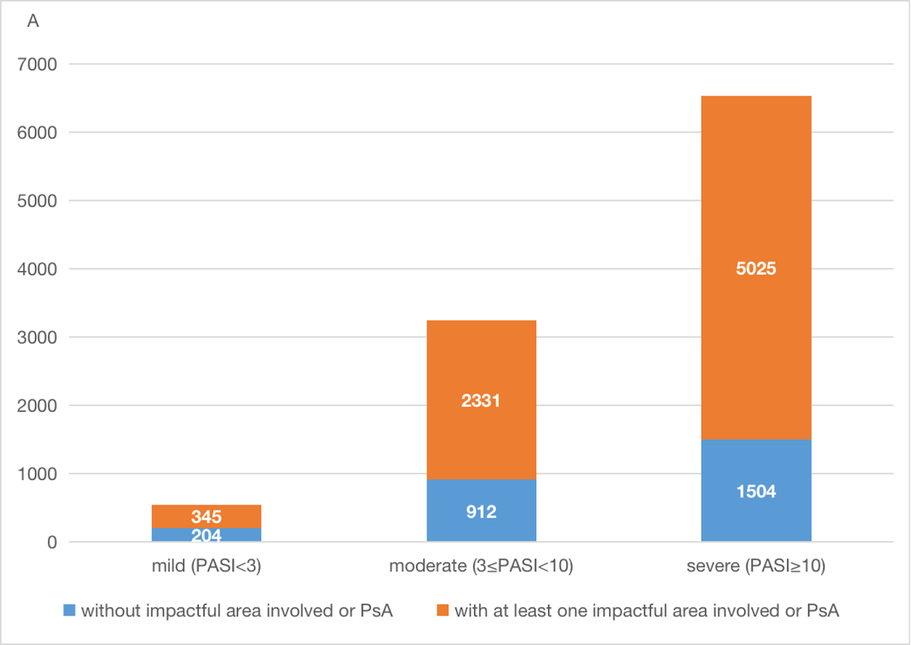
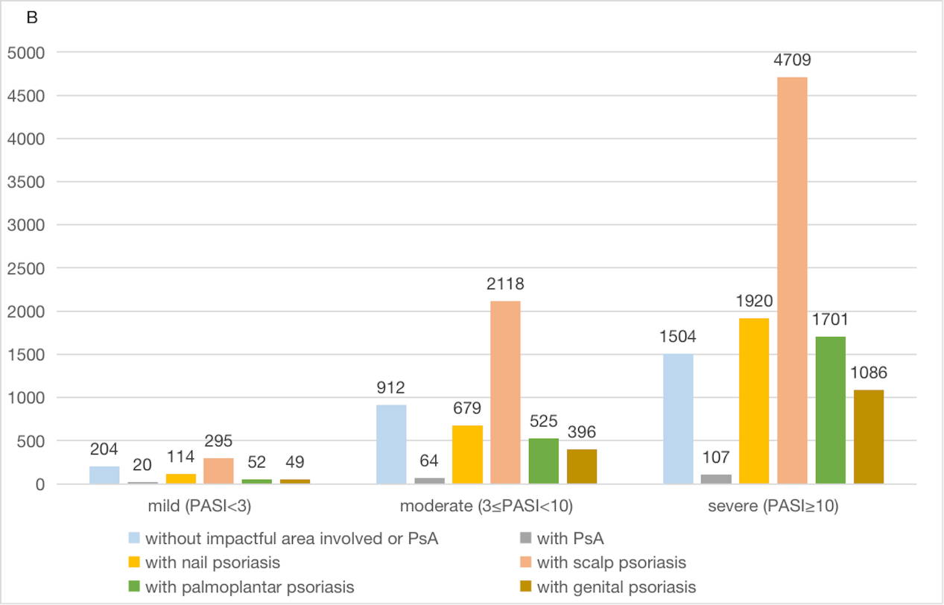
Supplementary Figure 1: The overall disease severity distribution (A) and the occurrence of psoriatic arthritis and impactful area involvement in each disease severity level (B) in the 10,321 patients with plaque psoriasis who initiated biological therapy at enrollment. PASI, psoriasis area and severity index.

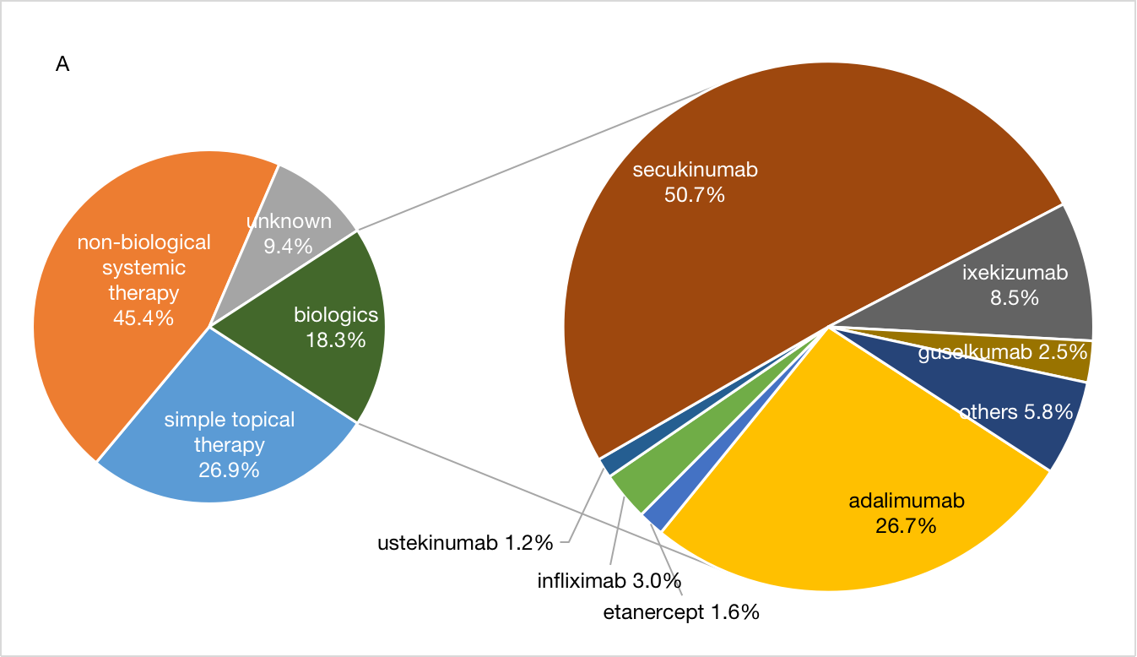
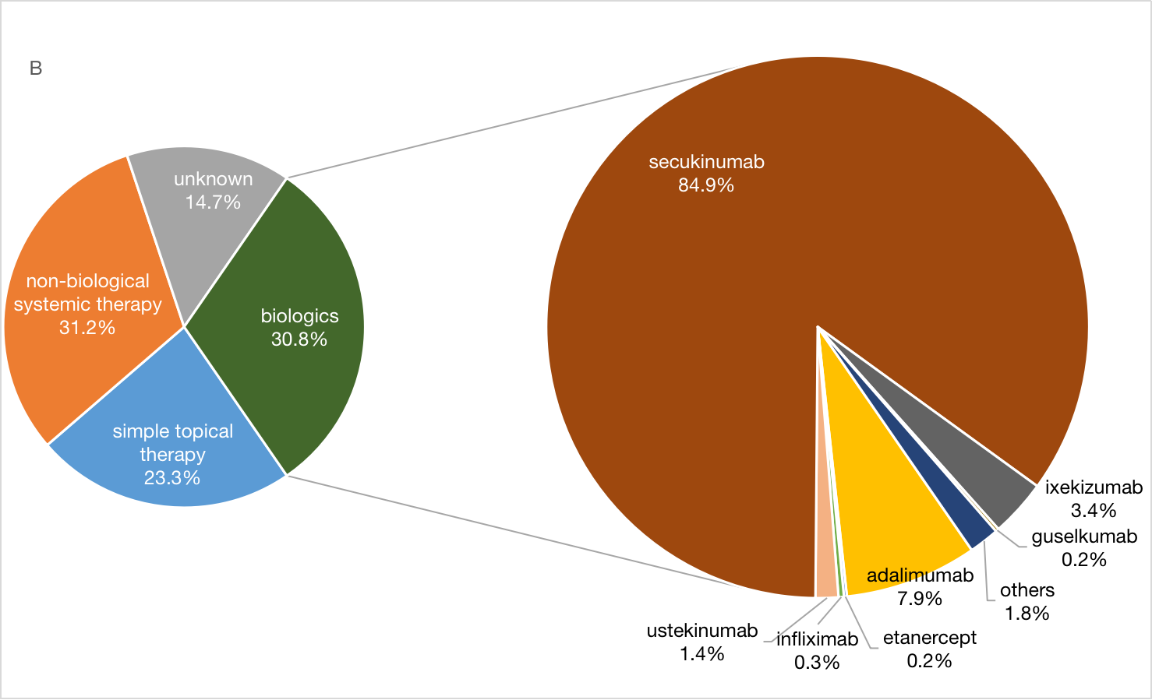
Supplementary Figure 2: Treatment distribution of Chinese patients with psoriasis at enrollment from Aug 2020 to Feb 2021 (A) and Mar 2021 to Mar 2022 (B).
There were 9,881 patients enrolled between Aug 2020 and Feb 2021, and 45,521 patients enrolled between Mar 2021 and Mar 2022.

