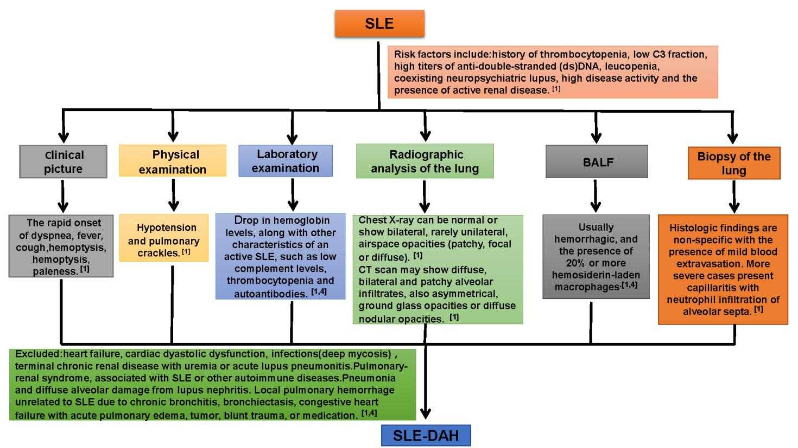
Supplementary Figure 1: Diagnostic process of SLE-DAH. BALF: Bronchoalveolar lavage fluid; DAH: Diffuse alveolar hemorrhage; SLE: Systemic lupus erythematosus.

