Supplementary Table 1. Characteristics of endometrial cancer patients in four datasets
Items | Characteristics | TCGA  (n=543) | CPTAC (n=96) | GEO  (n=91) | In-house (n=25)
Age (years) |  | 64±11 | 62±24 | 64±27 | 61±13
Molecular subtype | POLE | 17（7.33） | 7 (7.29)
 | MSI | 65（28.02） | 26 (27.08）
 | CNL | 90（38.79） | 44 (45.83）
 | CNH | 60（25.86） | 19 (19.79）
Histological type | Endometrioid | 399（73.48） | 86 (89.58） | 79 (86.81) | 25（100）
 | serous | 133（24.49） | 10 (10.42) | 12 (13.19)
FIGO stage | Ⅰ | 339（62.43） | 69 (71.88) | 91 (100) | 20 (80.00)
 | Ⅱ | 51（9.39） | 11 (11.46) |  | 2 (8.00)
 | Ⅲ | 124（22.84） | 14 (14.58) |  | 2 (8.00)
 | Ⅳ | 29（5.34） | 2 (2.08) |  | 1 (4.00)
Pathology grade | G1 | 98（18.05） | 37 (38.54) | 30 (32.97) | 5 (20.00)
 | G2 | 120（22.10） | 41 (42.71) | 36 (39.56) | 10 (40.00)
 | G3 | 325（59.85） | 18 (18.75) | 25 (27.47) | 10 (40.00)
Peritoneal wash status | Negative | 350（86.00）
 | Positive | 57（14.00）
Lymph node status | Negative | 364（67.03）
 | Positive | 179（32.97）
Data are expressed as mean ± standard deviation or n (%).
Supplementary Table 2. Primers used for qPCR
Gene | Forward primer | Reverse primer
SRARP | CAAAGGCACCATCCGTGAG | CCCGTGGGTGCAGTCAATA
FLNA | GGGTCCAGTAGGCGTCAATG | ACACCTTGATCTTGCTGAGGT
FSCN1 | TGGCAAGTTTGTGACCTCCA | CGCGGAACACGATGATGG
CDH1 | GCCTGTCGAAGCAGGATTGC | GCTCTTTGACCACCGCTCTC
CDH2 | CCATCCAGACCGACCCAAAC | TTCTGCAGCAACAGTAAGGAC
WNT7A | CTTCGCCAAGGTCTTTGTGG | ATTCCAGCTTCATGTTCTCCTC
FKBP5 | TCCAAACGAAGGAGCAACAGT | GGAATGTCGTGGTCTTCTCCT
HAND2 | AGAAGACCGACGTGAAAGAGG | TTCTTGTCGTTGCTGCTCACT
MIG6 | GCGAAGGATCTGCCAGTAAG | TCCAGGTATGGTGGTCGTTC
PAEP | AGATCATGCAGGGATTCATCAG | CGGCACGGCTCTTCCATC
PGR | CTTACCTGTGGGAGCTGTAAG | TCAACGATGCAGTCATTTCTTC
GAPDH | TCTGACTTCAACAGCGACAC | GCCAAATTCGTTGTCATACC

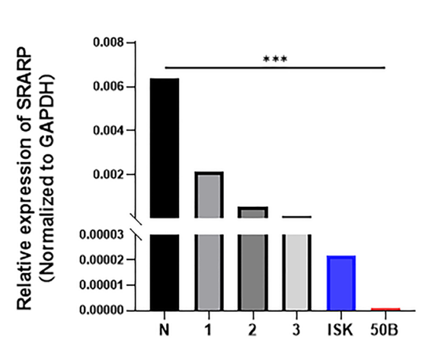
Supplementary Figure 1: Comparison of the expression levels of SRARP in representative tissue samples and EC cell lines detected by qRT-PCR. N: normal endometrium; 1: Grade 1, stage I, endometrioid EC tissue; 2: Grade 2, stage I, endometrioid EC tissue; 3: Grade 3, stage I, endometrioid EC tissue. ***P ≤ 0.001. 50B: HEC50B; EC: Endometrial cancer; ISK: Ishikawa; qRT-PCR: Quantitative real-time polymerase chain reaction; SRARP: Steroid receptor associated and regulated protein.

