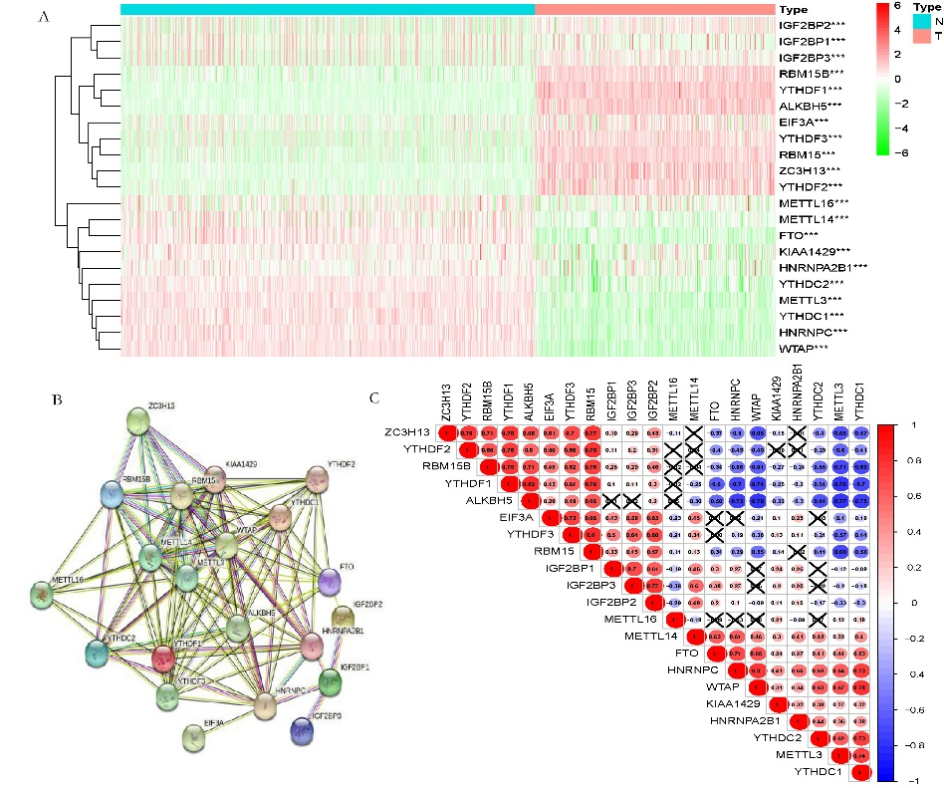

Supplementary Figure 1: The profiling of m6A methylation regulators in cutaneous melanoma. A. The heatmap of 21 m6A RNA methylation regulators in CM (TCGA) patients and normal control samples (GTEx) (red is upregulated and green is downregulated; *p<0.05, **p<0.01, ***p<0.001). B&C. The interactions and correlation analysis of the 21 m6A methylation regulators.
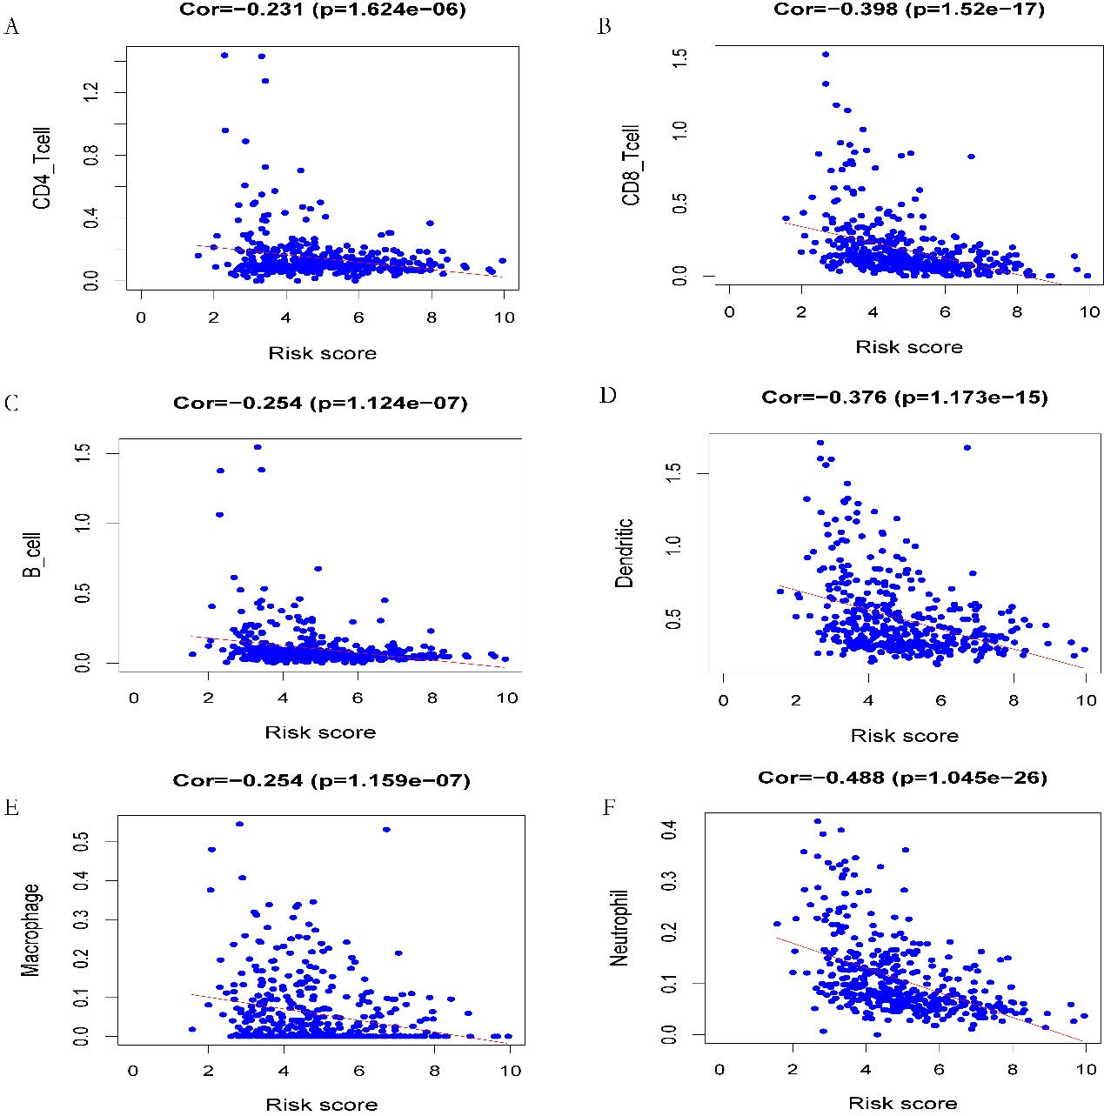

Supplementary Figure 2: The correlation analysis between the risk score and infiltration of immune cells. A-F: CD4+T cells, CD8+T cells, B cells, dendritic cells, macrophages and neutrophils respectively.

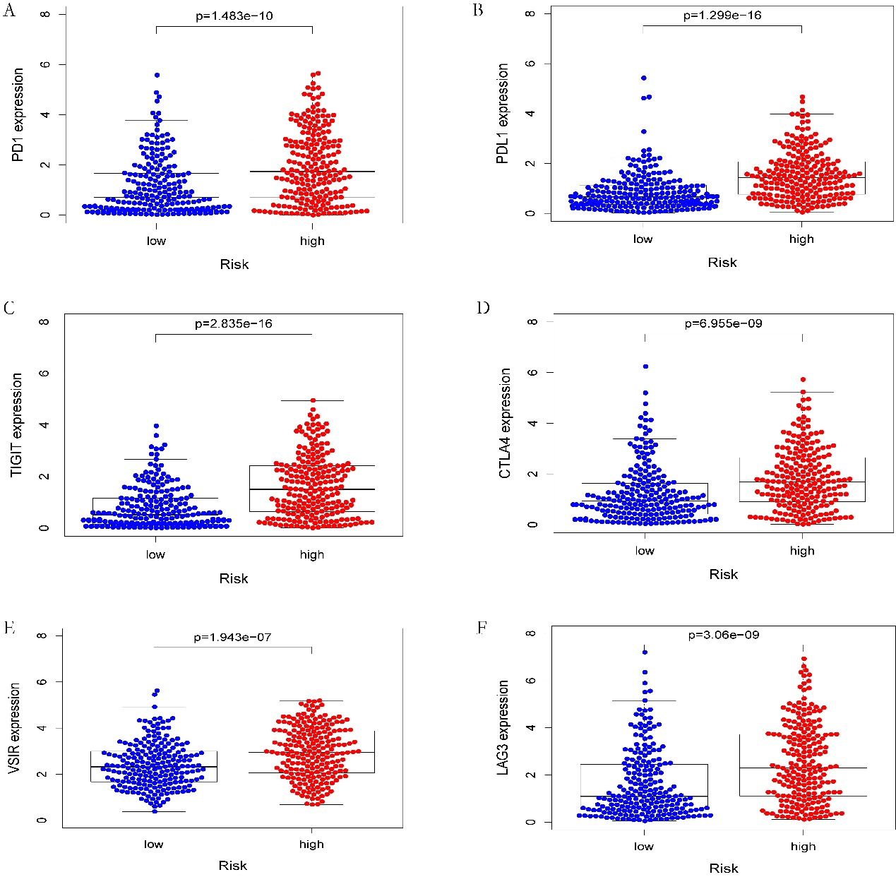

Supplementary Figure 3: The correlation analysis between the risk score and expression of immune checkpoint molecules. A-F: PD-1, PD-L1, TIGIT, CTLA-4, VSIR and LAG3 respectively.

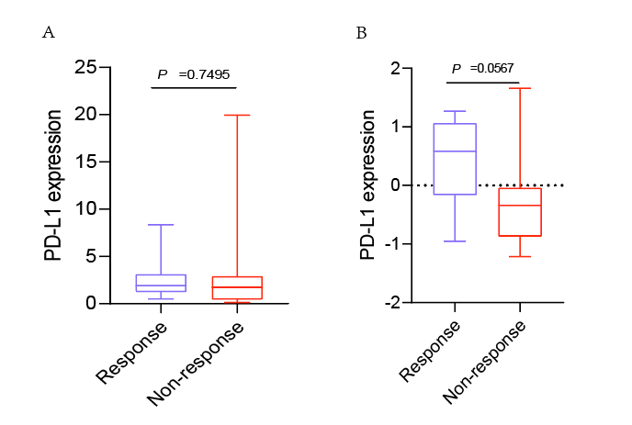

Supplementary Figure 4: The correlation between PD-L1 and response to immunotherapy. A. Boxplot of the response to anti-PD-1 monotherapy in the GSE78220 cohort. B. Boxplot of the response to anti-PD-1 monotherapy in the GSE100797 cohort.

