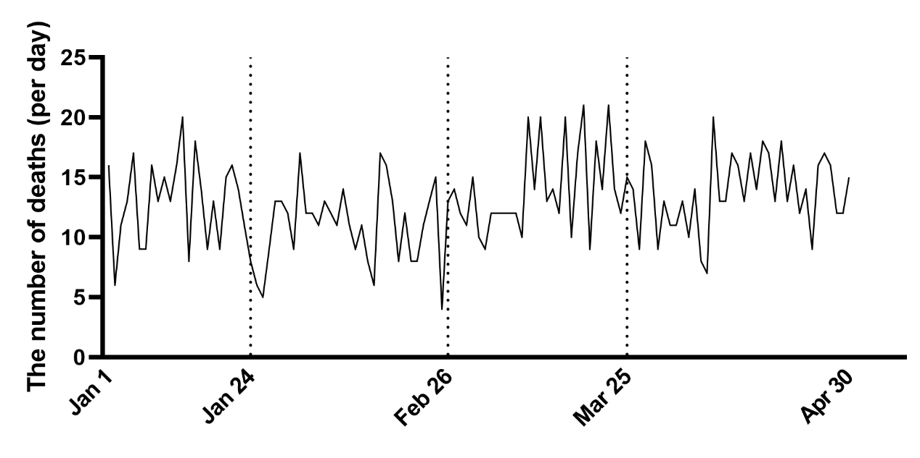
Supplementary Figure 1: The trend of daily out-hospital deaths.
Supplementary Table 1: The feature of suicides during COVID-19.
Parameters | Pre-outbreak | Level I (Serious) | Level II (Mild) | Level III (Controlled) | P-value
Deaths (per day)† | 4.87 ± 2.38 | 4.03 ± 1.64 | 6.14 ± 2.05* | 5.97 ± 2.09* | <0.001
Age (years) | 48.97 ± 20.13 | 52.97 ± 19.47 | 55.17 ± 20.45* | 48.78 ± 22.16 | 0.01
Gender |  |  |  |  | <0.001
Male† | 69 (61.6) | 59 (44.4)* | 107 (62.2) | 134 (59.0)
Female‡ | 43 (38.4) | 74 (55.6)* | 65 (37.8) | 93 (41.0)
Cause of death |  |  |  |  | 0.004
Hanging‡ | 32 (28.6) | 60 (45.1)* | 78 (45.3)* | 52 (22.9)
Drowning† | 17 (15.2) | 5 (3.8)* | 9 (5.2)* | 33 (14.5)
Falling | 23 (20.5) | 52 (39.1)* | 62 (36.0)* | 82 (36.1)*
Sharp instrument injury | 9 (8.0) | 8 (6.0) | 15 (8.7) | 24 (10.6)
Intoxication† | 30 (26.8) | 6 (4.5)* | 8 (4.7)* | 34 (15.0)
Others | 1 (0.9) | 2 (1.5) | 0 (0) | 2 (0.9)
*The statistical difference was ascertained through a comparison with the pre-outbreak situation, based on multiple comparison analysis. †There was a positive correlation between the severity of the epidemic (Serious to Controlled) and the characteristic. ‡There was a negative correlation between the severity of the epidemic (Serious to Controlled) and the characteristic. COVID-19: Coronavirus disease 2019.

