Supplemental Table 1: Endpoint information of phase III anticancer clinical trials (N=400).
Variables |  | n (%)
Single/multiple endpoint
 | Single endpoint (n=336)
 | PFS | 150 (44.6)
 | OS | 97 (28.9)
 | ORR | 35 (10.4)
 | DFS | 24 (7.1)
 | Multiple endpoint (n=64)
 | OS and PFS | 47 (73.4)
 | ORR and BOR | 8 (12.5)
 | OS and ORR | 4 (6.3)
Specific classification
 | Overall survival | 154 (38.5)
 | Surrogate endpoint | 295 (73.8)
 | Radiology-based endpoint | 281 (70.3)
 | Time-to-event endpoint | 243 (60.8)
 | Tumor-response endpoint | 40 (10.0)
 | Pathology-based endpoint | 9 (2.3)
 | Blood-based endpoint | 8 (2.0)
OS: Overall survival; PFS: Progression-free survival; ORR: Objective response rate; DFS: Disease-free survival; BOR: Best overall response.

Supplemental Table 2: Distribution of endpoints of phase III anticancer clinical trials among groups.
Variables | Single endpoint  (n=336) | Multiple endpoints  (n=64) | χ² | P-value
Stage of treatment* |  |  | 3.36 | 0.186
Neoadjuvant/Adjuvant | 42 (13.1) | 6 (9.4)
First-line | 165 (51.6) | 41 (64.1)
Second or Sequent-line | 113 (35.3) | 17 (26.6)
5-Year survival rates†,‡ |  |  | 4.07 | 0.131
>59.8% | 86 (26.7) | 11 (18.6)
26.7-59.8% | 101 (31.4) | 15 (25.4)
<26.7% | 135 (41.9) | 33 (55.9)
Immunotherapy drugs |  |  | 65.77 | <0.001
No | 257 (76.5) | 16 (25.0)
Yes | 79 (23.5) | 48 (75.0)
Targeted drugs |  |  | 4.78 | 0.029
No | 71 (21.1) | 6 (9.4)
Yes | 265 (78.9) | 58 (90.6)
Cytotoxic drugs |  |  | 3.02 | 0.082
No | 303 (90.2) | 62 (96.9)
Yes | 33 (9.8) | 2 (3.1)
Endocrine therapy drugs |  |  | 0.25 | 0.617
No | 320 (95.2) | 60 (93.8)
Yes | 16 (4.8) | 4 (6.3)
Masking |  |  | 1.16 | 0.559
Single-blind | 6 (1.8) | 0 (0.0)
Double blind | 210 (62.5) | 41 (64.1)
Open-label | 120 (35.7) | 23 (35.9)
Collaboration pattern |  |  | 12.31 | <0.001
Global study | 172 (51.2) | 48 (75.0)
Domestic study | 164 (48.8) | 16 (25.0)
Data and safety monitoring board |  |  | 15.60 | <0.001
No | 134 (39.9) | 9 (14.1)
Yes | 202 (60.1) | 55 (85.9)
Drug registration classification |  |  | 16.15 | <0.001
Chemical drugs | 179 (53.3) | 17 (26.6)
Biological products | 155 (46.1) | 47 (73.4)
Traditional Chinese drugs/natural drugs | 2 (0.6) | 0 (0)
*16 in single endpoint group were missing; †More than one cancer type used for 14 in single endpoint group and 5 in multiple endpoint group. ‡The interquartile range according to the newly published cancer survival rate data in China.^{[1]}

Table 3: Comparison of overall survival and surrogate endpoints for phase III anticancer clinical trials.
Variables | OS  (n=97) | Surrogate endpoints  (n=233) | χ² | P-value
Stage of treatment* |  |  | 26.47 | <0.001
Neoadjuvant/Adjuvant | 1 (2.4) | 40 (97.6)
First-line | 44 (27.0) | 119 (73.0)
Second or Sequent-line | 50 (44.3) | 63 (55.8)
5-Year survival rates† ‡ |  |  | 19.89 | <0.001
>59.8% | 9 (10.8) | 74 (89.2)
26.7-59.8% | 35 (35.7) | 63 (64.3)
<26.7% | 51 (37.8) | 84 (62.2)
Immunotherapy drugs |  |  | 7.67 | 0.006
No | 64 (25.5) | 187 (74.5)
Yes | 33 (41.8) | 46 (58.2)
Targeted drugs |  |  | 3.23 | 0.072
No | 26 (38.2) | 42 (61.8)
Yes | 71 (27.1) | 191 (72.9)
Cytotoxic drugs |  |  | 0.86 | 0.354
No | 85 (28.6) | 212 (71.4)
Yes | 12 (36.4) | 21 (63.6)
Endocrine therapy drugs |  |  | 0.67 | 0.414
No | 94 (29.8) | 221 (70.2)
Yes | 3 (20.0) | 12 (80.0)
Masking |  |  | 3.61 | 0.164
Single-blind | 3 (50.0) | 3 (50.0)
Double blind | 54 (26.1) | 153 (73.9)
Open-label | 40 (34.2) | 77 (65.8)
Collaboration pattern |  |  | 2.43 | 0.119
Global study | 57 (33.1) | 115 (66.9)
Domestic study | 40 (25.3) | 118 (74.7)
Data and safety monitoring board |  |  | 1.32 | 0.251
No | 33 (25.8) | 95 (74.2)
Yes | 64 (31.7) | 138 (68.3)
Drug registration classification |  |  | 6.30 | 0.043
Chemical drugs | 46 (26.1) | 130 (73.9)
Biological products | 49 (32.2) | 103 (67.8)
Traditional Chinese drugs/Natural drugs | 2 (100.0) | 0 (0.0)
*2 in OS group and 11 in surrogate endpoints group were missing; †More than one cancer type used for 2 in OS group and 12 in surrogate endpoints group. ‡The interquartile range according to the newly published cancer survival rate data in China.^{[1]}

Reference
1. Zeng H, Chen W, Zheng R, Zhang S, Ji JS, Zou X, et al. Changing cancer survival in China during 2003-15: a pooled analysis of 17 population-based cancer registries. Lancet Glob Health 2018;6:e555-e567.

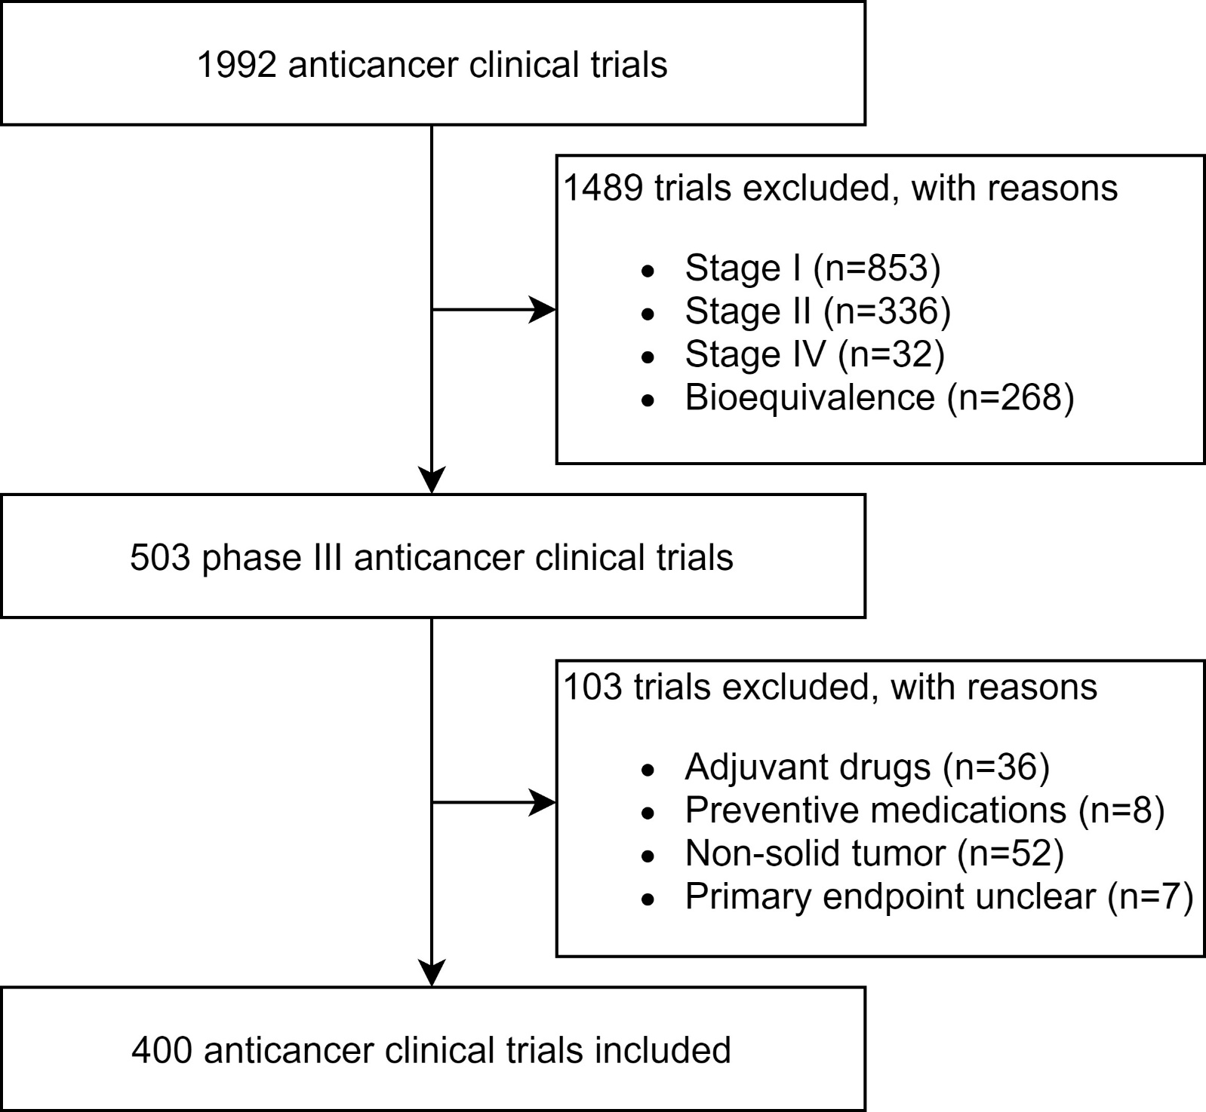
Supplemental Figure 1 Flow Chart of Data Processing

