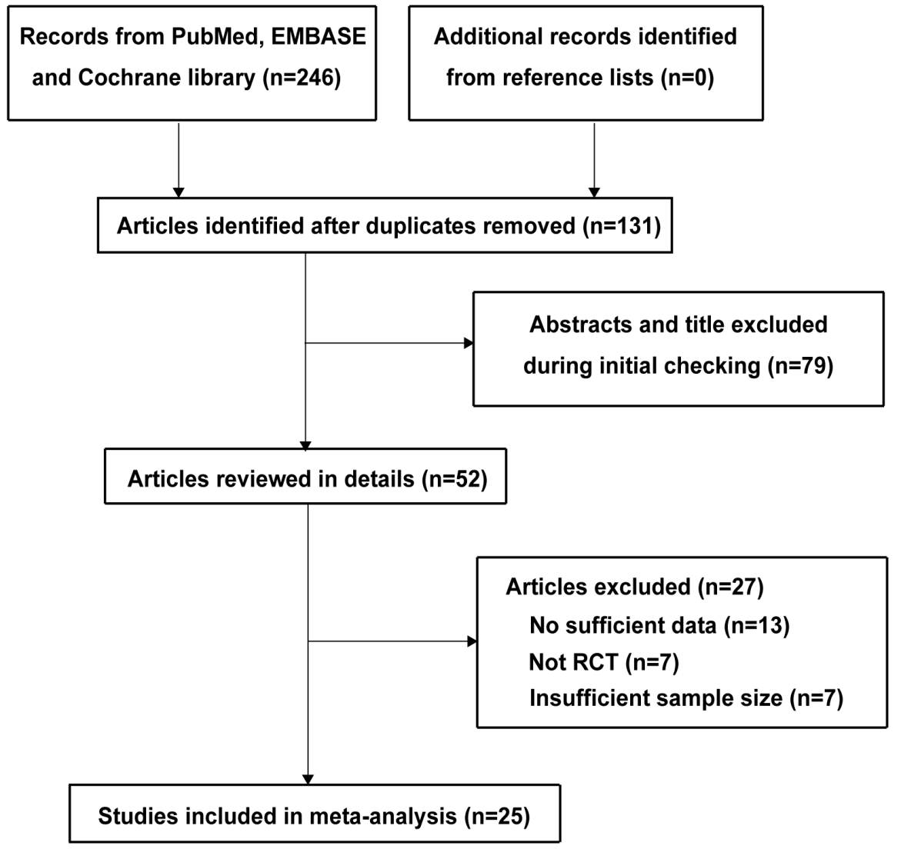
Supplementary Figure 1: The flow diagram of study retrieval and selection. RCT: Randomized controlled trial.
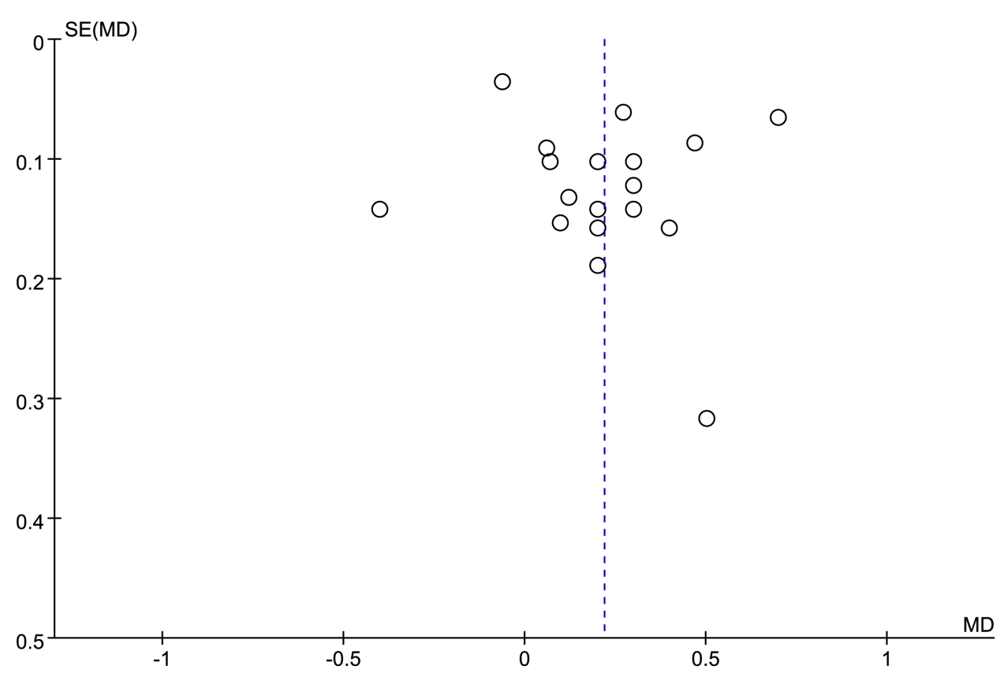
Supplementary Figure 2: Funnel plot of postoperative core temperature.
Supplementary Table 1: Search strategy of PubMed.
Search number | Query
6 | ((("Hypothermia"[Mesh]) OR ((hypothermia[Title/Abstract]) OR (hypothermy[Title/Abstract]))) AND ((forced-air warm*[Title/Abstract]) OR (forced air warm*[Title/Abstract]))) AND (((((((("Randomized Controlled Trial" [Publication Type]) OR "Randomized Controlled Trials as Topic"[Mesh]) OR "Random Allocation"[Mesh]) OR "Double-Blind Method"[Mesh]) OR "Single-Blind Method"[Mesh]) OR "Placebos"[Mesh]) OR ((random*[Text Word]) OR (placebo[Title/Abstract]))) OR (((((singl*[Text Word]) OR (doubl*[Text Word])) OR (trebl*[Text Word])) OR (tripl*[Text Word])) AND (((mask*[Text Word]) OR (blind*[Text Word])) OR (dumm*[Text Word]))))
5 | ((((((("Randomized Controlled Trial" [Publication Type]) OR "Randomized Controlled Trials as Topic"[Mesh]) OR "Random Allocation"[Mesh]) OR "Double-Blind Method"[Mesh]) OR "Single-Blind Method"[Mesh]) OR "Placebos"[Mesh]) OR ((random*[Text Word]) OR (placebo[Title/Abstract]))) OR (((((singl*[Text Word]) OR (doubl*[Text Word])) OR (trebl*[Text Word])) OR (tripl*[Text Word])) AND (((mask*[Text Word]) OR (blind*[Text Word])) OR (dumm*[Text Word])))
4 | (forced-air warm*[Title/Abstract]) OR (forced air warm*[Title/Abstract])
3 | ("Hypothermia"[Mesh]) OR ((hypothermia[Title/Abstract]) OR (hypothermy[Title/Abstract]))
2 | (hypothermia[Title/Abstract]) OR (hypothermy[Title/Abstract])
1 | "Hypothermia"[Mesh]
Supplementary Table 2: The references of 25 studies included in this systematic review.
1. Fossum S, Hays J, Henson MM. A comparison study on the effects of prewarming patients in the outpatient surgery setting. J Perianesth Nurs 2001;16:187–194. doi: 10.1053/jpan.2001.24039.
2. Janicki PK, Higgins MS, Janssen J, Johnson RF, Beattie C. Comparison of two different temperature maintenance strategies during open abdominal surgery: Upper body forced-air warming versus whole body water garment. Anesthesiology 2001;95:868–874. doi: 10.1097/00000542-200110000-00014.
3. Kabbara A, Goldlust SA, Smith CE, Hagen JF, Pinchak AC. Randomized prospective comparison of forced air warming using hospital blankets versus commercial blankets in surgical patients. Anesthesiology 2002;97:338–344. doi: 10.1097/00000542-200208000-00009.
4. Ng SF, Oo CS, Loh KH, Lim PY, Chan YH, Ong BC. A comparative study of three warming interventions to determine the most effective in maintaining perioperative normothermia. Anesth Analg 2003;96:171–176. doi: 10.1097/00000539-200301000-00036.
5. Lee L, Leslie K, Kayak E, Myles PS. Intraoperative patient warming using radiant warming or forced-air warming during long operations. Anaesth Intensive Care 2004;32:358–361. doi: 10.1177/0310057x0403200309.
6. Wong A, Walker S, Bradley M. Comparison of a radiant patient warming device with forced air warming during laparoscopic cholecystectomy. Anaesth Intensive Care 2004;32:93–99. doi: 10.1177/0310057x0403200115.
7. Torrie JJ, Yip P, Robinson E. Comparison of forced-air warming and radiant heating during transurethral prostatic resection under spinal anaesthesia. Anaesth Intensive Care 2005;33:733–738. doi: 10.1177/0310057x0503300605.
8. Fallis WM, Hamelin K, Symonds J, Wang X. Maternal and newborn outcomes related to maternal warming during cesarean delivery. J Obstet Gynecol Neonatal Nurs 2006;35:324–331. doi: 10.1111/j.1552-6909.2006.00052.x.
9. Wagner D, Byrne M, Kolcaba K. Effects of comfort warming on preoperative patients. AORN J 2006;84:427–448. doi: 10.1016/s0001-2092(06)63920-3.
10. Ng V, Lai A, Ho V. Comparison of forced-air warming and electric heating pad for maintenance of body temperature during total knee replacement. Anaesthesia 2006;61:1100–1104. doi: 10.1111/j.1365-2044.2006.04816.x.
11. Kim JY, Shinn H, Oh YJ, Hong YW, Kwak HJ, Kwak YL. The effect of skin surface warming during anesthesia preparation on preventing redistribution hypothermia in the early operative period of off-pump coronary artery bypass surgery. Eur J Cardiothorac Surg 2006;29:343–347. doi: 10.1016/j.ejcts.2005.12.020.
12. Ihn CH, Joo JD, Chung HS, Choi JW, Kim DW, Jeon YS, et al. Comparison of three warming devices for the prevention of core hypothermia and post-anaesthesia shivering. J Int Med Res 2008;36:923–931. doi: 10.1177/147323000803600508.
13. Insler SR, Bakri MH, Nageeb F, Mascha E, Mihaljevic T, Sessler DI. An evaluation of a full-access underbody forced-air warming system during near-normothermic, on-pump cardiac surgery. Anesth Analg 2008;106:746–750. doi: 10.1213/ane.0b013e318162c2d7.
14. Fanelli A, Danelli G, Ghisi D, Ortu A, Moschini E, Fanelli G. The efficacy of a resistive heating under-patient blanket versus a forced-air warming system: A randomized controlled trial. Anesth Analg 2009;108:199–201. doi: 10.1213/ane.0b013e31818e6199.
15. Leeth D, Mamaril M, Oman KS, Krumbach B. Normothermia and patient comfort: A comparative study in an outpatient surgery setting. J Perianesth Nurs 2010;25:146–151. doi: 10.1016/j.jopan.2010.03.010.
16. O’Brien D, Greenfield ML, Anderson JE, Smith BA, Morris M. Comfort, satisfaction, and anxiolysis in surgical patients using a patient-adjustable comfort warming system: A prospective randomized clinical trial. J Perianesth Nurs 2010;25:88–93. doi: 10.1016/j.jopan.2010.01.008.
17. Brandt S, Oguz R, Huttner H, Waglechner G, Chiari A, Greif R, et al. Resistive-polymer versus forced-air warming: Comparable efficacy in orthopedic patients. Anesth Analg 2010;110:834–838. doi: 10.1213/ANE.0b013e3181cb3f5f.
18. Egan C, Bernstein E, Reddy D, Ali M, Paul J, Yang D, et al. A randomized comparison of intraoperative PerfecTemp and forced-air warming during open abdominal surgery. Anesth Analg 2011;113:1076–1081. doi: 10.1213/ANE.0b013e31822b896d.
19. Nicholson M. A comparison of warming interventions on the temperatures of inpatients undergoing colorectal surgery. AORN J 2013;97:310–322. doi: 10.1016/j.aorn.2012.12.018.
20. Tanaka N, Ohno Y, Hori M, Utada M, Ito K, Suzuki T. A randomised controlled trial of the resistive heating blanket versus the convective warming system for preventing hypothermia during major abdominal surgery. J Perioper Pract 2013;23:82–86. doi: 10.1177/175045891302300404.
21. Pu Y, Cen G, Sun J, Gong J, Zhang Y, Zhang M, et al. Warming with an underbody warming system reduces intraoperative hypothermia in patients undergoing laparoscopic gastrointestinal surgery: A randomized controlled study. Int J Nurs Stud 2014;51:181–189. doi: 10.1016/j.ijnurstu.2013.05.013.
22. Torossian A, Van Gerven E, Geertsen K, Horn B, Van de Velde M, Raeder J. Active perioperative patient warming using a self-warming blanket (BARRIER EasyWarm) is superior to passive thermal insulation: A multinational, multicenter, randomized trial. J Clin Anesth 2016;34:547–554. doi: 10.1016/j.jclinane.2016.06.030.
23. Yoo JH, Ok SY, Kim SH, Chung JW, Park SY, Kim MG, et al. Efficacy of active forced air warming during induction of anesthesia to prevent inadvertent perioperative hypothermia in intraoperative warming patients: Comparison with passive warming, a randomized controlled trial. Medicine 2021;100:e25235. doi: 10.1097/md.0000000000025235.
24. Ralte P, Mateu-Torres F, Winton J, Bardsley J, Smith M, Kent M, et al. Prevention of perioperative hypothermia: A prospective, randomized, controlled trial of bair hugger versus inditherm in patients undergoing elective arthroscopic shoulder surgery. Arthroscopy 2020;36:347–352. doi: 10.1016/j.arthro.2019.08.015.
25. Smith N, Abernethy C, Allgar V, Foster L, Martinson V, Stones E. An open-label, randomised controlled trial on the effectiveness of the Orve + wrap(®) versus Forced Air Warming in restoring normothermia in the postanaesthetic care unit. J Clin Nurs 2020;29:1085–1093. doi: 10.1111/jocn.15159.

Supplementary Table 3: Basic characteristics of all included studies.
Study | Country | Sample size | Mean age (years) | Intervention | Control | Type of Anesthesia | Type of surgery
Fossum et al^{[1]} | America | 100 (50/50) | 45.2 | Forced-air warming (set at 41 °C) | Warmed cotton blanket (set at 68 °C) | General anesthesia | Outpatient  surgery
Kabbara et al^{[3]} | America | 83 (44/39) | 46.0 vs. 41.0 | Forced-air warming (set at 43 °C) | Hospital blanket | General anesthesia | Major surgery
Janicki et al^{[2]} | America | 53 (28/25) | 52.9 vs. 56.1 | Forced-air warming (set at 43 °C) | Water-garment (set at 36.8) | General anesthesia | Open abdominal surgery
Ng et al^{[10]} | Singapore | 60 (30/30) | 67.3 vs. 67.4 | Forced-air warming (set at 43 °C) | Electric heating pad (set at 39 °C) | n.r. | total knee  replacement
Lee et al^{[5]} | Australia | 59 (29/30) | 56.0 vs. 53.0 | Forced-air warming (set at 43 °C) | Radiant warming | n.r. | Elective or emergency non-cardiac surgery
Wong et al^{[6]} | New Zealand | 42 (21/21) | 40.5 vs. 38.1 | Forced-air warming (set at 43 °C) | Radiant warmer (set at 41 °C) | General anesthesia | Laparoscopic cholecystectomy
Torrie et al^{[7]} | New Zealand | 60 (32/28) | 73.0 vs. 72.0 | Forced-air warming (set at 42 °C) | Radiant warming (set at 41 °C) | Spinal anesthesia | Transurethral prostatic resection
Fallis et al^{[8]} | Canada | 62 (32/30) | 30.0 vs. 30.0 | Forced-air warming (set at 43 °C) | Warmed cotton blanket | Spinal anesthesia | Cesarean delivery
Wagner et al^{[9]} | America | 118 (60/58) | 50.0 vs. 48.0 | Forced-air warming (set at 38 °C) | Warmed cotton blanket | n.r. | Elective surgery
Ng et al^{[4]} | Singapore | 200 (100/100) | 66.3 vs. 65.8 | Forced-air warming (set at 43 °C) | Two-cotton-blanket | General anesthesia | Total knee  replacement
Kim et al^{[11]} | Korea | 40 (20/20) | 64.1 vs. 61.3 | Forced-air warming (set at 40 °C) | Cotton blanket | General anesthesia | Off-pump coronary artery bypass surgery
Ihn et al^{[12]} | Korea | 60 (30/30) | 51.0 vs. 48.0 | Forced-air warming (set at 42 °C) | Warmed cotton blanket (set at 42 °C) | General anesthesia | Abdominal hysterectomy
Insler et al^{[13]} | America | 56 (27/29) | 61.0 vs. 57.0 | Forced-air warming (set at 43 °C) | Fluid warming and passive insulation (set at 42 °C) | General anesthesia | Elective  cardiac surgery
Fanelli et al^{[14]} | Italy | 56 (28/28) | 66.0 vs. 70.0 | Forced-air warming (set at 43 °C) | Resistive carbon-fiber heating blanket (set at 40.7 °C) | Spinal anesthesia | Hip replacement
Leeth et al^{[15]} | America | 105 (56/49) | 43.0 vs. 44.0 | Forced-air warming (set at 38 °C) | Heated cotton blanket | n.r. | Outpatient surgery
O’Brien et al^{[16]} | America | 130 (58/72) | 18.0–80.0 | Forced-air warming (set at 37–43 °C) | Warmed blanket | n.r. | Orthopedic surgery
Brandt et al^{[17]} | Switzerland | 80 (40/40) | 39.0 vs. 37.0 | Forced-air warming (set at 43 °C) | Resistive-polymer system (set at 43 °C) | General/spinal anesthesia | Orthopedic surgery
Egan et al^{[18]} | America | 70 (34/36) | 51.0 vs. 51.0 | forced-air warming gown (set at 43 °C) | Resistive warming system (set at 40 °C) | General anesthesia | Elective major open abdominal surgery
Nicholson^{[19]} | Canada | 66 (34/32) | 18.0–85.0 | forced-air warming gown (set at 38 °C) | Unwarmed cotton blanket | Unclear | Colorectal surgery
Tanaka et al^{[20]} | Japan | 64 (33/31) | 55.0 vs. 60.9 | forced-air warming gown (set at 43 °C) | Resistive heating blanket (set at 42 °C) | Epidural and general anesthesia | Elective major open abdominal surgery
Pu et al^{[21]} | China | 110 (55/55) | 68.0 vs. 67.0 | forced-air warming gown (set at 41 °C) | Warming blanket | n.r. | Laparoscopic gastrointestinal surgery
Torossian et al^{[22]} | Germany | 246 (122/124) | 46.5 vs. 45.6 | forced-air warming gown (set at 42 °C) | Warming blanket | n.r. | Elective surgery
Yoo et al^{[23]} | Korea | 126 (63/63) | 58.2 vs. 60.0 | forced-air warming gown (set at 47 °C) | Cotton blanket | General anesthesia | Elective surgery
Ralte et al^{[24]} | England | 91 (47/44) | n.r. | forced-air warming gown (set at 43 °C) | Resistive heating system (set at 40 °C) | General anesthesia | Elective arthroscopic shoulder surgery
Smith et al^{[25]} | UK | 128 (64/64) | 63.3 vs. 62.6 | forced-air warming gown (set at 43 °C) | Insulation blanket (set at 50 °C) | General and spinal anesthesia | Selective major surgery
Note: Refer Supplementary Table 2 for studies.
Supplementary Table 4: Details of risk of bias of all included studies (n = 25).
Study | Random sequence generation (selection bias) | Allocation concealment (selection bias) | Blinding of participants and personnel (performance bias) | Blinding of outcome assessment (detection bias) | Incomplete outcome data (attrition bias) | Selective reporting (reporting bias) | Other bias
Brandt et al^{[17]} | Low | Low | Low | Low | Low | Low | Low
Egan et al^{[18]} | Low | Low | Low | Low | Low | Low | Low
Fallis et al^{[8]} | Low | Low | Low | Low | Low | Low | Low
Fanelli et al^{[14]} | Low | Low | Low | Low | Low | Low | Low
Fossum et al^{[1]} | Low | Unclear | Unclear | Unclear | Low | Low | Low
Ihn et al^{[12]} | Low | Unclear | Unclear | Unclear | Low | Low | Low
Insler et al^{[13]} | Low | Low | Unclear | Unclear | High | Low | Low
Janicki et al^{[2]} | Low | Low | Low | Low | Low | Low | Low
Kabbara et al^{[3]} | Low | Low | Low | Low | High | Low | Low
Kim et al^{[11]} | Unclear | Low | Low | Low | Low | Low | Low
Lee et al^{[5]} | Low | Low | Low | Low | High | Low | Low
Leeth et al^{[15]} | Unclear | Unclear | Low | Low | High | Low | Low
Ng et al^{[4]} | Unclear | Low | Low | Low | Low | Low | Low
Ng et al^{[10]} | Unclear | Low | Low | Low | Low | Low | Low
Nicholson ^{[19]} | Low | Low | Low | Low | Low | Low | Low
O’Brien et al^{[16]} | Low | Low | Low | Low | Low | Low | Low
Pu et al^{[21]} | Low | Unclear | High | Low | Low | Low | Low
Tanaka et al^{[20]} | Low | Low | Low | Low | Low | Low | Low
Torossian et al^{[22]} | Low | Unclear | High | High | High | Low | Low
Torrie et al^{[7]} | Low | Low | Low | Low | High | Low | Low
Wagner et al^{[9]} | Low | Low | Low | Low | High | Low | Low
Wong et al^{[6]} | Low | Unclear | Low | Low | Low | Low | Low
Yoo et al^{[23]} | Low | High | High | Low | Low | Low | Low
Ralte et al^{[24]} | Low | Low | Low | Low | Low | Low | Low
Smith et al^{[25]} | Low | Low | Low | Low | Low | Low | Low
Note: Refer Supplementary Table 2 for studies.

